1. Toast.js

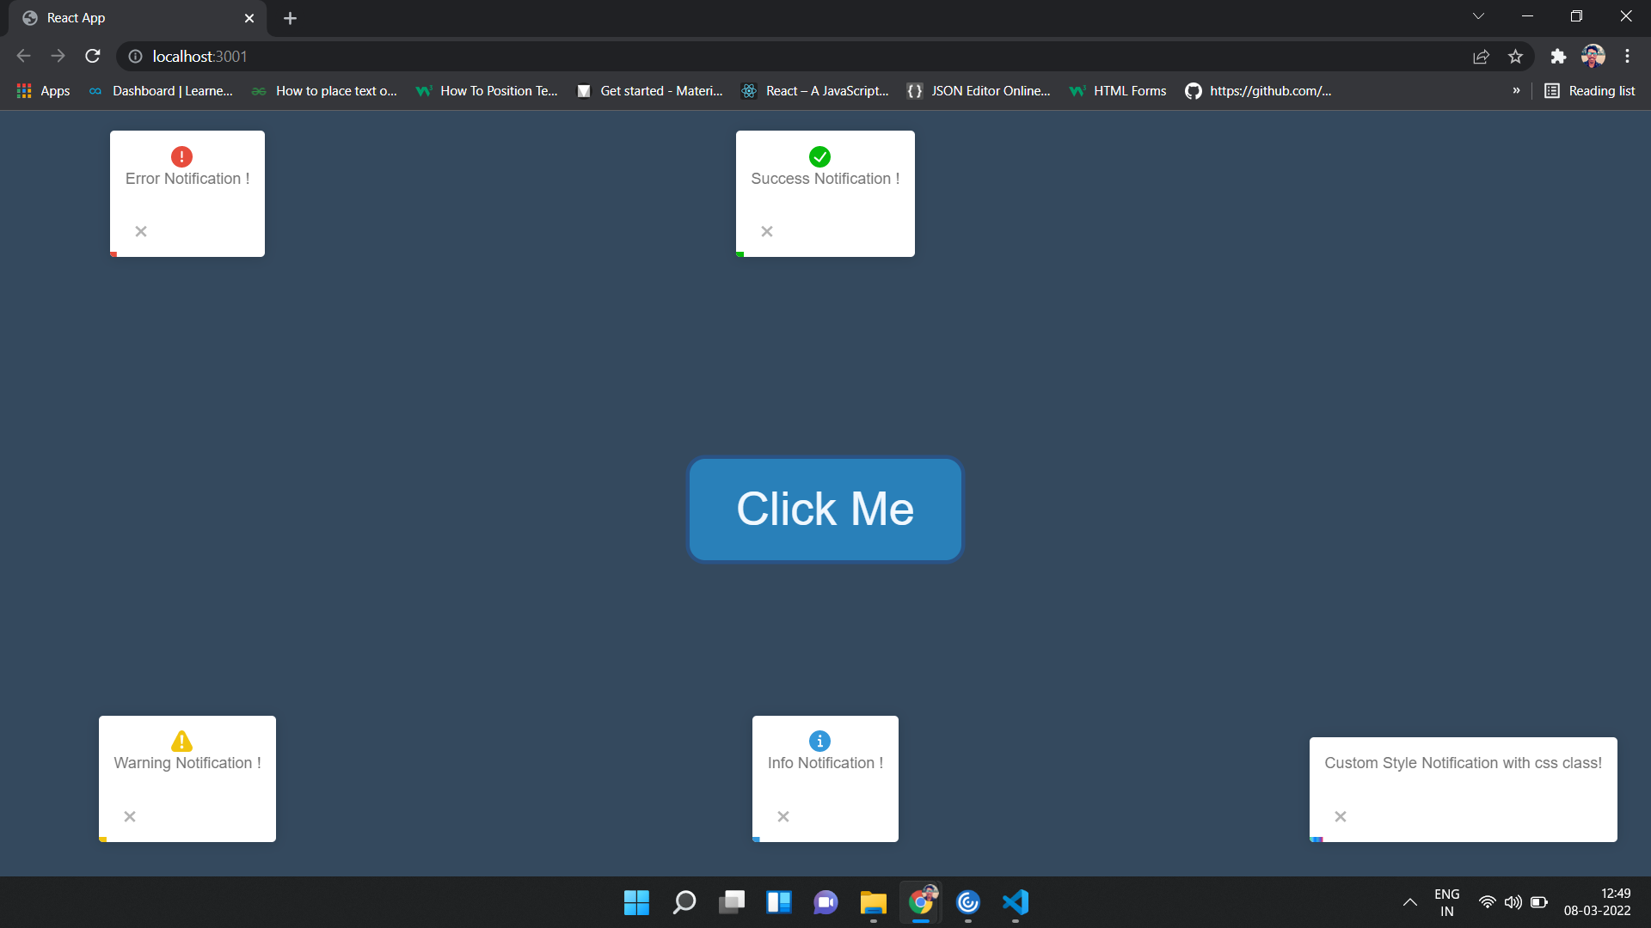

1. CustomHooks.js (same for UseEffectDependency.js)

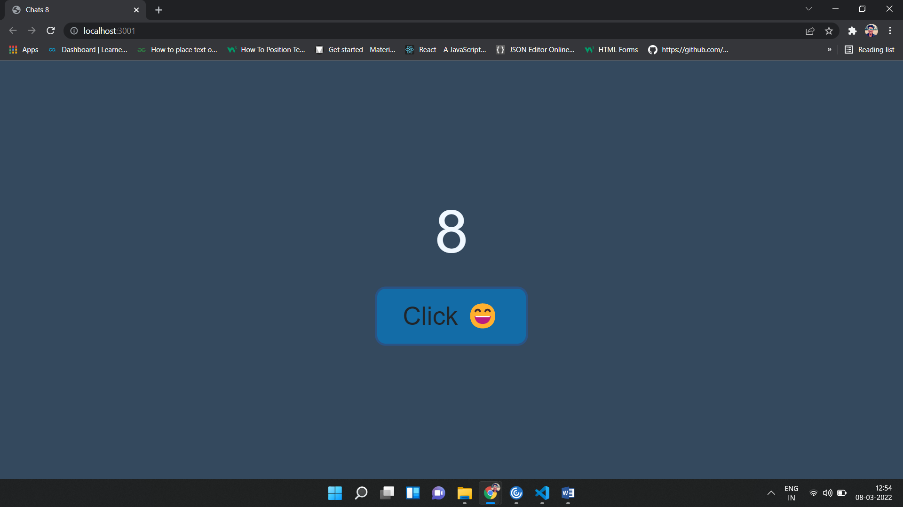

1. useReducer.js

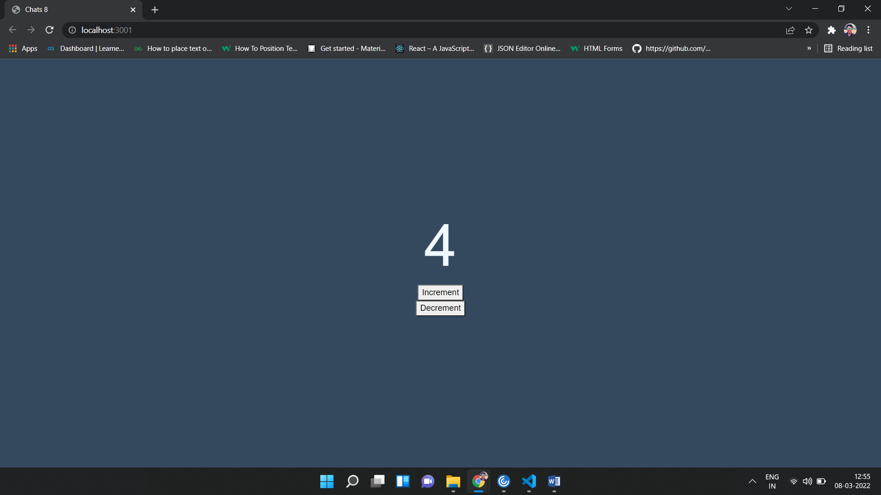

1. UncontrollCompo.js

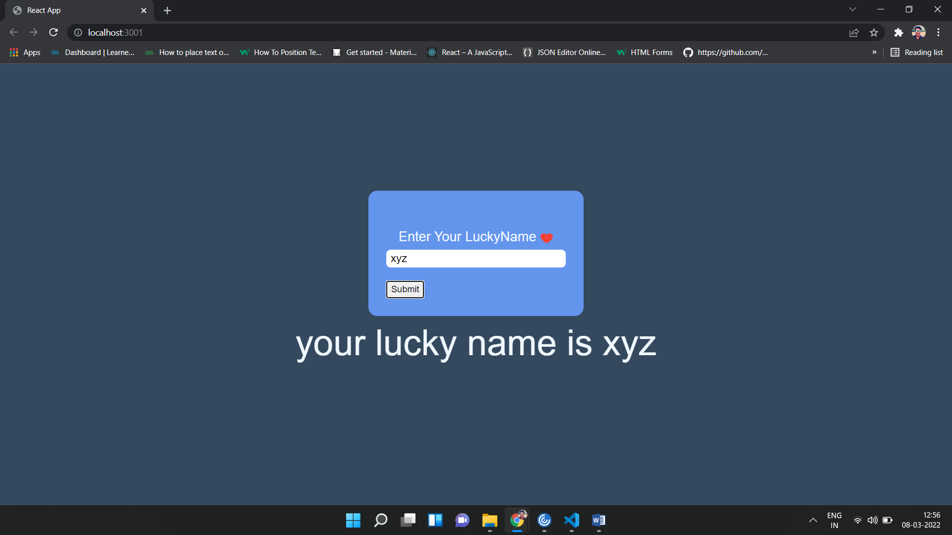

1. Challenge2.js (same for SpreadOperator.js, ArrayinHooks.js)

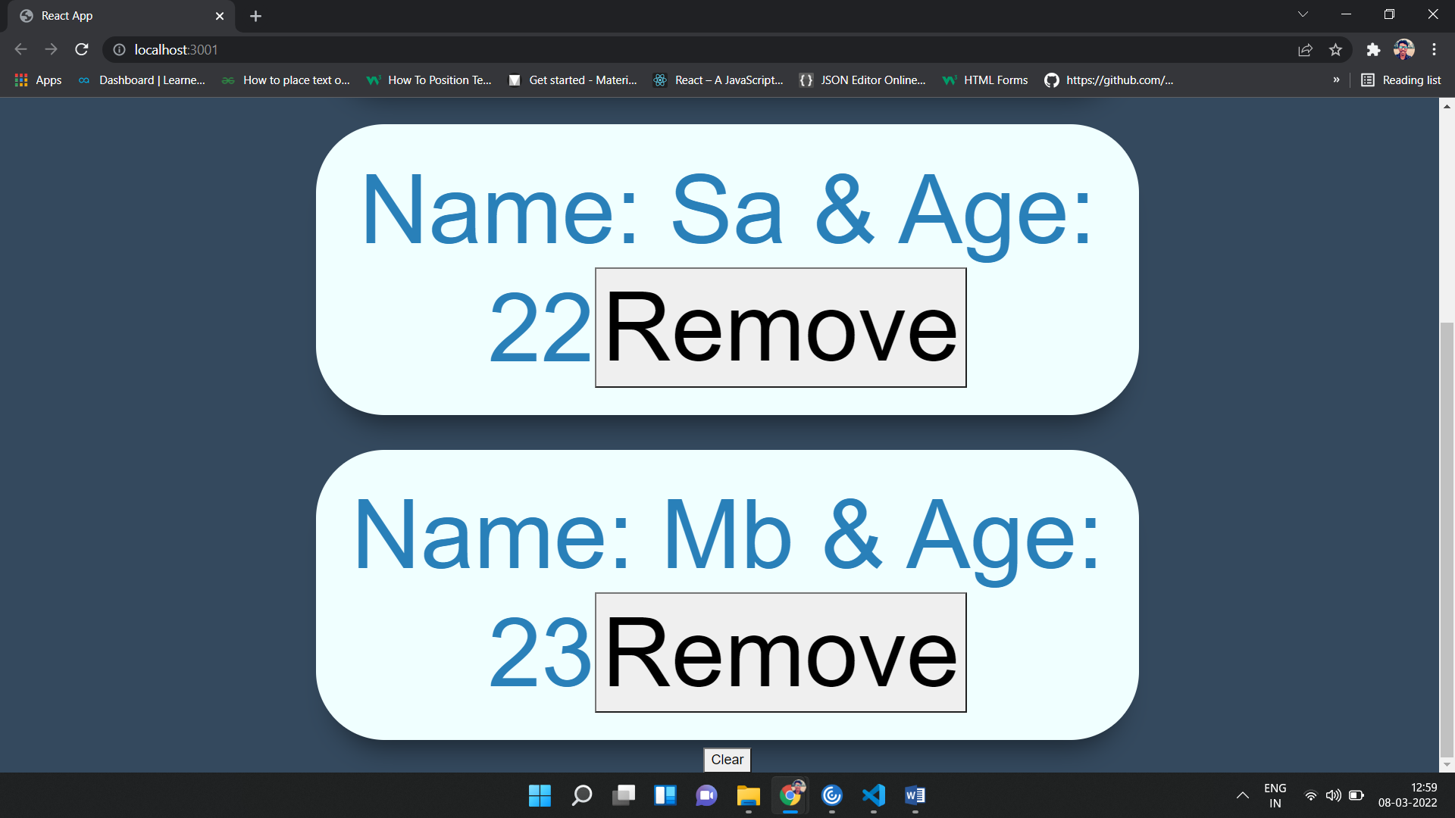

1. Simple.js (same for Challenge1.js but in Challenge1, we can click so many times in button, but in Simple.js, we can click only once time)

