|  |  |  |
| --- | --- | --- |
| **Drone Design for Warehouse Logistics** | | |
| Ameya Deshpande  Department of Mechanical Engineering Texas A&M University College Station, USA ameyaamd96@tamu.edu | Yuan Wei  Department of Mechanical Engineering Texas A&M University College Station, USA weiyuan1996@tamu.edu | Saurabh Nabar  Department of Mechanical Engineering Texas A&M University College Station, USA [saurabhnabar44@tamu.edu](mailto:saurabhnabar44@tamu.edu) |

*Abstract*—With the rise in e-commerce, warehouses are getting more complicated than ever to handle. They have also become a hazardous place to work. In this paper, we use the Multidisciplinary System Design Optimization approach to optimize the drone design and th`e path routine it takes as a single problem. We conducted design of experiments for getting a good starting point and then used both gradient-based and heuristic optimization techniques to obtain a global optima.

Keywords—DOE, SQP, Genetic Algorithm, Pareto Front

# Motivation

### Quite often warehouse automation is thought of as tach that will be used in some far-off future but the fact is that the automation technologies already have a place in today’s modern warehouses. Automated equipment for warehousing is used by more than 10% of U.S. warehouses. In 2016, sales of automation technology for warehouse management worldwide were $1.9 billion and by 2021 will reach $22.4 billion in market value. The shipments of variety of automation technologies for warehouses were 40,000 in 2016 and are expected are to be more than 600,000 by 2021 worldwide. One of the additional reasons for becoming an attractive market is the increasing safety concerns of the warehouse workers. From a study conducted in 2016, there were 5 injuries in the warehouse/storage industry per 100 full-time workers. Sometimes mistakes are bring made by humans due to exhaustion, distraction, etc. Automation has the potential to significantly [reduce the number of injur](https://www.conveyco.com/safety-standards-designing-new-warehouse/)es by removing the human element from the processes which are dangerous. Along with increasing the safety of the operations, automation technologies also increase the labor productivity by about 0.35% annually, which is on par with the impact felt from 1850 to 1910 from steam engine.

### There have been several studies optimizing the path routine of the fleet of robots. Studies have also been conducted to optimize the design of the mobile robots to minimize the cost and maximize the amount of load they can carry in a trip. In this report we have used the multi-disciplinary system design optimization approach to optimize the problem of robot design which includes the geometric design along with voltage supply required for functioning and path optimization as a single problem. By this approach we can increase the efficiency of the warehouse operations by custom designed robots for the specific warehouses as the available operation space in the warehouses are taken into consideration for the robot design. In this paper we achieved our goal optimization using both gradient-based optimization and heuristics approach.

# PROBLEM FORMULATION

## Objective

Maximize the mass and minimize the time of the products delivered by a warehouse drone by changing geometric parameters of the robot, voltage and turning radius while avoiding toppling of the products and avoiding obstacles in the environment with a fixed path that is to be followed.

## Master Table

In this problem we have 5 design variables for taking into consideration the geometry of the drone, voltage supplied, geometry of the load and turning radius of the drone. In this problem there are two objectives, to maximize the mass of the products moved and to minimize the time to do it. To reduce the complexity of the problem, we have 8 parameters. In order to incorporate safety in our design, we have constraints on the moment along x and y-axis.

|  |  |  |  |
| --- | --- | --- | --- |
| $$V$$ | Input Voltage | [V] | Design variable |
| *l* | Length of drone | [m] | Design variable |
| *w* | Width of drone | [m] | Design variable |
| *h* | Height of load | [m] | Design variable |
| *r* | Turning radius | [m] | Design variable |
| $$l_{c}$$ | Current length | [m] | Constraint |
| $$w_{c}$$ | Current width | [m] | Constraint |
| *Vc* | Current voltage | [V] | Constraint |
| $$M_{x}$$ | Moment along x axis (safety) | $$[N∙m]$$ | Constraint |
| $$M_{y}$$ | Moment along y axis (safety) | $$[N∙m]$$ | Constraint |
| $$v_{c}$$ | Current velocity | $$[m/s]$$ | Constraint |
| *M* | The weight of load | [kg] | Objective |
| *t* | Traveling time | [s] | Objective |
| $$T_{max}$$ | Maximum torque | [N/m] | Dependent |
| *v* | Steady state velocity | [m/s] | Dependent |
| $$a_{max}$$ | Maximum acceleration | $$[m/s^{2}]$$ | Dependent |
| *s* | Minimum path length | [m] | Dependent |
| *f* | Friction | [N] | Dependent |
| $$ρ$$ | Density of load | $$[kg/m^{3}]$$ | Parameter |
| *g* | Gravity acceleration | $$[m/s^{2}]$$ | Parameter |
| *m* | Weight of the drone | $$[kg]$$ | Parameter |
| *d* | Diameter of wheels | $$[m]$$ | Parameter |
| $$h_{c}$$ | Height of drone | $$[m]$$ | Parameter |
| *k* | Motor constant | [Nm/Sqrt] | Parameter |
| *R* | Resistance | [$Ω$] | Parameter |
| $$μ$$ | Friction coefficient | [/] | Parameter |

Table 1: Master Table

## $N^{2}$ Diagram

|  |  |  |  |  |  |
| --- | --- | --- | --- | --- | --- |
| $N^{2}$ Diagram | | | | | |
|  | Load Weight | Mechatronics module | Dynamics, Stability Module | | Routine Optimization |
| Design Variables | 2,3,4 | 1 | 2,3 | 5 | 5 |
|  |  | 6 | 6 | 6 |  |
|  |  |  | 7,8 | 7 | 7 |
|  |  |  |  |  |  |
|  |  |  |  |  |  |
|  |  |  |  |  |  |

Table 2: N2Diagram

|  |  |
| --- | --- |
| Design Variables | |
| 1 | Input Voltage |
| 2 | Length of Drone |
| 3 | Width of Drone |
| 4 | Height of load |
| 5 | Turning radius |
| Dependent variables | |
| 6 | Weight of load |
| 7 | Steady state velocity |
| 8 | Maximum acceleration |

Table 3: Variables in N2 Diagram

## From the $N^{2}$ Diagram we can note that there are multiple disciplines involved in this optimization like mechatronics, dynamics and routine optimization. The data of the dependent variables is exchanged between different modules making it a very interconnected problem between the disciplines involved.

## Block Diagram

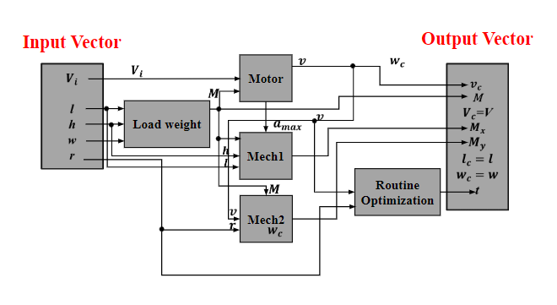

Figure 1: Block Diagram

Block diagram provides better understanding of the interconnectivity between the different modules. The weight of the load from the load weight module goes to Motor (Mechatronics module) so as to get velocity from the motor specifications. The weight of load also goes to Mech 1, 2 (Dynamics Module for X and Y direction) so as to ensure the safety (avoiding toppling) constraints are satisfied. The velocity goes to Mech 1, 2 modules as well as in the routine optimization module to set an upper bound on the turning radius.

## Assumptions

There are some assumption made to simplify the problem. Density of load is fixed and assumed uniform throughout the volume. DC motor specifications are fixed for the analysis. Friction coefficient between the load and the drone, and drone and the ground is assumed to be constant throughout the motion. Centre of mass of the system (drone and load) is assumed to be in the center of the geometry of the system. Also the fixed path used in the problem consists of a starting point, an ending point and a checkpoint in between. Only one checkpoint has been considered for simpler analysis, but multiple checkpoints can easily be added for the purpose of getting around the obstacles.

## Equations for each module and constraints

#### Load weight module:

$M=ρwlh$

Motor (Mechatronics module):

This equations are used to get velocity and maximum acceleration from the mechatronics module,

$$a_{max}=\frac{4T_{max}\frac{d}{2}-f}{M+m}=\frac{4\frac{Vk}{R}\frac{d}{2}-μ(M+m)g}{ρwlh+m}$$

$$v = d\frac{Vk-f\frac{R}{2d}}{2k^{2}}=d\frac{Vk-μ\left(M+m\right)g\frac{R}{2d}}{2k^{2}}$$

Mech 1 (Dynamics and Stability module for X-direction):

This equation is used as a safety constraint for the stability in X-direction,

$M_{x}= \left(M+m\right)g\frac{l}{2}-ma_{max}\frac{h_{c}}{2}-Ma_{max}\left(\frac{h}{2}+h_{c}\right)$

$$=\left(M+m\right)g\frac{l}{2}-m\frac{4\frac{Vk}{R}\frac{d}{2}-μ(M+m)g}{ρwlh+m}\frac{h_{c}}{2}-M\frac{4\frac{Vk}{R}\frac{d}{2}-μ(M+m)g}{ρwlh+m}\left(\frac{h}{2}+h_{c}\right)$$

Mech 2 (Dynamics and Stability module for Y-direction)

This equation is used as a safety constraint for the stability in Y-direction,

$M_{y}= \left(M+m\right)g\frac{l}{2}-\frac{mv^{2}h_{c}}{2r}-\frac{Mv^{2}\left(\frac{h}{2}+h_{c}\right)}{r}$

$$=\left(M+m\right)g\frac{l}{2}-\frac{m{\left(d\frac{Vk-μ\left(M+m\right)g\frac{R}{2d}}{2k^{2}}\right)}^{2}h_{c}}{2r}-\frac{M{\left(d\frac{Vk-μ\left(M+m\right)g\frac{R}{2d}}{2k^{2}}\right)}^{2}\left(\frac{h}{2}+h_{c}\right)}{r}$$

Constraints:

$l_{c}≤l_{max}$, $w_{c}≤w_{max}$, $V_{c}≤V_{max}$, $M_{x}≥0$, $M_{y}≥0$, $v_{c}≥0$

# Design of experiments

|  |  |  |  |  |  |  |  |
| --- | --- | --- | --- | --- | --- | --- | --- |
| Input voltage(V) | length(l) | width(w) | height of load(h) | turning Radius(r) | mass | time | Efficiency |
| 44 | 0.5 | 0.3 | 0.2 | 1 | 24 | 653.9 | 2.20 |
| 44 | 0.5 | 0.3 | 0.15 | 2 | 18 | 456.81 | 2.36 |
| 44 | 0.6 | 0.35 | 0.2 | 1 | 0.034 | 3.5 | 0.57 |
| 44 | 0.6 | 0.35 | 0.15 | 2 | 25 | 766.94 | 1.95 |
| 48 | 0.5 | 0.35 | 0.2 | 2 | 28 | 720 | 2.33 |
| 48 | 0.5 | 0.35 | 0.15 | 1 | 21 | 422.11 | 2.98 |
| 48 | 0.6 | 0.3 | 0.2 | 2 | 28 | 775.55 | 2.16 |
| 48 | 0.6 | 0.3 | 0.15 | 1 | 21 | 436.43 | 2.88 |

Table 4: Design of Experiments

A DOE was conducted to explore the design space for all the modules. The bounds based on the constraints were taken in Table 1 for each design variable. A full factorial was initially planned but many entries were removed due to computational costs and thus the focus was placed on doing partial factorial to get more information in lesser amount of time. DOE has 5 factors and 2 levels. These are some of the feasible starting points. DOE helped in the optimization process by giving a very good initial point for gradient base method. DOE had total 8 experiment. The trend showed that a small and compact drone had a higher efficiency to carry the load.

# algorithm selection

1. *Gradient based method*

Because all the variables of the system are continuous, which means that they are differentiable. Gradient based method is the easiest way to solve the problem. The problem has two objective function. The first objective function is maximizing the mass M of the load. Use “fmincon” function in Matlab with SQP algorithm. The maximum load that the drone can carry is 39.2857kg. Detailed iteration of optimizing M is shown in Figure 2. Function value is 1/M in the plot. After doing multi-start, Matlab gives the same result, so the solution is global maximum.

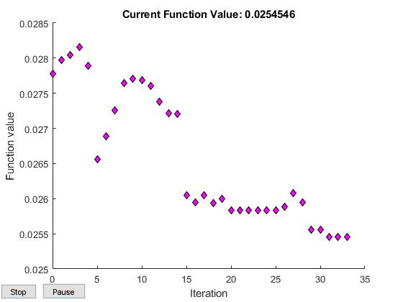

Figure 2: Iteration of objective function of mass

Use same function and the same option of “fmincon” on minimizing time cost “t”. The result shows that the minimum time cost is 417.93s in certain routine. Step tolerance, function tolerance, and constraint tolerance are $1×{10}^{-20}$. Detailed iteration of optimizing t is shown in Figure 3.

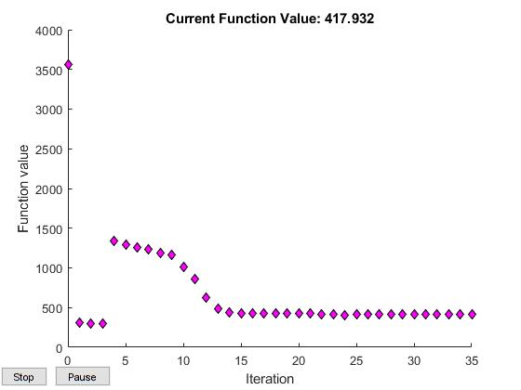

Figure 3: Iteration of objective function of time cost

Two input vectors are totally different while they reach global optimal of different objective function. Pareto front is needed to find a trade between the mass of the load and time cost.

1. *Heuristics in multi-objective problem*

Genetic algorithm (GA) can be used to verify if the result from gradient based method is global optima or not. It can also be used to search pareto front between two objective function. The pareto front is shown in Figure 4. The left plot shows the pareto front between maximizing M and minimizing t. The right plot shows the pareto front between maximizing M and 1/t.

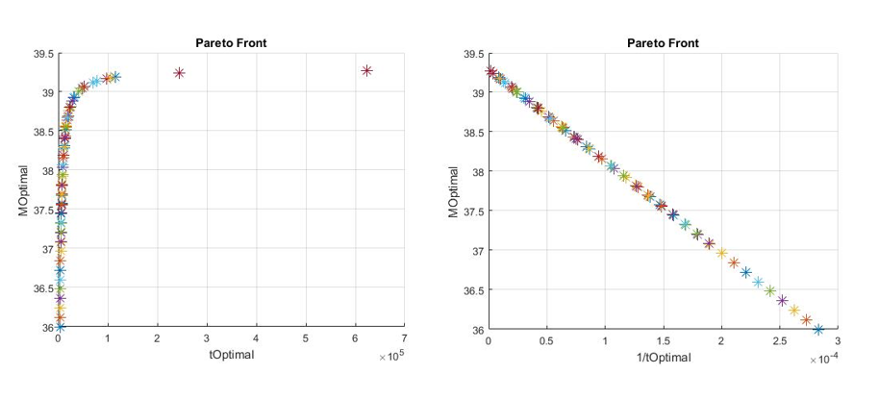

Figure 4: Pareto front between two objective functions

Although it looks like linear in right plot, it is convex by checking KKT condition.

1. *Conclusion*

It is hard to say which algorithm is better in the problem. Since a new objective function with trade between two objective function is needed, using gradient based method with the starting point found in DOE may be an economic choice to find a solution. However, GA is still needed to verify that the result given by gradient based method is global optima. Next chapter will cover the new objective function and the result of it by using different approach.

# Multi-Objective Analysis

1. *New objective function*

Apply new objective function based on right plot in Figure 4, where the mass increases while 1/t decreases. To maximize both value, new objective function is shown as Eq. (E1).

$\text{E=}\frac{\text{M}}{\text{t}}$



E is defined as efficiency (kg/min). It implies how much weight can be transported per minute.

1. *Gradient based method on the new objective function*

Use “fmincon” function in Matlab with SQP algorithm to optimize this single objective. Plot routine in each iteration as shown in Figure 5.

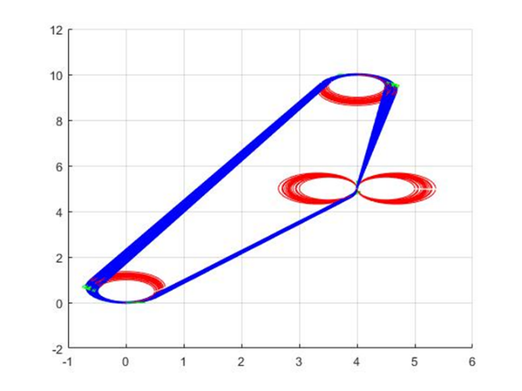

Figure 5: Routine in each iteration without scaling

Maximal efficiency is 3.8958kg/min with design vector $\left[\begin{matrix}\begin{matrix}\text{48V} & \text{0.82974m}\end{matrix} & \begin{matrix}\text{0.21853m} & \text{0.13542m} & \text{0.5m}\end{matrix}\end{matrix}\right]$. It runs twelve iterations. The hessian of the optima is $\left[\begin{aligned}\begin{matrix}\begin{matrix}\text{1.0012} & \text{0.0871}\end{matrix} & \begin{matrix}\text{-0.1825} & \text{0.2900} & \text{0.0028}\end{matrix}\end{matrix} \\ \begin{matrix}\begin{matrix}\text{0.0871} & \text{12.6273}\end{matrix} & \begin{matrix}\text{-11.3403} & \text{39.9503} & \text{0.8026}\end{matrix}\end{matrix} \\ \begin{matrix}\begin{matrix}\text{-0.1825} & \text{-11.3403}\end{matrix} & \begin{matrix}\text{29.0103} & \text{-34.5563} & \text{-0.3924}\end{matrix}\end{matrix} \\ \begin{matrix}\begin{matrix}\text{0.2900} & \text{39.9503}\end{matrix} & \begin{matrix}\text{-34.5563} & \text{201.9722} & \text{-1.6088}\end{matrix}\end{matrix} \\ \begin{matrix}\begin{matrix}\text{0.0028} & \text{0.8026}\end{matrix} & \begin{matrix}\text{-0.3924} & \text{-1.6088} & \text{0.3871}\end{matrix}\end{matrix}\end{aligned}\right]$.

The routine in optimal solution is shown in Figure 6. Red circle is turning radius in each turn. Blue one is the trajectory of the drone. Green arrows are moving direction of the drone. The drone move to the first station to be unloaded and reloaded, then move to second station, finally get back to starting point.

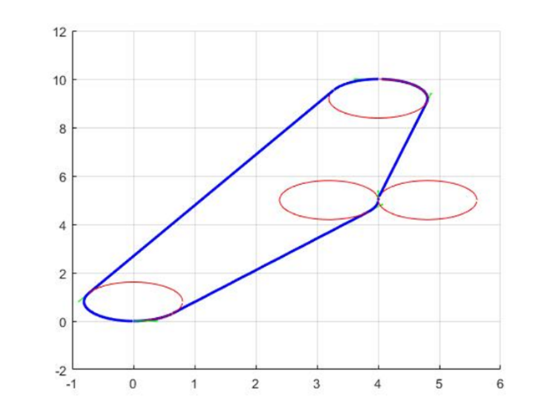

Figure 6: Routine in optimal solution

1. *Scaling*

The scales of diagonal values in hessian of optima are different, so scaling process might help to find a better solution. The scaling vector is $\left[\begin{matrix}\begin{matrix}1 & 3.55\end{matrix} & \begin{matrix}5.3861 & 14.21 & 0.62\end{matrix}\end{matrix}\right]$. Plot routine in each iteration as shown in Figure 7.

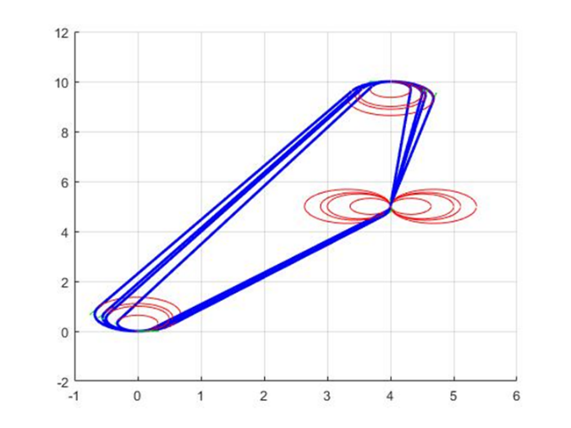

Figure 7: Routine in each iteration with scaling

The result is same as the one without scaling and the hessian of the optima becomes $\left[\begin{aligned}\begin{matrix}\begin{matrix}\text{1.0052} & \text{-0.1276}\end{matrix} & \begin{matrix}\text{-0.1804} & \text{-0.0600} & \text{-0.0072}\end{matrix}\end{matrix} \\ \begin{matrix}\begin{matrix}\text{-0.1276} & \text{3.1612}\end{matrix} & \begin{matrix}\text{4.4327} & \text{1.3429} & \text{0.1758}\end{matrix}\end{matrix} \\ \begin{matrix}\begin{matrix}\text{-0.1804} & \text{4.4327}\end{matrix} & \begin{matrix}\text{6.7143} & \text{1.6883} & \text{0.2433}\end{matrix}\end{matrix} \\ \begin{matrix}\begin{matrix}\text{-0.0600} & \text{1.3429}\end{matrix} & \begin{matrix}\text{1.6883} & \text{1.4723} & \text{0.0454}\end{matrix}\end{matrix} \\ \begin{matrix}\begin{matrix}\text{-0.0072} & \text{0.1758}\end{matrix} & \begin{matrix}\text{0.2433} & \text{0.0454} & \text{0.3957}\end{matrix}\end{matrix}\end{aligned}\right]$.

The result remains the same, but it only takes four iterations to get optimal solution, which is quicker than the one without scaling.

1. *Genetic algorithm on the new objective function*

Multi-start almost proves that the result given by gradient based method should be global optima. Genetic algorithm, however, is the best way to verify the statement. The options of “ga” function are

Population Size = 1000,

Max Generations = 500,

Function Tolerance = $\text{1×}{\text{10}}^{\text{-16}}$,

Constraint Tolerance = $\text{1×}{\text{10}}^{\text{-16}}$.

Figure 8 shows routine plot within one generation.

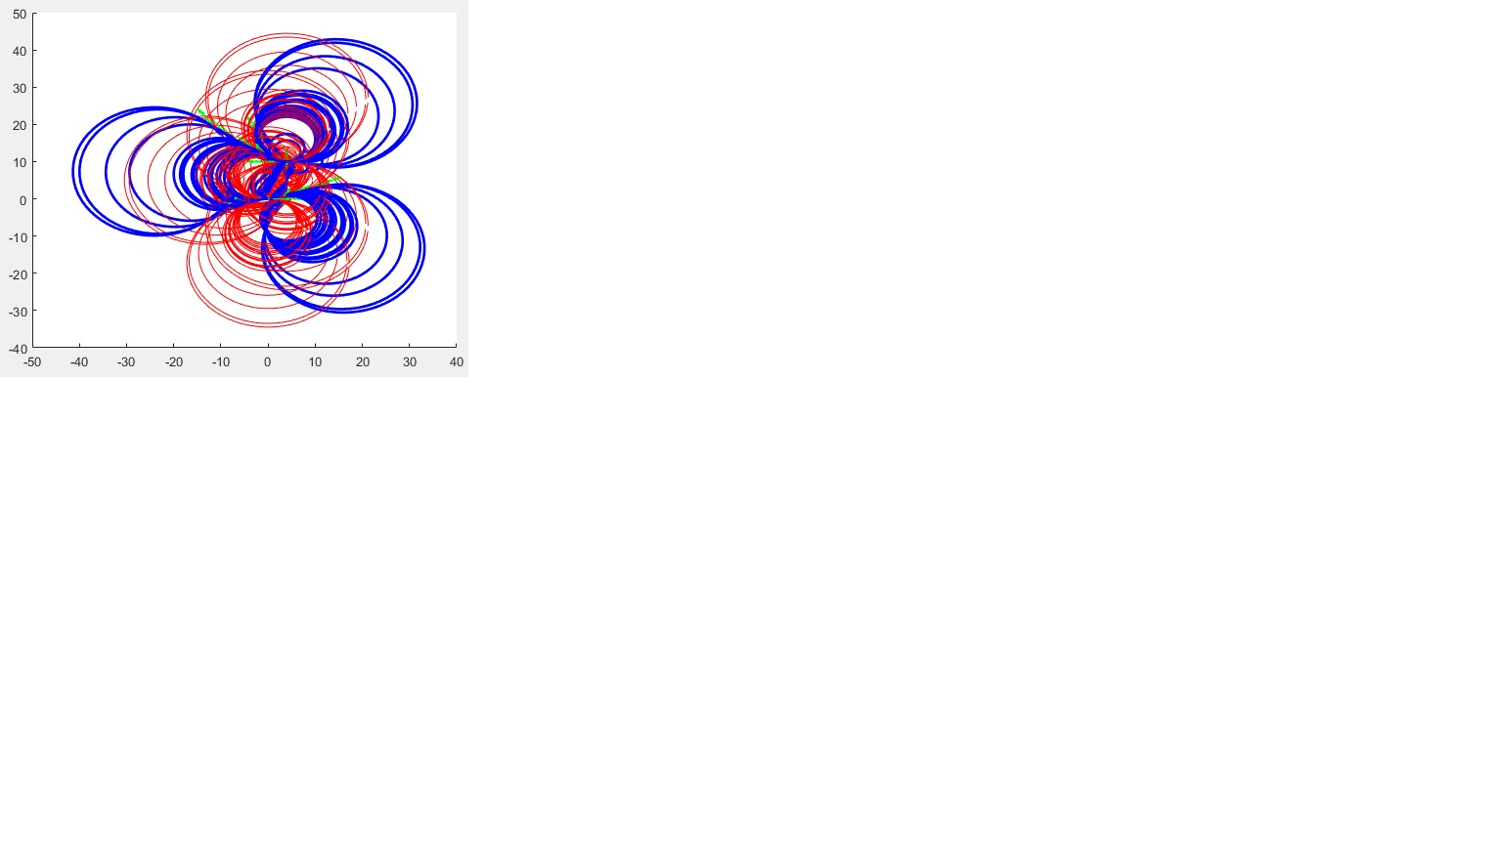

Figure 8: Routine plot within one generation

After one day running the program, maximal efficiency is 3.8958kg/min given by GA with design vector $\left[\begin{matrix}\begin{matrix}\text{48V} & \text{0.82974m}\end{matrix} & \begin{matrix}\text{0.21853m} & \text{0.13542m} & \text{0.5m}\end{matrix}\end{matrix}\right]$, which indicates that the solution by using gradient based method is the global optima.

# Final Design Based on Tradeoff

The final design is based on the tradeoff between two objective function as new objective function. Input voltage is 48V. The drone has length of 0.82974m and width of $\text{0.21853m}$. The height of the load should be no more than $\text{0.13542m}$. The turning radius is 0.5m. With the design, the drone has ability to carry 19.644kg load, which is as nearly twice weight as itself. The total time of completing task is equal to 302.54s each round. The efficiency is 3.8958kg/min.

# POST OPTIMALITY ANALYSIS

## Sensitivity analysis

The sensitivity analysis has been run on a previous found optimum. The optimum solution is that discussed in analysis part. The sensitivity has been tested for all the parameter like the density, Coefficient of friction, weight, height, wheel diameter. The discrete motor variable has been set constant for this analysis. Multi objective was combined into a single objective, efficiency (M/t) for the sensitivity calculations.

Figure 9: Sensitivity Analysis for Parameter

Other parameters have also been altered to see additional impacts. In the examples shown, it appears the wheel diameter has the highest impact.

Figure 10: Sensitivity Analysis of Design Variable

Sensitivity analysis for the design variable was done. The overall trend was similar to what was predicted. Length, weight, height, turning radius had similar effect on efficiency. Voltage specifications of the motor had significant impact on the efficiency as can be seen from the Jacobian. The Jacobian was normalized which gave relative sensitivity,

J = [1138.1 83.9 87.2 87.3 84.2] T

# Conclusion

Design of experiments gave a good starting point which played a pivotal in reaching global optimal faster. Fmincon found the global optimum simply as the functions were differentiable by using multi-start. Scaling helped in decreasing computational time drastically but did not change the global minima. Although, heuristics based optimization diverged in few cases, we confirmed with it the optima we got from the gradient based optimization. Through extensive testing with gradient-based and heuristic algorithms and exploration of design space we are very confident that we have found the global optima.

##### References

The template will number citations consecutively within brackets [1]. The sentence punctuation follows the bracket [2]. Refer simply to the reference number, as in [3]—do not use “Ref. [3]” or “reference [3]” except at the beginning of a sentence: “Reference [3] was the first ...”

Number footnotes separately in superscripts. Place the actual footnote at the bottom of the column in which it was cited. Do not put footnotes in the abstract or reference list. Use letters for table footnotes.

Unless there are six authors or more give all authors’ names; do not use “et al.”. Papers that have not been published, even if they have been submitted for publication, should be cited as “unpublished” [4]. Papers that have been accepted for publication should be cited as “in press” [5]. Capitalize only the first word in a paper title, except for proper nouns and element symbols.

For papers published in translation journals, please give the English citation first, followed by the original foreign-language citation [6].

1. G. Eason, B. Noble, and I. N. Sneddon, “On certain integrals of Lipschitz-Hankel type involving products of Bessel functions,” Phil. Trans. Roy. Soc. London, vol. A247, pp. 529–551, April 1955. *(references)*
2. J. Clerk Maxwell, A Treatise on Electricity and Magnetism, 3rd ed., vol. 2. Oxford: Clarendon, 1892, pp.68–73.
3. I. S. Jacobs and C. P. Bean, “Fine particles, thin films and exchange anisotropy,” in Magnetism, vol. III, G. T. Rado and H. Suhl, Eds. New York: Academic, 1963, pp. 271–350.
4. K. Elissa, “Title of paper if known,” unpublished.
5. R. Nicole, “Title of paper with only first word capitalized,” J. Name Stand. Abbrev., in press.
6. Y. Yorozu, M. Hirano, K. Oka, and Y. Tagawa, “Electron spectroscopy studies on magneto-optical media and plastic substrate interface,” IEEE Transl. J. Magn. Japan, vol. 2, pp. 740–741, August 1987 [Digests 9th Annual Conf. Magnetics Japan, p. 301, 1982].
7. M. Young, The Technical Writer’s Handbook. Mill Valley, CA: University Science, 1989.

**IEEE conference templates contain guidance text for composing and formatting conference papers. Please ensure that all template text is removed from your conference paper prior to submission to the conference. Failure to remove template text from your paper may result in your paper not being published.**