### App: CallBS

*Usability Report*

Ameya Deshpande

**I. PARTICIPANTS**

**Basic demographic information** (participant sample size: 5)

|  |  |  |  |
| --- | --- | --- | --- |
| **Name** | **Gender** | **Age** | **Occupation** |
| Prem | Male | 19 | Undergraduate |
| Michael | Male | 20 | Undergraduate student |
| Daniel | Male | 19 | EMT |

**II. TASKS**

* Query a statistic with the microphone
* Query a statistic with the search bar
* Read the data

**III. ISSUES ENCOUNTERED**

**General issues users encountered:**

The main confusion is if the query is submitted or not. People often assume after using the microphone and just wait for it load.

Recommendations by users:

1. Make instructions more clear (Recommended 2 times)
2. Make it auto search after the voice query (Recommended 3 times)
3. Add more data sets (Recommended 1 time)
4. Make data sets scrollable, more interactive (Recommended 2 times)
5. Add location-based data sets (Recommended 4 times)

**Before Suggestions:**

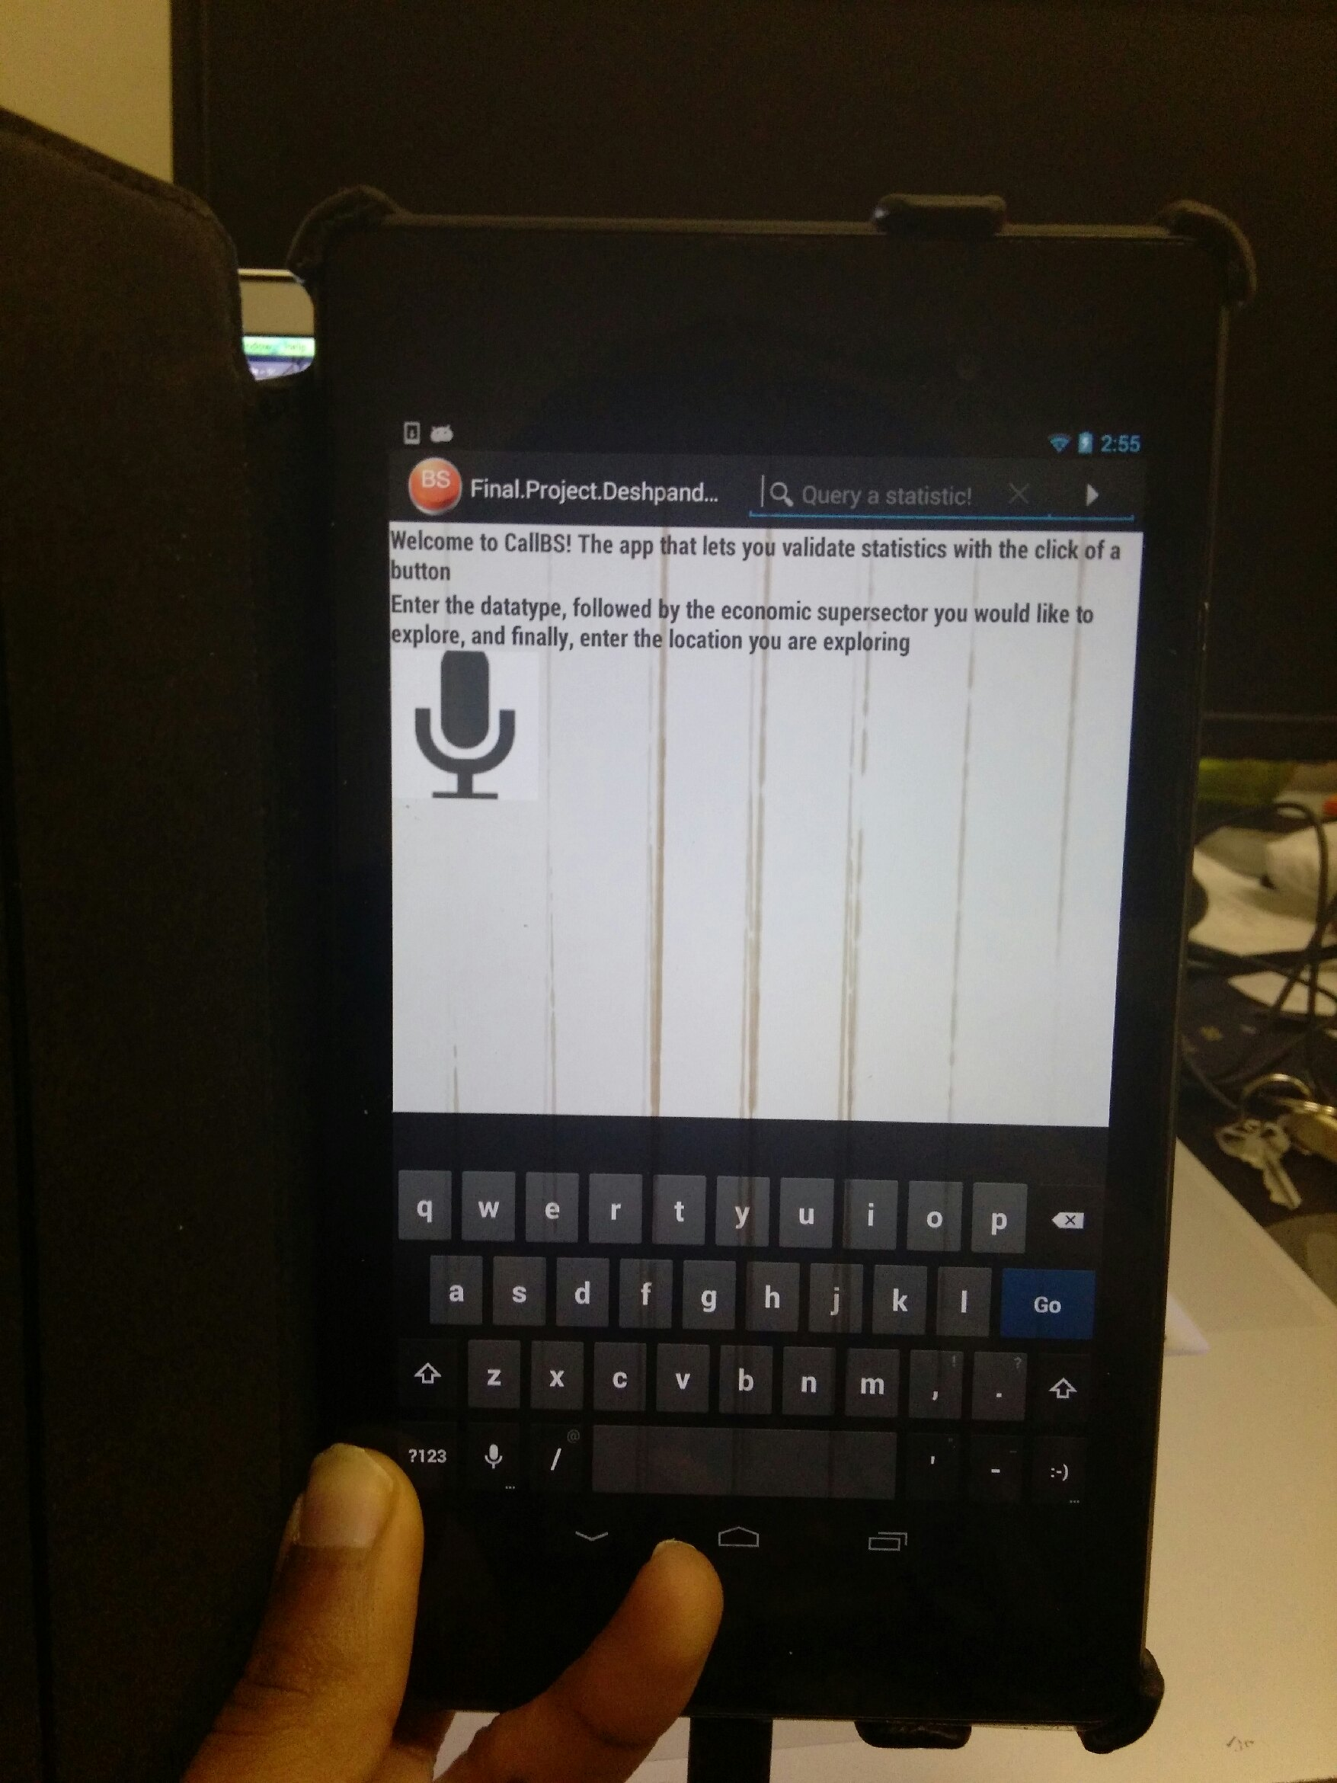

**After Suggestions:**

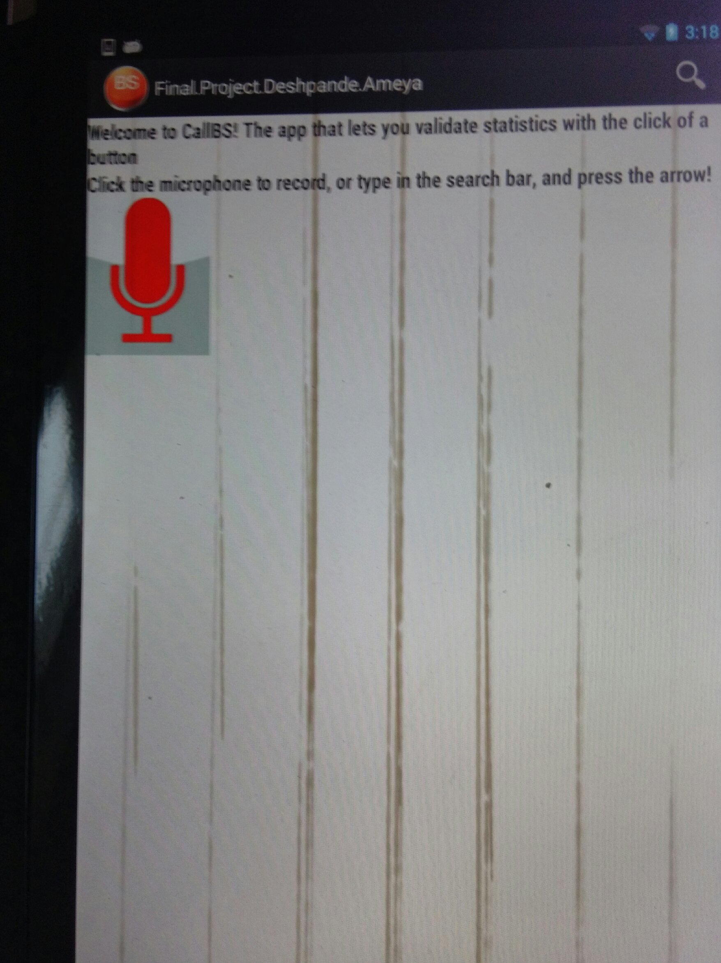

**IV. STEPS TAKEN + MOVING FORWARD**

Sadly, the Google SearchActivity is not very friendly towards customization, so auto-voice searching is not a possibility. To address the issue the best I could, I added better instruction to the initial screen.

Moving forward, I will be adding this:

1. Select data by state.
2. Dynamically getting data from the server itself using retrofit
3. Add interactivity to the graph