Content for main page

Mahadaan (महादान)

A Sacred Offering That Lives Beyond You
Mahadaan means “Great Charity” — a selfless act of giving performed with pure intention, without expectation, for the welfare of society. In our spiritual tradition, charity is not merely help — it is Dharma. It purifies the giver and uplifts the receiver.
When Mahadaan is performed in the presence of a Jivit Guru, it becomes a divine blessing in action.
Under the enlightened guidance of Acharya Upendra ji, every offering reaches the right hands, at the right time, for the right purpose. And the result multiplies. Under a Jivit Guru, Mahadaan becomes purified of pride and attachment. The Guru ensures that the act is aligned with Dharma - not ego.
The Guru transforms:
- Charity into Seva
- Donation into Devotion
- Contribution into Sadhana
Scriptures emphasize that daan must be given to a deserving recipient (supatra). A Jivit Guru, established in wisdom, ensures:
- The offering reaches the truly needy
- The resources are used for righteous purposes
- The impact benefits society and supports Dharma
Whether rich or poor, under a Jivit Guru both receive equal spiritual grace.
A small offering given with devotion becomes spiritually vast.
A large offering given with surrender becomes a foundation for generations.
Therefore, Mahadaan under the guidance of a Jivit Guru:
- Aligns with scriptural principles
- Purifies wealth
- Elevates the soul
When offering is blessed by a realized master, it becomes eternal merit.

🪔 The True Spirit of Mahadaan
Mahadaan is not about how much you give. It is about:
- Purity of intention
- Compassion in the heart
- Selflessness in action
Even a small act done with sincere feeling becomes Mahadaan.True giving does not only change the receiver — it transforms the giver.It softens the heart, removes fear of loss, awakens gratitude, and replaces ego with humility. Benefits are infinite.

🌺 The Eternal Law of Giving
And remember:
At the end of life, wealth stays here. Status stays here. Possessions stay here.
Only karma travels forward.
Mahadaan ensures that what travels with your soul is light — not burden.

🌟 The Power to Transform Lives — Including Yours
One day, every person asks:
“What will remain after me?”
Not property.
Not titles.
Not bank balance.
What remains is the good we leave behind.
It is a sacred opportunity for every human being — rich or ordinary.
When we give selflessly, we do not reduce what we have — we multiply its meaning.

These are not small acts — they carry immense spiritual merit.
True greatness is not in accumulation, but in upliftment.
Mahadaan turns success into legacy.
When we give, compassion spreads, hope rises, and Dharma strengthens.

Be the Change. Be the Blessing.
Give what you can. Give with humility. Give with devotion.
Because in the end, we are not remembered for what we owned - but for what we gave.
True wealth is not what we keep. It is what we offer.
Participate in Mahadaan!!! Uplift lives!!! Elevate your own!!!
Gain immense punya!!!

Donate now

Images for reference of other websites



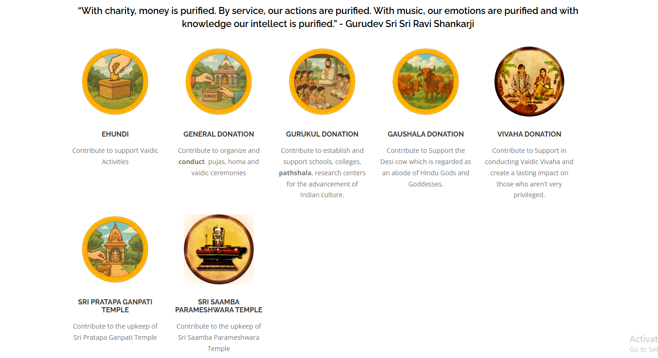

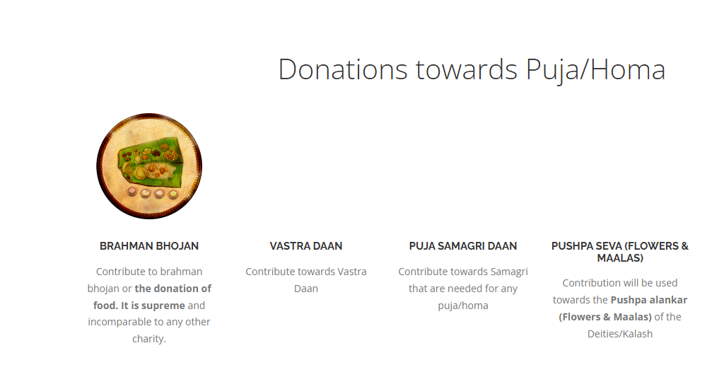

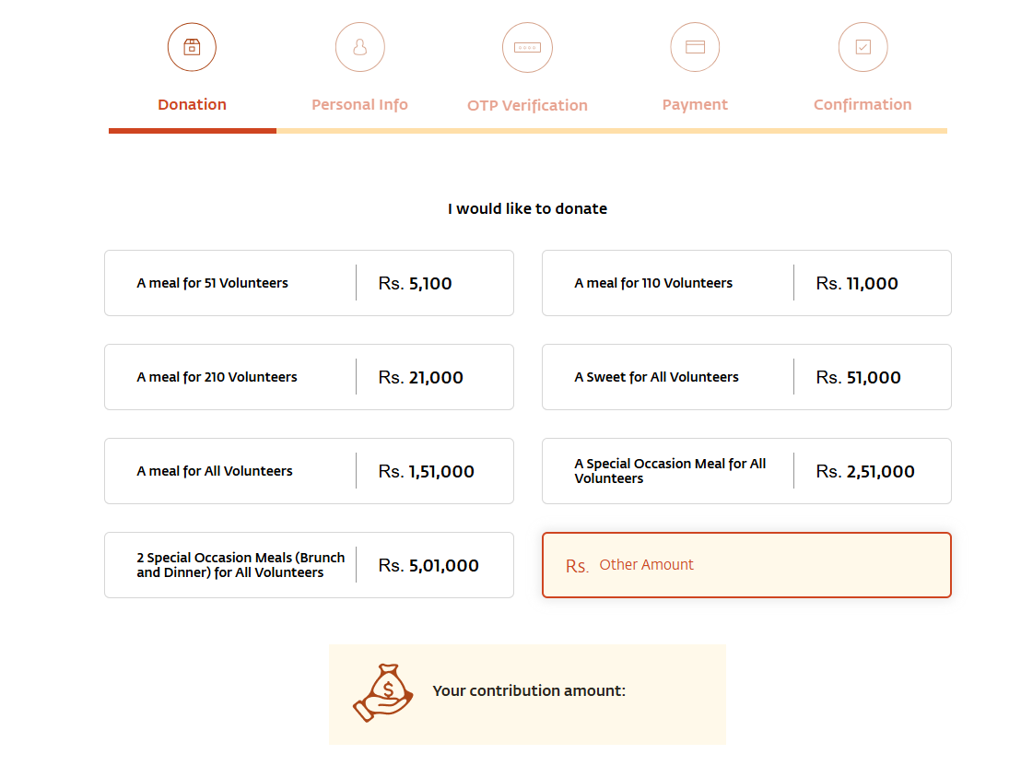

Donation categories:
(to be used as hierarchy)

- Donation for Gurukul branch - Donating for a higher cause like building a new Gurukul branch of a Jivit Guru is an investment in spiritual upliftment for generations.
A Gurukul is not just a structure — it is a sanctuary where lives are healed, minds are guided, and souls are awakened.
Your contribution helps create a sacred space where seekers can learn, meditate, and grow in Dharma.
When you support such a mission, you are helping spread wisdom, compassion, and divine guidance to countless lives.
A brick offered with devotion becomes a foundation for transformation.
Give not just to build walls — give to build a living center of light for society.
- Annadan -
When food is offered in a sacred spirit, it becomes Prasad — blessed nourishment.
Your contribution ensures that no one sleeps hungry while Dharma is being served.
A simple meal given with devotion becomes a powerful act of compassion and eternal merit
- Gurukul Donation -
- Donation towards Yadnya & Pooja
- Bramhan Bhojan - Donating for Brahman Bhojan under the guidance of a Jivit Guru is a sacred act rooted in scriptural tradition.
When learned Brahmins are respectfully offered food, it is considered an offering to knowledge, Dharma, and divine wisdom itself.
A humble contribution made with devotion turns into lasting merit and grace for the giver.
- Vastra Daan -
Clothing someone with compassion is like wrapping them in respect and humanity.
Your heartfelt contribution becomes comfort for someone — and quiet grace for your own soul.
- Pooja samagri daan -
When you offer for sacred materials, you become a silent part of every mantra chanted and every prayer offered.
Under the Guru’s blessings, even a small contribution turns into divine participation.
- Pushpa daan -
Each flower offered in worship carries your gratitude and surrender into sacred prayers.
Through Pushpa Daan, you allow your devotion to bloom — and grace to blossom in your life.
- Electronics equipment - Donation for Electronics Equipment Daan under a Jivit Guru supports the spread of wisdom to countless lives.
Through sound systems, cameras, screens, and digital tools, spiritual knowledge reaches far beyond physical boundaries.
Your contribution becomes a bridge that carries teachings to seekers everywhere.

- For books -
Printing, research, editing, translation, and writing all require collective support to release Acharya ji’s teachings in many languages.
Your contribution helps transform knowledge into books that reach homes, hearts, and future seekers.
Under the Guru’s blessings, every page becomes a lamp of guidance for the world.
Your contribution can help release teachings in multiple languages, so seekers from every region can benefit.
By supporting Book Daan — through funds, writing, or language seva — you help preserve knowledge for generations to come.
- Bhumi daan -
The land you support can become a foundation for bhakta niwas, meditation halls, annadaan, and other service activities.
What you offer as land today becomes a place of peace, prayer, and upliftment for generations. This will strengthen you Mangal
- Science of Healing related daan -
Aim to make swasth Bharat.
Your contribution helps arrange the venue, blood testing, basic medical support, and nourishing food for participants.
Through your support, many receive relief, clarity, and renewed strength to walk their life path with balance and hope.
- Labour daan -
By contributing your skills and hard work in building, organizing, cleaning, or serving, you turn action into seva.
Under the Guru’s guidance, even simple labour becomes spiritually powerful and deeply purifying.
Through Labour Daan, your hands serve society — and your heart grows in humility and grace.
- Daan to handicapped -
In our tradition, serving those who are physically challenged is considered direct seva to the Divine present in every being. When we help someone who cannot walk freely, see clearly, or work independently, we are not doing them a favor — we are purifying our own karma and softening our own heart.
Under the guidance of a Jivit Guru, such daan is performed with the right bhaav — without pity, without superiority, but with respect and reverence. The Guru ensures that support reaches them with dignity, love, and genuine care.
This offering becomes a bridge between compassion and consciousness.
It reduces ego, awakens gratitude, and strengthens Shani grah.
When you uplift someone who faces daily challenges, you invite divine grace into your own life.Their silent blessings become powerful prayers for you and your family.

- Daan to children -
Our scriptures teach that supporting education and nourishment of children brings immense punya, as they are pure souls and carriers of tomorrow’s संस्कार.
By uplifting a child today, you serve humanity tomorrow — and earn blessings that echo across generations.

- Daan to females (kumari, married, widows, aged) -
Scriptures proclaim (Manusmriti (Chapter 3, Verse 56) ), “यत्र नार्यस्तु पूज्यन्ते रमन्ते तत्र देवताः। यत्रैतास्तु न पूज्यन्ते सर्वास्तत्राफलाः क्रियाः॥ ” — where women are honored, divine energies reside.
By serving and uplifting women, you invite divine grace into your home and strengthen the very foundation of society and spirituality.
- Daan to Sanyasi -
Scriptures honor such giving as highly meritorious, for serving renunciates sustains spiritual knowledge and preserves sacred traditions.
By supporting a Sanyasi, you become a silent partner in their tapasya — and share in the spiritual blessings of their sadhana.

Testimonials of mahadaan:
Images of written testimonials. Videos

