Agentic Ops Copilot
Agentic AI Operations Copilot — an AI agent for on-call/support engineers that triages a ticket, gathers logs/metrics/service-context evidence in parallel, retrieves relevant runbooks, and drafts a grounded root-cause hypothesis instead of a human doing it manually across five tabs.
Runs fully offline out of the box — zero API keys, zero external services required — and is production-ready: typed adapters for real backends, a REST + streaming API, a dashboard, Docker, CI, and a test suite.
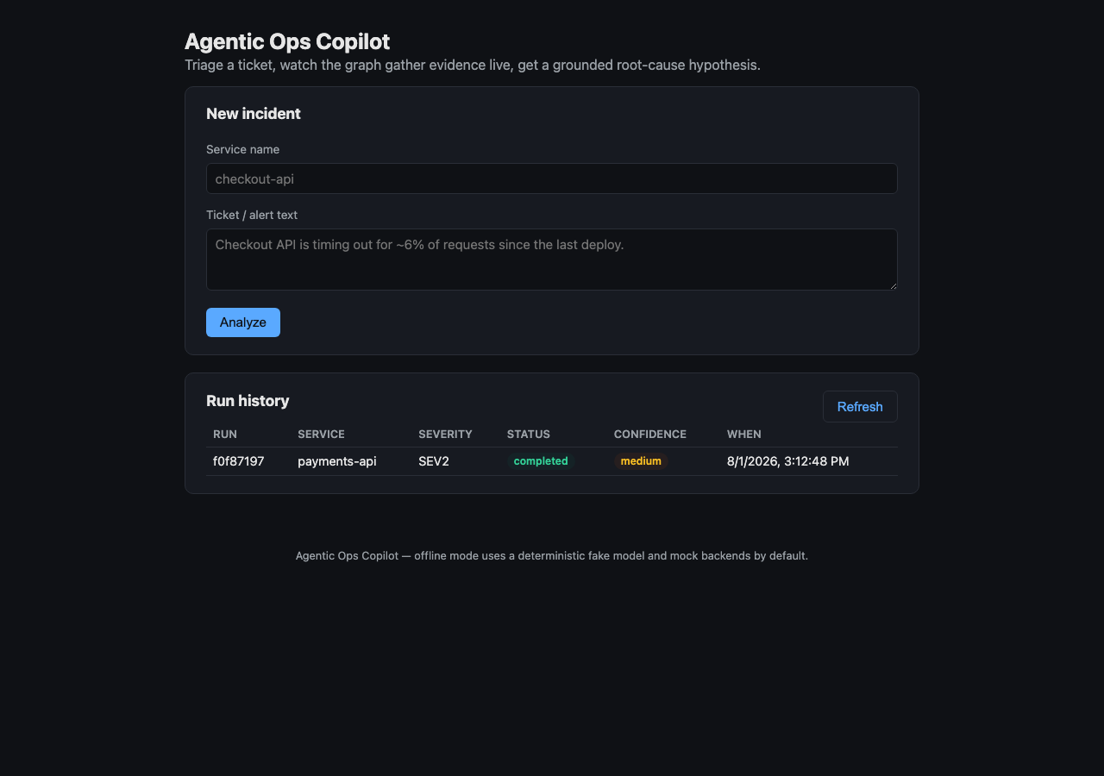
Dashboard

Table of contents
- Why it matters
- Architecture
- Quickstart
- Installation guide
- Configuration
- Using it
- API reference
- Docker
- Plugging in real backends
- Testing
- Project layout
- Troubleshooting
- Full project documentation — everything done in this project, in depth

Why it matters
Mirrors the shape of an AI support agent grounded strictly in retrieved evidence — the same pattern used in production for support/on-call copilots (Bedrock Agent + Kendra-style GenAI retrieval) that cut incident response from a manual, multi-tab investigation to near-instant, evidence-backed triage.
The core guarantee: the copilot will not invent a root cause it can’t support with evidence actually collected during the run. Every claim the model makes is checked against what was really fetched; unsupported claims are stripped and the finding is downgraded to “insufficient evidence” instead of shipping a confident guess.

Architecture
flowchart LR
A[Incident ticket] --> B[route<br/>triage + decide evidence needs]
B -->|logs needed| C[fetch_logs]
B -->|metrics needed| D[fetch_metrics]
B -->|always| E[fetch_context]
C --> F[retrieve_runbooks]
D --> F
E --> F
F --> G[synthesize<br/>structured, evidence-grounded]
G --> H[validate<br/>strip unsupported evidence_refs]
H --> I[Finding]
- route is the router agent: it classifies severity/category from the ticket text and decides which evidence sources are actually relevant — a billing question skips log/metric collection entirely.
- fetch_logs / fetch_metrics / fetch_context run truly in parallel as a LangGraph conditional fan-out; each node returns only its own state key so concurrent branches never race on the same write.
- synthesize calls the LLM with with_structured_output(Finding) — the model must return a typed object, not free text.
- validate is the enforced guardrail: every evidence_refs entry the model cites is checked against evidence that was actually collected this run. Anything fabricated is stripped; a finding with nothing left is downgraded to insufficient_evidence.
A SQLite checkpointer persists graph state across runs/restarts, so history survives a redeploy.

Quickstart
Requires Python 3.10+.
git clone <this-repo>
cd Agentic-ops-copilot
pip install -e .
ops-copilot serve
Open http://localhost:8000 — submit the pre-filled sample incident and watch it triage live. No API key, no external service, nothing else to configure.

Installation guide

1. Clone and create a virtual environment
git clone <this-repo>
cd Agentic-ops-copilot
python3 -m venv .venv
source .venv/bin/activate # Windows: .venv\Scripts\activate

2. Install
pip install -e . # core install — runs fully offline
pip install -e ".[dev]" # + test/lint/typecheck tooling
pip install -e ".[openai]" # + real OpenAI provider
pip install -e ".[bedrock]" # + Amazon Bedrock provider
pip install -e ".[retrieval]" # + real vector retrieval (Chroma + OpenAI embeddings)
Extras compose: pip install -e ".[openai,retrieval,dev]".

3. (Optional) configure
cp .env.example .env
# edit .env — every setting has a working default, so this step is optional

4. Run it
ops-copilot serve # API + dashboard on :8000
ops-copilot analyze "<ticket text>" --service svc # one-shot CLI run
ops-copilot backends # print resolved config
or the legacy one-shot demo the original prototype documented:
python agentic_ops_copilot.py

5. Run the tests
pip install -e ".[dev]"
pytest --cov=ops_copilot --cov-report=term-missing
ruff check . && ruff format --check .
mypy src/
or simply make test, make lint, make typecheck.

Configuration
Everything is an environment variable prefixed OPS_ (or a line in .env — see .env.example for the full, commented list). Every setting has a working default; the app runs with zero environment variables set at all (LLM provider fake, backends mock).
Setting | Default | Options
OPS_LLM_PROVIDER | fake | fake, openai, bedrock
OPS_LLM_MODEL | gpt-4o-mini | any model id for the chosen provider
OPS_LOGS_BACKEND | mock | mock, loki
OPS_METRICS_BACKEND | mock | mock, prometheus
OPS_RETRIEVAL_ENABLED | true | true, false
OPS_EMBEDDINGS_PROVIDER | none | none (in-memory store), openai (real Chroma vectors)
OPS_API_KEY | (unset) | set any value to require X-API-Key on every /api/v1/* request
OPS_RATE_LIMIT_PER_MINUTE | 60 | per-client-IP, per-worker (see note below)
OPS_CHECKPOINT_DB_PATH | data/checkpoints.sqlite | path to the run/checkpoint SQLite file
Rate limiting is an in-process sliding window keyed by client IP — simple and dependency-free, but per-worker rather than global: with multiple uvicorn workers or replicas, each enforces the limit independently. /healthz and /readyz are exempt so liveness/readiness probes are never rate-limited under load. Exceeding the limit returns 429 with Retry-After: 60.

Using it

The dashboard
ops-copilot serve then open http://localhost:8000. Submit a service name and ticket text, watch live per-node progress via Server-Sent Events, see the grounded finding with its confidence and cited evidence, and browse run history.

The CLI
ops-copilot analyze "Checkout API is timing out for ~6% of requests since the last deploy." --service checkout-api
╭─────────────────────────────────── Triage ────────────────────────────────────╮
│ severity=SEV2 category=deployment │
╰─────────────────────────────────────────────────────────────────────────────────╯
╭─────────────────────────── Root-cause hypothesis ─────────────────────────────╮
│ - Database connection pool exhaustion is driving elevated latency and │
│ 5xx errors. │
│ │
│ Recommended action: Roll back the most recent deploy if the timing │
│ correlates; scale the affected resource pool as a mitigation. │
│ Confidence: medium | Evidence: logs, metrics, context, runbooks │
╰─────────────────────────────────────────────────────────────────────────────────╯
(Mock backends select a scenario deterministically by service name — try a few different service names to see the bad_deploy, dependency_outage, and insufficient_evidence scenarios too.)

The API
curl -X POST localhost:8000/api/v1/incidents \
-H "Content-Type: application/json" \
-d '{"ticket_text": "Checkout API is timing out for ~6% of requests since the last deploy.", "service_name": "checkout-api"}'

API reference
Full interactive docs (OpenAPI/Swagger) are always served at /docs:
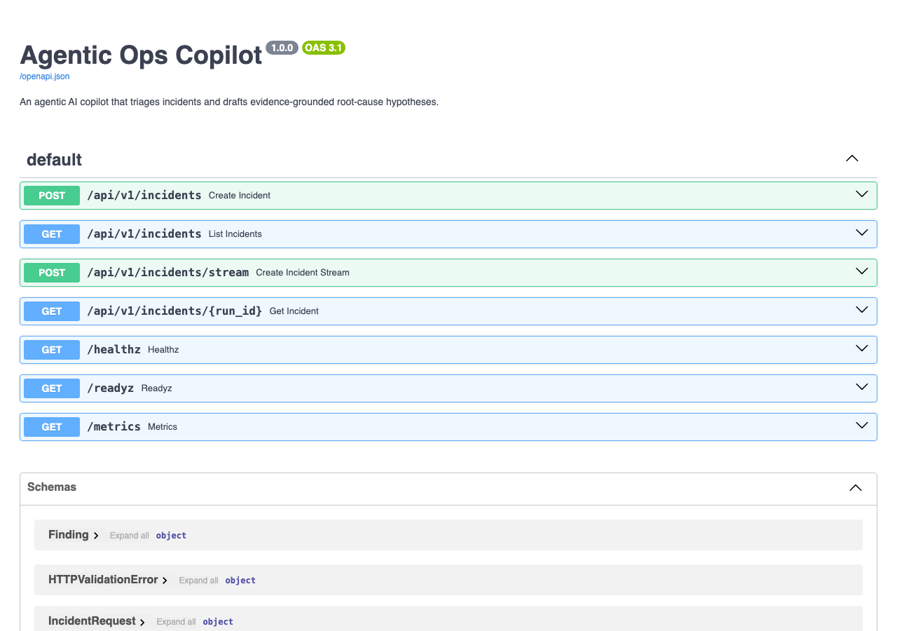
API docs
Method | Path | Description
POST | /api/v1/incidents | Run an analysis, return the final result as JSON
POST | /api/v1/incidents/stream | Same, streamed as Server-Sent Events (live node progress)
GET | /api/v1/incidents | List recent runs
GET | /api/v1/incidents/{run_id} | Fetch one run
GET | /healthz | Liveness probe
GET | /readyz | Readiness probe — reports resolved provider/backends
GET | /metrics | Prometheus metrics
GET | /docs | OpenAPI/Swagger UI
Set OPS_API_KEY to require an X-API-Key header on every /api/v1/* call; leave it unset for open access (fine for local/dev use).

Docker
docker compose up --build
Brings up the service on http://localhost:8000 with a persistent volume for run history. The image is a multi-stage, non-root build with a container HEALTHCHECK on /healthz.
To demo the real Prometheus/Loki adapters alongside it:
docker compose --profile real-backends up --build

Plugging in real backends
Every ops tool is defined as a typing.Protocol in src/ops_copilot/tools/base.py — LogsBackend, MetricsBackend, ServiceCatalog. Two implementations ship today:
- mock (default): rich, deterministic, zero-setup scenarios — good for demos, tests, and CI.
- one real adapter per capability, as a concrete reference: prometheus.py for metrics, loki.py for logs.
To point at your own stack: implement the relevant protocol against your internal system (Datadog, Splunk, PagerDuty, your service catalog/CMDB, …) and register it in tools/registry.py. No changes to the graph, guardrails, or API are needed.
LLM providers work the same way — see llm.py: fake (default, deterministic, offline), openai, bedrock.

Testing
make test # pytest with coverage
make lint # ruff check + format --check
make typecheck # mypy
The suite (39 tests, ~86% coverage) runs fully offline against the fake LLM provider and mock backends — no API keys or network access required. It includes:
- A zero-env import regression test — the original prototype crashed on import without OPENAI_API_KEY; this test proves the package now imports and builds the graph in a completely scrubbed environment.
- Unit tests for config, the fake model’s structured output (both the grounded and insufficient-evidence paths), guardrail enforcement, mock backends, and retrieval.
- Integration tests running the full graph end-to-end across multiple scenarios, including the parallel evidence fan-out, the router skipping irrelevant evidence sources, and a simulated backend failure that must degrade gracefully rather than crash the run.
- API tests (FastAPI TestClient-style, via httpx.ASGITransport) covering every endpoint, SSE streaming, auth, rate limiting, and history.
- Real-adapter tests (Prometheus/Loki) against httpx mock transports — no real network calls.
Honest limit: with no OPENAI_API_KEY or AWS credentials configured, the real OpenAI/Bedrock code paths and genuinely live Prometheus/Loki calls are not exercised by this suite — only their request/response handling logic is, via mocks. Everything reported as tested here is the offline suite.

Project layout
src/ops_copilot/
config.py pydantic-settings — every setting has a working default
schemas.py typed contracts (IncidentRequest, Finding, RunRecord, ...)
llm.py lazy LLM provider factory: fake | openai | bedrock
graph.py the LangGraph state machine
guardrails.py evidence-grounding enforcement
retrieval.py runbook retrieval (Chroma or dependency-free in-memory)
tools/ adapter protocols + mock/real backend implementations
store.py run-history persistence
observability.py structured logging + Prometheus metrics
api.py FastAPI app (REST + SSE + embedded dashboard)
cli.py Typer CLI
web/ the dashboard SPA (plain HTML/CSS/JS, no build step)
runbooks/ sample runbooks used by retrieval
tests/ unit + integration tests

Troubleshooting
- database is locked: two processes are writing to the same SQLite checkpoint file at once. Point OPS_CHECKPOINT_DB_PATH at separate files for separate processes (this is set automatically per-test).
- ModuleNotFoundError: langchain_openai / langchain_aws / langchain_chroma: install the matching extra, e.g. pip install -e ".[openai]".
- Dashboard prompts for an API key: this happens when OPS_API_KEY is set — the dashboard prompts once on the first 401, then remembers the key in the browser’s localStorage for subsequent requests. Clear it via your browser’s dev tools if you need to re-enter it.
- 429 rate limit exceeded: you’ve hit OPS_RATE_LIMIT_PER_MINUTE for your client IP on this worker process; wait for the Retry-After window or raise the setting.
- A finding cites logs/metrics/context I didn’t expect, or a source is missing with no explanation: check RunRecord.degraded in the response — if the source is listed there, the real backend (Prometheus/Loki/etc.) failed or timed out during this run rather than being skipped by the router; the run still completes with whatever evidence was collected.

