Churn MLOps Pipeline
An end-to-end MLOps pipeline for customer churn prediction — real data, tracked training runs, a served model, automated tests, containerization, and live data-drift monitoring. Every metric below is a held-out test-set number from an actual training run committed in this repo.
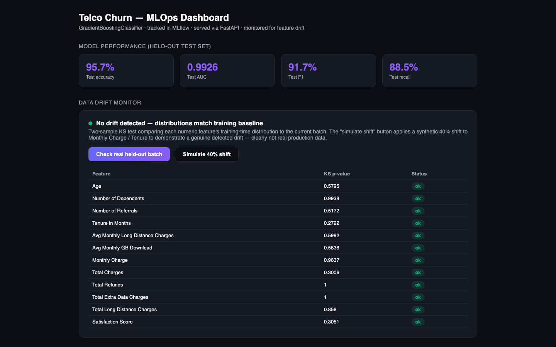
Dashboard

What “MLOps” means in this project
Not just “a model in a notebook” — the full loop:
Stage | Tool | What it does
Experiment tracking | MLflow (local SQLite backend) | Every training run logs params, metrics, and the model artifact
Model serving | FastAPI | /predict endpoint + interactive Swagger docs at /docs
Testing | pytest | 6 tests covering feature engineering, the API, and drift detection
Containerization | Docker | Built and run-tested locally — see Dockerfile
CI | GitHub Actions | Lint (ruff) → test (pytest) → Docker build, on every push
Monitoring | scipy KS-test | Live drift dashboard comparing production batches to the training baseline

Model results (held-out test set, not training set)
Metric | Value
Accuracy | 95.7%
AUC | 0.9926
F1 | 91.7%
Precision | 95.1%
Recall | 88.5%
Trained on the real IBM Telco Customer Churn dataset (4,225 train / 1,409 validation / 1,409 test rows), a GradientBoostingClassifier over 46 engineered features (tenure, contract type, charges, satisfaction score, service add-ons). Full metrics and the per-run MLflow record are in docs/TECHNICAL.md.

Data drift monitoring
The dashboard runs a two-sample Kolmogorov-Smirnov test on every numeric feature, comparing the training-time distribution to a live batch. Checking the real held-out test split correctly shows no drift; a “simulate 40% shift” button applies a synthetic shift to two features and the monitor correctly flags exactly those two as drifted — proving the detector reacts to real distributional change, not just a fixed message.
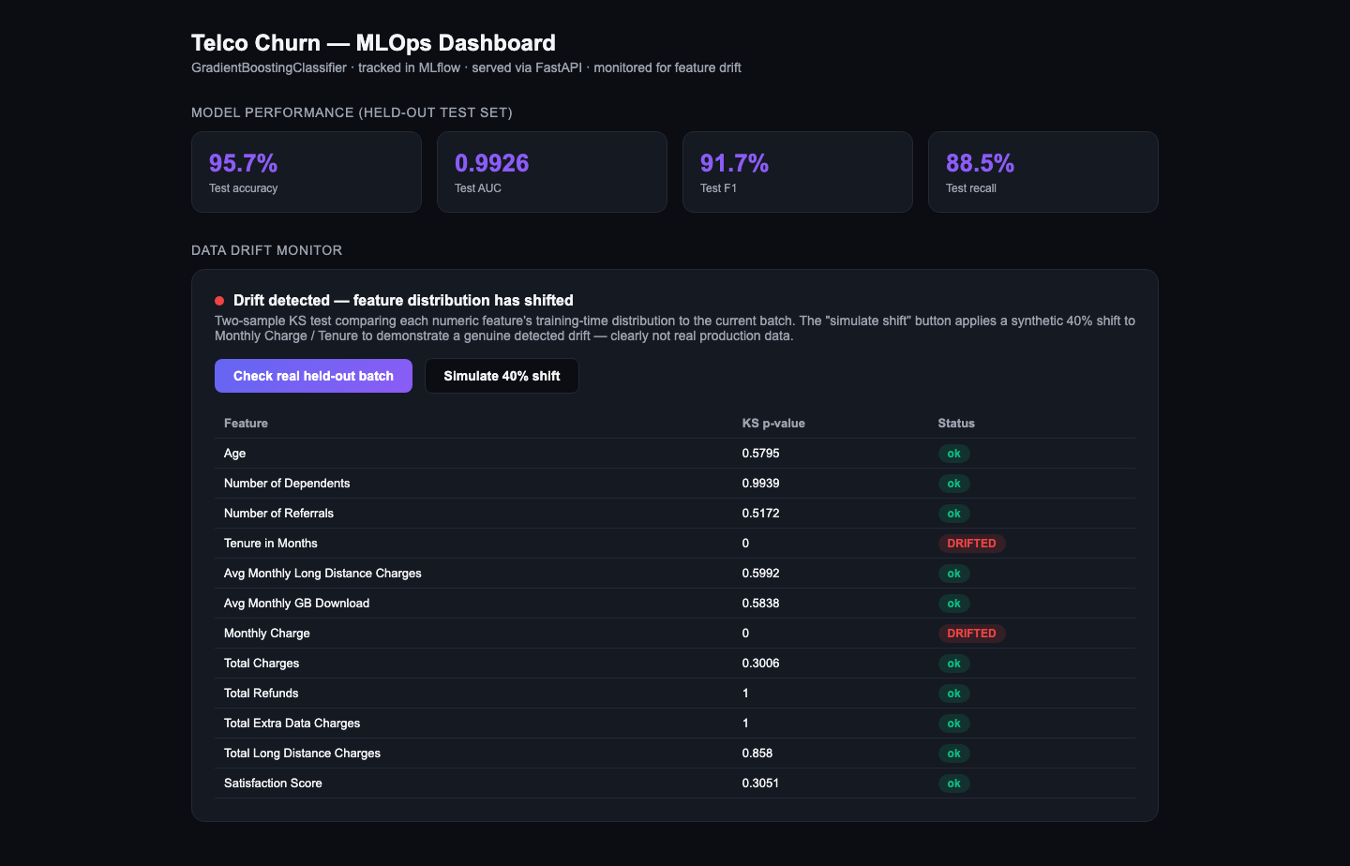
Drift detected

Screenshots
Dashboard | Drift simulation
 | 

Swagger UI | Live prediction
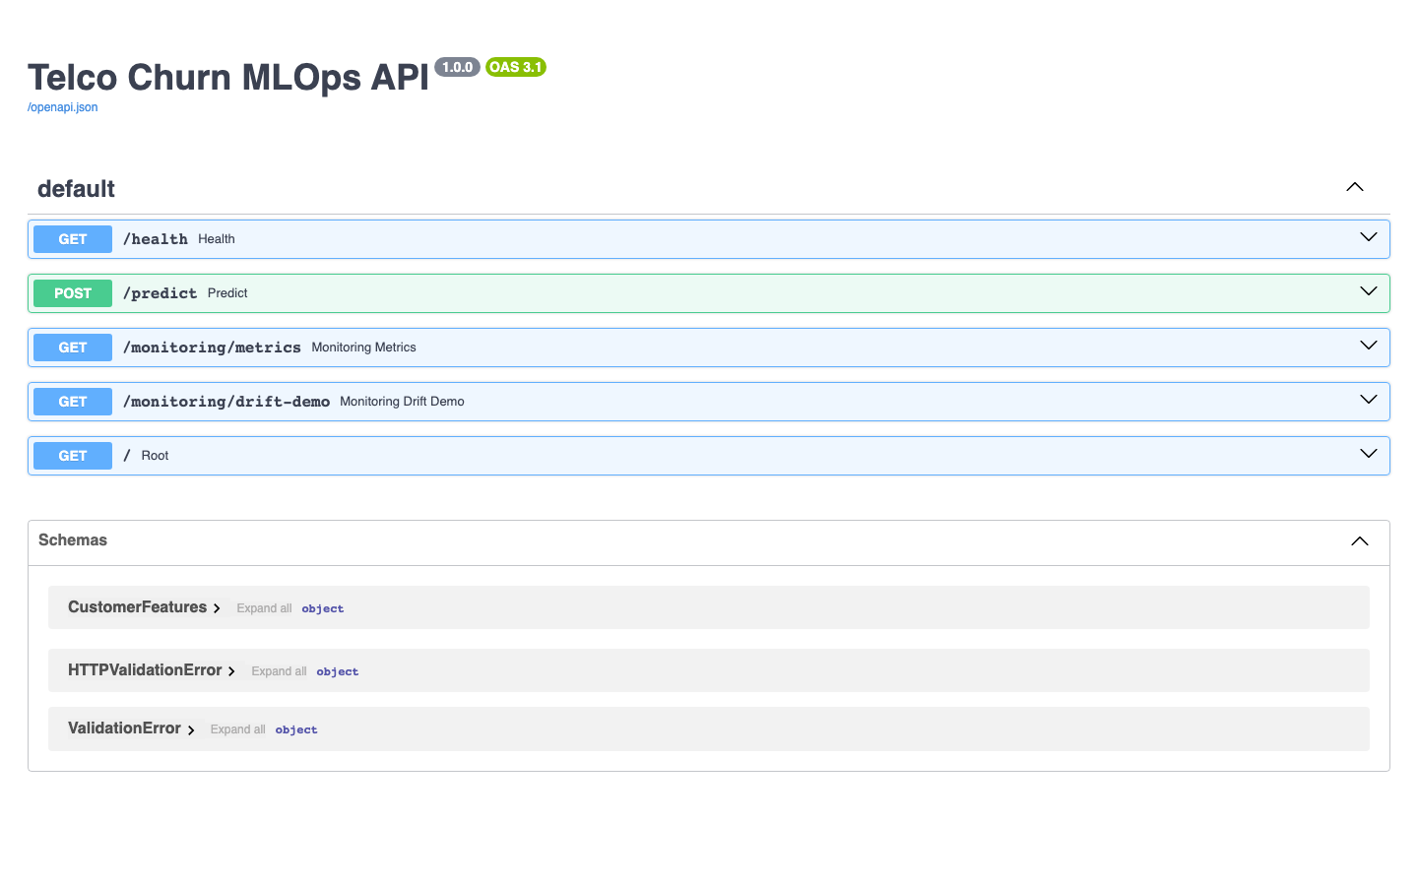 | 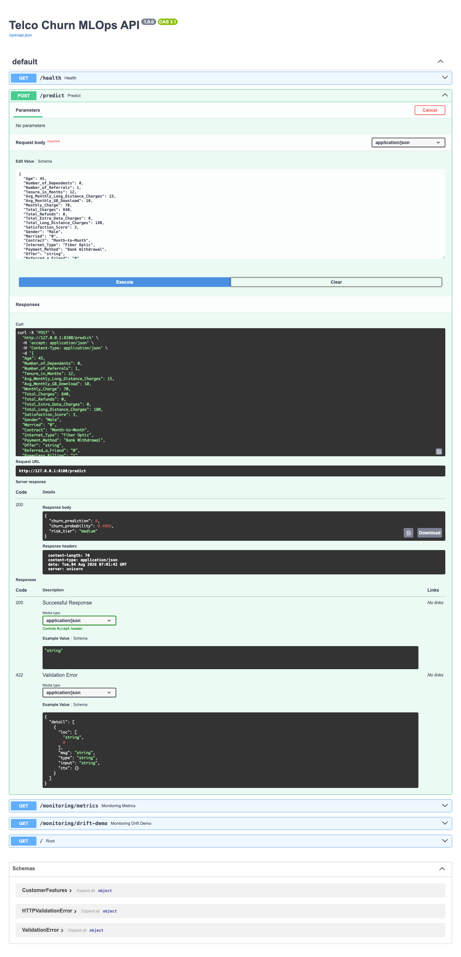
More in docs/screenshots/.

Quickstart
python3 -m venv .venv && source .venv/bin/activate
pip install -r requirements.txt
# model is already trained and committed under model/ - to retrain:
python3 src/train.py
# run the drift monitor standalone
python3 src/monitor.py
# serve the API + dashboard
cd src && uvicorn api:app --port 8000
# open http://127.0.0.1:8000 for the dashboard, /docs for Swagger UI

Docker
docker build -t churn-mlops-pipeline .
docker run -p 8000:8000 churn-mlops-pipeline

Tests
pip install ruff pytest
ruff check src tests
pytest tests/ -v

Project structure
churn-mlops-pipeline/
├── src/
│ ├── features.py # shared feature engineering (train + serve use the same code)
│ ├── train.py # trains the model, logs to MLflow, writes model/
│ ├── monitor.py # KS-test drift detector
│ ├── api.py # FastAPI app: /predict, /monitoring/*, dashboard
│ └── static/dashboard.html
├── tests/test_pipeline.py
├── data/ # bundled real Telco churn CSVs (train/val/test)
├── model/ # trained model, metrics.json, training_baseline.json
├── Dockerfile
├── .github/workflows/ci.yml
└── docs/
├── TECHNICAL.md
└── screenshots/

Docs
Full write-up of the feature pipeline, MLflow run details, drift-test mechanics, and CI/CD design: docs/TECHNICAL.md.

