Electricity Demand Forecasting
A time-series forecasting project on Spain’s real hourly electrical grid load (2015–2018, 35,064 hours) — and the part that makes it more than a typical forecasting demo: the model is benchmarked not just against a naive baseline, but against Spain’s actual transmission-system-operator (REE) day-ahead forecast, which is already in the dataset. That’s a real, professionally-produced forecast to compare against, not a synthetic one.
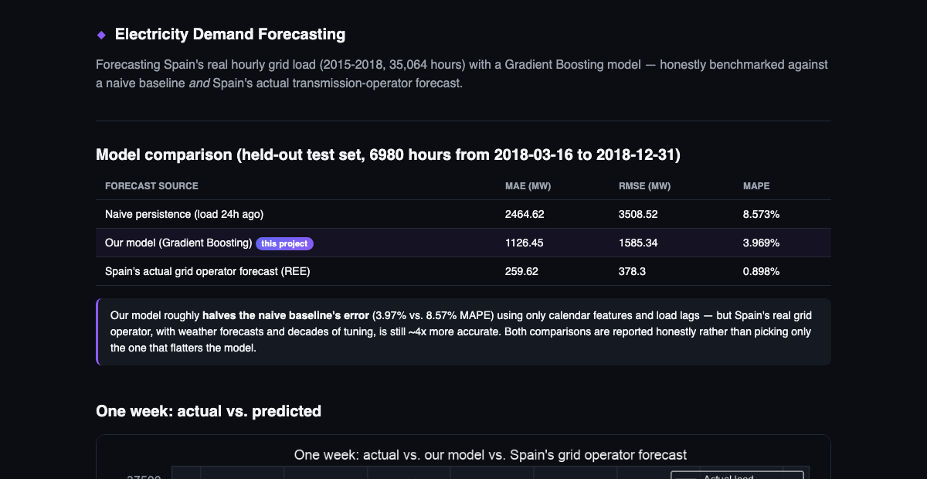
Model comparison

The honest result
Forecast source | MAE (MW) | RMSE (MW) | MAPE
Naive persistence (load 24h ago) | 2,464.62 | 3,508.52 | 8.573%
Our model (Gradient Boosting) | 1,126.45 | 1,585.34 | 3.969%
Spain’s actual grid operator forecast (REE) | 259.62 | 378.30 | 0.898%
Our model — trained only on calendar features (hour, day-of-week, month) and load lags/rolling means, no weather data — roughly halves the naive baseline’s error. But Spain’s real grid operator, which has access to weather forecasts and years of domain-specific tuning, is still about 4x more accurate. Both numbers are reported side by side rather than comparing only against the baseline that makes the model look best.

Why this matters more than a single accuracy number
Anyone can report “my model gets X% MAPE.” Whether that’s good depends entirely on what it’s being compared to. This project makes that comparison concrete and real: - Beats a naive baseline decisively → the model is learning genuine structure (daily/weekly cycles, recent load momentum). - Loses to a domain-specialist forecast with more inputs → an honest ceiling, and a plausible explanation (no weather data) rather than a vague excuse.

Screenshots
One week: actual vs. predicted | Error distribution
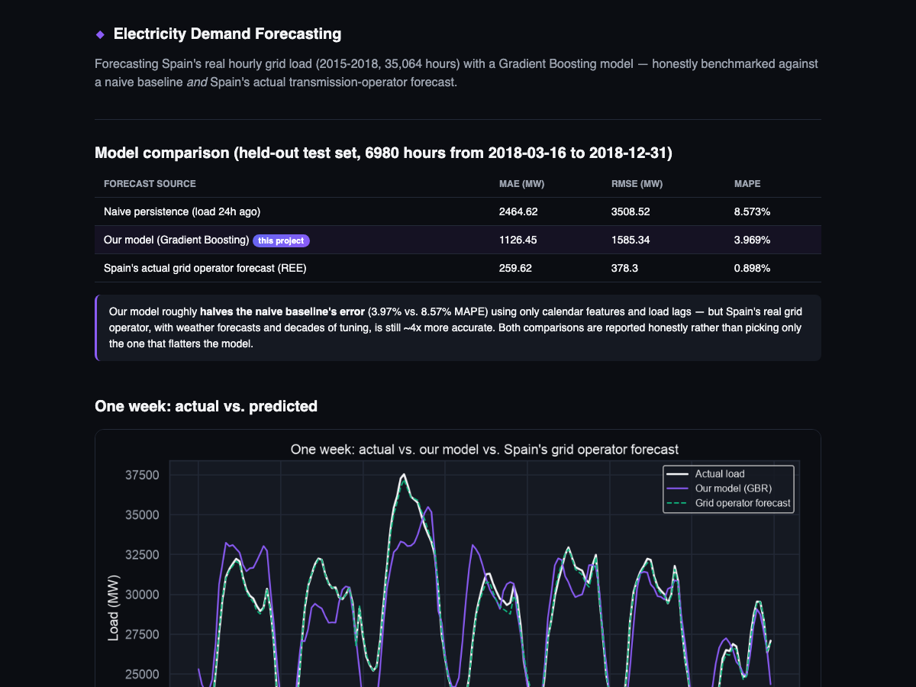 | 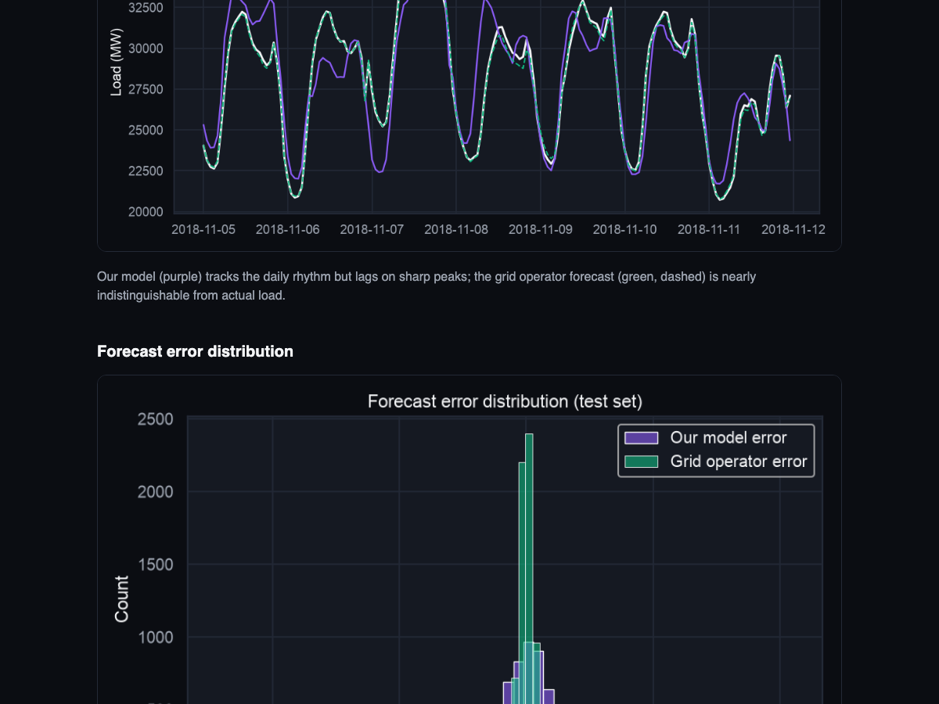

Live day chart
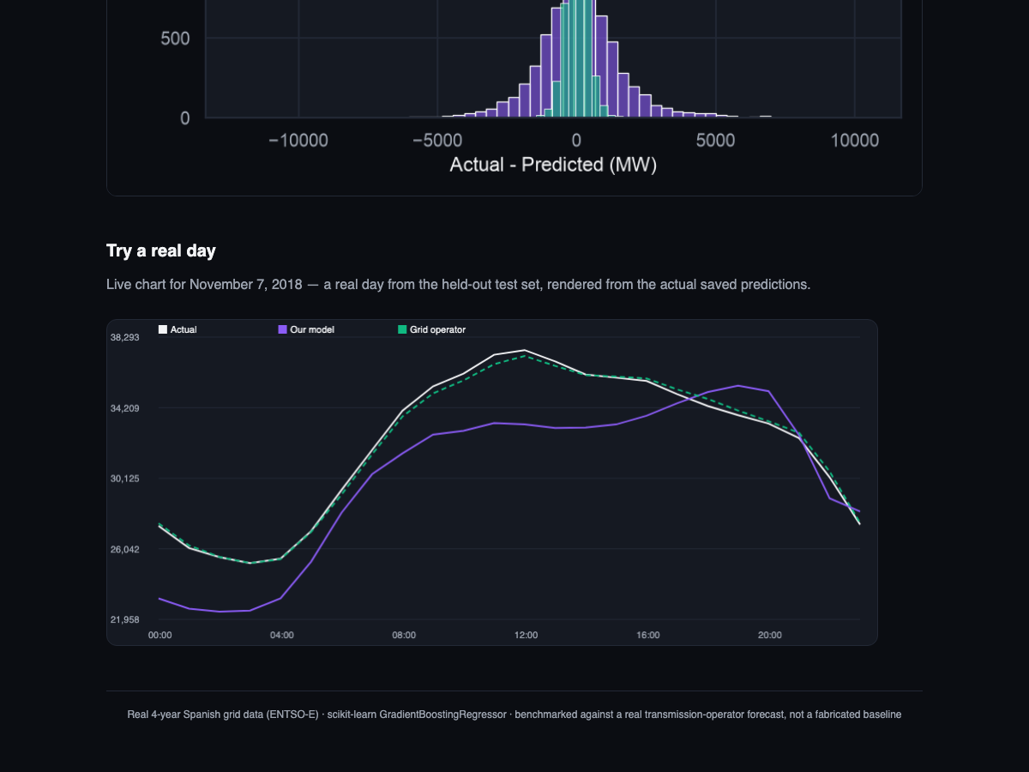
More in docs/screenshots/.

Tech stack
Layer | Tech
Modeling | scikit-learn GradientBoostingRegressor
Feature engineering | pandas (lag features, rolling means, calendar features)
Charts | matplotlib + seaborn (static), vanilla Canvas (live demo chart)
Serving | Flask

Quickstart
python3 -m venv .venv && source .venv/bin/activate
pip install -r requirements.txt
# model + charts are already generated and committed - to regenerate:
python3 src/train.py
python3 src/charts.py
python3 app.py
# open http://127.0.0.1:5300

Project structure
energy-demand-forecasting/
├── app.py # Flask dashboard + /api/sample-day
├── src/
│ ├── features.py # lag/rolling/calendar feature engineering
│ ├── train.py # trains model, benchmarks vs. naive + grid operator
│ ├── charts.py # generates static PNG charts
│ └── download_data.py # optional: regenerate data/ from Hugging Face
├── data/ # bundled real Spain ENTSO-E hourly grid data
├── model/ # trained model, metrics.json, test_predictions.csv
├── static/, templates/ # UI
└── docs/
├── TECHNICAL.md
└── screenshots/

Docs
Full methodology — feature design, the time-ordered split rationale, and the operator-forecast benchmark — in docs/TECHNICAL.md.

