📚 Enterprise RAG Knowledge Assistant
Production-ready Retrieval-Augmented Generation service that answers questions from internal documentation, with a reranking pass for precision and an explicit groundedness check so answers stay tied to real source text instead of drifting into the model’s own guesses.
All screenshots below are real captures of the running application (FastAPI backend + Streamlit UI, served locally, driven by a local Ollama model) — not mockups.

Table of contents
- Screenshots
- What’s included
- Architecture
- Prerequisites
- Installation
  - Option A — Docker (recommended)
  - Option B — Local Python
- Choosing and configuring an LLM provider
- Configuration reference
- Running the app
- API reference
- Using the UI
- Testing
- Project layout
- Extending the project
- Troubleshooting
- License
📖 Want the full story? docs/PROJECT_OVERVIEW.md documents every bug fixed, every design decision, the full testing strategy, and the exact end-to-end verification performed on this build.

Screenshots

Streamlit chat UI — freshly started
Sidebar shows live API health, which LLM provider is active, and the seeded knowledge base; main panel is the chat window.
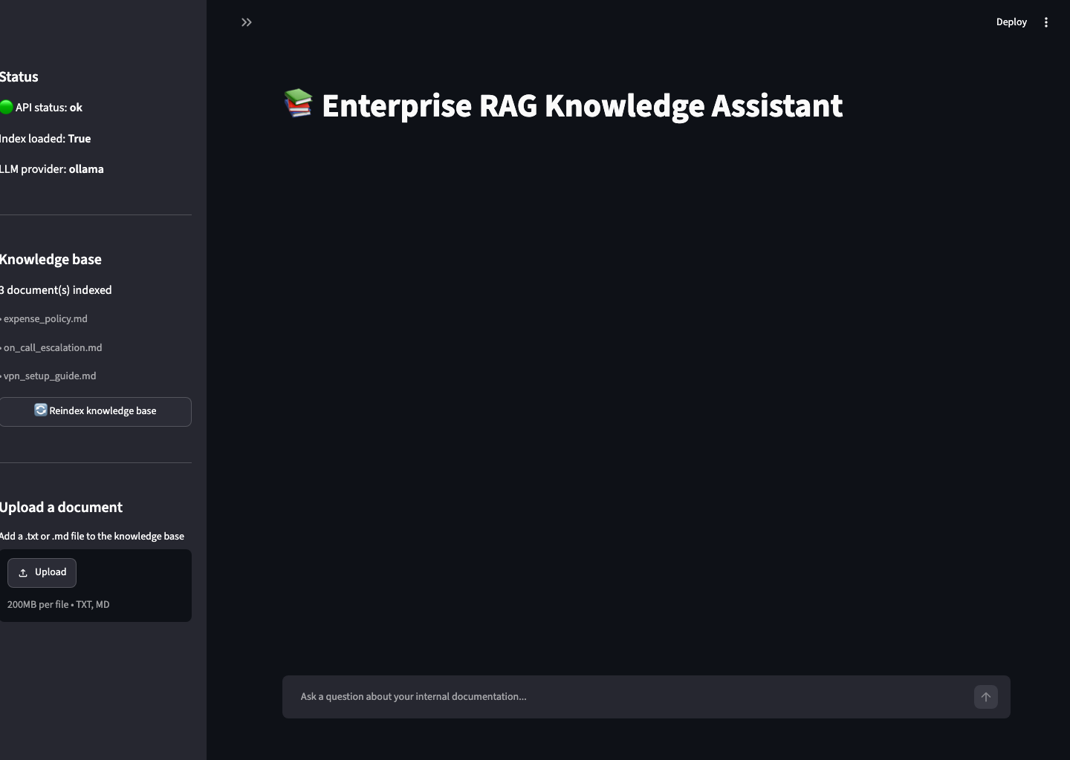
Streamlit UI on startup

A grounded, cited answer
Asking a question the knowledge base can actually answer. The answer cites its sources, and the UI shows a green “✅ Grounded” badge with the exact source files used.
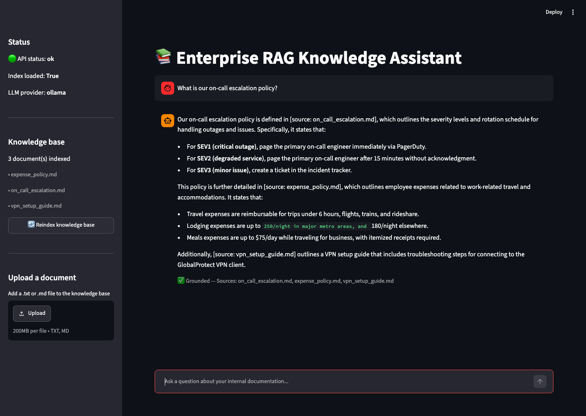
Grounded chat answer with citations

The groundedness gate rejecting an out-of-scope question
Asking something the knowledge base has no information about (“Write a haiku about the ocean”). Retrieval finds nothing relevant enough, so the assistant refuses rather than making something up — the whole point of the groundedness check.
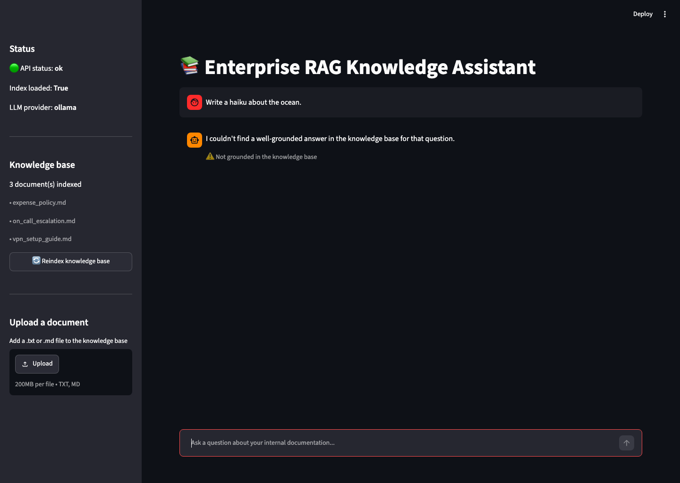
Ungrounded fallback response

FastAPI interactive docs (Swagger UI)
Every endpoint (/health, /ingest, /query, /documents) is self-documenting and testable directly in the browser at /docs.
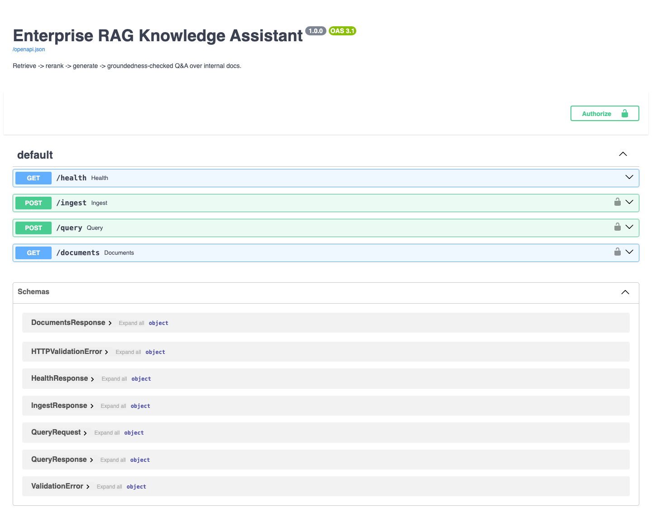
FastAPI Swagger UI

What’s included
- Provider-agnostic LLM layer — switch between OpenAI, Anthropic (Claude), or a local Ollama model with one config value, no code changes.
- FastAPI backend (/health, /ingest, /query, /documents) with optional bearer-token auth.
- Streamlit chat UI with live groundedness/citation display, reindex button, and knowledge-base browser.
- Idempotent indexing — re-running ingestion doesn’t duplicate chunks; the index only rebuilds when the knowledge base actually changed.
- Multi-format ingestion — .txt, .md, .pdf, .docx; a bad file is skipped and logged, not a crash.
- Fixed groundedness check — the original prototype’s check silently passed for any document missing source metadata; this version treats that as not grounded, and matches citations by filename rather than requiring an exact full-path match.
- Test suite that runs with zero API keys (a fake LLM stands in for the real ones), plus opt-in integration tests against real providers.
- Docker + docker-compose — one command to run the whole stack, model weights baked into the image so startup is fast.
- CI (GitHub Actions) — lint + unit tests on every push, no secrets required.
- A small seed knowledge base (on-call escalation, expense policy, VPN setup) so the app is immediately queryable after cloning.

Architecture

Pipeline
flowchart LR
subgraph Ingestion
A[".txt / .md / .pdf / .docx<br/>knowledge_base/"] --> B["Load documents<br/>(per-file error isolation)"]
B --> C["Chunk<br/>(RecursiveCharacterTextSplitter)"]
C --> D["Embed<br/>(all-MiniLM-L6-v2)"]
D --> E[("Chroma vector store")]
end
subgraph "Query time"
Q["User question"] --> R["Retrieve top-k<br/>(bi-encoder similarity)"]
E --> R
R --> S["Rerank top-n<br/>(cross-encoder)"]
S --> G["Generate answer<br/>(OpenAI / Anthropic / Ollama)"]
G --> H{"Groundedness check:<br/>does the answer cite<br/>a retrieved source?"}
H -- yes --> I["✅ Grounded answer + sources"]
H -- no --> J["⚠️ Refusal fallback"]
end

System components
flowchart TB
U["User"] --> UI["Streamlit UI<br/>(ui/streamlit_app.py)"]
UI -- HTTP --> API["FastAPI backend<br/>(src/rag_assistant/api)"]
API --> ASM["EnterpriseKnowledgeAssistant<br/>(assistant.py)"]
ASM --> VS[("Chroma<br/>vector store")]
ASM --> RR["Cross-encoder reranker"]
ASM --> LLM["LLMProvider<br/>(openai / anthropic / ollama)"]
LLM -->|API call| EXT["OpenAI API / Anthropic API /<br/>local Ollama server"]

Request sequence (POST /query)
sequenceDiagram
participant User
participant UI as Streamlit UI
participant API as FastAPI
participant VS as Chroma
participant RR as Reranker
participant LLM as LLM Provider
User->>UI: Ask a question
UI->>API: POST /query {question}
API->>VS: similarity_search(question, k)
VS-->>API: top-k candidate chunks
API->>RR: rerank(question, candidates)
RR-->>API: top-n reranked chunks
API->>LLM: generate(system, context + question)
LLM-->>API: answer text
API->>API: groundedness check (citation match)
alt cited a retrieved source
API-->>UI: {answer, grounded: true, sources}
else no valid citation
API-->>UI: {fallback answer, grounded: false, sources: []}
end
UI-->>User: render answer + grounded badge

Prerequisites
Requirement | Why | Notes
Python 3.11+ | Runs the API, UI, and pipeline | Check with python3 --version
pip | Installs Python dependencies | Bundled with Python
~2 GB free disk | Embedding + reranker model weights, plus Python deps | One-time download, cached afterward
An LLM provider (pick one) | Generates the actual answers | See Choosing and configuring an LLM provider
Docker + Docker Compose (optional but recommended) | One-command run, no local Python setup | Docker Desktop on macOS/Windows, docker + docker-compose-plugin on Linux
git | Clone the repository | —
You do not need a GPU. The embedding model and cross-encoder reranker are small enough to run comfortably on CPU.

Installation
Clone the repo first, either way:
git clone https://github.com/ameyagidh/Enterprise-rag-knowledge-assistant.git
cd Enterprise-rag-knowledge-assistant

Option A — Docker (recommended)
This builds one image containing both the API and the UI, with model weights pre-downloaded so the container starts fast and works even with restricted network access at runtime.
# 1. Create your environment file from the template
cp .env.example .env
# 2. Edit .env and set your provider's API key, e.g.:
# LLM_PROVIDER=anthropic
# ANTHROPIC_API_KEY=sk-ant-...
# (or OPENAI_API_KEY, or switch LLM_PROVIDER=ollama — see below)
# 3. Build and start everything
docker compose up --build
Once it’s up: - API: http://localhost:8000 (interactive docs at http://localhost:8000/docs) - UI: http://localhost:8501
Stop it with Ctrl+C, or docker compose down to remove the containers (the chroma_data volume persists your index between restarts — delete it with docker compose down -v if you want a clean slate).

Option B — Local Python
Use this if you want to develop, debug, or run without Docker.
# 1. Create and activate a virtual environment
python3 -m venv .venv
source .venv/bin/activate # Windows (PowerShell): .venv\Scripts\Activate.ps1
# Windows (cmd): .venv\Scripts\activate.bat
# 2. Upgrade pip and install the package + dev dependencies
python -m pip install --upgrade pip
pip install -e ".[dev]"
# 3. Create your environment file
cp .env.example .env
# edit .env and set your provider's API key (see next section)
# 4. Run the API (terminal 1)
uvicorn rag_assistant.api.main:app --reload --host 0.0.0.0 --port 8000
# 5. Run the UI (terminal 2, same venv activated)
export API_BASE_URL=http://localhost:8000 # Windows: set API_BASE_URL=http://localhost:8000
streamlit run ui/streamlit_app.py
The first request will download two small HuggingFace models (the embedder and the cross-encoder reranker, ~250 MB combined) and cache them under ~/.cache/huggingface — subsequent runs are instant.

Choosing and configuring an LLM provider
Set LLM_PROVIDER in .env to one of openai, anthropic, or ollama. Only the credentials for your chosen provider are required.

Anthropic (Claude) — default
- Create a key at console.anthropic.com.
- In .env:
- LLM_PROVIDER=anthropic
ANTHROPIC_API_KEY=sk-ant-...
ANTHROPIC_MODEL=claude-opus-5

OpenAI
- Create a key at platform.openai.com/api-keys.
- In .env:
- LLM_PROVIDER=openai
OPENAI_API_KEY=sk-...
OPENAI_MODEL=gpt-4o-mini

Ollama (free, fully local, no API key)
Runs entirely on your machine — no external API calls, no cost, works offline.
# Install (macOS)
brew install ollama
# or download from https://ollama.com/download for Linux/Windows
# Start the server (leave running in its own terminal)
ollama serve
# Pull a small, fast model
ollama pull llama3.2:1b # ~1.3 GB, good for testing
# or: ollama pull llama3 # larger, higher quality
In .env:
LLM_PROVIDER=ollama
OLLAMA_BASE_URL=http://localhost:11434
OLLAMA_MODEL=llama3.2:1b
Note: small local models (1–3B parameters) are noticeably less precise than Claude/GPT-4-class models — they’re great for free local development and demos, but expect the largest, best-quality answers from a hosted provider.

Configuration reference
All configuration is environment-driven (see .env.example for the canonical, always-up-to-date list) — nothing is hardcoded, and no secrets are committed to the repo.
Variable | Purpose | Default
LLM_PROVIDER | openai | anthropic | ollama | anthropic
ANTHROPIC_API_KEY / ANTHROPIC_MODEL | Claude credentials + model | model: claude-opus-5
OPENAI_API_KEY / OPENAI_MODEL | OpenAI credentials + model | model: gpt-4o-mini
OLLAMA_BASE_URL / OLLAMA_MODEL | Local model endpoint | http://localhost:11434, llama3
DOCS_DIR | Knowledge base directory | ./knowledge_base
PERSIST_DIR | Vector store location | ./chroma_store
CHUNK_SIZE / CHUNK_OVERLAP | Chunking parameters | 700 / 100
RETRIEVE_K | Candidates pulled from the vector store per query | 10
RERANK_TOP_N | Chunks kept after reranking, passed to the LLM | 4
API_HOST / API_PORT | Where the FastAPI server binds | 0.0.0.0 / 8000
API_AUTH_TOKEN | If set, /ingest, /query, /documents require Authorization: Bearer <token> | unset (no auth)
STREAMLIT_PORT | UI port | 8501
API_BASE_URL | Where the UI looks for the API | http://localhost:8000
LOG_LEVEL | Application log verbosity | INFO

Running the app

First-time indexing
The app indexes knowledge_base/ automatically on startup. To rebuild it later (e.g. after adding documents):
curl -X POST "http://localhost:8000/ingest?force=true"
…or click “🔄 Reindex knowledge base” in the Streamlit sidebar.

Adding your own documents
Drop .txt, .md, .pdf, or .docx files into knowledge_base/ (or point DOCS_DIR at any directory), then reindex as above.

API reference

GET /health
curl http://localhost:8000/health
{"status": "ok", "index_loaded": true, "llm_provider": "anthropic"}

POST /ingest
curl -X POST "http://localhost:8000/ingest?force=true"
{"chunks_indexed": 6, "documents_indexed": 3, "rebuilt": true}

POST /query
curl -X POST http://localhost:8000/query \
-H "Content-Type: application/json" \
-d '{"question": "What is our on-call escalation policy?"}'
Grounded answer (question the knowledge base can actually answer):
{
"answer": "Our on-call escalation policy is defined in [source: on_call_escalation.md]. For SEV1 (critical outage), page the primary on-call engineer immediately via PagerDuty...",
"grounded": true,
"sources": ["on_call_escalation.md"]
}
Ungrounded fallback (question outside the knowledge base — this is the groundedness gate working as intended, captured live in the screenshot above):
curl -X POST http://localhost:8000/query \
-H "Content-Type: application/json" \
-d '{"question": "Write a haiku about the ocean."}'
{
"answer": "I couldn't find a well-grounded answer in the knowledge base for that question.",
"grounded": false,
"sources": []
}

GET /documents
curl http://localhost:8000/documents
{"documents": ["expense_policy.md", "on_call_escalation.md", "vpn_setup_guide.md"]}

Authenticated requests
If API_AUTH_TOKEN is set, every endpoint except /health requires a bearer token:
curl -X POST http://localhost:8000/query \
-H "Authorization: Bearer $API_AUTH_TOKEN" \
-H "Content-Type: application/json" \
-d '{"question": "..."}'

Using the UI
The Streamlit app (see screenshots) is a standard chat interface:
- Sidebar — live API health, LLM provider in use, list of indexed documents, and a “🔄 Reindex knowledge base” button.
- Main panel — a chat input at the bottom; each assistant reply shows a caption underneath it, either ✅ Grounded — Sources: on_call_escalation.md or ⚠️ Not grounded in the knowledge base, so it’s always visible whether an answer is backed by a real document.

Testing
pytest # unit tests: no LLM API key needed (fake LLM provider)
pytest -m integration # also exercises real OpenAI/Anthropic calls; needs keys set
pytest --cov=rag_assistant # with coverage
ruff check src tests # lint
Unit tests use a deterministic fake LLM provider so retrieval, reranking, the groundedness check, and the API layer are all fully tested without network calls to a paid provider (23/23 passing as of this writing). Integration tests are marked @pytest.mark.integration and skip automatically (not fail) when the corresponding API key env var isn’t set — this is also how CI runs them, with zero secrets configured.

Project layout
Enterprise-rag-knowledge-assistant/
├── src/rag_assistant/
│ ├── config.py # pydantic-settings, single source of truth for all config
│ ├── llm/ # provider-agnostic LLM layer (openai/anthropic/ollama)
│ ├── ingestion/ # multi-format loaders + chunking
│ ├── retrieval/ # embeddings, Chroma vector store lifecycle, reranker
│ ├── assistant.py # retrieve -> rerank -> generate -> ground-check pipeline
│ └── api/ # FastAPI app
├── ui/streamlit_app.py # chat UI
├── knowledge_base/ # seed documents (replace with your own)
├── tests/ # unit + integration tests
├── docs/screenshots/ # README screenshots
├── Dockerfile / docker-compose.yml
└── .github/workflows/ci.yml

Extending the project
- Add documents: drop .txt/.md/.pdf/.docx files into knowledge_base/ (or mount your own directory via DOCS_DIR), then POST /ingest?force=true or click “Reindex” in the UI.
- Swap the vector store: src/rag_assistant/retrieval/vectorstore.py is the only file that imports Chroma directly — implement the same three functions against another backend (e.g. FAISS, pgvector) to swap it.
- Add an LLM provider: implement LLMProvider.generate(system, user) -> str in a new file under llm/, then add a branch in llm/factory.py.

Troubleshooting
Symptom | Likely cause / fix
llm_provider=anthropic but ANTHROPIC_API_KEY is not set on startup | Set the matching API key for whichever LLM_PROVIDER you chose in .env
/health returns "status": "degraded" | Check the API server logs — startup failed (bad key, unreachable Ollama, empty knowledge base). The error is logged on startup and echoed via /health.
/query returns 502 with an Anthropic/OpenAI error message | Your API key is invalid/expired, or the account has no quota — the error message from the provider is passed through directly
Could not reach Ollama at http://localhost:11434 | Run ollama serve in a separate terminal, and confirm ollama pull <model> completed
First request is slow | Expected — the embedding model and cross-encoder are being downloaded and cached the first time. Subsequent requests are fast.
RuntimeError: No documents to index | knowledge_base/ (or your DOCS_DIR) is empty or contains only unsupported file types — add at least one .txt/.md/.pdf/.docx file
Docker container starts but immediately unhealthy | Check docker compose logs — most commonly a missing/invalid API key in .env
Answers cite the wrong file or nothing at all | This is the groundedness check working as designed for that question — try rephrasing, or check whether the relevant document is actually in knowledge_base/ via GET /documents

License
MIT

