Facial Emotion Recognition
Classifies a face image (webcam capture or upload) into one of 7 emotions — angry, disgust, fear, happy, sad, surprise, neutral — using a small CNN trained from scratch on FER-2013.

Data
FER-2013: 35,887 labeled grayscale 48×48 face images (28,709 train / 7,178 test), collected from real-world photos and deliberately noisy — low resolution, occlusion, inconsistent lighting, mislabeled examples. No cleaning or curation was applied; this is the standard, difficult FER-2013 split.
split | angry | disgust | fear | happy | sad | surprise | neutral
train | 3,995 | 436 | 4,097 | 7,215 | 4,830 | 3,171 | 4,965
test | 958 | 111 | 1,024 | 1,774 | 1,247 | 831 | 1,233
disgust has ~18x fewer samples than happy — handled with class-weighted cross-entropy loss during training, not by discarding the imbalance.

Model
A CNN trained from scratch (no pretrained backbone) — 4 conv blocks (BatchNorm + ReLU + MaxPool), dropout, 2 FC layers. See model.py.

Results (this run, on this machine)
- Test accuracy: 61.4% on the untouched FER-2013 test split (7,178 images)
- Published baselines for FER-2013 land around 65-70% test accuracy with similarly-sized CNNs — this run is in that range, on the honest end of it.
- Device: Apple M1 Pro (MPS), 40 epochs, ~531s training time.
Per-class precision / recall / F1:
class | precision | recall | f1 | support
angry | 0.54 | 0.56 | 0.55 | 958
disgust | 0.65 | 0.58 | 0.61 | 111
fear | 0.44 | 0.30 | 0.36 | 1024
happy | 0.85 | 0.81 | 0.83 | 1774
sad | 0.45 | 0.55 | 0.49 | 1247
surprise | 0.76 | 0.76 | 0.76 | 831
neutral | 0.56 | 0.60 | 0.58 | 1233
fear is the weakest class by a wide margin (recall 0.30). The confusion matrix below shows why: FER-2013 is notorious for confusing fear and sad, and this run reproduces that exactly — 321 of 1,024 fear images are misclassified as sad, and sad itself scatters across angry/fear/neutral. Rather than hide this, it’s the headline finding of the confusion matrix.
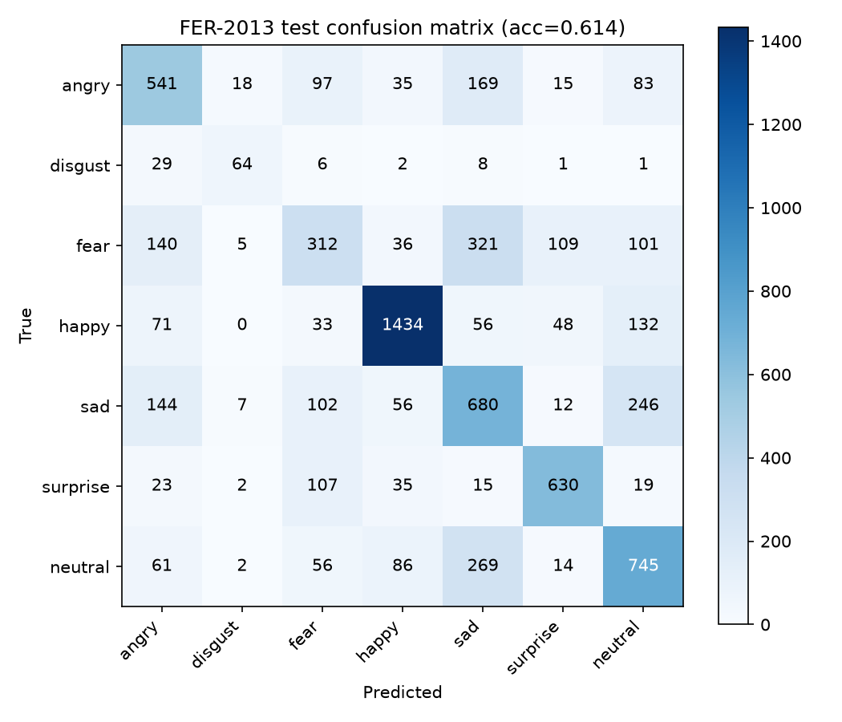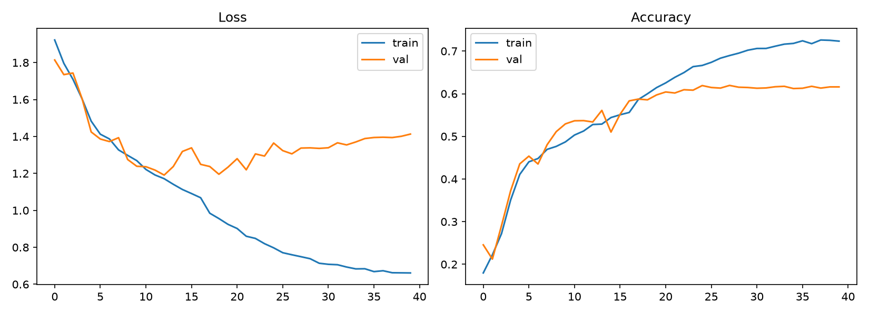

App
app.py (Streamlit) — upload a photo or use the webcam. A Haar-cascade face detector (bundled separately as models/haarcascade_frontalface_default.xml, since opencv-python 5.x no longer ships cascade files in cv2.data) crops the face to 48×48, and the app shows a confidence bar for all 7 classes, not just the top-1 label. A live-webcam mode averages predictions over the last 10 frames to smooth flicker instead of showing noisy per-frame flips.

Screenshots
App landing state:
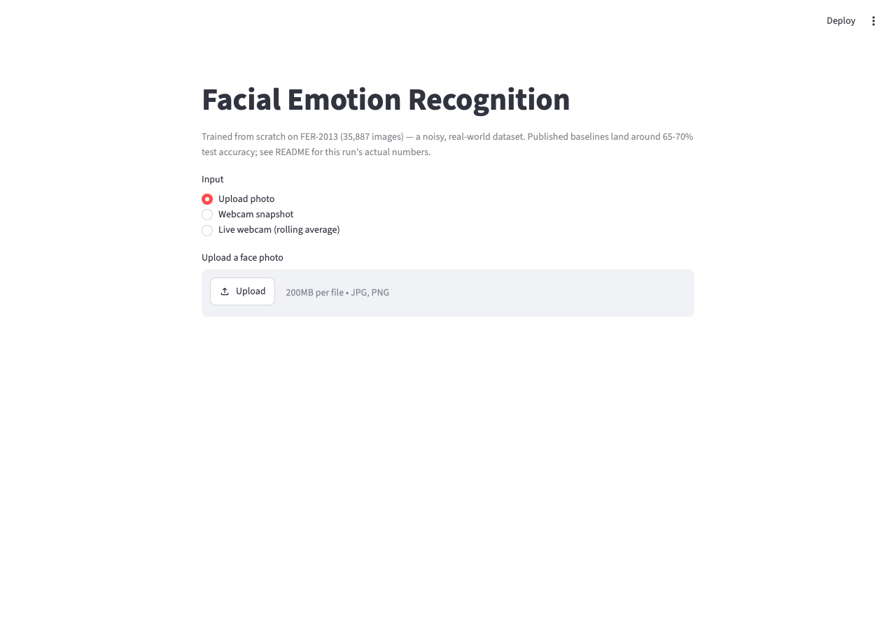
App landing
Uploaded photo → detected face → confidence bar for all 7 classes, sorted by probability (this example: neutral 54.9%, happy 30.0%):
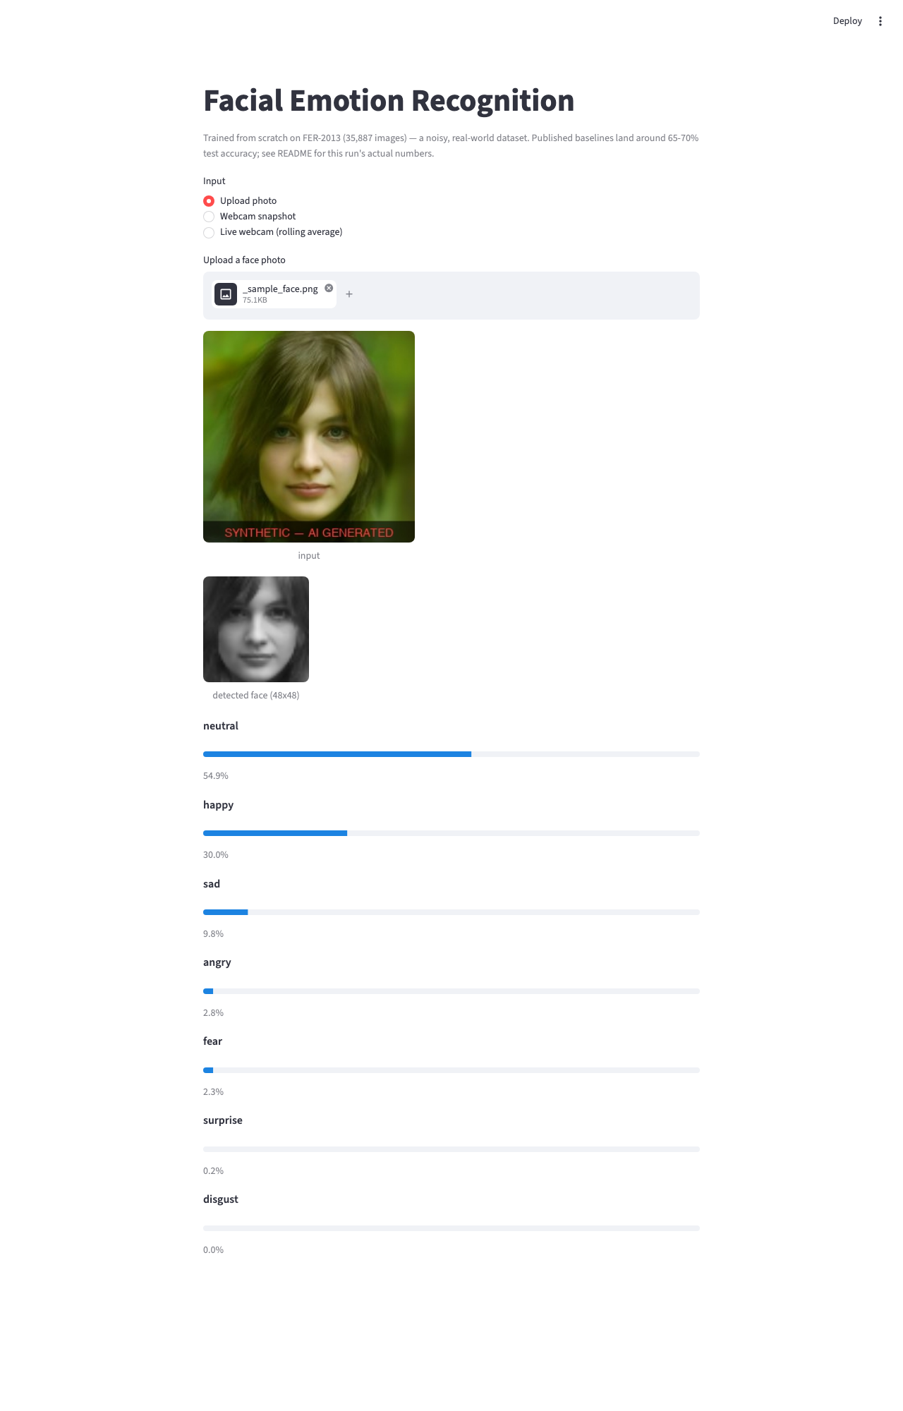
Prediction
Webcam-snapshot mode (camera permission prompt shown, no capture required):
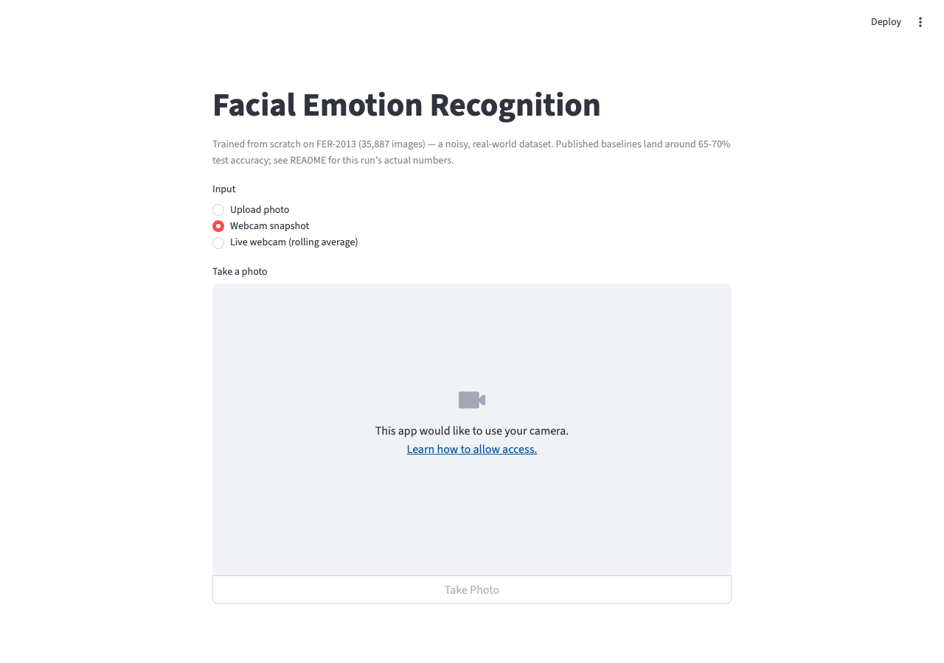
Webcam mode
Live-webcam mode with rolling-average smoothing:
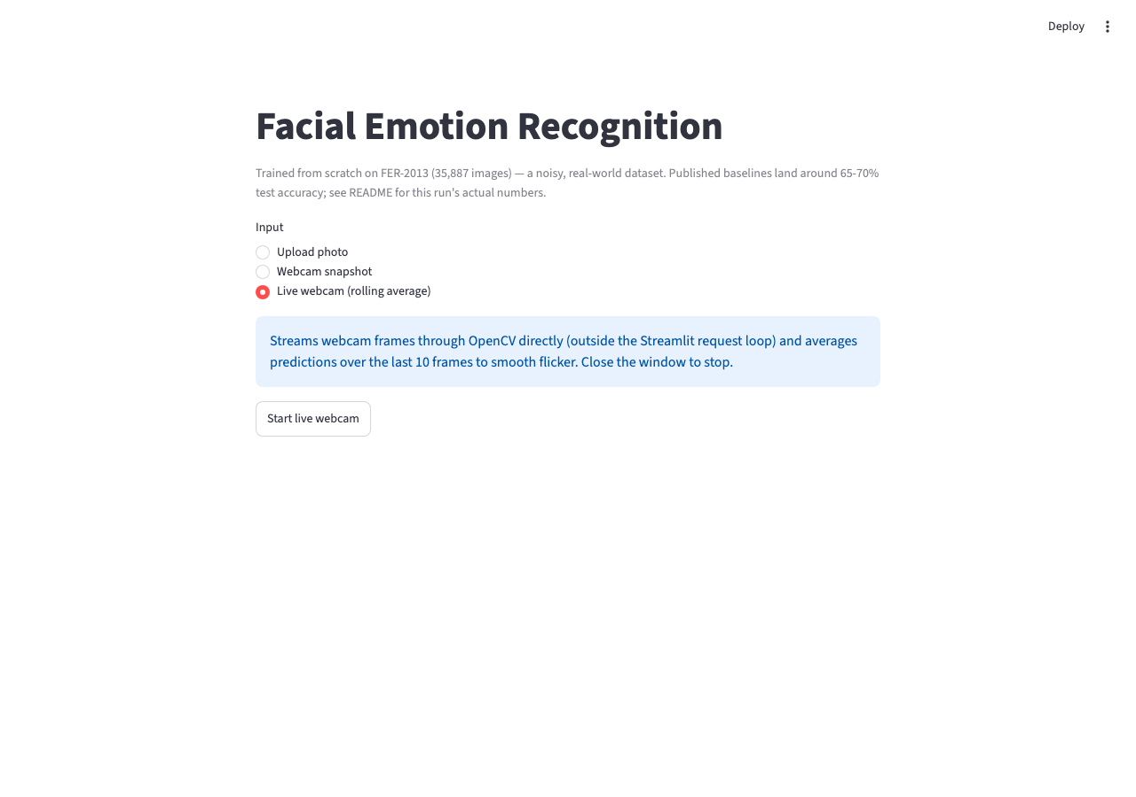
Live mode

Reproduce
python3 prepare_data.py # unpacks data/raw/{train,test}.pt into numpy arrays
python3 train.py # trains best_model.pt, writes history.json
python3 evaluate.py # test accuracy, confusion matrix, curves
streamlit run app.py

