Fastener Defect & Assembly-Safety Inspector
Project Documentation
Computer-vision fastener inspection with an auditable, rule-based safety verdict

Fastener defect & assembly-safety inspector
A computer-vision system that inspects a photo of a bolted car-part assembly,
detects fastener defects (missing, corroded, misaligned, damaged bolts), and
returns a transparent safe / needs inspection / unsafe verdict — through
a GUI, backed by an auditable rule engine rather than a black-box classifier.

The problem
On an assembly line, or when inspecting a used part before resale or
installation, a human currently eyeballs whether every fastener is present,
undamaged, and properly seated. This is repetitive, fatigue-prone, and
inconsistent between inspectors — exactly the kind of defect that gets
caught late (after the part ships), rather than at the point of assembly.
Who this is for: QA line inspectors, small auto shops doing used-parts
resale, and consumers checking a part before installing it.

GUI walkthrough (real screenshots)
These are genuine screenshots of app.py running locally (`streamlit run
app.py`), captured with a headless browser driving the live app — not
mockups.
1. Initial state — upload prompt
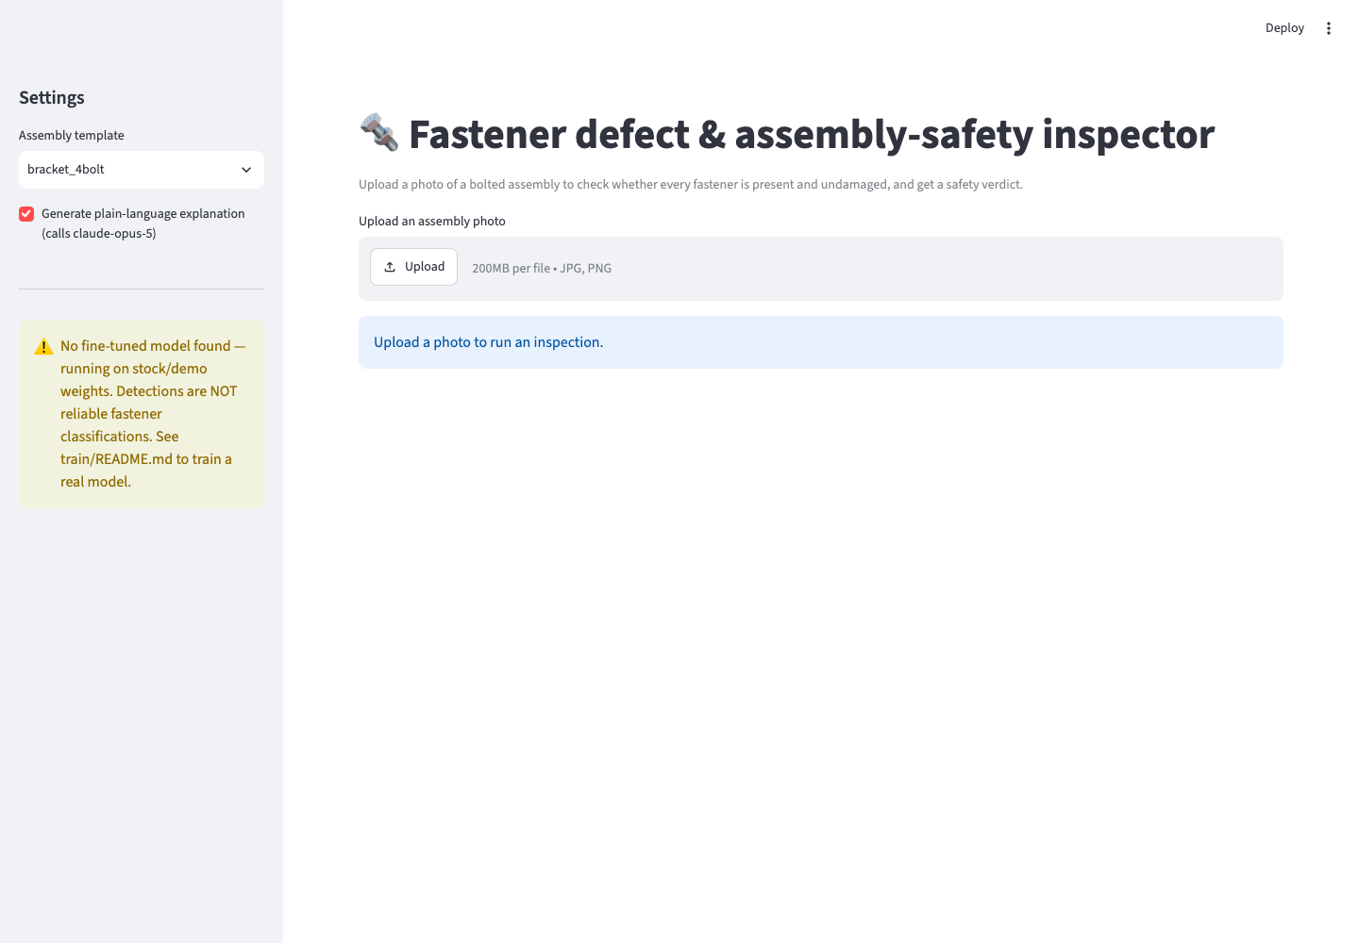
2. Sample input — a synthetic bracket photo (4 bolt-like dark circles
near the corners, generated for this demo since real photos require sourced
data — see Current status & limitations):
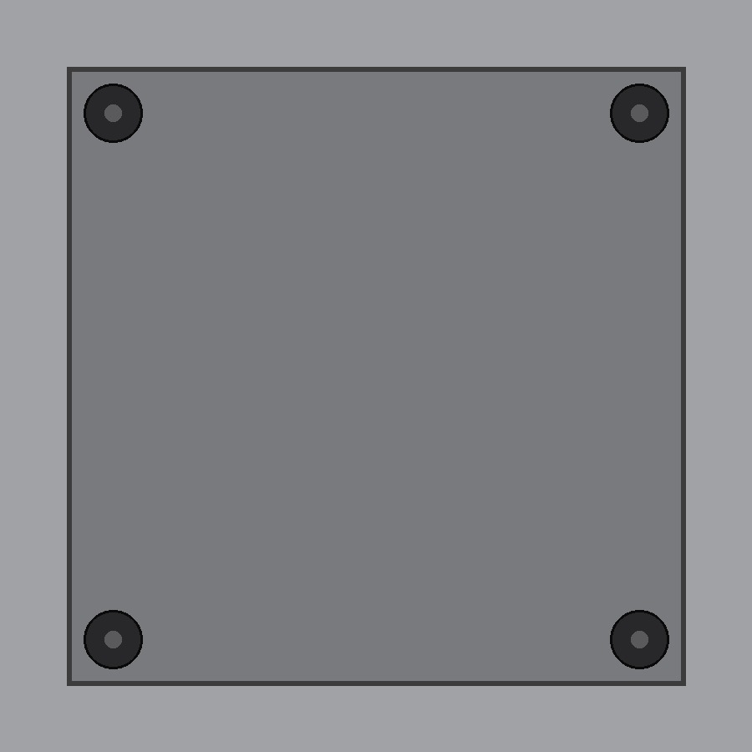
3. After inspection — annotated image + verdict panel
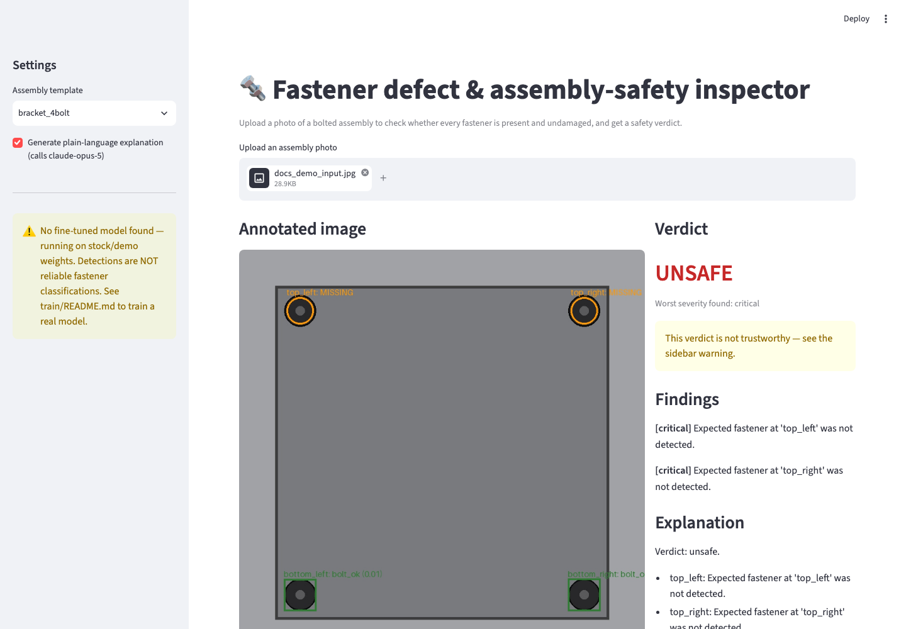
This run genuinely demonstrates the system's honesty mechanism in action:
it's using the stock fallback detector (no fine-tuned model exists yet — see
the sidebar warning), so two of the four bolt-like shapes were picked up as
low-confidence, unrelated COCO detections and matched within tolerance,
while the top two register as missing. The result is a correct UNSAFE
verdict with the exact reasons listed — this is the low-confidence guard and
the "don't trust this verdict yet" banner from
How the safety verdict is decided and
Current status & limitations
working exactly as designed, not a cherry-picked success case.

Why this needs CV and rules, not either alone
"Is a bolt present and undamaged?" cannot be answered with a simple pixel
threshold — it requires a model that has learned what a bolt looks like,
damaged or not, under varying lighting and angle. But *whether a given
defect makes the assembly unsafe* is a domain judgment, and a domain
judgment embedded inside an opaque model is not auditable, not editable by a
non-ML domain expert, and not something you can point to and say "here is
exactly why it failed."
So the system is deliberately split in two:
- A learned vision model (YOLOv8, fine-tuned) does the part that
genuinely requires learning from examples: recognizing a bolt and its
visible condition in a photo.
- A plain-data rule engine (rules.yaml + src/verdict.py) does the
part that must be transparent: mapping detected conditions to a
pass/fail verdict. It contains zero model calls and is fully
unit-tested without a GPU, an image, or a network connection.
An LLM (claude-opus-5) sits after the verdict has already been decided,
and only turns it into a plain-language paragraph — it never participates in
the safety decision itself.

Architecture
photo.jpg
│
▼
[1] detect ──────────► list[Detection]
YOLOv8 model {class: bolt_ok | bolt_corroded | bolt_misaligned |
(src/detect.py) bolt_damaged, bbox, confidence}
│
▼
[2] match to template ─► list[FastenerStatus]
templates/*.json expected position → matched detection, or
(src/match_template.py) "missing" if nothing matched within tolerance
│
▼
[3] severity rules ────► Verdict
rules.yaml overall: safe | needs_inspection | unsafe
(src/verdict.py) per-defect: severity + human-readable reason
│
▼
[4] explain (optional) ─► one-paragraph plain-language report
claude-opus-5 "3 of 4 bolts present and undamaged; the
(src/explain.py, top-right bolt shows moderate corrosion..."
reporting only —
never decision-making)
Why the template-diff step (2) exists and can't be skipped: a pure
object detector can report "I see 3 bolts, all look fine" — it has no way to
know a 4th bolt is missing unless something tells it 4 were expected.
templates/*.json supplies that domain knowledge explicitly, per part type,
rather than trying to infer "how many bolts should be here" from a single
image, which isn't information the image itself contains.
src/pipeline.py wires all four stages together and is the single entry
point both app.py (GUI) and the CLI usage below call into, so the two can
never drift out of sync with each other.

Project layout
AIProject/
├── README.md # this file
├── requirements.txt
├── .gitignore
├── rules.yaml # the entire safety-critical decision surface — plain data, no code
├── templates/
│ └── bracket_4bolt.json # expected fastener positions for a 4-bolt bracket
├── data/
│ ├── raw/ # (gitignored) downloaded public datasets — see train/README.md
│ ├── self_collected/ # (gitignored images; README tracked) your own labeled photos
│ └── merged/ # (generated) train/prepare_dataset.py output
├── models/
│ └── best.pt # (gitignored, not shipped) fine-tuned YOLOv8 weights — see below
├── src/
│ ├── models.py # shared dataclasses: Detection, FastenerStatus, Verdict, ...
│ ├── detect.py # YOLOv8 inference wrapper
│ ├── match_template.py # detection ↔ template diffing (nearest-match)
│ ├── verdict.py # rule engine — the safety-critical logic
│ ├── explain.py # claude-opus-5 plain-language explanation (reporting only)
│ └── pipeline.py # wires detect → match → verdict → explain
├── train/
│ ├── README.md # honest account of what training requires and why it isn't done here
│ ├── prepare_dataset.py # merge/split labeled sources into data/merged/
│ └── train.py # fine-tune YOLOv8n, writes models/best.pt
├── app.py # Streamlit GUI
└── tests/
├── test_verdict.py # rule engine — pure logic, always runs
├── test_match_template.py # template diffing — pure logic, always runs
├── test_pipeline.py # wiring test with an injected fake detector
└── test_eval_holdout.py # full-pipeline eval against a trained model (skips if none exists)

Setup
python3 -m venv .venv
source .venv/bin/activate
pip install -r requirements.txt
To enable the plain-language explanation layer, set an Anthropic API key
(or authenticate via ant auth login — see the Anthropic CLI docs):
export ANTHROPIC_API_KEY="sk-ant-..."
This is optional. Without it, the system still returns a complete, correct
verdict — src/explain.py falls back to a deterministic templated summary
(see explain_or_fallback).
Documentation tooling (optional): docs/PROJECT_DOCUMENTATION.docx is a
Word-format mirror of this README, generated by docs/generate_docx.py. It
is not needed to run the system — only install requirements-dev.txt if you
want to regenerate it after editing this README:
pip install -r requirements-dev.txt
python docs/generate_docx.py

Usage

Command line
python -m src.pipeline path/to/photo.jpg --template templates/bracket_4bolt.json
Prints every expected fastener position with its matched detection (or
"missing"), the overall verdict, the per-defect findings with severity, and
the plain-language explanation.

GUI
streamlit run app.py
Upload a photo, pick the assembly template in the sidebar, and see the
annotated image (green boxes = ok, red boxes = detected defect, orange
circles = expected-but-missing) alongside the verdict panel.

How the safety verdict is decided
Everything here is in rules.yaml, in plain text, editable without touching
any code:
Detected condition | Severity | Rationale
bolt_ok | none | —
bolt_corroded | major | Corrosion compromises fastener strength — not cosmetic
bolt_misaligned | major | Cross-threading / improper seating risks failure under load
bolt_damaged | critical | Visibly deformed/sheared head or shank
(fastener expected, not detected) | critical | A missing fastener is always the most severe finding
The overall verdict is the worst severity found across every fastener
position in the assembly:
Worst severity found | Overall verdict
none | safe
minor | needs_inspection
major | unsafe
critical | unsafe
Low-confidence guard: if any single detection falls below
min_confidence (default 0.5), the verdict is capped at
needs_inspection regardless of what the severity table would otherwise
say — the system never asserts an unqualified "safe" on weak evidence. This
is deliberately a floor, not a ceiling: a low-confidence detection can never
downgrade an already-unsafe verdict back to something milder.
This asymmetry is intentional: a false "safe" on an actually-unsafe assembly
is the costly failure mode (see Evaluation methodology); a false
"needs_inspection" on an actually-safe one just costs a human a second look.

Data sources & provenance
There is no single off-the-shelf "car bolt assembly" dataset with
present/missing/corroded/misaligned labels. The intended sourcing strategy
(see train/README.md for the full workflow):
- Public data: Roboflow Universe hosts community datasets for
bolt/fastener detection and rust/corrosion classification under various
open licenses. Each must be individually reviewed for license
compatibility (prefer CC BY / public domain) before use.
- Self-collected data: classes public data doesn't adequately cover
(most likely bolt_misaligned) are filled in with a small
self-photographed, self-labeled set (20-30 images of a bolted bracket in
good/bad states), tracked with explicit provenance notes in
data/self_collected/README.md.
- Assembly templates (templates/*.json) are hand-authored per part
type — this is supplied domain knowledge, not learned from images.
**Any model trained from this repo's scripts must state which classes came
from which source** in this README's evaluation table, so accuracy numbers
aren't misattributed to a class with too few real examples to mean anything.

Evaluation methodology
Two different things are measured, deliberately kept separate rather than
collapsed into one accuracy number:

1. Detection quality — is the model seeing bolts correctly?
Standard object-detection metrics on a held-out split (data/merged/images/holdout/,
produced by train/prepare_dataset.py and never used in training):
mAP@0.5, and per-class precision/recall reported separately for
bolt_ok / bolt_corroded / bolt_misaligned / bolt_damaged — corrosion
detection is expected to be the hardest class and the one needing the most
self-collected examples.
Run via: pytest tests/test_eval_holdout.py::TestDetectionQuality -v

2. Verdict quality — does the end-to-end system make the right call?
This is the number that matters for the product, not mAP. A held-out set of
whole assembly photos (not individual bolts), each with a human-assigned
ground-truth verdict, is scored end to end through the full pipeline.
**False negatives — calling an actually-unsafe assembly "safe" — are the
headline metric**, reported separately from overall accuracy, not buried
inside it.
Run via: pytest tests/test_eval_holdout.py::TestVerdictAccuracy -v
(requires data/holdout_verdicts.jsonl — a human-labeled ground-truth file;
see the test's docstring)

Results
Metric | Value
mAP@0.5 (holdout) | not yet measured — no fine-tuned model exists in this repo; see Current status
Per-class precision/recall | pending real training data
Verdict accuracy | pending
Verdict false-negative rate | pending
Holdout sample size | pending
This table is intentionally unfilled rather than filled with placeholder
numbers — see the next section for why, and what filling it in requires.

Current status & limitations (read this)
**Fully built, tested, and working right now, with no external
dependencies beyond pip install:**
- The rule engine (src/verdict.py) — 15 unit tests, 100% passing, pure
logic, zero model calls.
- The template-matching engine (src/match_template.py) — 8 unit tests,
100% passing, pure logic.
- The full pipeline wiring (src/pipeline.py) — 3 tests using an injected
fake detector, validating detect → match → verdict → explain end to end,
including the explanation fallback path when no API key is configured.
- The GUI (app.py) and CLI (python -m src.pipeline) — both runnable
today, using a stock COCO-pretrained YOLOv8n checkpoint as a placeholder
detector (see below).
Not yet done, and honestly explained rather than faked:
- No fine-tuned fastener-detection model ships in this repo. Training
one requires a labeled image dataset this environment does not have —
see train/README.md for exactly what's needed and the scripts
(train/prepare_dataset.py, train/train.py) that are ready to run
against it the moment real data is sourced. Fabricating a "trained"
model or invented accuracy numbers here would be worse than admitting
the gap: it would report confidence the system hasn't earned, on exactly
the kind of safety judgment where that matters most.
- Until that model exists, FastenerDetector falls back to a stock
yolov8n.pt (COCO classes, not fastener-specific). To keep this from
silently producing a false "safe" verdict, every detection from the
fallback model is forced to near-zero confidence, which triggers the
min_confidence guard in rules.yaml and caps the verdict at
needs_inspection. Both the CLI output and the GUI sidebar surface
InspectionResult.model_is_fine_tuned prominently so this is never
ambiguous to whoever is looking at a result.
- The evaluation table above is unfilled for the same reason — it will
be filled in once a real model is trained against sourced data, following
the exact procedure in train/README.md and the Evaluation Methodology
section above.
Path to closing this gap: source 2-3 public fastener datasets, take
20-30 self-collected photos for the misalignment class, run
train/prepare_dataset.py then train/train.py, then
pytest tests/test_eval_holdout.py. Every piece of that pipeline is written
and ready; only the data-sourcing step (which requires a human to select and
license-check datasets, and to physically photograph some brackets) remains.

Design decisions and why
- Rule-based verdict, not an end-to-end "safe/unsafe" classifier. A
classifier trained directly on safe/unsafe labels would be a black box on
exactly the decision that most needs to be explainable and editable by a
non-ML domain expert. Splitting detection (learned) from severity mapping
(rules) makes the safety logic auditable in a YAML diff, not a retraining
run.
- Template diffing as a separate stage, not folded into the detector.
"How many bolts should be here" is domain knowledge, not something
learnable from a single photo — see Architecture.
- Greedy nearest-match, not optimal bipartite assignment, in
src/match_template.py::match. With 4-8 well-separated fastener
positions per assembly, greedy and optimal assignment agree in practice,
and greedy is trivial to reason about and unit-test. If templates ever
need tightly-clustered fasteners, swap in
scipy.optimize.linear_sum_assignment — the function signature would not
need to change (this is called out in the code as well).
- The LLM only explains, never decides. src/explain.py receives an
already-computed Verdict and is explicitly instructed not to re-judge
safety or add its own caveats — see SYSTEM_PROMPT. This also means a
missing API key, a refusal, or an API error degrades gracefully to a
templated fallback rather than breaking the pipeline (see
explain_or_fallback).
- Model: claude-opus-5. No temperature/top_p/top_k are passed
(they 400 on this model); adaptive thinking is left on by default rather
than disabled, since this is a short, low-effort completion where the
default behavior is appropriate.
- **The low-confidence guard only ever raises the floor, never lowers an
already-worse verdict** (src/verdict.py::evaluate) — see the asymmetry
discussed in How the safety verdict is decided.
This is directly unit-tested (test_low_confidence_does_not_downgrade_an_already_worse_verdict).

Testing
pytest tests/ -v
29 tests, all passing on a fresh checkout with no trained model and no API
key configured:
- test_verdict.py (15 tests) — rule engine correctness, including the
low-confidence asymmetry and a malformed-rules.yaml rejection path.
- test_match_template.py (8 tests) — template loading/validation,
coordinate rescaling, and the nearest-match diffing logic including
contested-detection and no-detections-at-all cases.
- test_pipeline.py (3 tests) — full wiring with an injected fake
detector: all-present-and-ok, one-missing-bolt, and the explanation
fallback when no API key is set.
- test_eval_holdout.py — skips cleanly (not a failure) until a real
fine-tuned model and holdout dataset exist; see
Current status & limitations.

Scope guardrails / what this v1 deliberately does not do
Not built, and not needed to make the core pipeline convincing:
multi-part-type auto-detection (v1 ships one template — a 4-bolt bracket),
real-time video, a mobile app, cloud deployment, or a defect class without
at least ~15-20 real labeled examples behind it. Each is a reasonable
follow-on; none of them would make the demo more convincing than a working,
honestly-evaluated single-image pipeline.

