🎬 movieverse
Netflix-style movie discovery, watchlist, and reviews. MERN full-stack portfolio project — hero carousel, genre rows, cursor-paginated search, aggregation-pipeline “similar movies,” and a personal watchlist. Backed by real film data from Wikidata (kept keyless on purpose).
Every movie is real, imported from Wikidata via its public SPARQL endpoint — no API key required (see docs/DECISIONS.md for why Wikidata over TMDB, and the tradeoffs that come with it). Poster art is downloaded once at seed time from Wikimedia Commons; Commons’ rate limiter held coverage to 13/114 films (11%) despite retry/backoff across two full seed runs — see docs/DECISIONS.md for why that’s stated plainly rather than hidden, and how the UI degrades gracefully for the rest.

Screenshots
Login | Home
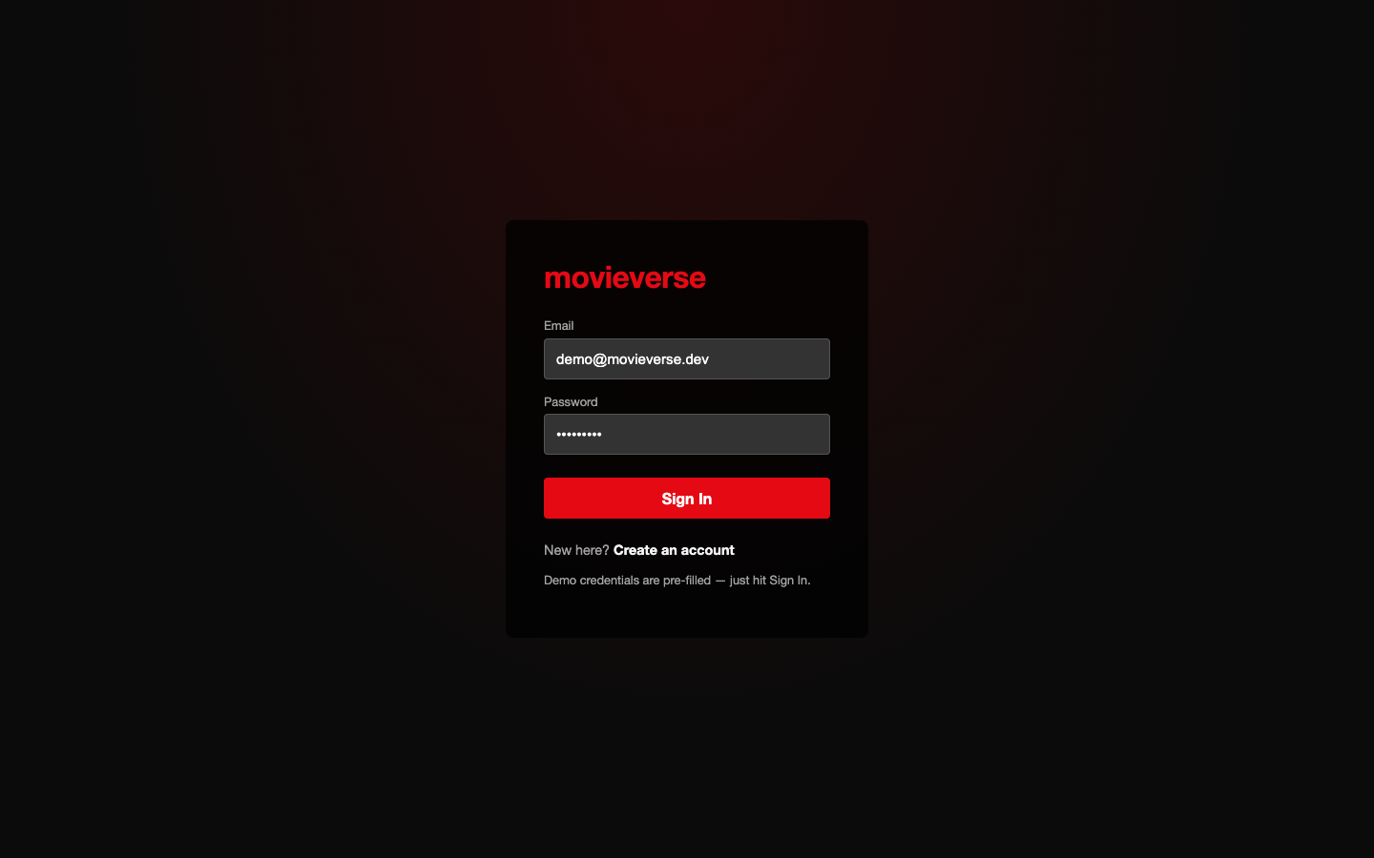 | 

Browse | Movie detail
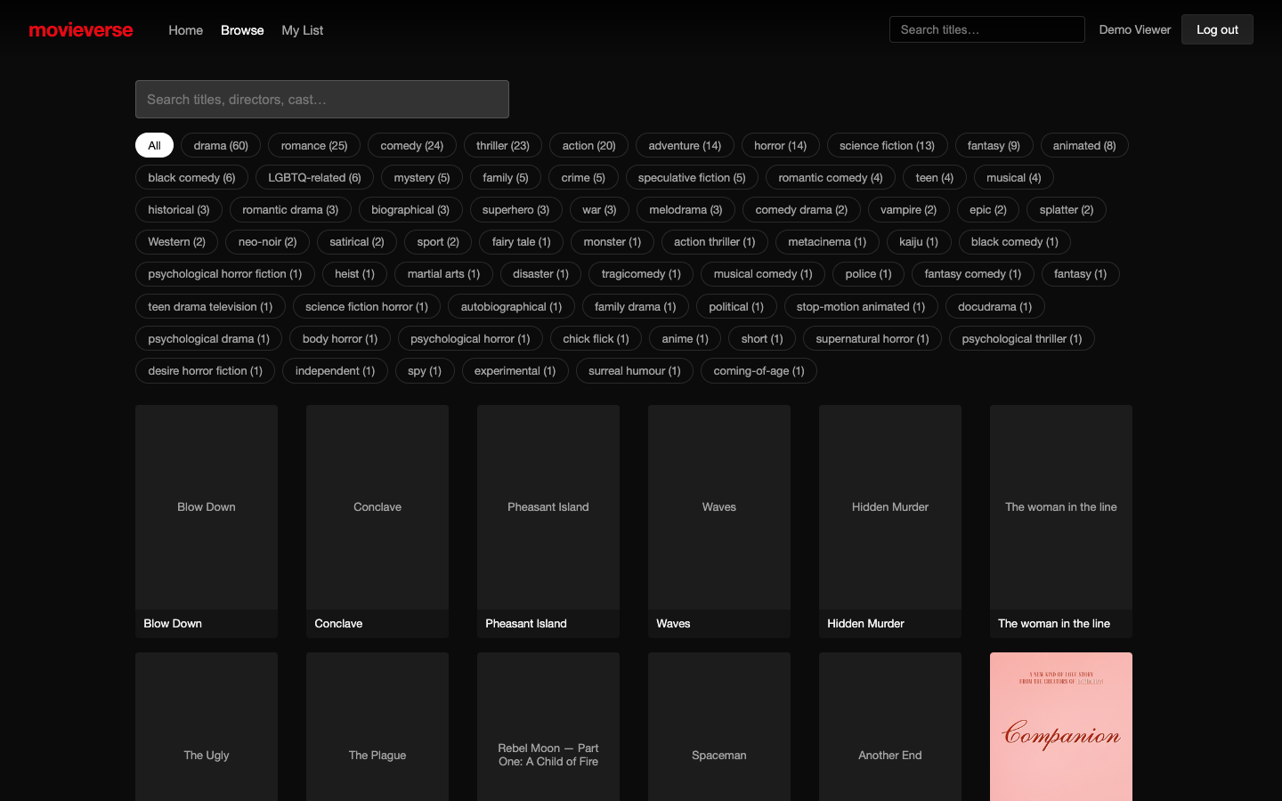 | 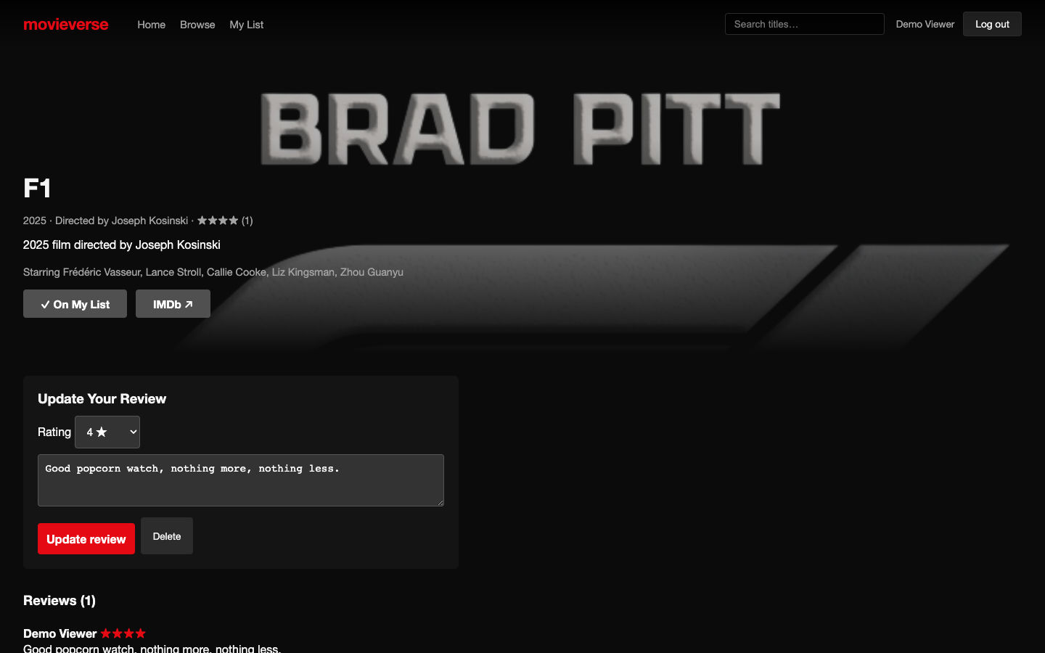

My List
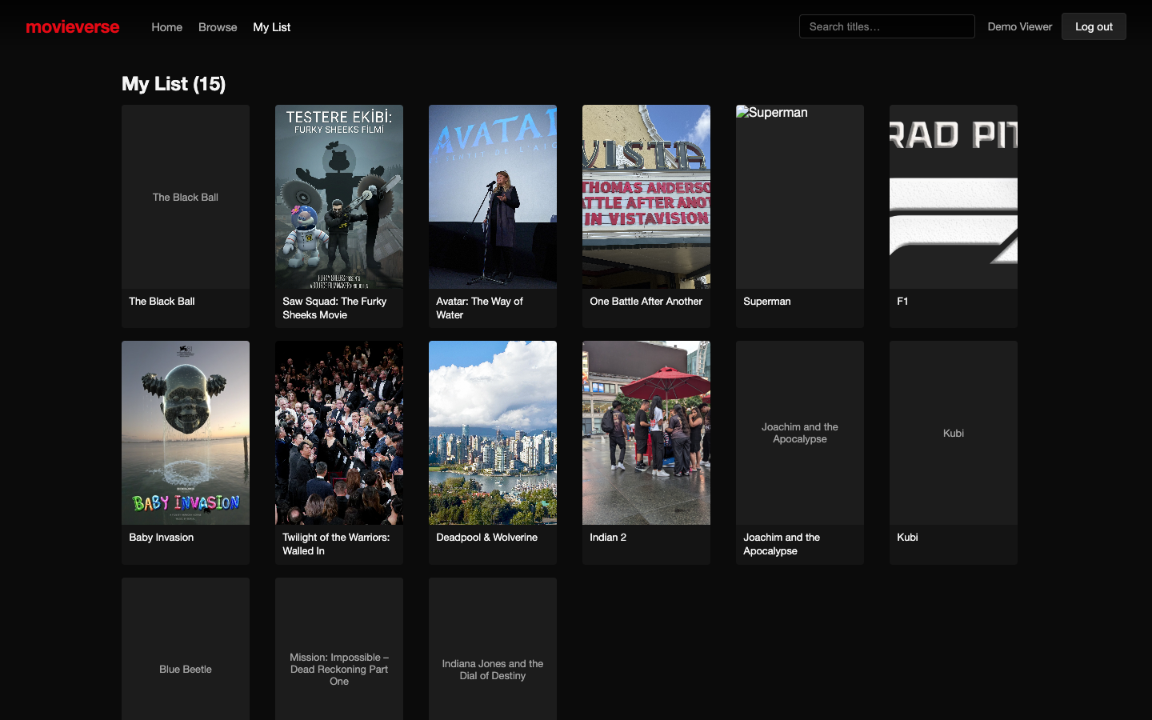

Mobile


Features
- Auth: JWT access token (in memory) + refresh token (httpOnly cookie, rotated on refresh) — same pattern as the other two repos in this portfolio
- Home: a rotating hero carousel and one horizontally-scrolling row per genre
- Browse: full-text search (title/director/cast) + genre facet filter, cursor-paginated
- Movie detail: description, cast, director, IMDb link, your rating, other users’ reviews, and “similar movies” computed live via a genre-overlap aggregation pipeline
- My List: a personal watchlist, add/remove from any movie card or detail page
- Reviews: one review per user per movie, edit-in-place, ownership enforced at the query level

Stack
Express 4 · Mongoose 8 · Zod · JWT · bcrypt — React 18 · Vite · React Router · Axios · hand-written CSS

Architecture
See docs/ARCHITECTURE.md and docs/DECISIONS.md — including a real bug the build caught (Wikimedia Commons rate-limiting hotlinked poster images, fixed by downloading them once at seed time instead).

API
Method | Route | Description
POST | /api/auth/register | /login | /refresh | /logout | Auth lifecycle
GET | /api/auth/me | Current user
GET | /api/movies/home | Hero list + genre rows
GET | /api/movies | Cursor-paginated search — q, genre, cursor, limit
GET | /api/movies/genres | Genres with counts
GET | /api/movies/:id | Detail + reviews + similar movies + your watchlist status
GET/POST/DELETE | /api/watchlist | Manage your watchlist
POST/DELETE | /api/reviews | Create/update/delete your review

Getting started
Requires Node 22 (see .nvmrc) and Docker.
nvm use
npm install
docker compose up -d # Mongo on host port 27020
npm run seed # imports Wikidata fixtures + downloads posters once (~2-10 min,
# depending on Commons' rate limiter; safely re-runnable/resumable)
npm run dev # API on :4004, client on :5176
Demo credentials (pre-filled on the login page): demo@movieverse.dev / Demo1234! (also seeded: alex@movieverse.dev, priya@movieverse.dev, and an admin — all Demo1234! / Admin123!).

Testing
docker compose up -d && npm run seed
npm run test:unit # Jest — fixture import/dedup, JWT signing
npm run test:integration # Jest + Supertest against the Docker Mongo, throwaway DB per suite
npm run test:e2e # Playwright — auto-starts the dev servers if not already running
npm test # runs all three, in that order
23 tests total: 7 unit, 9 integration, 7 end-to-end.

Regenerating screenshots
With the stack running and seeded:
npm run screenshots

Project structure
movieverse/
├── server/
│ ├── src/ Express API, Mongoose models, Wikidata import, poster downloader
│ └── public/posters gitignored, regenerated by `npm run seed`
├── client/ React + Vite frontend
├── e2e/ Playwright specs
├── docs/ architecture, decisions, screenshots
└── docker-compose.yml

