ProjectManagementWebsite
A real-time, multi-user project management platform built on the MERN stack, with an AI microservice that triages incoming tasks by predicted priority. Teams create rooms (“projects”), organize work across Pending / Active / Completed columns with live drag-and-drop, and chat in real time - all backed by MongoDB and Socket.IO.

Screenshots
Login | AI task triage
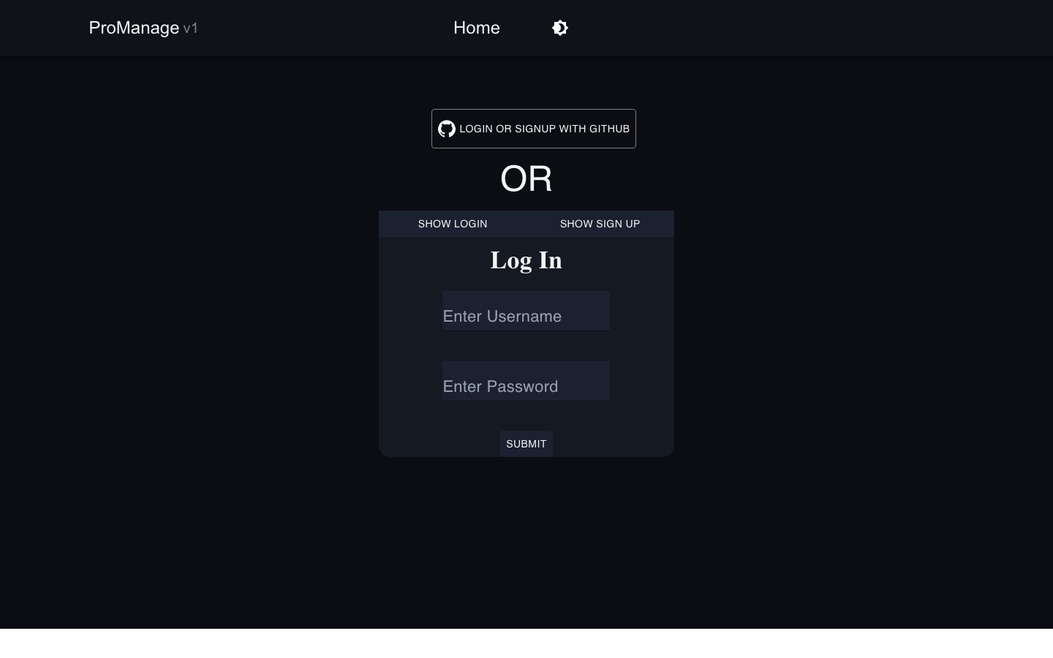 | 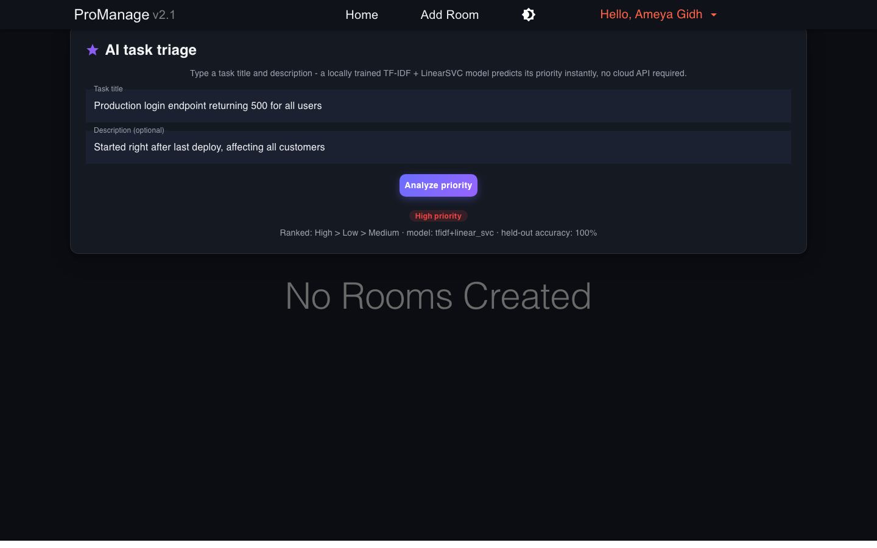

Home | Kanban board
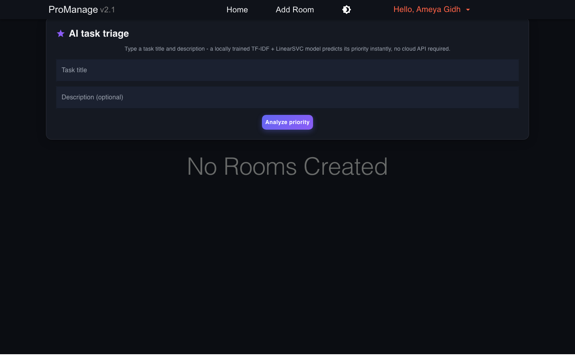 | 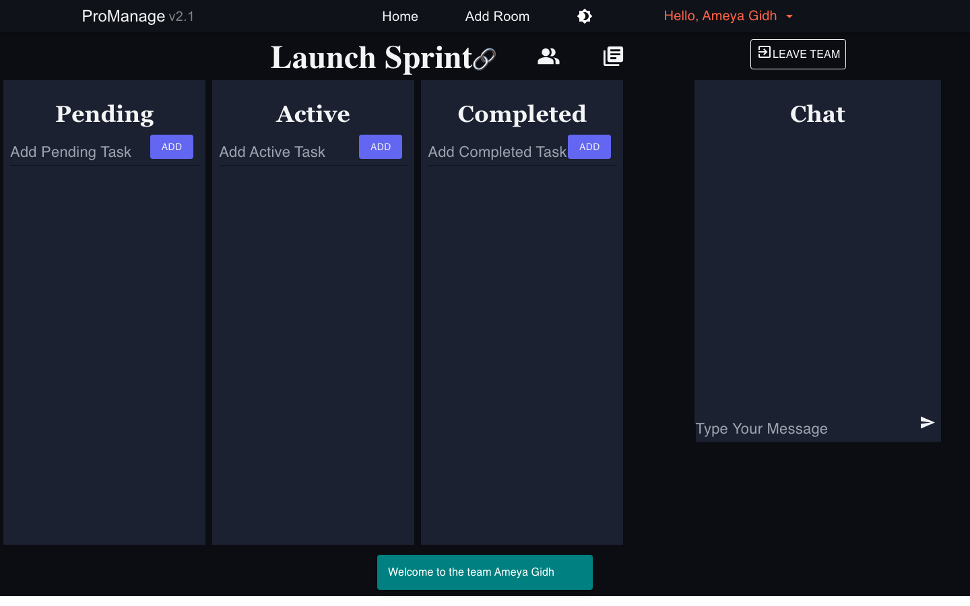
More in docs/screenshots/. See docs/TECHNICAL.md for the full architecture and AI pipeline write-up.

Features
- Real-time Kanban boards - drag tasks between Pending, Active, and Completed columns (react-beautiful-dnd), synced across all room members over Socket.IO.
- AI task triage - type a task title/description and get an instant priority prediction (High/Medium/Low) from a locally trained TF-IDF + LinearSVC model. No API key or network call required; see ProManageAI.
- Rooms with role-based access - room owners can promote/demote members and block users; GitHub-repo-backed rooms are auto-created for a user’s public repos.
- Live chat with priority flags - high-priority chat messages email other room members (optional, requires SMTP credentials).
- Dark/light theme - a shared design-token palette (src/contexts/ThemeContext.js) used across every screen.

Tech stack
Layer | Technology
Frontend | React 17, MUI 5 / Material-UI 4, react-beautiful-dnd, socket.io-client
Backend | Node.js, Express, Socket.IO, Mongoose
Database | MongoDB
AI service | Python, FastAPI, scikit-learn (TF-IDF + LinearSVC), optional LangChain
Testing/tooling | Playwright (screenshot generation)

Running it locally
Three processes: MongoDB, the Express/Socket.IO API, the AI microservice, and the React client.
# 1. MongoDB - point at any local or hosted instance
mongod --dbpath /path/to/data # or use an existing local mongod service
# 2. Backend
cd ProManageServer
cp .env.example .env # fill in MONGODB_URI at minimum
npm install
npm start # http://localhost:4000
# 3. AI microservice
cd ../ProManageAI
python3 -m venv .venv && source .venv/bin/activate
pip install fastapi "uvicorn[standard]" scikit-learn joblib
python train_triage.py # trains and saves model/triage_model.joblib
uvicorn main:app --port 8001 # http://localhost:8001
# 4. Frontend
cd ../ProManageClient
cp .env.example .env # REACT_APP_BACKEND_URL=http://localhost:4000
npm install
npm start # http://localhost:3000
Sign up with a username/password on the login screen (the GitHub-OAuth login path needs GITHUB_CLIENT_ID/GITHUB_SECRET_KEY, which are optional).

AI/ML pipeline
Feature | Model | Input | Output
Task auto-triage | TF-IDF (1-2 grams) + LinearSVC | task title + description | priority: High/Medium/Low, ranked by decision margin
Standup summary | Extractive term-frequency scoring, or LangChain + Claude/GPT if LLM_PROVIDER + an API key is set | recent room activity logs | 3-sentence summary
The triage model trains in seconds from ProManageAI/data/tasks_corpus.csv (364 labelled examples) and is checked into ProManageAI/model/triage_model.joblib, so no training step is required to run the app - train_triage.py is there for reproducing or extending it. See docs/TECHNICAL.md for the full pipeline and honest accuracy caveats.

Configuration
The database connection is configured via the MONGODB_URI environment variable - see .env.example. No credentials are hardcoded in source.

License
MIT License

