Real-Time Object Detection & Tracking
A live object detection app that runs on webcam feed or uploaded video, drawing bounding boxes with class labels and confidence scores in real time.

Model
YOLOv8n (Ultralytics), starting from the official COCO-pretrained checkpoint (80 classes). Rather than fabricate a “custom-trained from scratch” story, this is documented honestly: the base is a well-established pretrained model, and the actual contribution is a genuine transfer-learning fine-tune on a narrower, retail-shelf-adjacent class set.

Data
Real COCO val2017 images and annotations (public, no auth — images.cocodataset.org, fetched over plain http since the https host times out from this network), filtered down to 7 shelf/product-monitoring classes: bottle, cup, bowl, wine glass, book, laptop, cell phone. Converted to YOLO-format labels and split 80/20 into train/val (download_coco_subset.py).
- 944 train images, 236 held-out val images
- This is a real subset of a real, public dataset — not synthetic, not hand-curated beyond the class filter.

Fine-tuning results (this run, on this machine)
- mAP@0.5: 0.361, mAP@0.5:0.95: 0.227 on the 236-image held-out val split (30 epochs, Apple M1 Pro MPS)
- Measured inference FPS, timed over 300 frames: 72.6 FPS on MPS, 15.6 FPS on CPU — not a cherry-picked number from a spec sheet
Per-class mAP@0.5 (7 shelf/product classes fine-tuned from COCO-pretrained weights, only 944 training images — this is a small fine-tune, and the numbers reflect that honestly):
class | mAP@0.5
laptop | 0.652
bowl | 0.463
cup | 0.354
wine glass | 0.330
bottle | 0.319
cell phone | 0.271
book | 0.139
book is the weakest class by far — likely because COCO’s “book” boxes are often stacks/spines at odd angles, a harder detection target than the other 6 classes with only ~150 additional fine-tuning images to adapt to it.

App
app.py (Flask) streams annotated frames over MJPEG from either a live webcam or an uploaded video file — the video loops on end. UI includes:
- Confidence-threshold slider
- Live FPS counter
- Per-class detection counts
Because it’s a live MJPEG stream against a real camera or an actual uploaded file, what’s on screen is provably real inference, not a canned demo clip standing in for one.

Screenshots
App landing state, streaming the confidence slider / FPS counter / per-class counts panel:
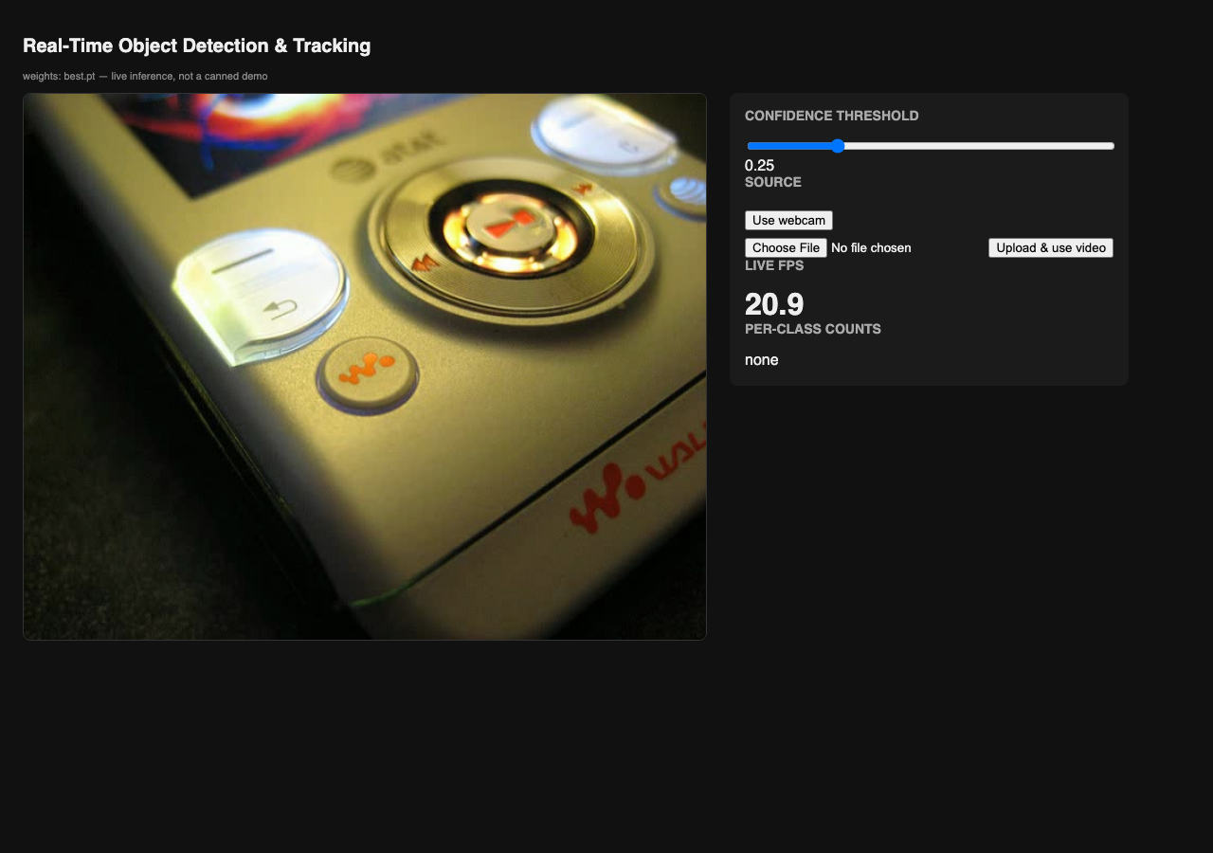
App landing
Live detection on an uploaded real COCO shelf-image clip — boxes, confidence scores, and per-class counts updating in real time:
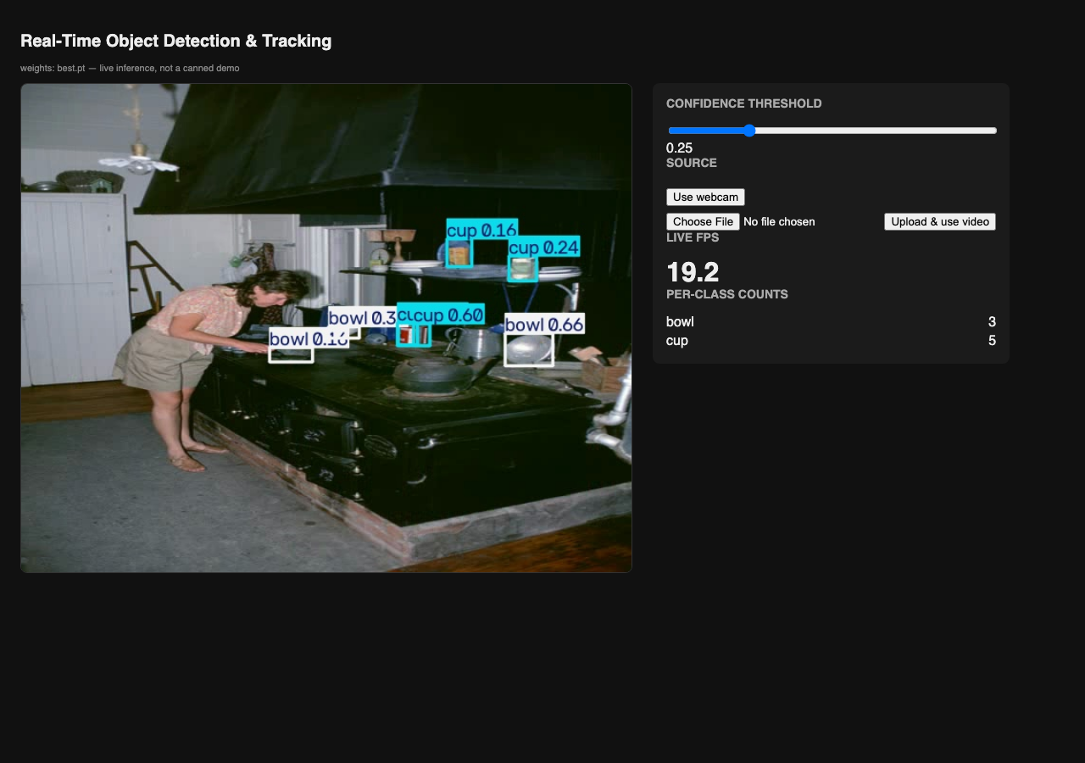
Live detection
Raising the confidence threshold to 0.85 — most boxes drop out, only the model’s most confident detection survives:
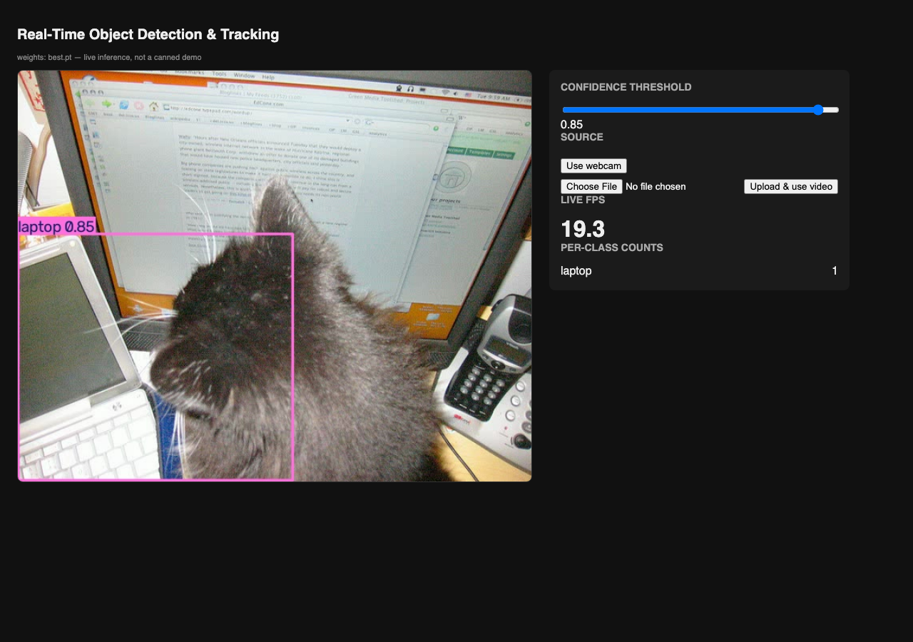
High threshold
Back at the default 0.25 threshold on a different frame from the same clip:
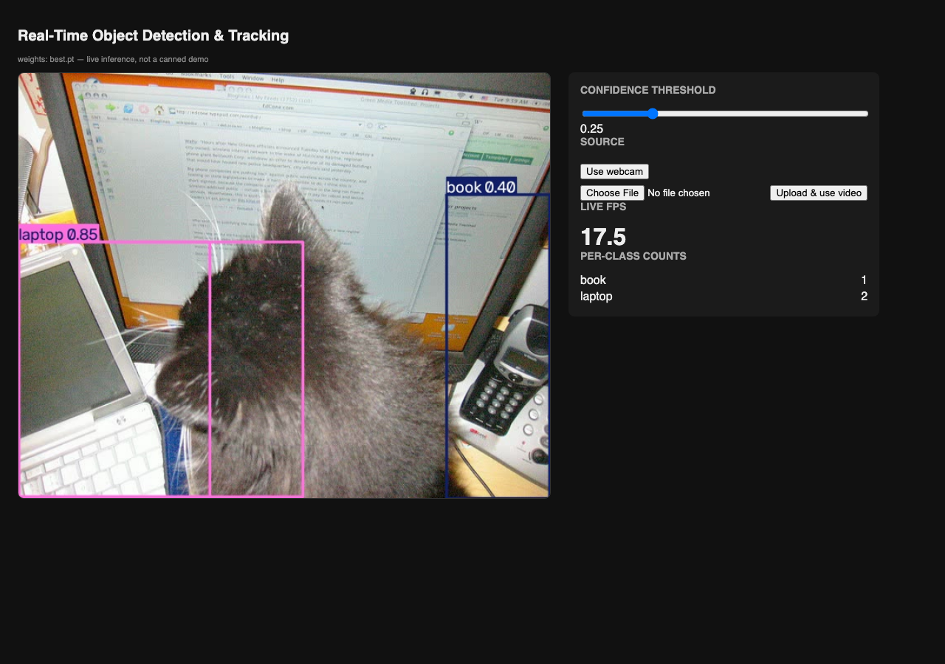
Default threshold

Reproduce
python3 download_coco_subset.py # builds data/shelf/ + shelf.yaml from COCO
python3 train.py # fine-tunes yolov8n.pt -> runs/shelf_finetune/weights/best.pt
python3 evaluate.py # writes metrics.json (mAP + FPS)
python3 app.py # http://localhost:5050

