E-Commerce Microservices Platform
A real Spring Boot microservices system with a genuine CI/CD pipeline: build → test → containerize → publish to a container registry → deploy to a live Kubernetes cluster and verify the deployment actually works — all inside GitHub Actions, all free (GHCR + Actions minutes are free for public repos, no paid cloud).

Architecture
┌─────────────────────┐
client ───────▶ │ gateway-service │ (Spring Cloud Gateway, :8080)
└──────────┬───────────┘
/api/inventory/** \ /api/orders/**
▼ ▼
┌─────────────────────┐ ┌─────────────────────┐
│ inventory-service │ │ order-service │
│ (Spring Boot, :8081)│◀──│ (Spring Boot, :8082)│
│ H2 in-memory DB │ │ H2 in-memory DB │
└─────────────────────┘ └─────────────────────┘
order-service calls inventory-service over HTTP to reserve stock before confirming an order — a real service-to-service call, not a stub. Each service is independently deployable, has its own database, and exposes Actuator health/readiness/liveness probes for Kubernetes.

Why this is a genuine CI/CD pipeline, not just three Spring Boot apps
Every stage below actually runs and is verified, not aspirational:
- Build + test (build-test job) — each service compiled and its real test suite run independently: 10 tests total across the three services, covering the inventory reservation logic, the order confirm/reject branching, and the gateway’s health endpoint.
- Containerize + publish (docker-publish job) — each service built into a multi-stage Docker image and pushed to GHCR (ghcr.io/ameyagidh/<service>), free for public repos, no credit card.
- Deploy + verify on real Kubernetes (k8s-deploy-verify job) — a real kind (Kubernetes-in-Docker) cluster is created inside the GitHub Actions runner, the three Deployments + Services are applied from k8s/, the rollout is awaited, and then the pipeline makes a real HTTP request through the gateway — lists products and places an order — to prove the cluster isn’t just “green,” it’s actually serving traffic correctly end to end.
See a real completed run here: Actions run #1 — all 7 jobs green, total duration 4m34s, k8s-deploy-verify (the real kind cluster deploy + live HTTP verification) completed in 3m36s.

Local development
# build + test everything
mvn test
# run all three services together with Docker Compose
docker-compose up --build
# gateway: http://localhost:8080
# inventory: http://localhost:8081
# order: http://localhost:8082
Try it:
curl http://localhost:8080/api/inventory/products
curl -X POST http://localhost:8080/api/orders \
-H "Content-Type: application/json" \
-d '{"sku":"SKU-WIDGET-001","quantity":5}'

Screenshots
All 10 tests passing | Docker images built
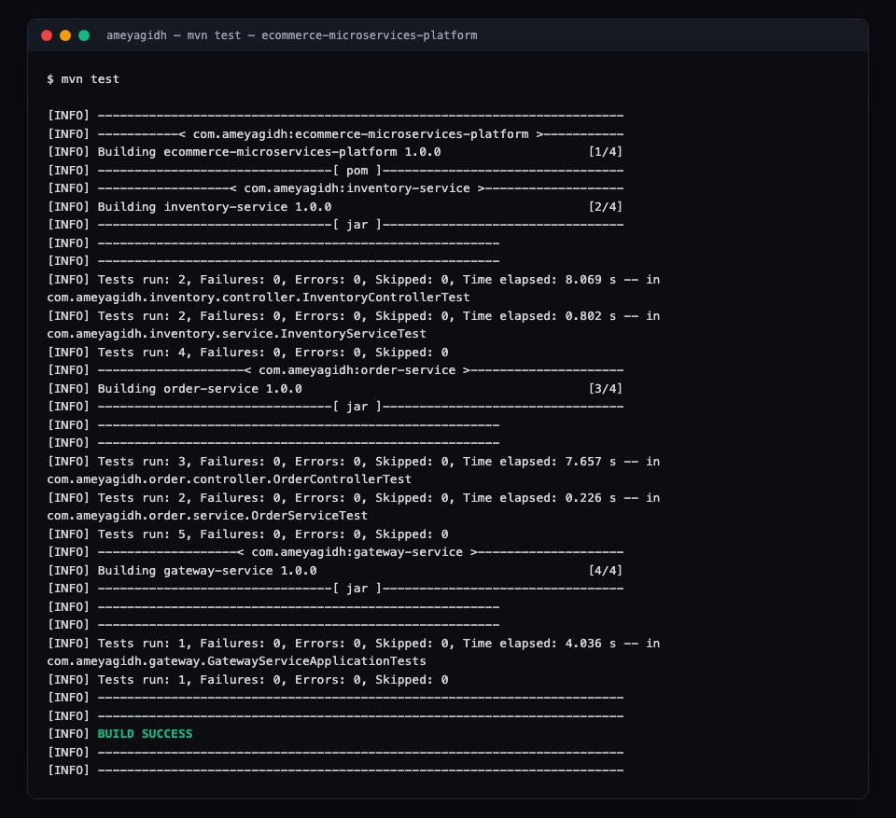 | 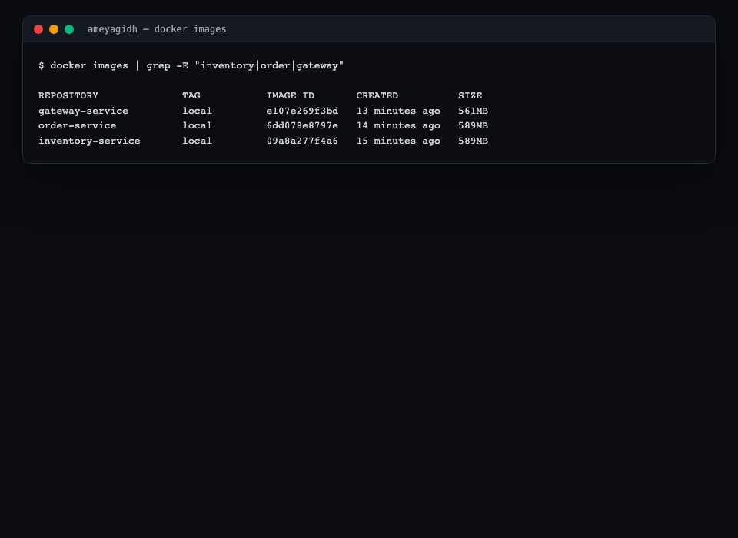

GitHub Actions — all 7 jobs green
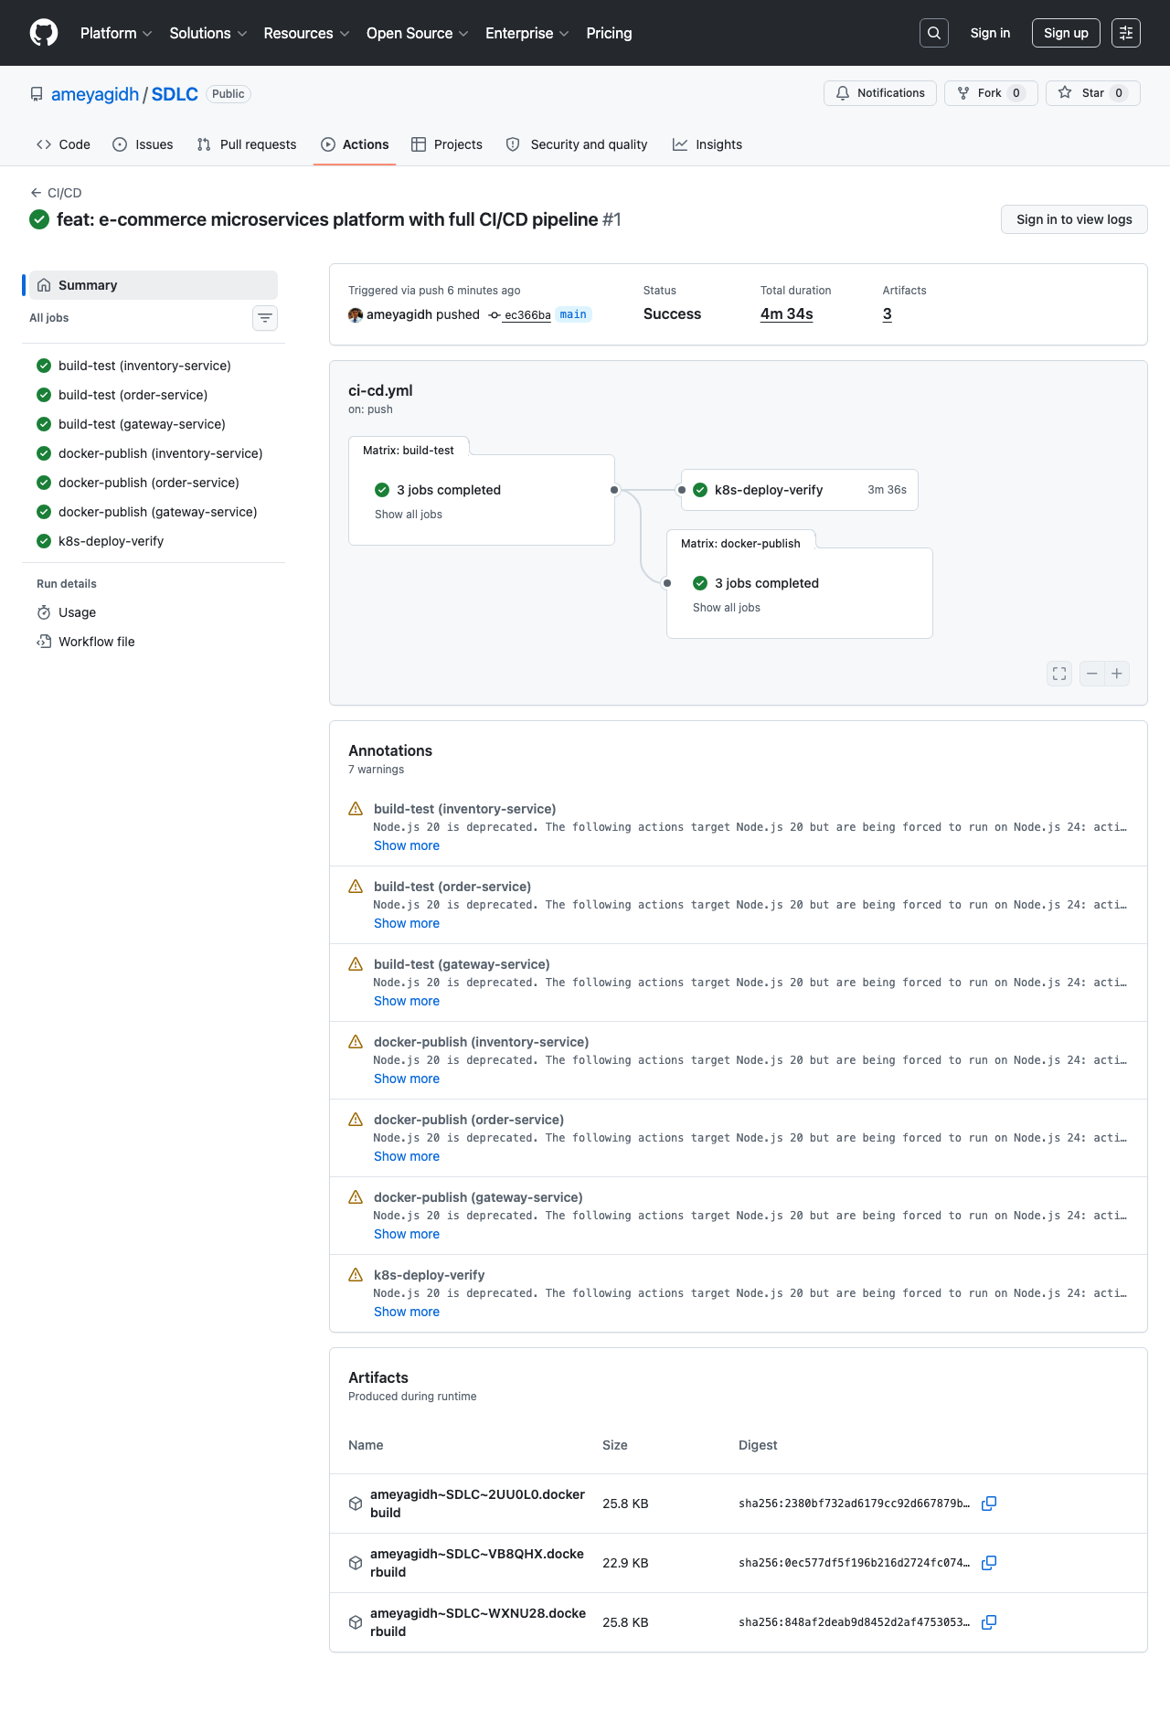
More in docs/screenshots/.

Tech stack
Layer | Tech
Services | Spring Boot 3.3, Java 17, Maven (multi-module reactor)
Gateway | Spring Cloud Gateway
Data | Spring Data JPA + H2 (in-memory, per-service)
Containers | Docker (multi-stage builds)
Registry | GitHub Container Registry (GHCR)
Orchestration | Kubernetes manifests, deployed to kind in CI
CI/CD | GitHub Actions

What “hosted free” means here, precisely
Free, credit-card-free Kubernetes with a permanently-live public URL doesn’t really exist. Rather than fake it, here’s exactly what’s real and what isn’t:
- Real and verified on every push: the Docker images, the GHCR publish, and the Kubernetes deployment — the k8s-deploy-verify job creates an actual cluster and actually serves a real request through it.
- Not continuously hosted: the kind cluster only exists for the duration of the CI job. There’s no 24/7 public URL for this project (see docker-compose.yml for the always-available local-run path).
This is a deliberate, stated tradeoff, not a hidden gap — see docs/TECHNICAL.md for the full reasoning.

Project structure
ecommerce-microservices-platform/
├── pom.xml # parent reactor POM
├── inventory-service/ # stock management
├── order-service/ # order placement, calls inventory-service
├── gateway-service/ # Spring Cloud Gateway, single entry point
├── k8s/ # Deployment + Service manifests
├── docker-compose.yml # local multi-service run
├── .github/workflows/ci-cd.yml # build → test → publish → deploy → verify
└── docs/
├── TECHNICAL.md
└── screenshots/

Docs
Full pipeline design, the real bugs found while building this (a reserved SQL keyword, a Spring MVC parameter-name reflection gotcha, a Docker base-image platform mismatch), and the honest local-vs-CI verification story: docs/TECHNICAL.md.

