📚 openshelf
Book discovery, shelves, reviews, and a social graph. MERN full-stack portfolio project — faceted full-text search with cursor pagination, MongoDB aggregation-pipeline recommendations, a follow graph with an activity feed, avatar uploads, and a published OpenAPI spec.
The catalog is real: 117 books imported from the Open Library public API (captured as committed fixtures — see docs/DECISIONS.md for why), with real covers, authors, and subjects. Every screenshot below was captured against the running app.

Screenshots
Login | Browse & search
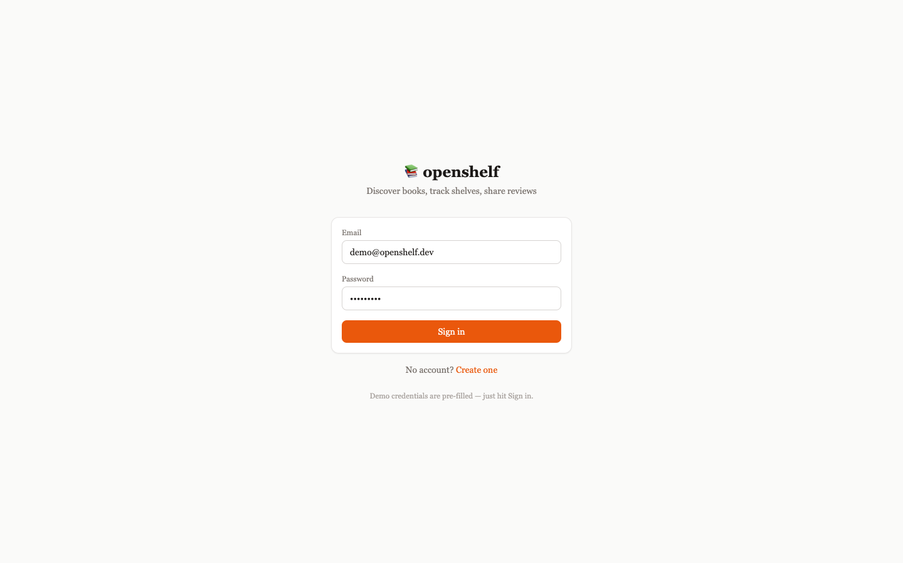 | 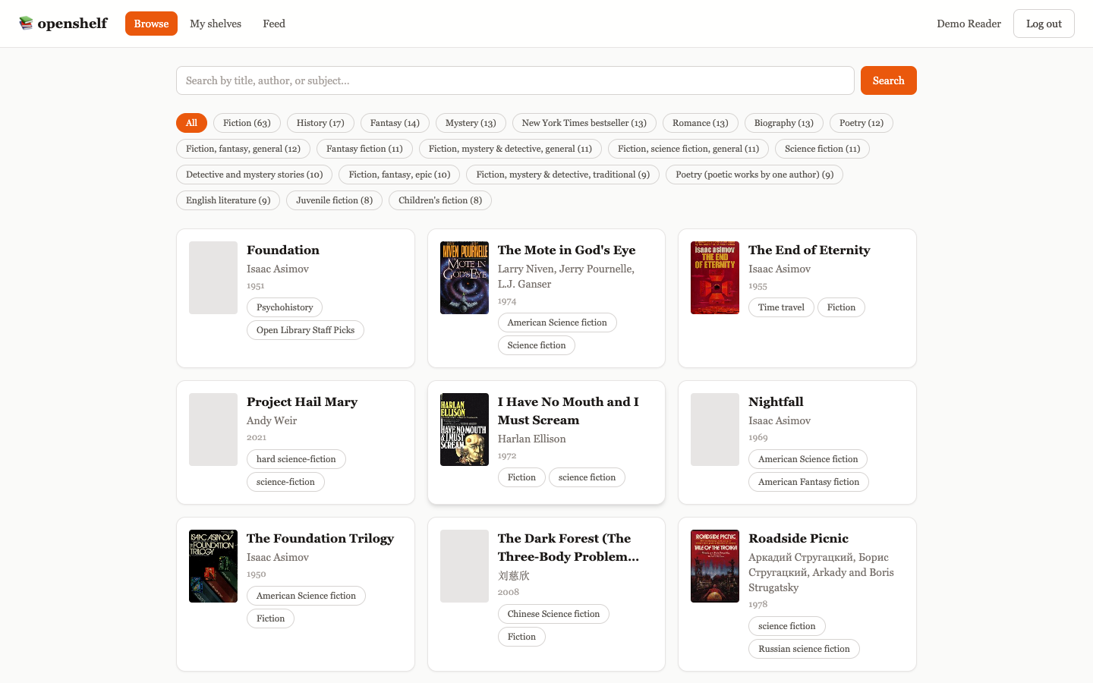

Book detail | My shelves
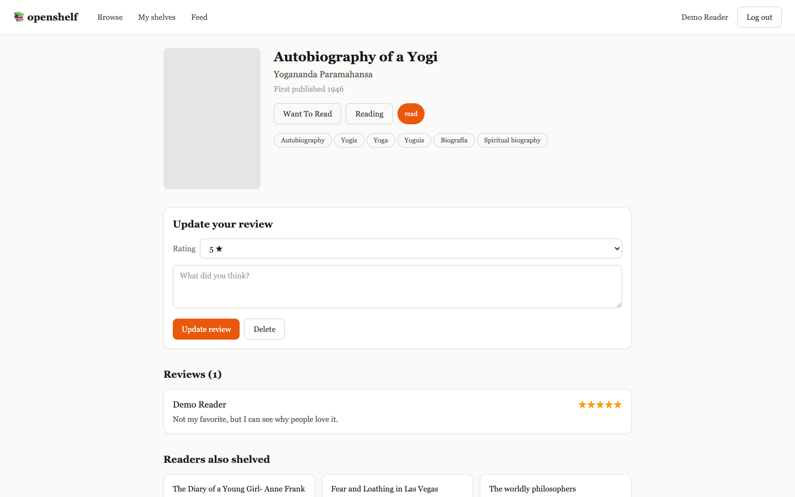 | 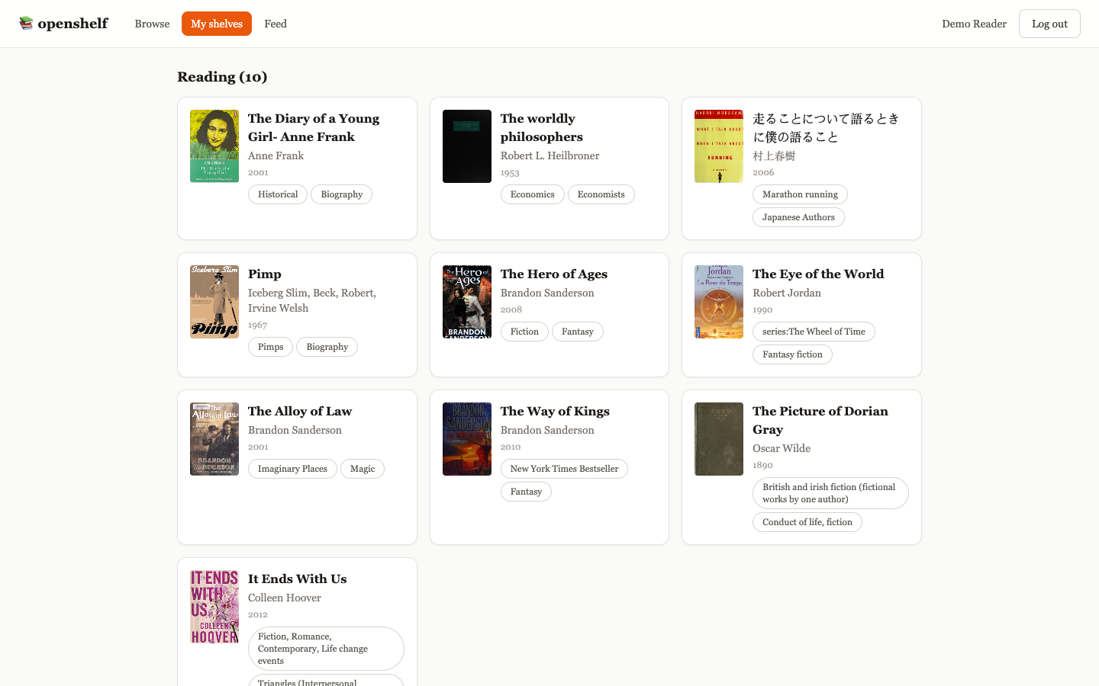

Activity feed | API docs (Swagger)
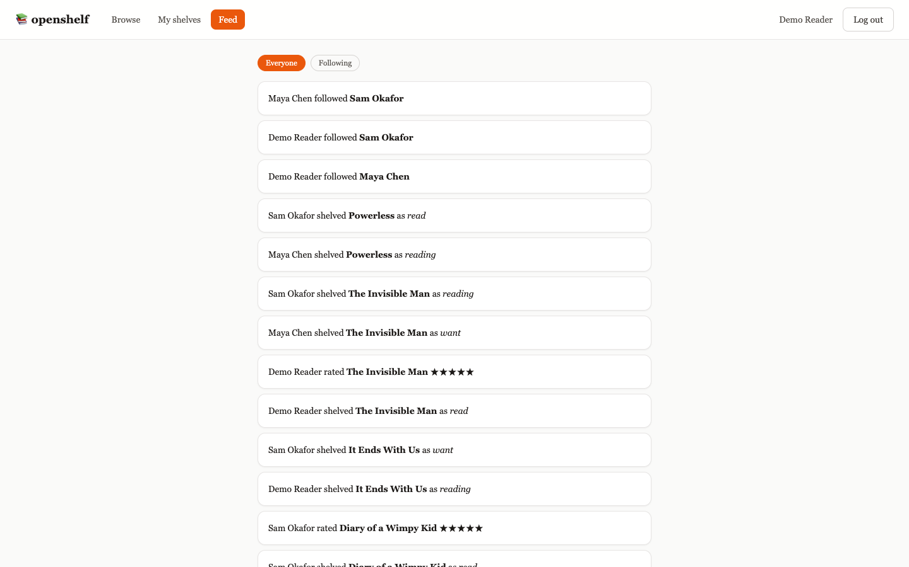 | 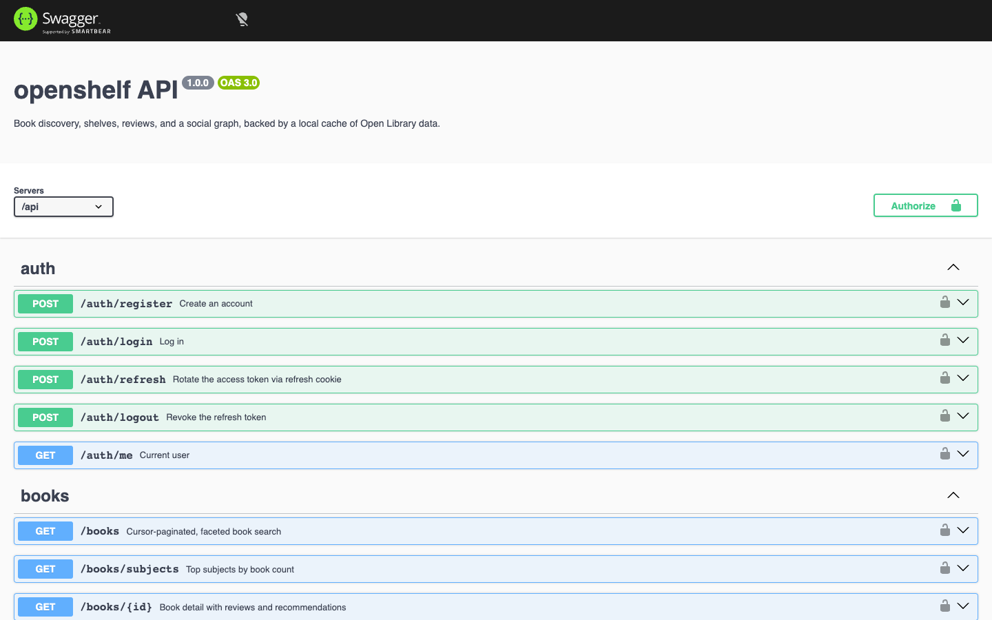

Mobile
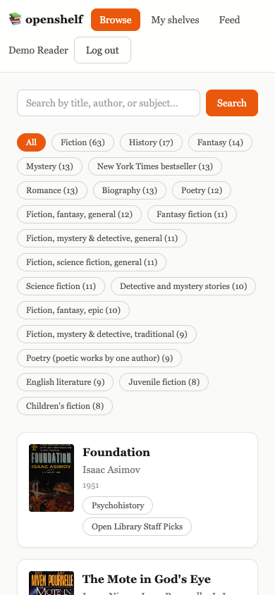

Features
- Auth: JWT access token (in memory) + refresh token (httpOnly cookie, rotated on refresh), same pattern as the pulseboard repo
- Search: full-text search (title/author/subject) over a MongoDB text index, combined with subject and publish-year facets, paginated with an _id-based cursor (not offset/skip)
- Shelves: want-to-read / reading / read, one entry per (user, book), moving shelves upserts rather than duplicating — with optimistic UI updates via TanStack Query
- Reviews: one review per user per book (re-reviewing edits in place), ownership enforced at the query level so you can never delete or see edit controls for someone else’s review
- Recommendations: “readers also shelved” computed live via a MongoDB aggregation pipeline — no precomputed table, no external ML service
- Social graph: follow/unfollow, follower/following lists, public profiles
- Activity feed: global or following-only, covering shelving, reviewing, and following events
- Avatar uploads: multer-backed multipart upload with type/size validation
- API docs: a full OpenAPI 3.0 spec served at /api/docs via Swagger UI

Stack
Express 4 · Mongoose 8 · Zod · JWT · bcrypt · multer · swagger-ui-express — React 18 · Vite · React Router · TanStack Query · Tailwind CSS · Axios

Architecture
See docs/ARCHITECTURE.md for the request-flow diagram and docs/DECISIONS.md for the reasoning behind cursor pagination, the live-aggregation recommender, and the denormalized activity feed.

API
Full interactive docs at /api/docs once running. Summary:
Method | Route | Auth | Description
POST | /api/auth/register | /login | /refresh | /logout | mixed | Auth lifecycle
GET | /api/auth/me | user | Current user
GET | /api/books | user | Faceted, cursor-paginated search
GET | /api/books/subjects | user | Top subjects by book count
GET | /api/books/:id | user | Detail + reviews + recommendations + your shelf status
GET/POST/DELETE | /api/shelf | user | Manage your shelves
POST/DELETE | /api/reviews | user | Create/update/delete your review
GET | /api/users/:id | user | Public profile + follow counts
POST | /api/users/me/avatar | user | Upload an avatar
POST/DELETE | /api/users/:userId/follow | user | Follow / unfollow
GET | /api/activity/feed | user | Global or following-scoped feed

Getting started
Requires Node 22 (see .nvmrc) and Docker.
nvm use
npm install # installs both workspaces (server + client)
docker compose up -d # Mongo on host port 27018 (kept off 27017 so this can run
# alongside pulseboard's own Mongo container)
npm run seed # imports the committed Open Library fixtures
npm run dev # API on :4002, client on :5175
Demo credentials (also pre-filled on the login page):
User | Email | Password
Demo Reader | demo@openshelf.dev | Demo1234!
Maya Chen | maya@openshelf.dev | Demo1234!
Sam Okafor | sam@openshelf.dev | Demo1234!
Admin | admin@openshelf.dev | Admin123!
Demo Reader already follows Maya and Sam, and has books shelved across all three statuses with a few reviews — the feed and recommendations pages aren’t empty on first login.

Testing
docker compose up -d && npm run seed # integration + e2e both need Mongo up and seeded
npm run test:unit # Jest — pure logic (fixture import/dedup, JWT signing)
npm run test:integration # Jest + Supertest against the Docker Mongo, throwaway DB per suite
npm run test:e2e # Playwright — auto-starts the API + client dev servers if not running
npm test # runs all three, in that order
25 tests total: 5 unit, 12 integration, 8 end-to-end.

Regenerating screenshots
With the stack running and seeded:
npm run screenshots

Project structure
openshelf/
├── server/ Express API, Mongoose models, OpenAPI spec, tests
├── client/ React + Vite + TanStack Query frontend
├── e2e/ Playwright end-to-end specs
├── scripts/ screenshots.mjs
├── docs/ architecture, decisions, screenshots
└── docker-compose.yml

