Cameras Screen
  - Purpose
    - This screen manages the information of different cameras.
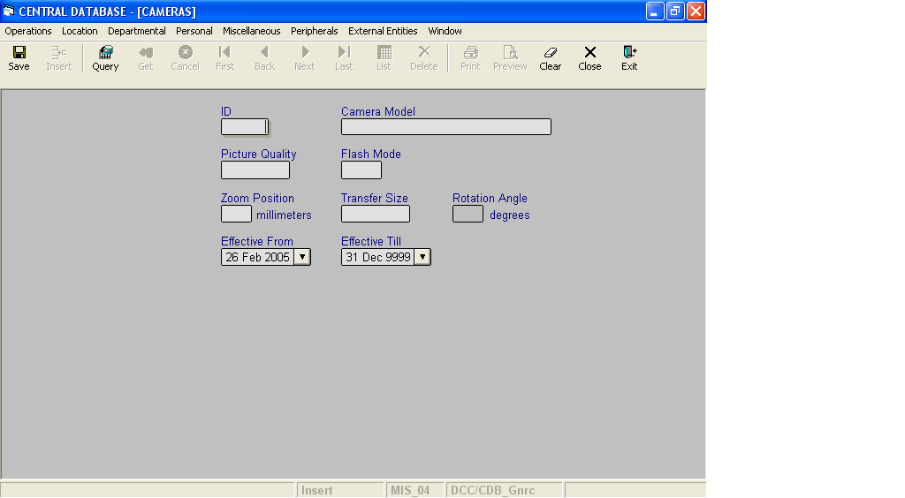

Layout as seen on opening of the Screen
  - Events associated
None
  - Modes
    - It will start in Insert mode.
    - It supports Insert, Query, Retrieve, Browse and List modes.
  - Field specifications
 | Type | Length | Optional | Insert Mode | Query Mode | BrowseMode
ID | camera_id | 2 | N | Allow | Allow | Display
Camera Model | varchar | 30 | N | Allow | Allow | Allow
Picture Quality | varchar | 10 | N | Allow | Allow | Allow
Flash Mode | char | 5 | N | Allow | Allow | Allow
Zoom Position | smallInt | 2 | N | Allow | Allow | Allow
Transfer Size | varchar | 10 | N | Allow | Allow | Allow
Rotation Angle | smallInt | 2 | Y | Allow | Allow | Allow
Effective From | datetime | 8 | N | Allow | Allow | Allow
Effective Till | datetime | 8 | N | Allow | Allow | Allow
  - Fields
    - ID
      - This is the camera ID, which uniquely identifies all the cameras.
    - Camera Model
      - This is the model of the camera.
      - It is user defined. It can be changed in Browse Mode.
      - Camera Model is uniquely defined in the database.
    - Picture Quality
      - This is the quality of the picture taken from the camera.
      - The quality of the picture can be changed in Browse Mode.
      - The quality of the picture can be Good, Better or Best.
iv. Flash Mode
a) This is the mode of the flash of the camera.
b) The Flash mode can be changed in Browse Mode.
c) The Flash Mode of the camera can be On, Off or Auto.
v. Zoom Position
a) It is the distance to which the camera has to be zoomed in millimetres.
b) The Zoom Position can be changed in Browse Mode.
c) The Zoom Position of the camera can be in between 70 and 200.
vi. Transfer Size
a) It is the size of the picture to be transferred like 320x240, 640x480, 800x600, etc.
b) The transfer size can be changed in Browse Mode.

vii. Rotation Angle
a) It is the angle by which the picture is to be rotated.
b) The Rotation angle can be changed in Browse Mode.
c) The Rotation angle of the camera can be 90, 180 or 270.
d) If the picture is not to be rotated, it is NOT to be specified.
viii. Effective From
a) This is the date since which a camera is effective.
b) By default, the system will display the current date in Insert Mode.
c) Normally, it should not be a future date. This is the recommendation. System will display a warning, if future date is specified.
      - It cannot be later than the date specified in Effective Till.
ix. Effective Till
- This is the date till which a camera is effective.
- By default, the system will display 31-Dec-9999 in Insert Mode.
- Normally, it should not be a past date.
- It cannot be earlier than the date specified in Effective From.

  - Action Buttons
None
  - Users / User Roles
CDB_Gnrc user is permitted to insert, update, delete and select camera.
  - Other Considerations
None

