Countries Screen
  - Purpose
    - This screen manages the information of different countries.
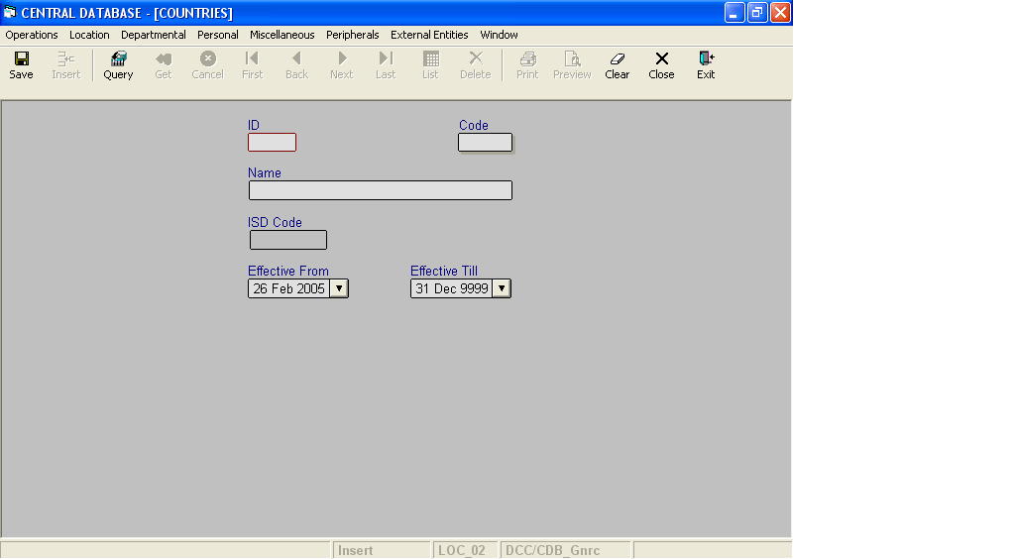

Layout as seen on opening of the Screen
  - Events associated
None
  - Modes
    - It will start in Insert mode.
    - It supports Insert, Query, Retrieve, Browse, List, New, Update and Reference modes.
  - Field specifications
    - Simple Fields

 | Type | Length | Optional | Insert Mode | Query Mode | BrowseMode
ID | country_id | 2 | N | N.A. | Allow | Display
Code | char | 5 | N | Allow | Allow | Allow
Name | varchar | 35 | N | Allow | Allow | Allow
ISD Code | varchar | 10 | Y | Allow | Allow | Allow
Effective From | datetime | 8 | N | Allow | Allow | Allow
Effective Till | datetime | 8 | N | Allow | Allow | Allow
    - Tabular Field Items

 | Type | Insert Mode | Query Mode | Browse Mode
State Code | Key | N.A | N.A | Display
State Name | Key | N.A | N.A | Display
State ID | Key | N.A | N.A | Display

e. Fields
i. ID
      - This is the Country ID, which uniquely identifies all the countries.
      - This field will be automatically generated by the system.
      - The user will be informed of the generated ID as part of the message, which will be shown on successful saving of information in Insert Mode.
ii. Code
a) This is the code of the Country.
b) It is user defined. It can be changed in Browse and Update Modes.
c) Code of the country is uniquely defined in the database.
    - Name
      - This is the name of the Country.
      - The name can be changed in Browse and Update Modes.
      - Name of the country is uniquely defined in the database.
    - ISD Code
a) This is the ISD Code of the Country.
b) The ISD Code can be changed in Browse and Update Modes.
c) ISD code should contain only digits. It has been kept as varchar so that like searches can be made.
    - Effective From
      - This is the date since which a country is effective.
      - By default, the system will display the current date in Insert Mode.
      - Normally, it should not be a future date. This is the recommendation. System will display a warning, if future date is specified.
      - It cannot be later than the date specified in Effective Till.
    - Effective Till
      - This is the date till which a country is effective.
      - By default, the system will display 31-Dec-9999 in Insert Mode.
      - Normally, it should not be a past date.
      - It cannot be earlier than the date specified in Effective From.

f. Tabular Field Items
i. State Code
a) It is the code of the State, which is a part of the country.
ii. State Name
a) It is the name of the State, which is a part of the country.
iii. State ID
a) It is the ID of the State, which is a part of the country.
g. Action Buttons
None
i. Users / User Roles
CDB_Gnrc user is permitted to insert, update, delete and select country.
j. Other Considerations
None

