Departments Screen
  - Purpose
    - This screen manages the information of different departments.
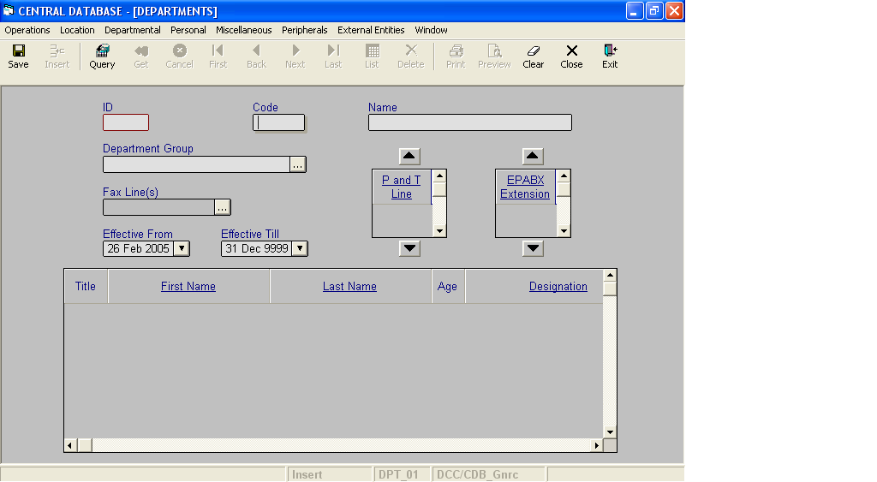

Layout as seen on opening of the Screen
  - Events associated
None
  - Modes
    - It will start in Insert mode.
    - It supports Insert, Query, Retrieve, Browse and List modes.
  - Field specifications
i. Simple Fields
 | Type | Length | Optional | Insert Mode | Query Mode | BrowseMode
ID | department_id | 2 | N | N.A. | Allow | Display
Code | char | 5 | N | Allow | Allow | Allow
Name | varchar | 35 | N | Allow | Allow | Allow
Department Group | Key |  | N | Allow | Allow | Allow
Fax Line(s) | Key |  | Y | Allow | Allow | Allow
P and T line | Key |  | Y | Allow | Allow | Allow
EPABX Extension | Key |  | Y | Allow | Allow | Allow
Effective From | datetime | 8 | N | Allow | Allow | Allow
Effective Till | datetime | 8 | N | Allow | Allow | Allow
ii. Tabular Field Items

 | Type | Insert Mode | Query Mode | Browse Mode
Title | person_title | Display | Allow | Display
First Name | Key | Allow | Allow | Display
Last Name | Key | Allow | Allow | Display
Age | number | Display | Allow | Display
Designation | Key | Allow | Allow | Display
Effective From | datetime | Display | Allow | Display
Effective Till | datetime | Display | Allow | Display
Person ID | person_id | Display | Allow | Display

  - Simple Fields
    - ID
      - This is the department ID, which uniquely identifies all the departments.
      - This field will be automatically generated by the system.
      - The user will be informed of the generated ID as part of the message which will be shown on successful saving of information in Insert Mode.
    - Code
      - This is the code of the Department.
      - It is user defined. It can be changed in Browse Mode.
      - Code of the department is uniquely defined in the database.
    - Name
      - This is the name of the Department.
      - The name can be changed in Browse Mode.
      - Name of the department is uniquely defined in the database.
    - Department Group
a) This field specifies the department group to which the department belongs.
v. Fax Line(s)
a) This field specifies the telephone number of the Department.
vi. Effective From
      - This is the date since which a department is effective.
      - By default, the system will display the current date in Insert Mode.
      - Normally, it should not be a future date. This is the recommendation. System will display a warning, if future date is specified.
      - It cannot be later than the date specified in Effective Till.
vii. Effective Till
      - This is the date till which a department is effective.
      - By default, the system will display 31-Dec-9999 in Insert Mode.
      - Normally, it should not be a past date.
      - It cannot be earlier than the date specified in Effective From.

  - Tabular Fields for Persons spread
i. Title
a) It is the title of the person, who is associated with the department.
b) The value of this field is filled based on the selection of First name or Last name.
ii. First Name
- It is the first name of the person, who is associated with the department.
iii. Last Name
      - It is the last name of the person, who is associated with the department.
- Age
  - It is the age of the person, who is associated with the department.
  - The value of this field is filled based on the selection of First name or Last name.
- Designation
a) It is the designation of the person, who is associated with the department.
- Effective From
  - It is the date from which the person associated with the department is effective.
  - The value of this field is filled based on the selection of Designation.
vii. Effective Till
- It is the date till which the person associated with the department is effective.
- The value of this field is filled based on the selection of Designation.
viii. Person ID
- It is the ID of the person, who is associated with the department.
- The value of this field is filled based on the selection of First name or Last name.

  - Tabular Fields for P and T Lines spread
i. P and T line
a) This field specifies the telephone number of the Department.

  - Tabular Fields for EPABX spread
i. EPABX Extension
a) This field specifies the extension number of the Department.

  - Lookup or Help
Field | Items of Information as will be shown | Remarks
Department Group | Name, Code | Only active Department Groups will be shown.
Fax Line(s) | Fax Line | Only active P and T lines will be shown.
P and T line(P and T Lines Spread ) | Fax Line | Only active P and T lines will be shown.
EPABX Extension(EPABX Spread) | EPABX Extension | Only active EPABX lines will be shown.
First Name (Persons Spread) | First Name, Middle Name, Last Name | Only active Persons will be shown.
Last Name (Persons Spread) | Last Name, First Name, Middle Name | Only active Persons will be shown.
Designation (Persons Spread) | Designation Name | Only active Designations will be shown.

  - Action Buttons
None
  - Users / User Roles
CDB_Gnrc user is permitted to insert, update, delete and select Departments.
  - Other Considerations
- User can change the order in which the P and Lines and EPABX extension appear on the screen by selecting a P and T line or EPABX line respectively and then clicking on the buttons marked ▲ & ▼.

