Designations Screen
  - Purpose
    - This screen manages the information of different designations.
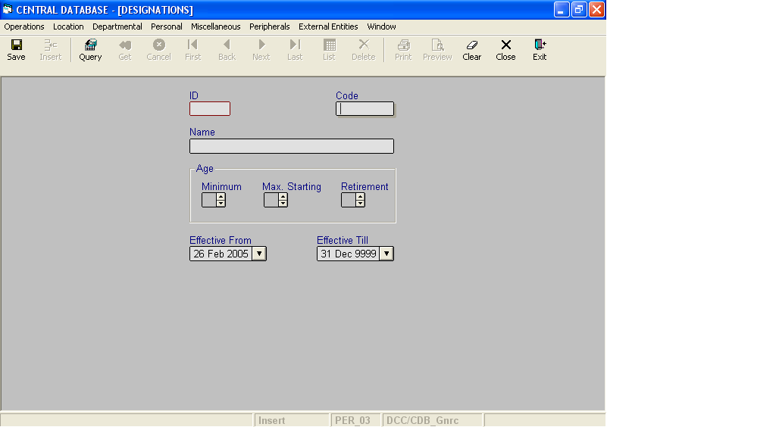

Layout as seen on opening of the Screen
  - Events associated
None
  - Modes
    - It will start in Insert mode.
    - It supports Insert, Query, Retrieve, Browse and List modes.

  - Field specifications
 | Type | Length | Optional | Insert Mode | Query Mode | BrowseMode
ID | designation_id | 2 | N | N.A. | Allow | Display
Code | char | 5 | N | Allow | Allow | Allow
Name | designation_nm | 35 | N | Allow | Allow | Allow
Minimum | age | 1 | Y | Allow | Allow | Allow
Max. Starting | age | 1 | Y | Allow | Allow | Allow
Retirement | age | 1 | Y | Allow | Allow | Allow
Effective From | datetime | 8 | N | Allow | Allow | Allow
Effective Till | datetime | 8 | N | Allow | Allow | Allow
  - Fields
    - ID
      - This is the Designation ID, which uniquely identifies all the designations.
      - This field will be automatically generated by the system.
      - The user will be informed of the generated ID as part of the message which will be shown on successful saving of information in Insert Mode.
    - Code
      - This is the code of the Designation.
      - It is user defined. It can be changed in Browse Mode.
      - Code for the Designation is uniquely defined in the database.
    - Name
      - This is the name of the Designation.
      - The name can be changed in Browse Mode.
      - Name of the designation is uniquely defined in the database.
    - Minimum
a) This is the minimum age that a person should have for this designation.
b) The minimum age should be less than the maximum age for the designation.
c) The minimum age for the designation can be changed in Browse Mode.
    - Max. Starting
a) This is the maximum age that a person can have for this designation.
b) The maximum age should be less than the retirement age and greater than the minimum age for the designation.
c) The maximum age for the designation can be changed in Browse Mode.
vi. Retirement
a) This is the age after which a person will be retired from the designation.
b) It can not be less than the maximum age for the designation.
c) The retirement age for the designation can be changed in Browse Mode.
    - Effective From
      - This is the date since which a designation is effective.
      - By default, the system will display the current date in Insert Mode.
      - Normally, it should not be a future date. This is the recommendation. System will display a warning, if future date is specified.
      - It cannot be later than the date specified in Effective Till.
    - Effective Till
      - This is the date till which a designation is effective.
      - By default, the system will display 31-Dec-9999 in Insert Mode.
      - Normally, it should not be a past date.
      - It cannot be earlier than the date specified in Effective From.

  - Action Buttons
None
  - Users / User Roles
CDB_Gnrc user is permitted to insert, update, delete and select Designation.
  - Other Considerations
None

