Occupations Screen
  - Purpose
    - This screen manages the information of different Occupations.
    - This table stores the occupations like Self-Employed, Business, Service, House-wife, Retired, Student, etc.
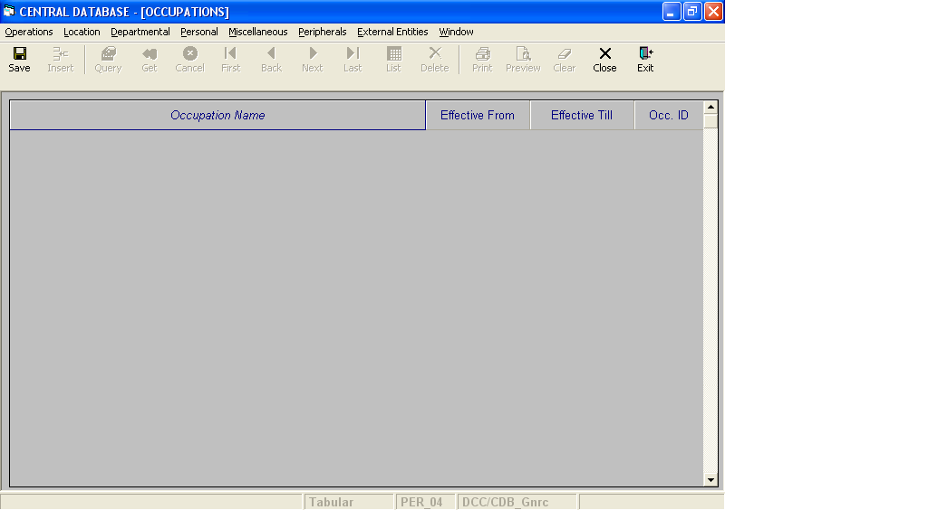

Layout as seen on opening of the Screen
  - Events associated
None
  - Modes
    - This screen operates in Tabular mode.

  - Field specifications
    - Tabular Field Items
 | Type | Length | Optional
Occupation Name | varchar | 20 | N
Effective From | datetime | 8 | N
Effective Till | datetime | 8 | N
Occ. ID | occupation_id | 2 | N

  - Tabular Field Items
    - Occupation Name
      - This is the Occupation Name.
      - It is user defined.
      - Occupation Name is uniquely defined in the database.
    - Effective From
      - This is the date since which an Occupation is effective.
      - By default, the system will display the current date in Insert Mode.
      - Normally, it should not be a future date. This is the recommendation. System will display a warning, if future date is specified.
      - It cannot be later than the date specified in Effective Till.
    - Effective Till
      - This is the date till which an Occupation is effective.
      - By default, the system will display 31-Dec-9999 in Insert Mode.
      - Normally, it should not be a past date.
      - It cannot be earlier than the date specified in Effective From.

    - Occ. ID
a) This is the Id of the Occupation, which uniquely identifies all the Occupations.
b) This field will be automatically generated by the system.
  - Action Buttons
None
  - Users / User Roles
CDB_Gnrc user is permitted to insert, update and delete Occupation.
  - Other Considerations
None

