Persons Screen
  - Purpose
    - This screen manages the information of all the persons.
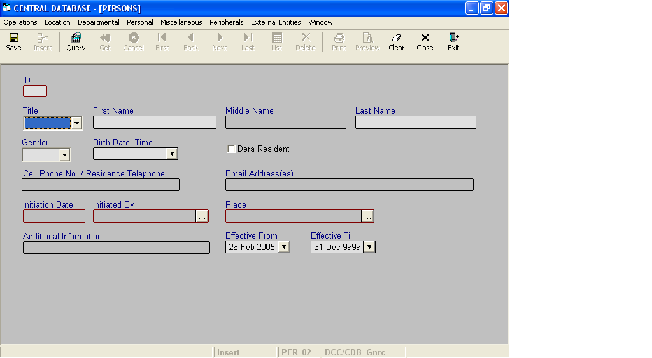

Layout as seen on opening of the Screen
  - Events associated
None
  - Modes
    - It will start in Insert mode.
    - It supports Insert, Query, Retrieve, Browse and List modes.
  - Field specifications
 | Type | Length | Optional | Insert Mode | Query Mode | BrowseMode
ID | person_id | 4 | N | N.A. | Allow | Display
Title | Key |  | N | Allow | Allow | Allow
First Name | person_part_nm | 30 | N | Allow | Allow | Allow
Middle Name | person_part_nm | 30 | Y | Allow | Allow | Allow
Last Name | person_part_nm | 30 | N | Allow | Allow | Allow
Gender | gender | 6 | N | Allow | Allow | Allow
Dera Resident | boolean | 3 | N | Allow | Allow | Allow
Cell Phone Number | telephone_lines | 50 | Y | Allow | Allow | Allow
Email Address | email_addresses | 50 | Y | Allow | Allow | Allow
Birth Date- Time | Smalldatetime | 4 | N | Allow | Allow | Allow
Additional Information | Varchar | 50 | Y | Allow | Allow | Allow
Initiation Date
Initiated By
Place
Effective From | datetime | 8 | N | Allow | Allow | Allow
Effective Till | datetime | 8 | N | Allow | Allow | Allow
  - Fields
    - ID
      - This is the Person ID, which uniquely identifies all the items.
      - This field will be automatically generated by the system.
      - The user will be informed of the generated ID as part of the message, which will be shown on successful saving of information in Insert Mode.
    - Title
      - This is the title of the Person.
      - It can be changed in Browse Mode.
    - First Name
      - This is the first name of the Person.
      - The First name can be changed in Browse Mode.
      - First name should contain only alphabets and apostrophe. No other character should be permitted.

    - Middle Name
      - This is the middle name of the Person.
      - The Middle name can be changed in Browse Mode.
      - Middle name should contain only alphabets and apostrophe. No other character should be permitted.
v. Last Name
a) This is the last name of the Person.
b) The Last name can be changed in Browse Mode.
c) Last name should contain only alphabets and apostrophe. No other character should be permitted.
vi. Gender
a) This is the gender of the person.
b) The gender can be changed in Browse Mode.

- Birth Date- Time
a) This is the birth date-time of a person.
b) The birth date-time of a person can be changed in Browse Mode.

- Dera Resident
a) This field states whether a person is residing in dera or not.
b) This field can be changed in Browse Mode.

- Cell Phone No./Residence Telephone
a) It will contain the Cell Phone number if available; else it will contain the residence telephone number. If both are not available, it will be null.
b) The contact number of a person can be changed in Browse Mode.

- Email Address
a) This field contains the e-mail Id of a person if available; else it will be null.
b) The email-id of a person can be changed in Browse Mode.

- Initiation Date
a) This is the date on which the person gets initiated.
b) This date can be changed in Browse Mode.

- Initiated By
a) This is the name of the person, from whom the person gets initiated.
b) This date can be changed in Browse Mode.

- Place
a) This is the place, where the person gets initiated.
b) This place can be changed in Browse Mode.

- Additional Information
a) This field provides additional information about a person, on the basis of which we can differentiate one person from another when their names, title, date of birth and gender match.
b) Additional Information can be changed in Browse and Update Modes.
xv. Effective From
a) This is the date since which a person is effective.
b) By default, the system will display the current date in Insert Mode.
c) Normally, it should not be a future date. This is the recommendation. System will display a warning, if future date is specified.
      - It cannot be later than the date specified in Effective Till.
xvi. Effective Till
a) This is the date till which a person is effective.
b) By default, the system will display 31-Dec-9999 in Insert Mode.
c) Normally, it should not be a past date.
d) It cannot be earlier than the date specified in Effective From.
  - Action Buttons
None
  - Users / User Roles
CDB_Gnrc user is permitted to insert, update, delete and select Person.

  - Other Considerations
None

