Qualifications Screen
  - Purpose
    - This screen manages the information of different Qualifications.
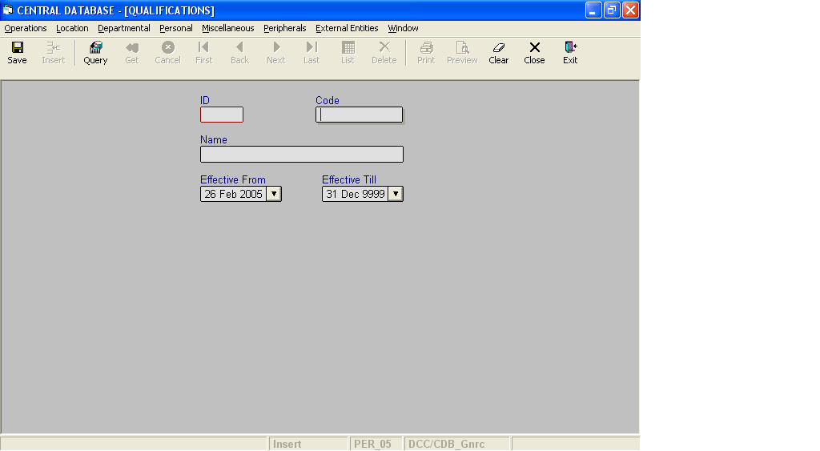

Layout as seen on opening of the Screen
  - Events associated
None
  - Modes
    - It will start in Insert mode.
    - It supports Insert, Query, Retrieve, Browse and List modes.

  - Field specifications
 | Type | Length | Optional | Insert Mode | Query Mode | BrowseMode
ID | qualification_id | 2 | N | N.A. | Allow | Display
Code | varchar | 12 | N | Allow | Allow | Allow
Name | varchar | 50 | N | Allow | Allow | Allow
Effective From | datetime | 8 | N | Allow | Allow | Allow
Effective Till | datetime | 8 | N | Allow | Allow | Allow
  - Fields
    - ID
      - This is the ID, which uniquely identifies all the Qualifications.
      - This field will be automatically generated by the system.
      - The user will be informed of the generated ID as part of the message which will be shown on successful saving of information in Insert Mode.
    - Code
      - This is the code of the Qualification.
      - It is user defined. It can be changed in Browse Mode.
      - Code of the Qualification is uniquely defined in the database.
    - Name
      - This is the name of the Qualification.
      - The name can be changed in Browse Mode.
      - Name of the Qualification is uniquely defined in the database.
    - Effective From
      - This is the date since which a Qualification is effective.
      - By default, the system will display the current date in Insert Mode.
      - Normally, it should not be a future date. This is the recommendation. System will display a warning, if future date is specified.
      - It cannot be later than the date specified in Effective Till.
    - Effective Till
      - This is the date till which a Qualification is effective.
      - By default, the system will display 31-Dec-9999 in Insert Mode.
      - Normally, it should not be a past date.
      - It cannot be earlier than the date specified in Effective From.

  - Action Buttons
None
  - Users / User Roles
CDB_Gnrc user is permitted to insert, update, delete and select Qualification.
  - Other Considerations
None

