Representatives Screen
  - Purpose
    - This screen manages the information of different representatives.
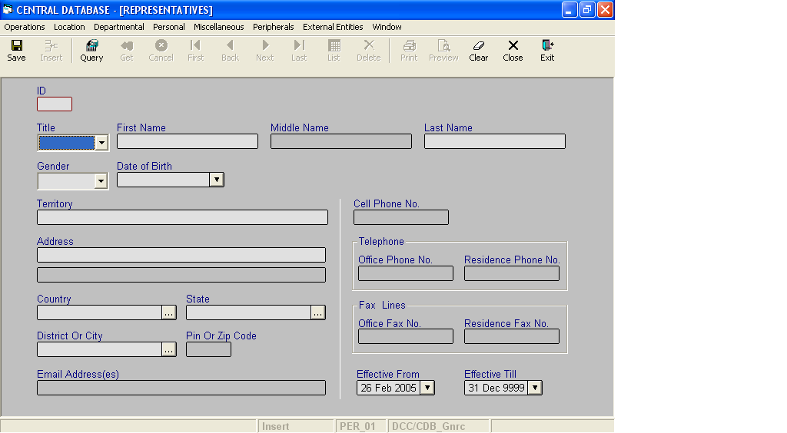

Layout as seen on opening of the Screen
  - Events associated
None
  - Modes
    - It will start in Insert mode.
    - It supports Insert, Query, Retrieve, Browse and List modes.
  - Field specifications
 | Type | Length | Optional | Insert Mode | Query Mode | BrowseMode
ID | representative_id | 4 | N | N.A. | Allow | Display
Title | Key |  | N | Allow | Allow | Allow
First Name | person_part_name | 30 | N | Allow | Allow | Allow
Middle Name | person_part_name | 30 | Y | Allow | Allow | Allow
Last Name | person_part_name | 30 | N | Allow | Allow | Allow
Gender | gender | 6 | N | Allow | Allow | Allow
Date Of Birth | smalldatetime | 4 | N | Allow | Allow | Allow
Territory | Varchar | 100 | N | Allow | Allow | Allow
Address(Address line 1) | address_line | 50 | N | Allow | Allow | Allow
Address(Address line 2) | address_line | 50 | Y | Allow | Allow | Allow
Country | Key |  | N | Allow | Allow | Allow
State | Key |  | N | Allow | Allow | Allow
District or City | Key |  | N | Allow | Allow | Allow
Pin or Zip Code | pin_or_zip_code | 6 | Y | Allow | Allow | Allow
Email Address(es) | email_address | 50 | Y | Allow | Allow | Allow
Cell Phone No. | cell_phone_no | 20 | Y | Allow | Allow | Allow
Office Phone No. | telephone_lines | 50 | Y | Allow | Allow | Allow
Residence Phone No. | telephone_lines | 50 | Y | Allow | Allow | Allow
Office Fax Line | telephone_lines | 50 | Y | Allow | Allow | Allow
Residence Fax Line | telephone_lines | 50 | Y | Allow | Allow | Allow
Effective From | datetime | 8 | N | Allow | Allow | Allow
Effective Till | datetime | 8 | N | Allow | Allow | Allow
  - Fields
    - ID
      - This is the ID of the Representative, which uniquely identifies all the items.
      - This field will be automatically generated by the system.
      - The user will be informed of the generated ID as part of the message which will be shown on successful saving of information in Insert Mode.
    - Title
      - This is the Title of the Representative.
      - It can be changed in Browse Mode.
    - First Name
      - This is the first name of the Representative.
      - The first name can be changed in Browse Mode.

    - Middle Name
a) This is the middle name of the Representative.
b) The middle name can be changed in Browse Mode.
    - Last Name
a) This is the last name of the Representative.
b) The last name can be changed in Browse Mode.
    - Gender
a) This is the Gender of the Representative.
b) This field can be changed in Browse Mode.
    - Date of Birth
a) This is date of birth of the Representative.
b) This field can be changed in Browse Mode.
    - Territory
a) This is the territory where the representative resides.
b) This field can be changed in Browse Mode.
    - Address Line1
a) This is the address of the representative.
b) This field is user defined. It can be changed in Browse Mode.
    - Address Line 2
a) This is the address of the representative.
b) This field is user defined. This field can be changed in Browse Mode.

    - Country
a) This is the name of the country where the representative resides.
b) The country of the representative can be changed in Browse Mode.
    - State
a) This is the name of the state where the representative resides.
b) The state of the representative can be changed in Browse Mode.
    - District or City
a) This is the district or city where the representative resides.
b) The district or city of the representative can be changed in Browse Mode.
    - Pin or Zip Code
a) This is the pin or zip code of the place where the representative resides.
b) The pin or zip code of the representative can be changed in Browse Mode.
    - Email Address(es)
a) This is the e-mail Id of the representative.
b) This field can be changed in Browse Mode.
    - Cell Phone No.
a) This is the mobile number of the representative.
b) This field can be changed in Browse Mode.
    - Office Phone No.
a) This is the office phone number of the representative.
b) This field can be changed in Browse Mode.
    - Residence Phone No.
a) This is the residence phone number of the representative.
b) This field can be changed in Browse Mode.
    - Office Fax Line
a) This is the Fax number of the office of the representative.
b) This field can be changed in Browse Mode.
    - Residence Fax Line
a) This is the Fax number of the residence of the representative.
b) This field can be changed in Browse Mode.
    - Effective From
      - This is the date since which a Representative is effective.
      - By default, the system will display the current date in Insert Mode.
      - Normally, it should not be a future date. This is the recommendation. System will display a warning, if future date is specified.
      - It cannot be later than the date specified in Effective Till.
    - Effective Till
      - This is the date till which a Representative is effective.
      - By default, the system will display 31-Dec-9999 in Insert Mode.
      - Normally, it should not be a past date.
      - It cannot be earlier than the date specified in Effective From.

  - Lookup or Help
Field | Items of Information as will be shown | Remarks
Country | Name, Code | Only active countries will be shown.
State | Name, Code | Only active states will be shown.
District or City | Name, Code | Only active districts or cities will be shown.

  - Action Buttons
None
  - Users / User Roles
CDB_Gnrc user is permitted to insert, update, delete and select Representative.
  - Other Considerations
None
unique constraint :
CONSTRAINT UK_Representatives_Person
UNIQUE NONCLUSTERED (person_id, effective_from)
in the schema

