Roles Screen
  - Purpose
    - This screen manages the information of different roles.
    - It defines all the roles that a party can have like Supplier, Manufacturer, Distributor, Donor, etc.
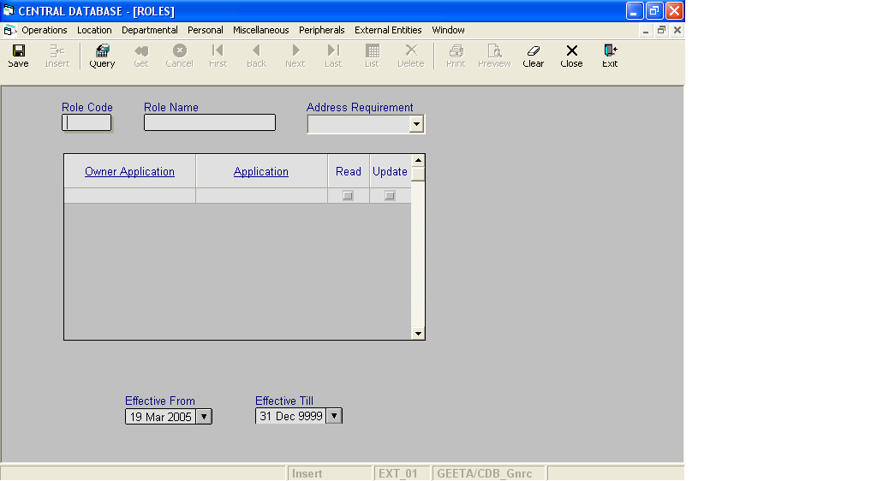

Layout as seen on opening of the Screen
  - Events associated
None
  - Modes
    - It will start in Insert mode.
    - It supports Insert, Query, Retrieve, Browse, List, New, Update and Reference modes.
  - Field specifications
i. Simple Fields
 | Type | Length | Optional | Insert Mode | Query Mode | BrowseMode
Role Code | role_cd |  | N
Role Name | varchar | 15 | N | Allow | Allow | Allow
Address Requirement | requirement |  | N | Allow | Allow | Allow
Effective From | datetime | 8 | N | Allow | Allow | Allow
Effective Till | datetime | 8 | N | Allow | Allow | Allow
Update Party Roles |  |  |  | NA | NA | Allow
ii. Tabular Field Items

 | Type | Insert Mode | Query Mode | Browse Mode | Optional
Owner Application | application_id |  | Allow |  | N
Application |  | Allow | Allow |  | N
Read | boolean | Allow | Allow |  | N
Update | boolean |  | Allow |  | N

  - Simple Fields
    - Role Code
      - This is the Code of a role, which uniquely identifies all the roles.
      - It is user defined.
    - Role Name
      - This is the name of the Role.
      - It is user defined. It can be changed in Browse Mode.
      - Role Name is uniquely defined in the database.
    - Address Requirement
      - It specifies whether the address is to be specified or not (when role is being defined for a party). Values are Mandatory, Optional and Not Required.
      - The name can be changed in Browse Mode.

iv. Effective From
a) This is the date since which a department is effective.
b) By default, the system will display the current date in Insert Mode.
c) Normally, it should not be a future date. This is the recommendation. System will display a warning, if future date is specified.
      - It cannot be later than the date specified in Effective Till.
v. Effective Till
a) This is the date till which a department is effective.
b) By default, the system will display 31-Dec-9999 in Insert Mode.
c) Normally, it should not be a past date.
d) It cannot be earlier than the date specified in Effective From.

  - Tabular Fields for Persons spread
i. Owner Application
a) Owner application specifies that the application can create the parties with this role.
b) The value of this field is filled based on the selection of First name or Last name.
ii. Application
- .
iii. Read
      - It specifies that the application can only view the party or not.
- Update
  - It specifies that the application can modify the information of the party or not.

  - Lookup or Help
Field | Items of Information as will be shown | Remarks
Owner Application | Application ID, Application Name, Package ID
Application | Application ID, Application Name, Package ID

  - Action Buttons
None
  - Users / User Roles
CDB_Gnrc user is permitted to insert, update, delete and select Roles.
  - Other Considerations
None

