Skills Screen
  - Purpose
    - This screen manages the information of different Skills.
    - This table stores the skills like electrician, mason, doctor, trader, etc.
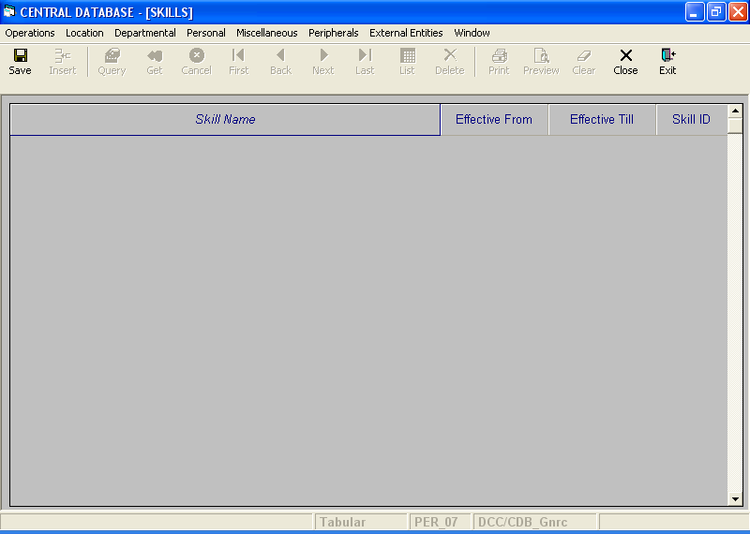

Layout as seen on opening of the Screen
  - Events associated
None
  - Modes
    - This screen operates in Tabular mode.

  - Field specifications
    - Tabular Field Items
 | Type | Length | Optional
Skill Name | varchar | 20 | N
Effective From | datetime | 8 | N
Effective Till | datetime | 8 | N
Skill ID | skill_id | 2 | N

  - Tabular Field Items
    - Skill Name
      - This is the Skill Name.
      - It is user defined.
      - Skill Name is uniquely defined in the database.
    - Effective From
      - This is the date since which a Skill is effective.
      - By default, the system will display the current date in Insert Mode.
      - Normally, it should not be a future date. This is the recommendation. System will display a warning, if future date is specified.
      - It cannot be later than the date specified in Effective Till.
    - Effective Till
      - This is the date till which a Skill is effective.
      - By default, the system will display 31-Dec-9999 in Insert Mode.
      - Normally, it should not be a past date.
      - It cannot be earlier than the date specified in Effective From.

    - Skill ID
a) This is the Skill ID, which uniquely identifies all the skills.
b) This field will be automatically generated by the system.

  - Action Buttons
None
  - Users / User Roles
CDB_Gnrc user is permitted to insert, update and delete Skills.
  - Other Considerations
None

