States Screen
  - Purpose
    - This screen manages the information of different States.
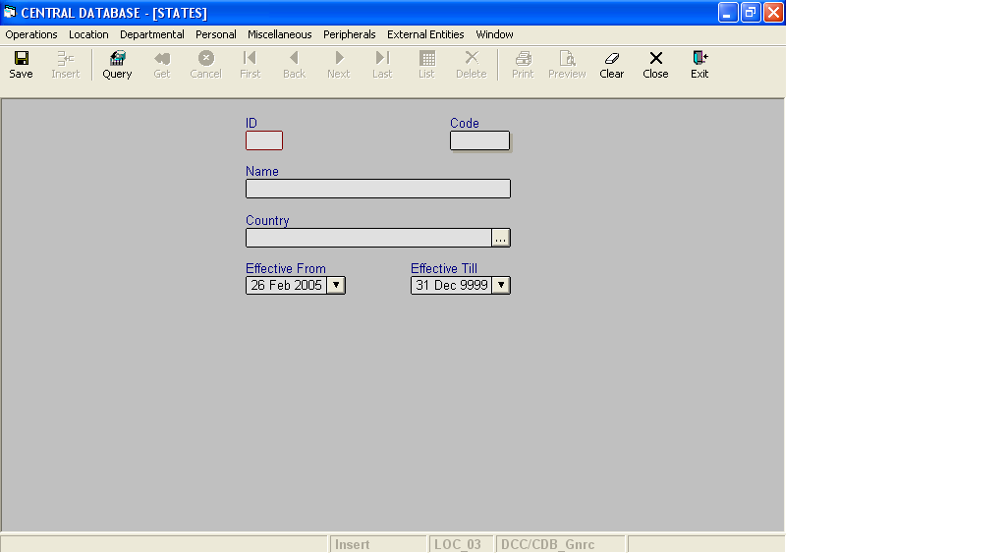

Layout as seen on opening of the Screen
  - Events associated
None
  - Modes
    - It will start in Insert mode.
    - It supports Insert, Query, Retrieve, Browse, List, New, Update and Reference modes.
  - Field specifications
    - Simple Fields

 | Type | Length | Optional | Insert Mode | Query Mode | BrowseMode
ID | State_id | 4 | N | N.A. | Allow | Display
Code | char | 5 | N | Allow | Allow | Allow
Name | varchar | 35 | N | Allow | Allow | Allow
Country | Key |  | N | Allow | Allow | Allow
Effective From | datetime | 8 | N | Allow | Allow | Allow
Effective Till | datetime | 8 | N | Allow | Allow | Allow
    - Tabular Fields

 | Type | Insert Mode | Query Mode | Browse Mode
District/City Code | Key | N.A | N.A | Display
District/City Name | Key | N.A | N.A | Display
Dist. /City ID | Key | N.A | N.A | Display

  - Simple Fields
    - ID
      - This is the state ID, which uniquely identifies all the states.
      - This field will be automatically generated by the system.
      - The user will be informed of the generated ID as part of the message which will be shown on successful saving of information in Insert Mode.
    - Code
      - This is the code of the State.
      - It is user defined. It can be changed in Browse and Update Modes.
    - Name
      - This is the name of the State.
      - The name can be changed in Browse and Update Modes.
    - Country
      - This field specifies the Country to which this state belongs.
    - Effective From
      - This is the date since which a State is effective.
      - By default, the system will display the current date in Insert Mode.
      - Normally, it should not be a future date. This is the recommendation. System will display a warning, if future date is specified.
      - It cannot be later than the date specified in Effective Till.
    - Effective Till
      - This is the date till which a State is effective.
      - By default, the system will display 31-Dec-9999 in Insert Mode.
      - Normally, it should not be a past date.
      - It cannot be earlier than the date specified in Effective From.

f. Tabular Field Names
i. District/City Code
a) It is the code of the District/City, which is a part of the state.
ii. District/City Name
a) It is the name of the District/City, which is a part of the state.
iii. Dist. /City ID
a) It is the ID of the District/City, which is a part of the state.

- Lookup or Help
Field | Items of Information as will be shown | Remarks
Country | Name, Code | Only active Countries will be shown.
h. Action Buttons
None
i. Users / User Roles
CDB_Gnrc user is permitted to insert, update, delete and select State.
j. Other Considerations
- The combination of Code of the state and country should be unique.
- The combination of Name of the state and country should be unique.

