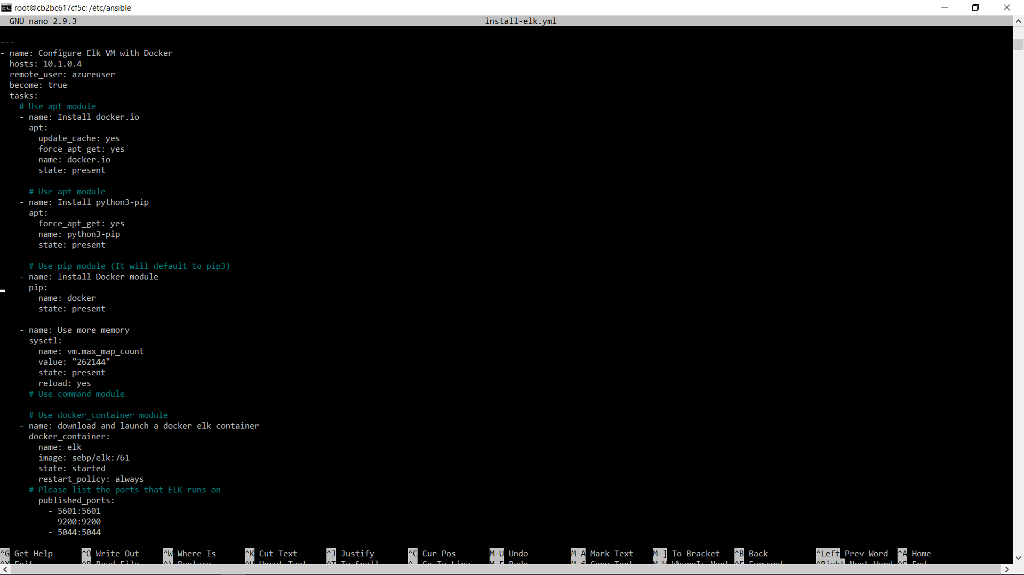
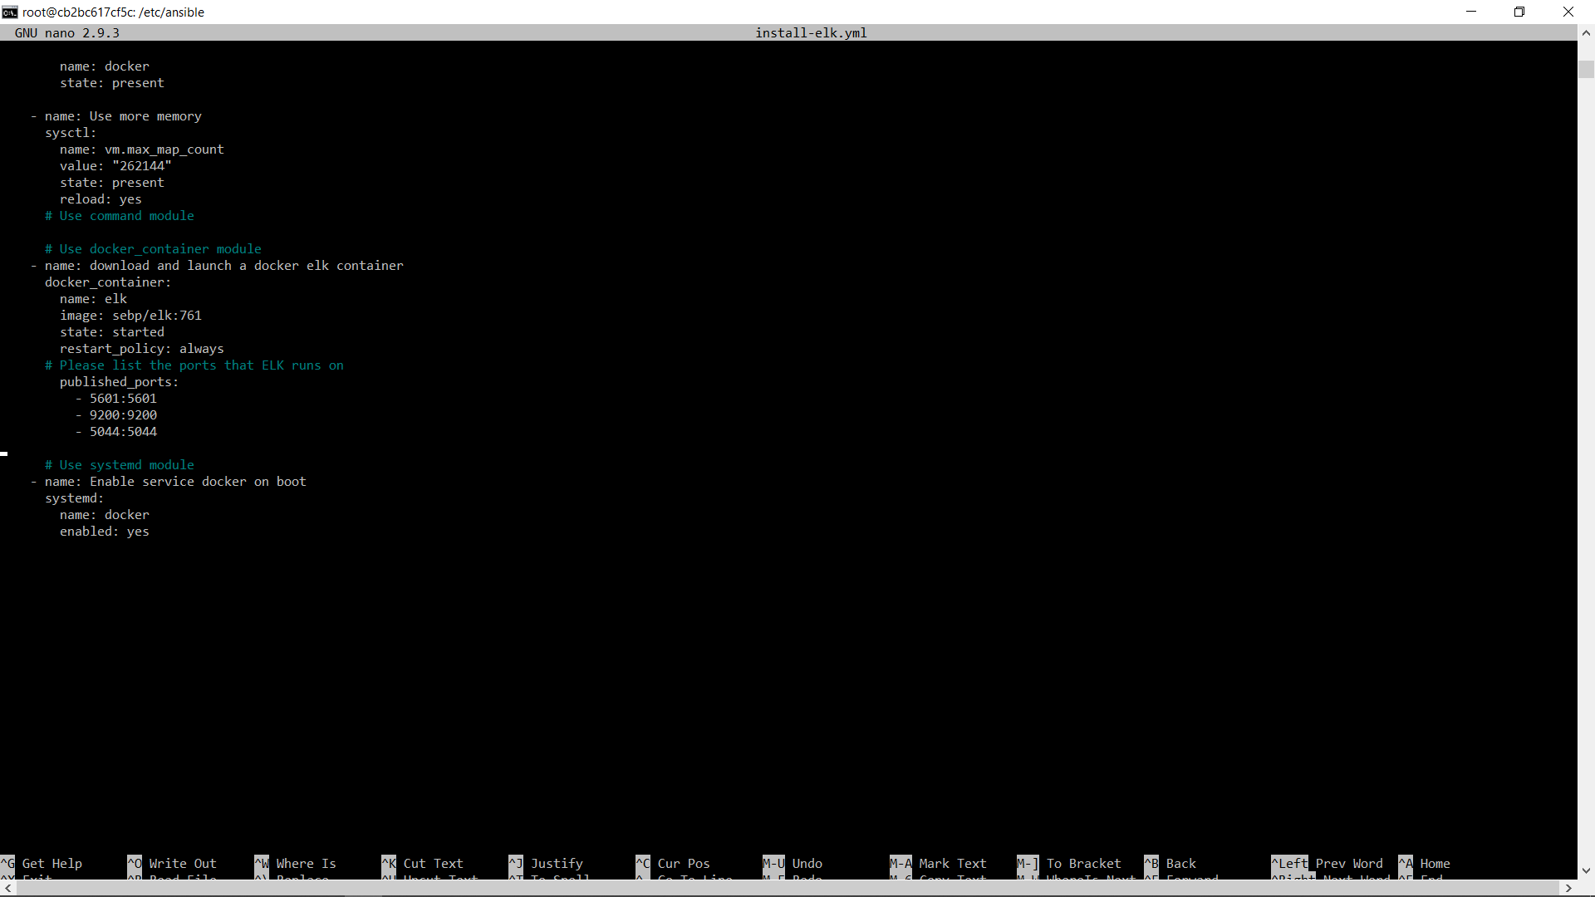

---
- name: installing and launching filebeat
hosts: webservers
become: yes
tasks:

- name: download filebeat deb
command: curl -L -O https://artifacts.elastic.co/downloads/beats/filebeat/filebeat-7.4.0-amd64.deb

- name: install filebeat deb
command: dpkg -i filebeat-7.4.0-amd64.deb

- name: drop in filebeat.yml
copy:
src: /etc/ansible/filebeat-config.yml
dest: /etc/filebeat/filebeat.yml

- name: enable and configure system module
command: filebeat modules enable system

- name: setup filebeat
command: filebeat setup

- name: start filebeat service
command: service filebeat start

- name: enable service filebeat on boot
systemd:
name: filebeat
enabled: yes

