**Department of Labor LCA Visa determinations issued for Federal Fiscal Q1- Q3 2014  
(between October 1, 2013 and June 30, 2014)**

The objective of this team project is to analyze a Department of Labor dataset of employer Labor Condition Applications (LCA) for nonimmigrant foreign workers that were decisioned between October 1, 2013, and June 30, 2014. In this project we describe interesting patterns that we found of various measures and dimensions, and we also add an analysis with a focus on a subset that only includes the applications for positions related to business analytics.

### Takeaways from analysis

Because this data is limited to just the applications that were *decisioned* between October 1, 2013, and June 30, 2014, we likely can’t extrapolate the means and proportions we found to the whole population of applications that are being submitted or that will be submitted at different points in time. Moreover, the job market for analytics and other fields are changing rapidly due to economical pressures, so the means and proportions found here may vary widely from year to year. A practical inference that may be made is that the data found here may be similar to those positions available to US nationals. Because companies are required to pay the foreign workers at minimum the prevailing wage for a given position, we may be able to infer that the wage information could be similar to US nationals with comparable qualifications. All in all, conducting similar analysis of prior time periods would provide a more complete picture of the tentative trends that we found described in the following sections.

## General statistic information for dataset population

We first begin by describing the analysis from the total population in the dataset of about 418,000 application entries. The measures we used were total number of workers that employers applied for, yearly wages, counts of various application status, the count of full time vs. part time work, and the number of days in between the application submission date and its decision date. The dimensions that we used to break down the measures were employer’s state, primary and secondary work locations, status application, industry classification, standard occupational code, and employer name.

### Population: Application Status

Figure 1 of the appendix shows the proportions of each application status as a percentage of the total number of applications. Below are the statuses with its proportions:

* Certified = 370,118 applicants (88%).
  + This is the number that were approved.
* Certified- Withdrawn = 26,038 applicants (6%).
  + This were approved in a prior decision period, and now the certification is being withdrawn by the employer.
* Denied = 9,548 applicants (3%)
* Withdrawn = 12,724 applicants (2%)

About 6.57% of certified visas were later withdrawn. We can conclude that out of every 100 workers, about 6 could have found better job opportunities elsewhere or for other reasons choose to part ways with the employer. This data can be helpful to the employers when considering costs, time, or other resources spent on the visa applications for these people. When an industry hires hundreds of employees, this cost will multiple and thus it will be a potential expense.

### State Level: Application Status

The top 10 States by number of applications certified are listed below (Appendix Figure 2):

|  |  |
| --- | --- |
| 1. California 69,625 2. Texas 36,778 3. New York 34,727 4. New Jersey 27,869 5. Illinois 19,835 | 1. Pennsylvania 13,986 2. Massachusetts 13,913 3. Georgia 13,113 4. Washington 12,225 5. Florida 12,757 |

### Population: Decision Time

The maximum time it takes for an application to be decisioned initially is 6 business days. Therefore about ⅘ of all applications are decisioned in less than a week and about ⅙ in less than 2 weeks. If an applicant receives a visa decision in more than 6 days, it would be because he/she has applied for the visa more than one time (if a decision is not Certified, then the applicant can apply as soon as the next day again); however, the original submission date remains the same for each new decision. Less than 1% of applications are resubmitted and re-decisioned for longer than 3 weeks, and a few of these may last a few years.

### Highest Paying Positions: Occupational Category and Job Title

The SOC system from the Bureau of Labor Statistics is used to classify workers into standard occupational categories to be used for statistical purposes, primarily Federal agencies. The Figure 3 shows the top 10 Highest paid SOC.Surgeons, Gynecologist, Anaesthesiologists, chief executive, etc. This also shows that Medical field pays more when compared with technical fields. On an average, surgeons are paid $ 210,000.

Figure 4 shows the 10 Highest Paid job Positions. Chief executives and vice presidents are paid very high when compared with other titles.

The confidence intervals can also be created for job position salary. The average of computer system analyst for the whole population is $70,614.87 and Standard Deviation is $90,475.75 which means that standard deviation is too high than mean and the data has outliers. So we removed the two outliers that appear to be entry errors. For the adjusted data, the Mean yearly wage is $69,421.64 and standard Deviation is $22,861 .27 hence the 95% confidence interval for the top paid position is ($23,699.10 , $115,144.18).

### Full-Time and Part-Time Positions

The top 5 occupational codes that tend to have the highest number of job positions are computer system analysts (209,489), computer programmers (105,660), software developers (90,026), computer occupations (74,889) and accountants and auditors (34,563). As shown in the “Full-Time/Part-Time” chart (Figure 6), the top 3 occupational codes for part-time job positions are accountants and auditors, market research analysts and marketing specialists and pharmacists. The top 3 occupation types that offered the most full -time job positions are computer system analysts, computer programmers and software developers and applications.

### Popular States for Applicants

Referring to the “Most Popular States” regional graph (Figure 5), most companies that apply for foreign applicant visas tend to be located in largely populated states such as California, Texas and New York. The number of application submitted are 79,722, 41,983 and 39,608, respectively. Comparatively, the top 5 states that have the highest median employer’s proposed yearly wages are California ($84,484), New York ($75,000), Texas ($69,000), Maryland ($66,600) and New Jersey ($65,000). In general for a lot of foreign applicants, large, urbanized, and “international” states will provide more opportunities and possibly a higher success rate of getting a worker visa certified. In contrast, a smaller number of companies apply for foreign workers when located in the midwest such as Montana, Wyoming and South Dakota because these states provide relatively less amount of job positions. In terms of a broader regional area, more applications come from states on the east and west coasts instead of the southwest and midwest regions. Compared to California and Texas, Arizona is not one of the “popular states”; there were only 5,681 applications for foreign workers that were decisioned in this period.

### Employment Duration

Based on the data, more than 90% of the time, applications request employment for the full 36 months. Less than 10% of the time is the period shorter.

## Analytics Related Positions Analysis

To narrow the scope of this data set to just analytics related positions, we used specific job title keywords like Analytics, Business Intelligence, data analyst or scientist, Operations Research/Decision/Management Science, etc (see Appendix A for detail on selection). We also excluded certain job titles for senior or managerial position levels based on related keywords like president, head, vp, senior, etc. These higher ranking roles would likely skew wage information up due to the additional experience required. Titles with the words “scientist” and “engineer” were also excluded because these types of jobs usually require substantially more years of experience in the field and/or doctoral or engineering degrees. With this we try to include only the types of positions most students in the MS-BA program may enter immediately after completing the program.

Below we describe some of the interesting insights we found from analyzing this data set related to analytics positions.

### Application status

Out of the 6,070 total H1B visa applications related to analytics positions (excluding those already certified and then withdrawn), 5,740 of them were certified, 139 were denied, and 191 were withdrawn. The respective proportions are 94.56%, 2.29%, and 3.15%.

### State level of primary work location: Total workers, wages, and application status

At the state level of primary work location, we analyzed the the measures of number of total workers that companies applied for, yearly wage means and standard deviations, and application status proportions. Figure 7 summarizes these measures for the top 10 states with the highest number of workers that companies applied for.

From these top 10 states, we see a mean wage range of $17,216 with a maximum of $76,172 in CA and a minimum of $58,956 in FL. The respective standard deviations for these two states are $36,081 for CA and $16,288 for FL. This means that a majority of wages (68%) should be between $52,000 and $99,000 in CA and between $42,000 and $75000 in FL.

In Arizona (ranked 25th in terms of total workers), companies applied for a total of 40 workers with a mean yearly wage of $59,239 and a standard deviation of $16,605. A majority of yearly wages are likely to be between $42,000 and $75,000.

The application Certified status proportions for these top 10 states had a maximum of 97.88% for TX and a minimum of 89.88% for FL. The mean proportion for these 10 states was 94.03% with a standard deviation of 2.48%. Arizona had a Certified status proportion of 87.50%.

### Relationship of Positions with Two Work Locations: Proportions

For the international visas where applications included two different working location cities, we examined the relationship between states. The highest proportion of the first work location state to the second work location state is within California. The proportion of total workers who applied for working visas with both first and second working locations in California is 32.43%. The proportion of applications whose number of workers first work location is in California and also have a different second work location is 36.86%.

For the particular selection the only proportion between two individual states greater than 5% is the relationship between workers with first working location in New Jersey and a second working location in New York. On average the applications with work locations in New Jersey have lower average salaries than those in New York. If an employer has offices in both New Jersey and New York it may be monetarily beneficial to list a work location in New Jersey and pay a lower salary but still have employees in close proximity to New York.

### Industry level: Total workers, wages, and application status

At the industry level (based on NAICS codes) we also analyzed the measures of number of total workers that companies applied for, yearly wage means and standard deviations, and application status proportions. Figure 8 summarizes these measures for the top 10 industry NAICS codes with the highest number of workers that companies applied for.

From these top 10 industries , we see a mean wage range of $23,510 with a maximum of $83,686 in “Other Computer Peripheral Equipment Manufacturing” and a minimum of $60,176 in “Other Accounting Services”. The respective standard deviations for these two industries are $17,508 and $11,084. This means that a majority of wages (68%) should be between $66,000 and $1,010,000 in “Other Computer Peripheral Equipment Manufacturing” and between $49,000 and $71,000 in “Other Accounting Services”.

The application Certified status proportions for these top 10 industries had a maximum of 100% for “Other Account Services”, “Other Computer Peripheral Equipment Manufacturing”, and for “Electronic Computer Manufacturing”. The minimum proportion was 87.69% for “Management, Scientific, and Technical Consulting Services”. The mean proportion for these 10 industries was 95.51% with a standard deviation of 4.28%.

### Standard Occupational Classification Level: Total workers

The top Standard Occupational Classifications (SOCs) were examined. This sample consists of 74 different SOCs. All SOCs that made up less than 1% of the total sample have been consolidated and classified as “Other” (Figure 9). The top five single SOCs represented are Management Analysts (33.39%), Operations Research Analysts (16.25%), Computer Occupations (12.33%), Computer Systems Analysts and Statisticians (4.39%).

As current and future job seekers, students may keep these terms in mind to aid in finding fitting positions. For example, analytics is still a budding term in the job market but focusing on words like management analyst, or operations research analyst can broaden search and open doors to more opportunities. Within the Management Analyst SOC there are 163 different job titles represented for nearly 2,300 workers. This is just for the international applications. It is exciting to think about what kind of similarities this may have for domestic job seekers and the opportunities that may be in store.

Continuing with the same sample for analytics positions that have been used for the analysis of the number of workers assigned to each SOC. On average, companies hiring for these analytics positions list 1.2 different SOC types. JP Morgan Chase & Co has had applications for 10 different SOCs in the first three federal fiscal quarters for a total of 53 workers. By comparison, Apple Inc. has had applications for five different SOCs for 310 workers. Other employers with high counts of different occupational classification are LinkedIn Corporation, Salesforce.com, Inc., Citibank, N.A., Cummins, Inc., CVS Pharmacy, Inc., Facebook, Inc., Google, Inc. and Visa U.S.A. Inc (Figure 10).

With more resources it would be interesting to explore individual companies and attempt to answer why some want to hire more workers for fewer occupation classifications and some want to hire a higher proportion of occupation classification for the number of workers being hired. Is there a true trend here or do some companies find it easier to be less accurate with the use of classifications? More data would be needed to dive deeper into these questions.

### Wage Data

Among analytics positions described in the discussion of the number of workers, the different SOCs have average annual salaries ranging from $31,200 to $148,000. The top paying SOCs are Geological and Petroleum Technicians, General and Operations Managers, Personal Financial Advisors, Marketing Managers and Computer and Information Research Scientist. While these are high paying positions they only make up less than one percent of the analytics sample. These are extremes but the range is large and as such the sample on whole has a large variation.

For the analytics positions, jobs classified as Management Analyst occupations are about 30% of the total analytics type positions nationwide. The beginning average annual salary point estimate is $65,833. The other top four SOC classifications mentioned before, Operations Research Analysts, Computer Occupations, Computer Systems Analysts and Software Developers, Applications, have the average beginning salaries of $67,389, $70,045, $74,248 and $83,626, respectively (Figure 11). There is larger proportion of these classifications, because they represent the average of more potential workers their averages wages are closer to the mean of the sample when compared to those classification that only represent a few workers.

By examining the top paying SOCs by state, the variability nationwide becomes apparent. Nationwide, the average top paying SOC is Geological and Petroleum Technician. On the State level Management Analyst are on average paid the most in Montana, New Hampshire, Mississippi, Arkansas and New Mexico although the average paid in each state varies from $47,003 to $82,000. In Arizona, highest paid occupation is the Computer Systems Analyst, Non R&D with reported salary of $97,850 (Figure 12).

### Company level: Total workers and wages

At the company level we analyzed the measures of number of total workers that the companies applied for and yearly wage means and standard deviations for each of the company. Figure 13 summarizes these measures for the top 20 companies with the highest number of workers that they applied for.

(A single outlier data point was deleted above for Bloomberg which had a yearly wage of $220,000)

From these top 20 companies, we see a mean wage range of $41,418 with a maximum of $95,902 at Apple Inc. and a minimum of $54,484 in Cognizant Technology Solutions. The respective standard deviations for these two companies are $17,893 and $6,813. This means that a majority of wages (68%) should be between $78,000 and $114,000 at Apple and between $48,000 and $61,000 at Cognizant for analytics related positions without including the senior/manager or engineer/scientist roles as explained in the introduction of this section.

# 

# 

# **APPENDIX A**

Link to data: <http://www.foreignlaborcert.doleta.gov/performancedata.cfm>

Filtering keywords used for the analytics related positions subset:

* **Analytcs** (Yes/Null): If yes, indicates that the job title has the word “analytics” anywhere in it
* **BI** (Yes/Null): If Yes, indicates that the job title has an of the following strings in it:
  + “business intel”, “BI “ or “intelligence analy”
* **DataSA**: If Yes, indicates that the job title has any of:
  + “data analys” or “data science”
* **OMD_SA**: if yes, indicates that the job title has any of:
  + “decision analys”, “decision science”, “management analys”, “management science”, “operations analys”, or “operations research”
* **ScienctistEngineer:** If yes, the job title has the keywords “scientist” or “engineer”. These job positions (from personal anecdotal evidence browsing job requirements) tend to require a lot of years of experience and/or PhDs or engineering degrees.
* **HighRank:** If yes, the job title has any of the keywords:
  + **“**avp”, “director, “head”, “lead”, “leader”, “manager”, “president”, “principal”, “vp “, “senior”, “sr.”, or “sr “.
  + These titles tend to require more years of experience as well, so they might skew the wages towards the higher side. This also only includes titles with the analytics/BI/data
  + keywords above.

Figure 1

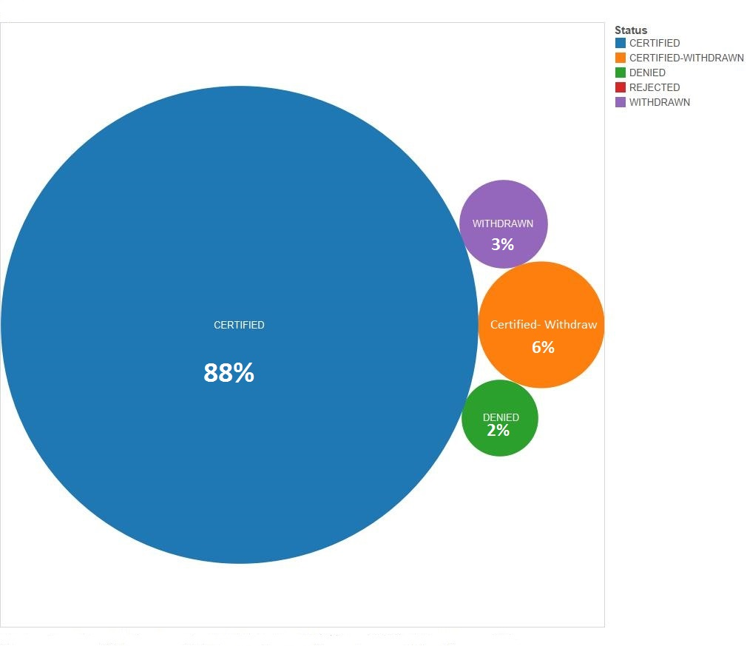

Figure 2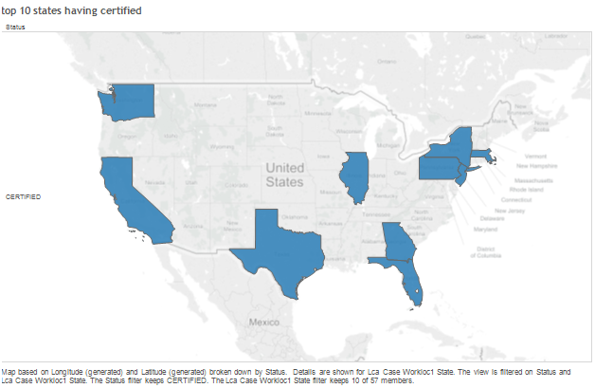

Figure 3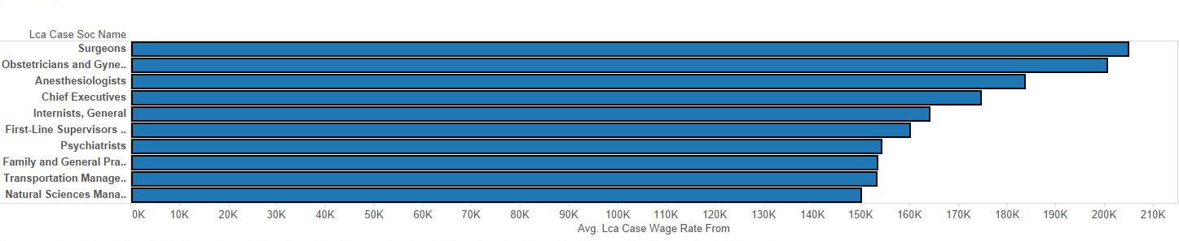

Figure 4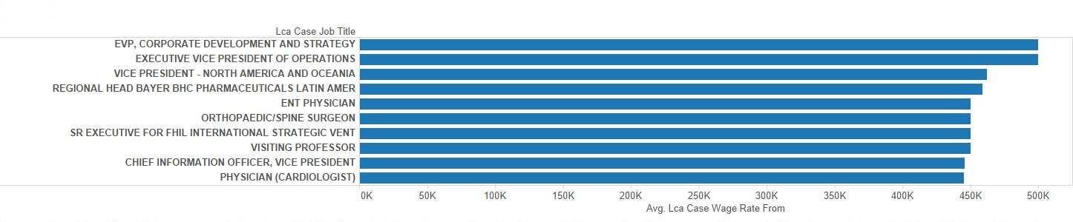

Figure 5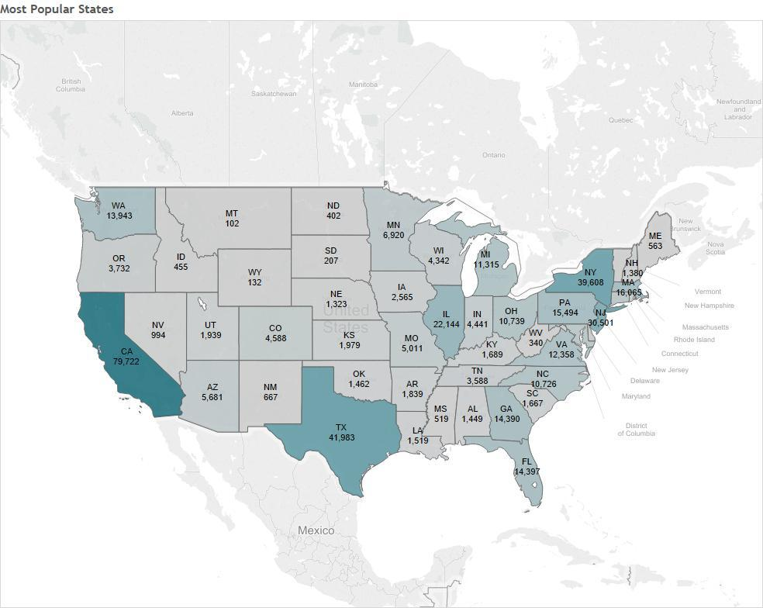

Figure 6

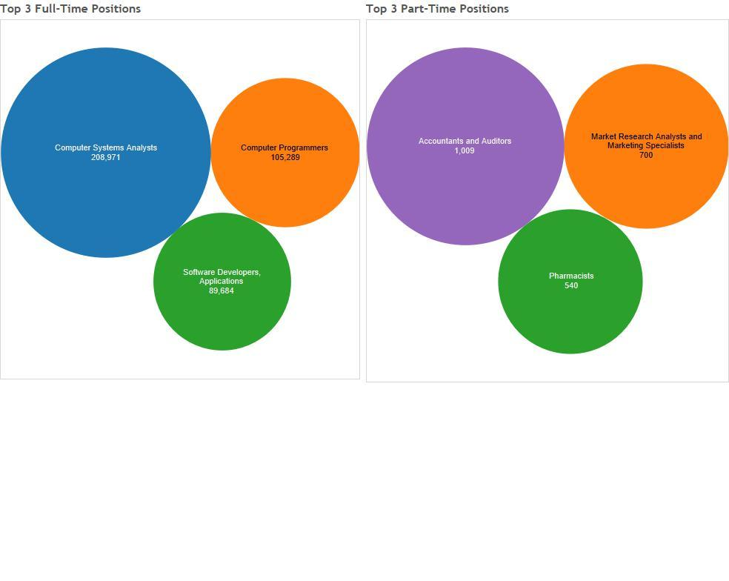

Table 7

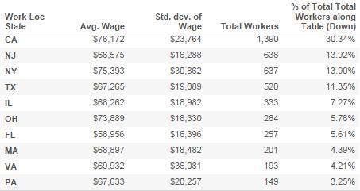

Figure 8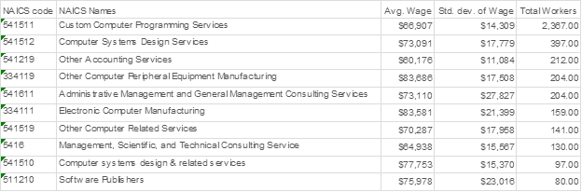

Figure 9

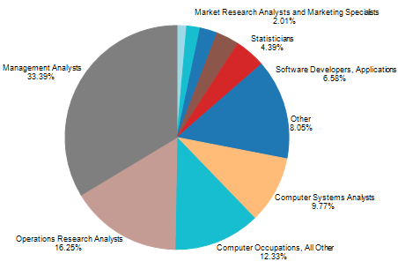

Figure 10

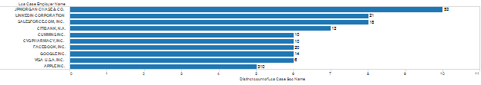

Figure 11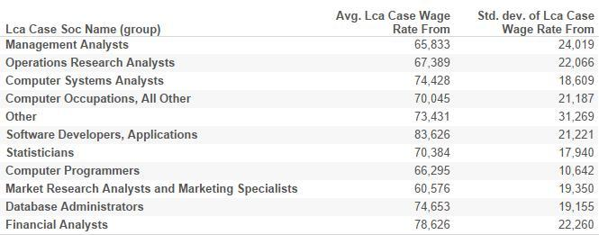

Figure 12

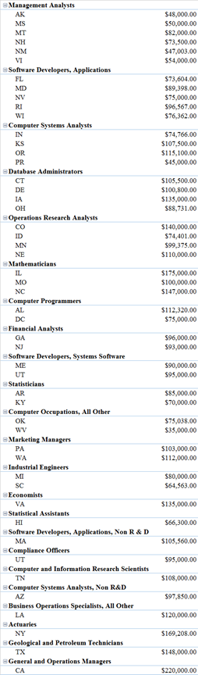

Figure 13