- Write a shell script tofind greatest among 3 numbers entered by user

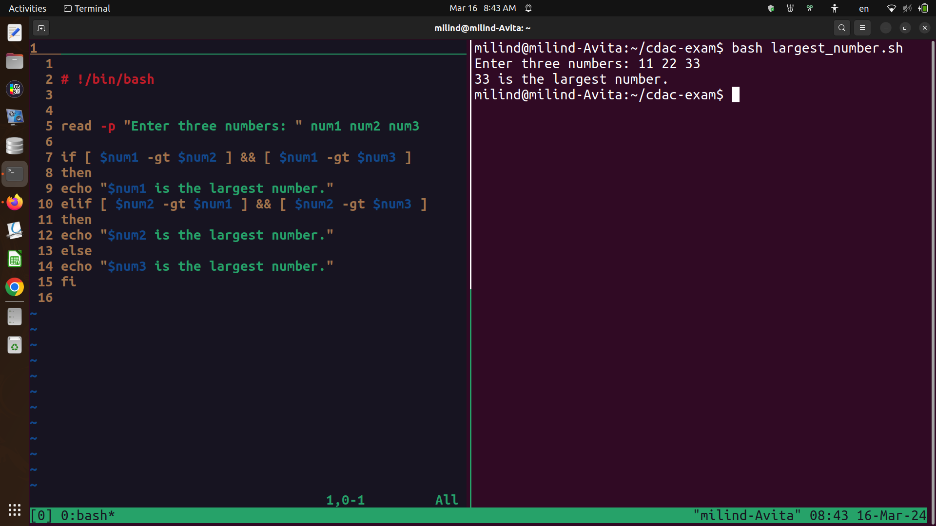

#!/bin/bash

echo "1. Date"
echo "2. cal"
echo "3. Ls "
echo "4. Pwd"
echo "5. Exit"

read -p " choose number from above " num

case $num in

1)
date ;;

2)

cal ;;

3)

ls ;;

4)

pwd ;;

5)
exit ;;

*)

echo " number not from menu " ;;

esac

output

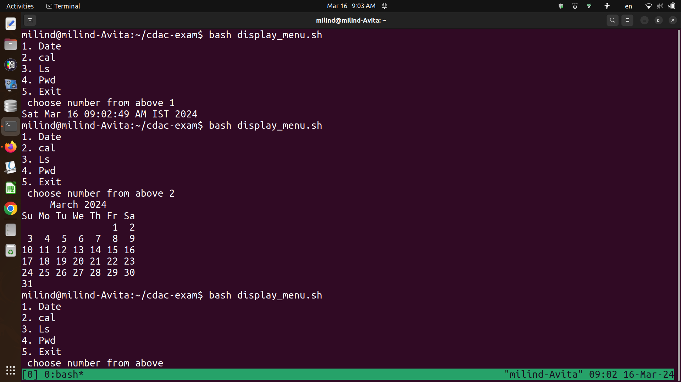

echo " 1. create a new directory with specified name"

echo " 2. rename existing directory with specified name"

echo " 3. move existing directory to new location"

echo " 4. delete existing directory "

read -p " select options from above " num

case $num in

1)

read -p " enter name of directory" dir1
mkdir $dir1 ;;

2)

read -p " enter name for existing directory"
read -p " enter new name " nname

3)

read -p " name of directory to move " dir2
read -p " new address for directory " addr

mv $dir2 $addr ;;

4)

read -p " name of directory to delete" dir3

rm $dir3 ;;

5)

read -p "name of new file " file
read -p " address of file " addr2
read -p " password for superuser " pass
touch $addr2/$file
sudo chmod ug+rw $addr2/$file $pass ;;

*)
echo " enter valid number "
;;

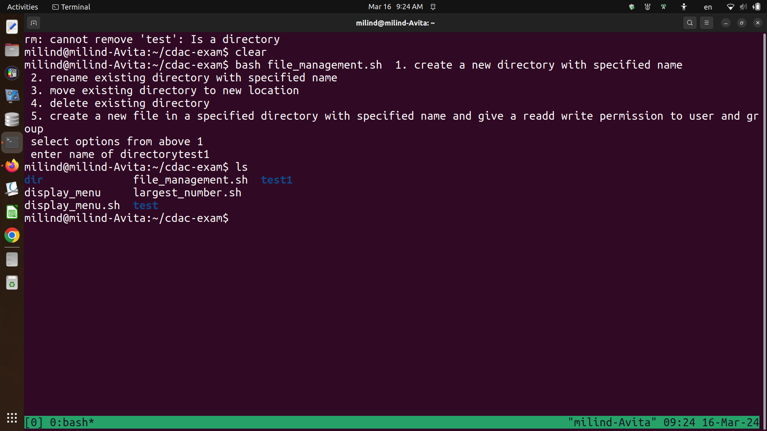

Cloud

- Ec2

1



2

3.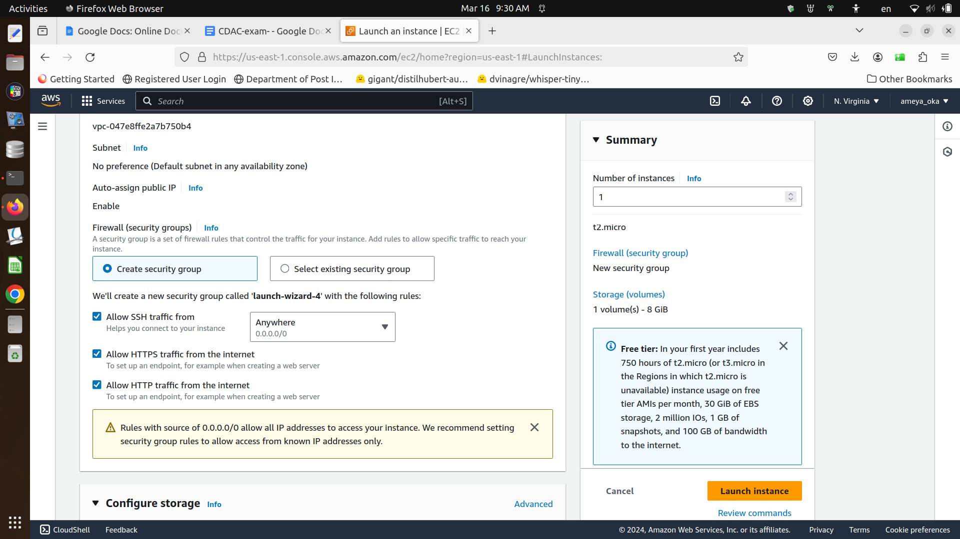4.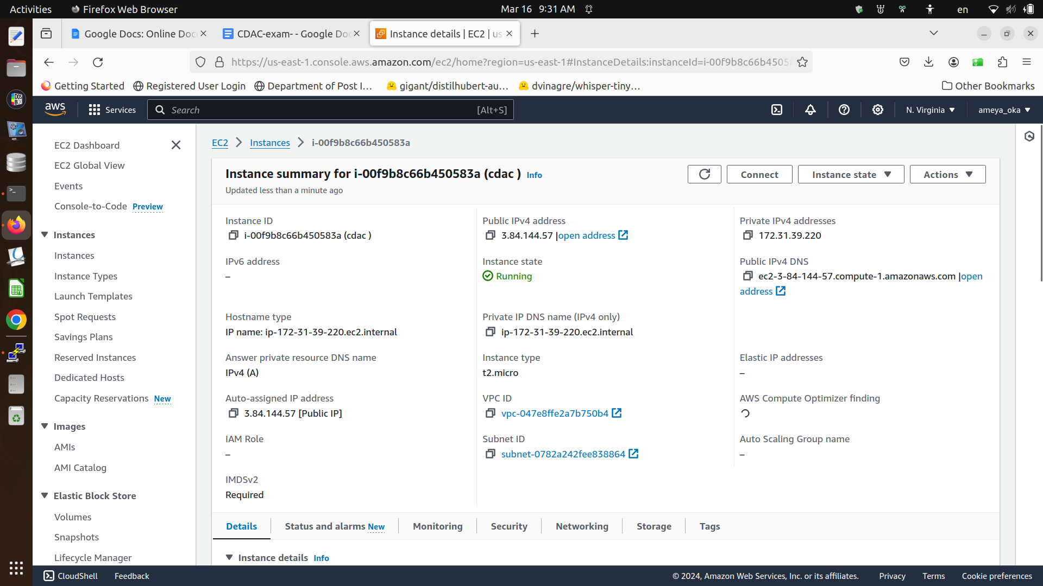5

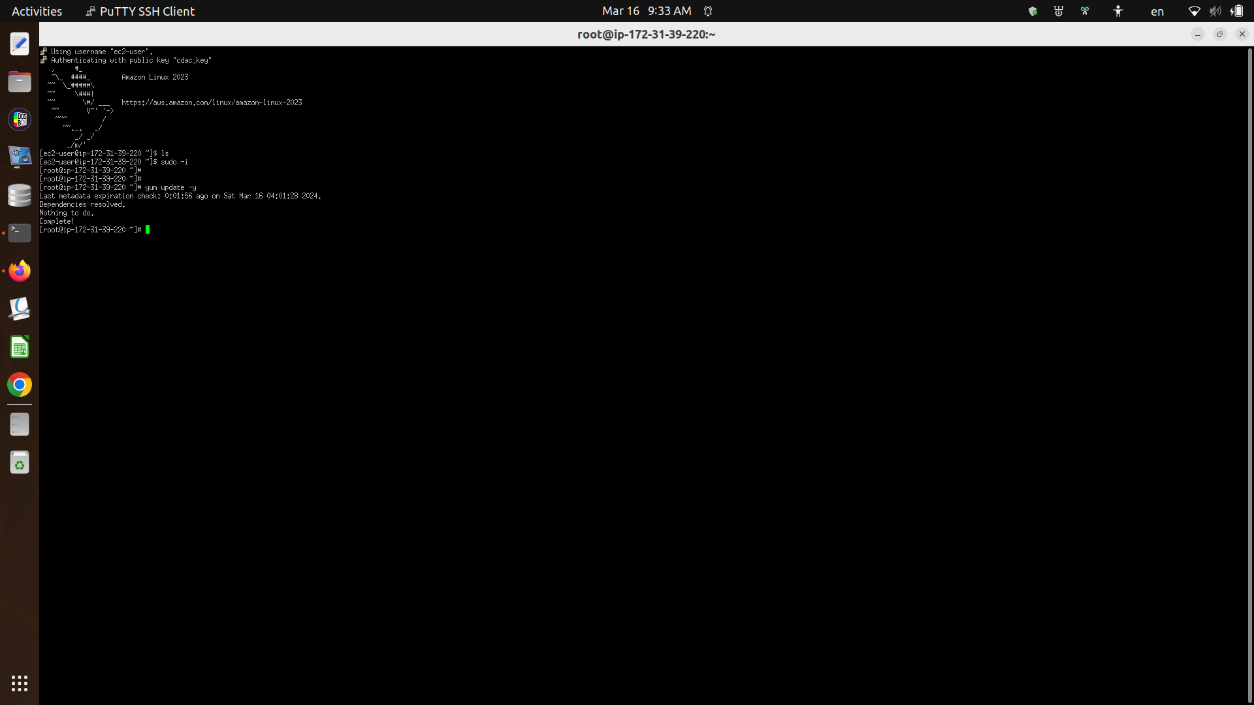8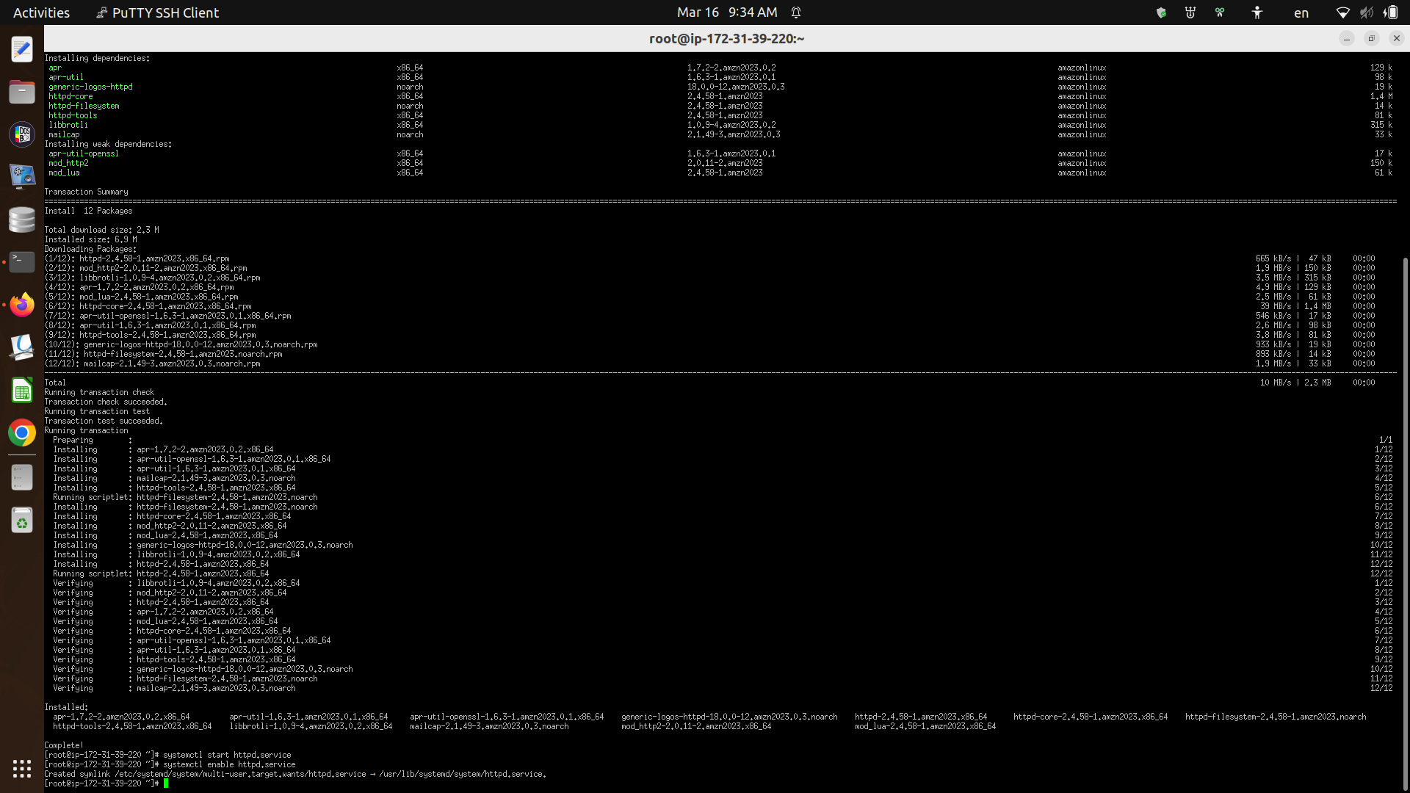8.