**Expt 7: Apriori Algorithm**

**Name: Ameya Ranade BE-IT UID: 2019140053**

**Aim:** To apply the Apriori algoritm to a given dataset Association rule mining with WEKA software

**Procedure:**

1. Make the CSV file

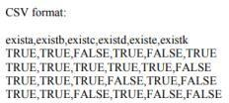

1. Open the concerned CSV file in WEKA. It will look like this after opening

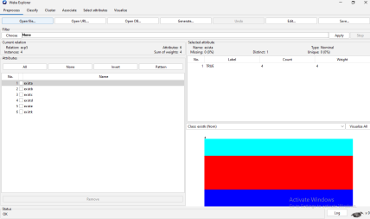

1. Open Associate and select all the parameters in apriori algoritm.

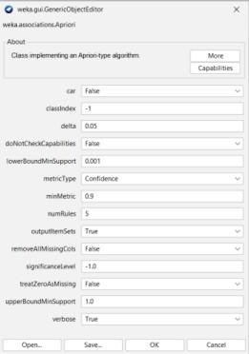

1. Press start so that WEKA can start the Apriori algorithm and find out the best rules. The minimum support is 0.6 and minimum confidence is 0.9.

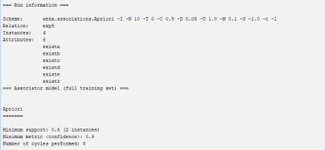

1. After performing all the steps of Apriori we can find out the Best rules

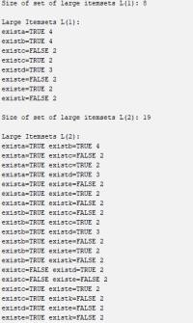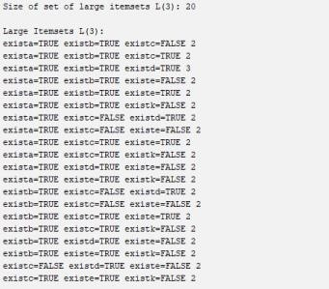

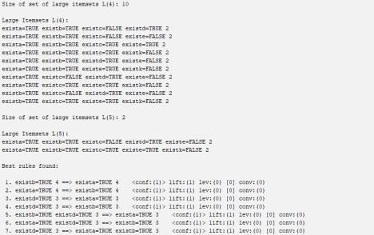

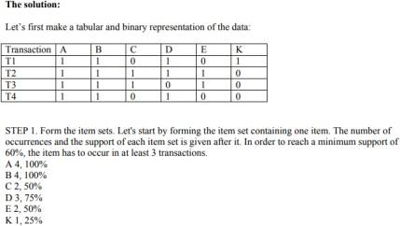

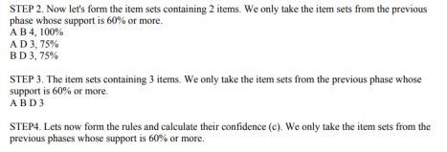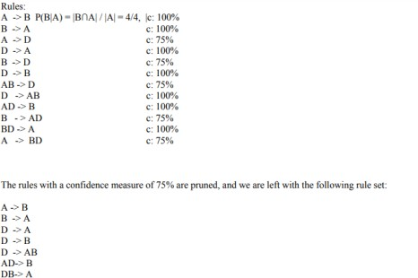

**Conclusion:** We can see that the best rules found from the manual solution and from WEKA are the same. Therefore we can conclude that both are solutions are correct and Apriori has been performed.

# Supermarket.arff

The Apriori Algorithm was run for an inbuilt dataset called supermarket.arff Case1: The minimum support is 0.15 and confidence is 0.9

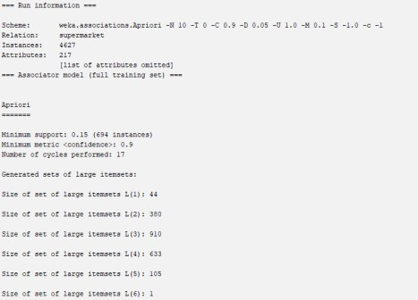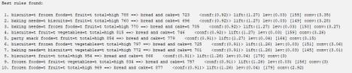

We can see that in this case 10 rules are generated all with the confidence of 0.9 or higher

Case 2: The minimum support is 0.3 and confidence is 0.9.

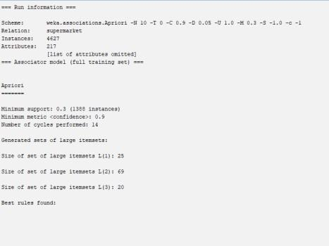

In this case we can see that no rule is generated because the minimum support is high.

Case 3: The minimum support is 0.3 and confidence is 0.7.

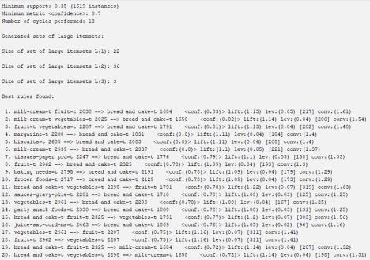

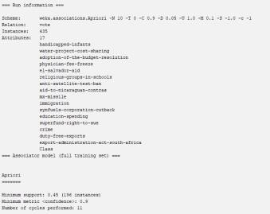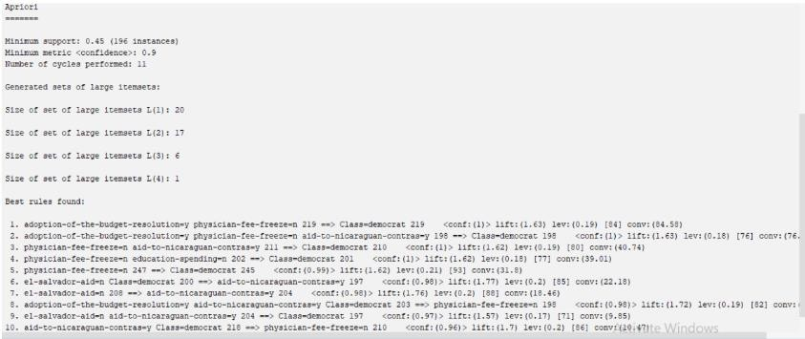

In this case we can see that because the confidence is lowered there are 20 rules generated.

# The Apriori algorithm was also run on another inbuilt Vote.arff

The minimum support was 0.45 and confidence was 0.9 and 10 rules were generated. Here all the classes that are associated are the democrats. If we increase the republic party entries in our dataset, we shall see some republican class associated rules as well.

# Conclusion

The Apriori algorithm has been performed on WEKA. With the help of parameters like support and confidence we have been able to find the association rules between different variables. By using apriori algorithm we can find essential relationships between different quantities which aids in effective decision making. For example, we can decide which grocery items to place together in a market depending on which are being bought together so as to increase sales.