Solar Sales, Operations & Customer Insights
Database Analysis Report | Dataset: solar_analysis | Database: Orion_solar_operations_cleaned
1. Sales Performance
Q1. What is the total net sales generated by B2B Dealers compared with Residential Customers?
Objective: Compare overall net sales volume between B2B Dealers and Residential buyers to measure revenue dependency.
SELECT
customer_type,
SUM(net_sales_inr) AS total_net_sales
FROM solar_sales
WHERE customer_type IN ('Dealer', 'Residential')
AND order_status = 'Completed'
GROUP BY customer_type
ORDER BY total_net_sales DESC;

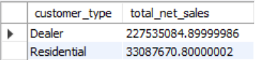
Figure 1: What is the total net sales generated by B2B Dealers compared with Residential Customers?

Key Findings & Business Impact:
- Dealers account for ₹22.75 Cr, generating roughly 87.3% of cumulative revenue across both channels.
- Residential orders generate ₹3.31 Cr, indicating bulk distribution via dealers is the core revenue driver.
Q2. What is the revenue contribution and market share of each solar equipment brand?
Objective: Evaluate equipment brand concentration and market share across completed orders.
SELECT
brand,
SUM(net_sales_inr) AS total_sales,
ROUND(
100 * SUM(net_sales_inr) /
SUM(SUM(net_sales_inr)) OVER (),
2
) AS revenue_share_percentage
FROM solar_sales
WHERE order_status = 'Completed'
GROUP BY brand
ORDER BY total_sales DESC;

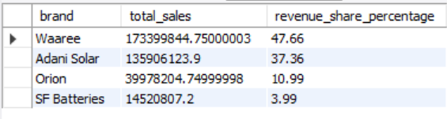
Figure 2: What is the revenue contribution and market share of each solar equipment brand?

Key Findings & Business Impact:
- Waaree (47.66%, ₹17.34 Cr) and Adani Solar (37.36%, ₹13.59 Cr) make up 85.02% of total brand sales.
- Orion (10.99%) and SF Batteries (3.99%) supply specialized niche hardware segments.
Q3. Which dealer accounts used discounts while maintaining an average order value above the overall average?
Objective: Pinpoint high-performing dealer accounts claiming discounts that still maintain basket sizes higher than the company benchmark.
SELECT
customer_id,
COUNT(*) AS order_count,
SUM(net_sales_inr) AS total_sales,
ROUND(AVG(net_sales_inr), 2) AS average_order_value
FROM solar_sales
WHERE customer_type = 'Dealer'
AND discount_pct > 0
AND order_status = 'Completed'
GROUP BY customer_id
HAVING AVG(net_sales_inr) > (
SELECT AVG(net_sales_inr)
FROM solar_sales
WHERE order_status = 'Completed'
)
ORDER BY average_order_value DESC LIMIT 5;

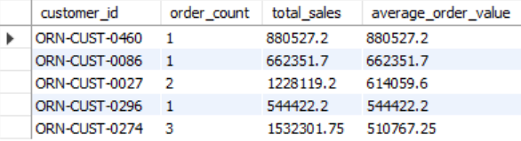
Figure 3: Which dealer accounts used discounts while maintaining an average order value above the overall average?

Key Findings & Business Impact:
- Dealer ORN-CUST-0460 leads with an AOV of ₹8,80,527.20.
- Dealer ORN-CUST-0274 demonstrates strong consistency with 3 orders totaling ₹15.32L.
Q4. How does quarterly net sales and order volume trend across the financial year?
Objective: Analyze quarterly seasonality across the financial year (Q1: Apr-Jun, Q2: Jul-Sep, Q3: Oct-Dec, Q4: Jan-Mar).
SELECT
CASE
WHEN MONTH(transaction_date) BETWEEN 4 AND 6 THEN 'Q1'
WHEN MONTH(transaction_date) BETWEEN 7 AND 9 THEN 'Q2'
WHEN MONTH(transaction_date) BETWEEN 10 AND 12 THEN 'Q3'
ELSE 'Q4'
END AS quarter,
COUNT(DISTINCT transaction_id) AS order_volume,
SUM(net_sales_inr) AS quarterly_net_sales
FROM solar_sales
WHERE order_status = 'Completed'
GROUP BY
CASE
WHEN MONTH(transaction_date) BETWEEN 4 AND 6 THEN 'Q1'
WHEN MONTH(transaction_date) BETWEEN 7 AND 9 THEN 'Q2'
WHEN MONTH(transaction_date) BETWEEN 10 AND 12 THEN 'Q3'
ELSE 'Q4'
END
ORDER BY
FIELD(quarter, 'Q1', 'Q2', 'Q3', 'Q4');

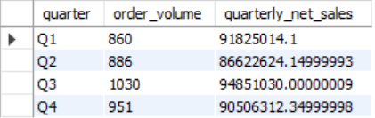
Figure 4: How does quarterly net sales and order volume trend across the financial year?

Key Findings & Business Impact:
- Q3 represents peak demand with 1,030 completed transactions and ₹9.49 Cr in revenue.
- Q2 experiences the lowest volume (₹8.66 Cr), reflecting seasonal slowdowns during monsoon installations.
Q5. Which product categories have the highest percentage of discounted orders?
Objective: Assess discount frequency across equipment categories to identify margin vulnerability.
SELECT
product_category,
COUNT(*) AS total_orders,
SUM(
CASE
WHEN discount_pct > 0 THEN 1
ELSE 0
END
) AS discounted_orders,
ROUND(
100 * SUM(
CASE
WHEN discount_pct > 0 THEN 1
ELSE 0
END
) / COUNT(*),
2
) AS discounted_order_percentage
FROM solar_sales
WHERE order_status = 'Completed'
GROUP BY product_category
ORDER BY discounted_order_percentage DESC;

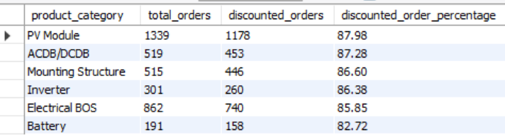
Figure 5: Which product categories have the highest percentage of discounted orders?

Key Findings & Business Impact:
- PV Modules have the highest discount rate at 87.98% across 1,339 total orders.
- All listed categories experience heavy discounting above 82%, indicating widespread reliance on price reductions.
2. Operations & Fulfillment
Q6. What is the distribution of completed orders across different shipping types?
Objective: Review fulfillment method share, volume of equipment moved, and revenue throughput.
SELECT
shipping_type,
COUNT(*) AS shipment_count,
SUM(quantity) AS units_shipped,
SUM(net_sales_inr) AS equipment_value
FROM solar_sales
WHERE order_status = 'Completed'
GROUP BY shipping_type
ORDER BY shipment_count DESC;

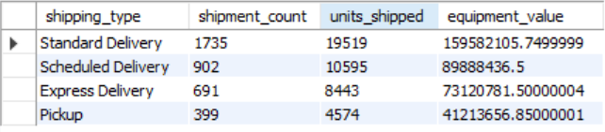
Figure 6: What is the distribution of completed orders across different shipping types?

Key Findings & Business Impact:
- Standard Delivery is the primary channel, fulfilling 1,735 shipments worth ₹15.96 Cr.
- Direct customer pick-ups account for 399 shipments and ₹4.12 Cr, reducing logistics overhead.
Q7. What are the top 3 most demanded equipment models within each product category?
Objective: Identify top-selling models within product lines using window ranking functions.
WITH product_demand AS (
SELECT
product_category,
product_name,
SUM(quantity) AS total_quantity
FROM solar_sales
WHERE order_status = 'Completed'
GROUP BY
product_category,
product_name
),
ranked_products AS (
SELECT
product_category,
product_name,
total_quantity,
RANK() OVER (
PARTITION BY product_category
ORDER BY total_quantity DESC
) AS product_rank
FROM product_demand
)
SELECT
product_category,
product_name,
total_quantity,
product_rank
FROM ranked_products
WHERE product_rank <= 3
ORDER BY
product_category,
product_rank LIMIT 5;

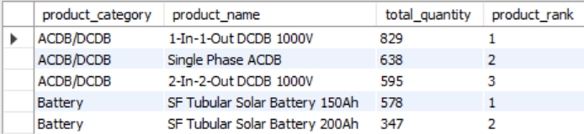
Figure 7: What are the top 3 most demanded equipment models within each product category?

Key Findings & Business Impact:
- 1-In-1-Out DCDG 1000V (829 units) and Single Phase ACDB (638 units) lead protection hardware demand.
- SF Tubular Solar Battery 150Ah (578 units) outsells the 200Ah version (347 units).
Q8. How does average order value compare between Express Delivery and Standard Delivery orders?
Objective: Determine whether expedited delivery orders correlate with larger transaction sizes.
SELECT
shipping_type,
COUNT(*) AS order_count,
ROUND(AVG(net_sales_inr), 2) AS average_order_value
FROM solar_sales
WHERE shipping_type IN (
'Express Delivery',
'Standard Delivery'
)
AND order_status = 'Completed'
GROUP BY shipping_type
ORDER BY average_order_value DESC;

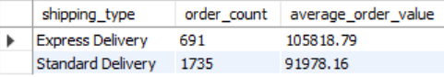
Figure 8: How does average order value compare between Express Delivery and Standard Delivery orders?

Key Findings & Business Impact:
- Express Delivery AOV is ₹1,05,818.79, approximately 15.0% higher than Standard Delivery (₹91,978.16).
- High-value purchases justify express delivery costs for faster turnarounds.
Q9. What is the installation volume and equipment value distributed across different cities?
Objective: Map geographic demand for technician dispatch and local installation resource planning.
SELECT
customer_city,
COUNT(*) AS installation_orders,
SUM(quantity) AS equipment_units,
SUM(net_sales_inr) AS equipment_value
FROM solar_sales
WHERE installation_required = 'Yes'
AND order_status = 'Completed'
GROUP BY customer_city
ORDER BY equipment_value DESC;

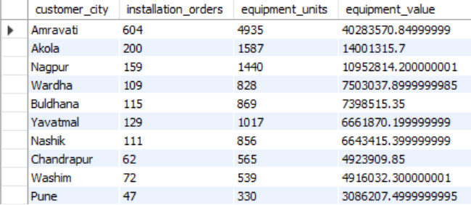
Figure 9: What is the installation volume and equipment value distributed across different cities?

Key Findings & Business Impact:
- Amravati is the primary regional market with 604 installation orders and ₹4.03 Cr in equipment value.
- Akola (₹1.40 Cr) and Nagpur (₹1.10 Cr) follow as secondary installation hubs.
3. Customer Insights
Q10. How are customers distributed based on their purchasing history?
Objective: Segment accounts into New, Returning, and High-Frequency tiers to inspect customer retention.
WITH customer_orders AS (
SELECT
customer_id,
customer_type,
COUNT(*) AS order_count,
SUM(net_sales_inr) AS lifetime_sales
FROM solar_sales
WHERE order_status = 'Completed'
GROUP BY
customer_id,
customer_type
)
SELECT
customer_type,
CASE
WHEN order_count = 1
THEN 'New Account'
WHEN order_count BETWEEN 2 AND 5
THEN 'Returning Account'
ELSE 'High-Frequency Account'
END AS customer_segment,
COUNT(*) AS customer_count,
SUM(lifetime_sales) AS segment_revenue
FROM customer_orders
GROUP BY
customer_type,
customer_segment
ORDER BY segment_revenue DESC;

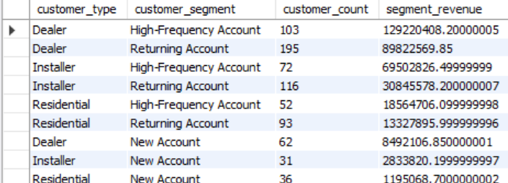
Figure 10: How are customers distributed based on their purchasing history?

Key Findings & Business Impact:
- 103 High-Frequency Dealers drive the largest share of business at ₹12.92 Cr.
- Returning accounts (2-5 orders) represent the largest retention base across Dealers (195) and Installers (116).
Q11. Which customers have placed the highest number of orders and generated the highest lifetime revenue?
Objective: Identify the top 5 key accounts ranked by transaction count and cumulative lifetime spend.
SELECT
customer_id,
customer_type,
COUNT(*) AS total_orders,
SUM(net_sales_inr) AS lifetime_revenue,
ROUND(AVG(net_sales_inr), 2) AS average_order_value
FROM solar_sales
WHERE order_status = 'Completed'
GROUP BY
customer_id,
customer_type
ORDER BY
total_orders DESC,
lifetime_revenue DESC
LIMIT 5;

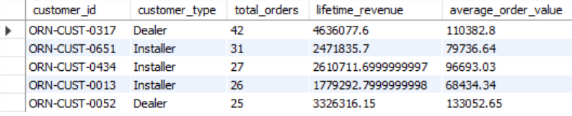
Figure 11: Which customers have placed the highest number of orders and generated the highest lifetime revenue?

Key Findings & Business Impact:
- Top account ORN-CUST-0317 (Dealer) accounts for 42 completed orders and ₹46.36L in revenue.
- Installer accounts ORN-CUST-0651 (31 orders) and ORN-CUST-0434 (27 orders) demonstrate strong re-order rates.

