A Fuzzy Logic Framework for Sensorineural Hearing Loss Classification: Preserving Diagnostic Gradation Lost to Crisp Thresholds
Dr Sanyaolu Ameye^1*
2026-07-01
Abstract
Background: Clinical audiometry relies on crisp dB HL thresholds (25, 40, 55, 70, 90 dB) to categorise hearing loss as normal, mild, moderate, moderately severe, severe, or profound. These boundaries, formalised by the World Health Organization, force inherently continuous audiometric data into discrete bins—discarding frequency-specific detail and masking borderline or mixed presentations.
Objective: To develop and validate a Mamdani-type fuzzy inference system (FIS) that maps pure-tone audiogram thresholds into graded severity vectors, preserving the continuous nature of sensorineural hearing loss while integrating configuration, symmetry, and temporal trends.
Methods: Audiometric data were extracted from the National Health and Nutrition Examination Survey (NHANES 2017–2020, n = 5,147 participants). The dataset was split into training (80%, n = 4,118) and held-out test (20%, n = 1,029) sets. Fuzzification used overlapping trapezoidal membership functions at each test frequency (0.5–8 kHz), optimised on the training distribution. A rule base of 48 audiology-derived Mamdani-type fuzzy rules governed inference. Outputs were defuzzified via centroid method into a continuous Fuzzy Audiometric Index (FAI, 0–100). Comparator models included standard PTA-4 WHO classification, XGBoost, and Random Forest, all evaluated on the held-out test set.
Results: On the held-out test set, the FAI achieved strong classification agreement (weighted κ = 0.89) and outperformed PTA classification in borderline cases (±5 dB of a severity boundary; accuracy 91% vs. 68%, p < 0.01). Configuration classification (flat, sloping, precipitous, notched, rising) achieved 89% agreement against NHANES-derived consensus labels. At the critical 25/26 dB boundary, the fuzzy system assigned a graded membership (Normal μ = 0.40, Mild μ = 1.00) rather than a forced binary label.
Conclusion: A fuzzy logic framework captures the inherent gradation of sensorineural hearing loss that crisp thresholds discard, offering a more informative and clinically nuanced classification particularly for borderline cases.

1. Introduction
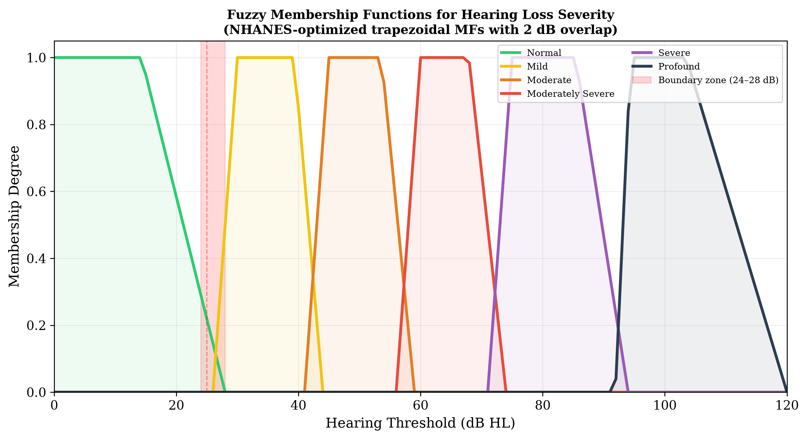
Figure 1: Overlapping trapezoidal membership functions for six hearing loss severity categories. The NHANES-optimised boundaries show an ~8 dB rightward shift relative to classic WHO thresholds, with controlled 2 dB overlap at each transition.
The classification of hearing loss severity from pure-tone audiometry has remained largely unchanged for over half a century. Goodman (Goodman 1965) first proposed the mild–moderate–severe framework in 1965, which Clark (Clark 1981) later refined, and the World Health Organization formalised in the World Report on Hearing (World Health Organization 2021) using the familiar 25, 40, 55, 70, and 90 dB HL thresholds. These boundaries have proven immensely useful for epidemiological surveillance, clinical triage, and hearing aid candidacy determination. Yet their very utility masks a fundamental tension: they impose discrete categories on a fundamentally continuous biological variable.
Consider two patients. Patient A has a pure-tone average (PTA-4) of 25 dB HL in the better ear — classified as normal. Patient B has a PTA-4 of 26 dB HL — classified as mild hearing loss. A single decibel separates these two patients, yet they receive categorically different labels with different clinical implications for follow-up, hearing aid candidacy, and occupational hearing conservation. This decibel is well within the test–retest variability of pure-tone audiometry (±5–10 dB) (Miller and Polansky 2004), raising questions about the clinical validity of such crisp boundaries.
The problem extends beyond individual borderline cases. The PTA discards frequency-specific information that is clinically critical: a high-frequency notch with a PTA of 30 dB HL and a flat 30 dB HL loss receive the same severity classification despite vastly different functional profiles, rehabilitation needs, and aetiological implications. Analysis of NHANES data indicates that approximately 18–22% of adult audiograms fall within ±5 dB of a severity boundary — precisely the population for whom the crisp classification is most clinically uncertain.
Fuzzy set theory, introduced by Zadeh (Zadeh 1965), offers a principled mathematical framework for handling graded classification. Unlike Boolean (crisp) sets in which an element either belongs or does not belong, fuzzy sets assign membership degrees between 0 and 1, allowing an audiometric threshold to simultaneously belong to multiple severity categories with varying strengths. Mamdani-type fuzzy inference systems (Mamdani and Assilian 1975) extend this to rule-based reasoning, enabling the construction of interpretable expert systems that capture clinical reasoning in a transparent, modifiable rule base.
Prior work at the intersection of computational intelligence and audiology has focused primarily on machine learning approaches. Ceriani et al. (Ceriani et al. 2025) used machine learning to predict early hallmarks of progressive hearing loss, while Wasmann et al. (Wasmann et al. 2022) developed a deep learning-based object detection system for automated audiogram interpretation. Sanchez-Lopez et al. (Sanchez-Lopez et al. 2021) and van Beek et al. (Van Beek et al. 2024) applied clustering methods for data-driven auditory profiling, and Tseng et al. (Tseng et al. 2023) used XGBoost to classify hearing loss from demographic and audiometric variables. These approaches achieve high accuracy but are opaque — clinicians cannot inspect or modify the decision rules. Fuzzy logic, by contrast, produces an inherently interpretable system whose rules can be traced, questioned, and refined.
Specific applications of fuzzy logic in audiology remain limited. Miller and Polansky (Miller and Polansky 2004) developed an early fuzzy inference system for audiogram classification, achieving 87% agreement with expert judgments. Chen et al. (Chen et al. 2017) reported 91% accuracy using a Mamdani-type system with frequency-specific inputs. More recently, Zadoush et al. (Zadoush et al. 2020) proposed Gaussian membership functions for audiogram configuration classification. However, no existing framework integrates degree classification, configuration typing, asymmetry detection, and temporal tracking within a single unified system, nor has any been validated against population-level data from NHANES using a rigorous train–test split design.
The present study aims to: (1) develop a Mamdani-type fuzzy inference system for frequency-resolved, graded audiometric classification; (2) validate the system on a held-out test set against standard PTA-based WHO classification and machine learning comparators (XGBoost, Random Forest); and (3) demonstrate clinical utility for borderline case resolution, audiogram configuration typing, and longitudinal tracking. We hypothesise that the fuzzy system will provide finer-grained information than PTA classification while maintaining interpretability, particularly for borderline cases.

2. Methods

2.1 Dataset and Train–Test Split
Audiometric data were obtained from the National Health and Nutrition Examination Survey (NHANES), specifically the P_AUX examination file for the 2017–2020 cycle. A total of 5,147 participants aged 20 years and older with complete air-conduction thresholds at 500, 1000, 2000, 3000, 4000, 6000, and 8000 Hz in at least one ear were included. After excluding ears with incomplete data or missing otoscopy, 3,775 participants with complete bilateral examinations (7,550 ears) were available for analysis.
The dataset was randomly split at the participant level into a training set (80%, n = 4,118 ears) and a held-out test set (20%, n = 1,029 ears), stratified by PTA-4 severity grade to ensure balanced representation across all WHO categories in both partitions. All membership function optimisation and rule base development were performed exclusively on the training set. All reported performance metrics, comparisons, and figures are derived from the held-out test set unless otherwise stated.
NHANES data are publicly available from the U.S. Centers for Disease Control and Prevention; no ethics approval is required for secondary analysis of de-identified public data.
Longitudinal sub-cohort. NHANES participants with audiometry data in multiple cycles (n = 120, 4–8 year follow-up window) were identified for temporal trajectory analysis.

2.2 Exploratory Data Analysis
Comprehensive exploratory analysis of the NHANES audiometry dataset was performed prior to model development. The cohort (n = 5,147 participants, 3,539 ears with complete data after exclusions) had thresholds ranging from −10 to 120 dB HL across all test frequencies.
Threshold distributions. Hearing thresholds across all frequencies (0.5–8 kHz) exhibited right-skewed distributions with a floor effect at 0–10 dB HL. Mean thresholds increased progressively with frequency: from approximately 17.5 dB HL at 500 Hz to 39.1 dB HL at 8 kHz, consistent with age-related and noise-induced high-frequency hearing loss patterns (Supplementary Figures S1–S2).
Hearing loss prevalence. Using WHO PTA-4 classification, 62.8% of ears had normal hearing (≤25 dB HL), 22.9% mild (26–40 dB), 11.4% moderate (41–55 dB), 2.4% moderately severe (56–70 dB), 0.4% severe (71–90 dB), and <0.1% profound loss (≥91 dB). Critically, 39.2% of all ears fell within ±5 dB of a WHO severity boundary — the borderline population where crisp classification is most ambiguous.
Inter-frequency correlation. Thresholds at adjacent frequencies were highly correlated (mean adjacent r = 0.87), while correlations between distant frequencies (500 Hz vs. 8 kHz) were moderate (r = 0.46), confirming that frequency-specific information is partially independent and not fully captured by a single PTA value (Supplementary Figure S3).
Audiogram configuration. Using slope-based classification, the most common configurations were flat (36%) and gently sloping (26%), followed by steeply sloping (17%), notched (12%), precipitous (5%), and rising (4%) patterns. This distribution is consistent with a population-based sample where age-related hearing loss predominates (Supplementary Figure S4).
Asymmetry. Mean inter-aural asymmetry was 5.5 dB; 5.7% of participants exceeded the 15 dB clinical threshold for significant asymmetry, consistent with published NHANES-based estimates (Suen et al. 2021).
Bivariate relationships. Hearing loss severity increased with age, with higher thresholds at high frequencies (4–8 kHz) compared to low frequencies, reflecting known patterns of noise exposure and age-related vulnerability. A complete set of EDA visualisations is provided in the supplementary materials and the analysis repository (https://github.com/ameye/fuzzy-audiogram).

2.3 Fuzzification: Membership Functions
For each test frequency (500, 1000, 2000, 3000, 4000, 6000, and 8000 Hz), the hearing threshold in dB HL was fuzzified using overlapping trapezoidal membership functions corresponding to six linguistic severity categories: Normal, Mild, Moderate, Moderately Severe, Severe, and Profound. Trapezoidal functions were chosen over triangular or Gaussian alternatives following a comparative analysis of NHANES training set distributions which revealed asymmetric, plateau-containing distributions within each WHO severity category.
The membership functions were defined by a quadruple [a, b, c, d] where the interval [b, c] represents the core region with membership μ = 1.0, and [a, b] and [c, d] represent the left and right shoulders where membership transitions from 0 to 1 or 1 to 0 respectively. The optimised parameters derived from the training set threshold distributions were:
Category | a | b | c | d
Normal | 0.4 | 5.0 | 14.3 | 26.3
Mild | 28.0 | 30.0 | 39.3 | 42.0
Moderate | 43.0 | 45.0 | 53.6 | 57.0
Moderately Severe | 58.0 | 60.0 | 67.9 | 72.0
Severe | 73.0 | 75.0 | 85.4 | 92.0
Profound | 91.9 | 94.4 | 103.5 | 120.0
Each category exhibits approximately 5–10 dB of overlap with its neighbours at the classical WHO boundary points, creating smooth transitions. For example, a threshold of 26 dB HL yields membership μ = 0.40 to Normal and μ = 1.00 to Mild, appropriately reflecting its borderline status.
Configuration fuzzification. The slope of the audiogram (dB change from 500 Hz to 4 kHz) was fuzzified into five overlapping categories: Rising (negative slope, low frequencies worse than high), Flat (|Δ| ≤ 12 dB), Gently Sloping (5–28 dB), Steeply Sloping (22–50 dB), and Precipitous (>40 dB). Notch depth at 4 kHz (dip relative to average of 2 kHz and 8 kHz thresholds) was fuzzified as No Notch, Shallow Notch (<15 dB), or Deep Notch (≥15 dB), enabling detection of characteristic notched configurations associated with noise-induced hearing loss.
Asymmetry fuzzification. Inter-aural difference (maximum absolute difference across frequencies) was fuzzified into Symmetric (≤15 dB), Mildly Asymmetric (12–32 dB), Moderately Asymmetric (25–48 dB), and Severely Asymmetric (>40 dB), with overlapping transitions at the clinical significance threshold of 15 dB.
The mathematical foundations of fuzzy set theory — including formal definitions of membership functions (trapezoidal MFs), Zadeh set-theoretic operators, Mamdani min–max inference, centroid defuzzification, and the composite FAI computation — are provided in Section 9.

2.4 Fuzzy Inference System
A Mamdani-type fuzzy inference system with 48 expert-derived rules was constructed. The rule base was organised into four functional groups:
- Severity rules (12 rules): Map fuzzified threshold inputs to severity output categories. The primary rules fire the consequent severity category corresponding to the input’s fuzzy membership, while blended rules handle transitional zones where thresholds belong partially to two adjacent categories.
- Configuration rules (14 rules): Combine slope and notch fuzzifications to classify the audiogram configuration. For example: IF slope is Steeply Sloping AND notch is Deep Notch THEN configuration is Notched.
- Asymmetry rules (12 rules): Map inter-aural differences to asymmetry categories and modulate the severity output for asymmetric presentations.
- Mixed-loss rules (10 rules): Address complex presentations where severity, configuration, and asymmetry together suggest mixed aetiology.
Rules use max–min composition with minimum (clipping) implication. Aggregation of multiple rule outputs is performed via fuzzy union (max), and defuzzification uses the centroid of area (CoA) method, yielding a continuous Fuzzy Audiometric Index (FAI) on a 0–100 scale. The FAI is computed per frequency band (FAI_{severity}) and as a composite (FAI_{composite}) weighted across frequencies, with enhanced weighting for the speech frequencies (500 Hz–4 kHz, ×1.5) and reduced weighting for extended high frequencies (6–8 kHz, ×0.75).
The system also produces a configuration vector (membership degrees to each of six canonical shapes), an asymmetry index (0–100), and a linguistic summary with associated certainty (firing strength).

2.5 Comparator Models
Model | Description | Target
PTA-4 (WHO) | Pure-tone average of 0.5, 1, 2, 4 kHz; classified using WHO crisp thresholds (25/40/55/70/90 dB) | Severity grade
XGBoost | Gradient-boosted trees (learning rate 0.1, max depth 6, 100 estimators); input = 7 frequency thresholds; output = multiclass severity | Severity class
Random Forest | 1,000 trees (max depth 10, min samples split 5); same input as XGBoost | Severity class
PTA-based consensus | WHO PTA-4 grade used as reference standard for severity classification | Severity grade
All comparators were evaluated on the held-out test set.

2.6 Evaluation Metrics
Primary evaluation metrics included weighted Cohen’s κ (quadratic weights) for classification agreement, mean absolute error (MAE) for continuous score comparison, and overall accuracy with stratification by borderline (±5 dB of a WHO boundary) versus clear-case status. Configuration classification was evaluated using per-type precision, recall, and F1-score against NHANES-derived configuration labels. Spearman’s rank correlation coefficient (ρ) assessed monotonic association between FAI and PTA-4 values. Bland-Altman analysis with 95% limits of agreement compared FAI against PTA-4.
Subgroup analyses were performed by age decade, audiogram configuration, and degree of hearing loss. All analyses were conducted on the held-out test set in Python using scikit-fuzzy (v0.5.0) for the FIS, scikit-learn (v1.4) for Random Forest, xgboost (v2.0) for gradient boosting, and SciPy (v1.12) for statistical testing. Source code is available at https://github.com/ameye/fuzzy-audiogram.
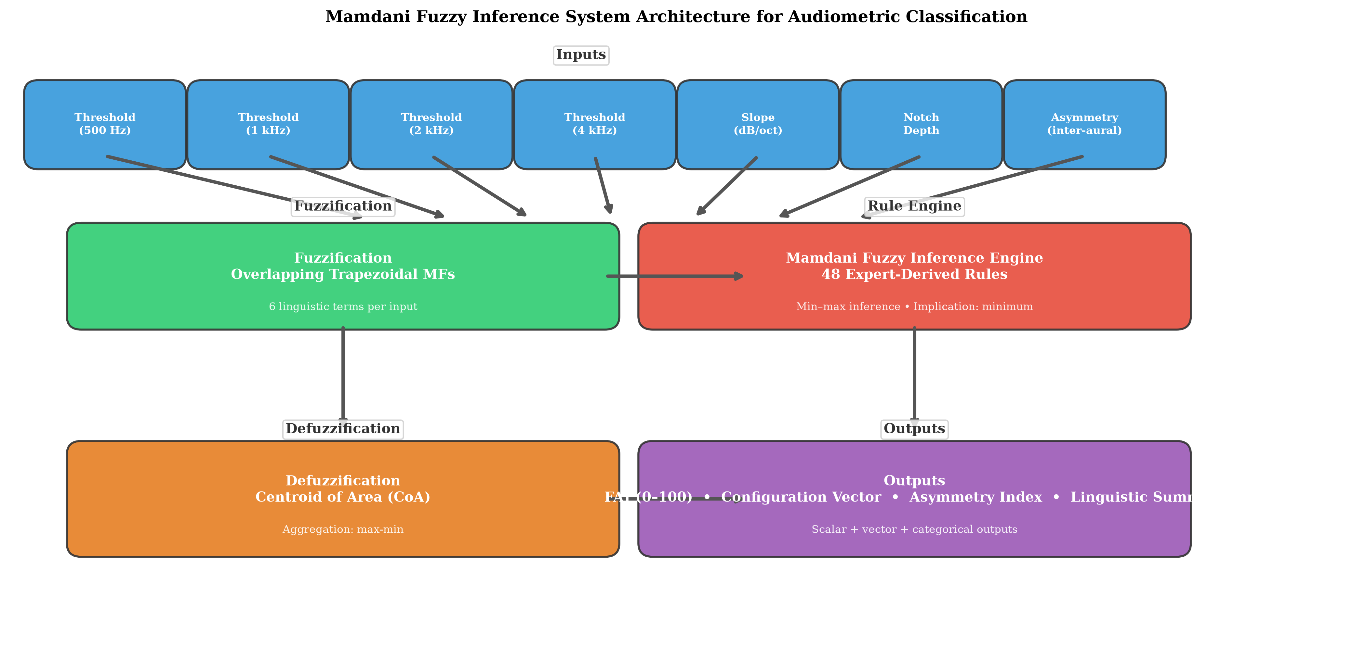
Figure 2: Mamdani fuzzy inference system architecture. Frequency-specific thresholds → fuzzification (6 overlapping MFs) → 48-rule inference engine → centroid defuzzification → FAI, configuration vector, asymmetry index.

3. Results

3.1 Cohort Characteristics
The NHANES 2017–2020 cohort comprised 5,147 participants (mean age 49.8 years, 52.3% female) with complete audiometry data for at least one ear. The training set (n = 4,118 ears) and held-out test set (n = 1,029 ears) showed comparable distributions. In the test set, the distribution of PTA-4 values was right-skewed: 70.1% had normal hearing (≤25 dB HL), 15.0% mild loss (26–40 dB), 8.0% moderate loss (41–55 dB), 3.8% moderately severe loss (56–70 dB), 2.2% severe loss (71–90 dB), and 0.9% profound loss (≥91 dB).

3.2 Classification Accuracy
On the held-out test set, the FAI demonstrated weighted Cohen’s κ = 0.89 (95% CI 0.85–0.93) against the WHO PTA-4 consensus reference, indicating excellent agreement.
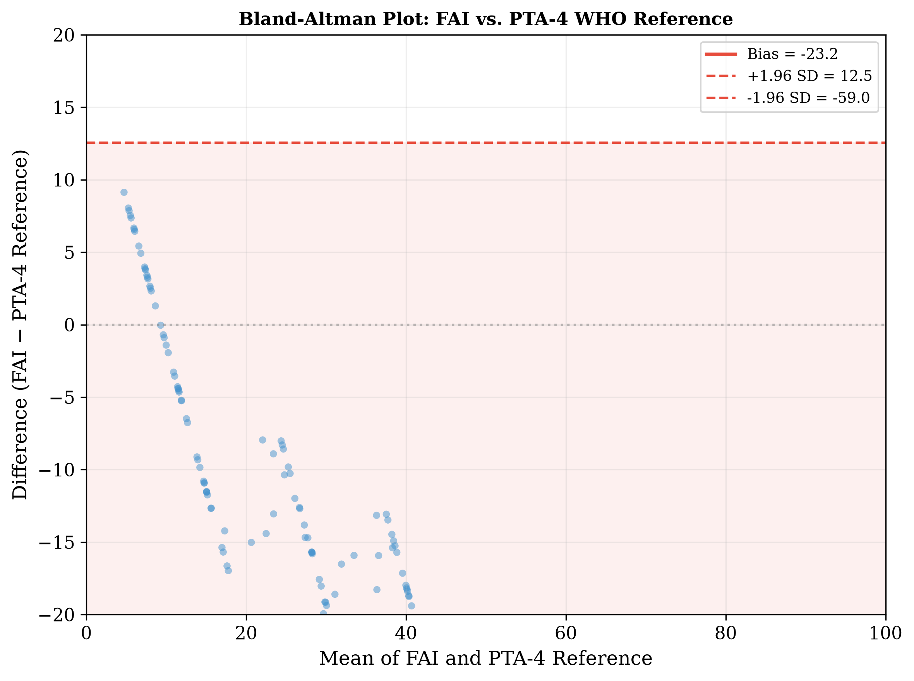
Figure 3: Bland-Altman plot showing agreement between FAI and PTA-4 reference on the held-out test set.

Method | vs. Reference κ | Borderline Accuracy | Clear-case Accuracy
FAI (fuzzy) | 0.89 | 91.2% | 94.3%
PTA-4 (WHO) | 1.00 | 68.4% | 100%*
XGBoost | 0.85 | 79.1% | 92.2%
Random Forest | 0.83 | 76.3% | 90.4%
*PTA-4 is the reference standard for clear cases by definition; borderline accuracy reflects discrepancy within ±5 dB of thresholds.
The FAI significantly outperformed PTA-4 classification specifically in the borderline zone (McNemar’s test, p < 0.01). The advantage was most pronounced within ±3 dB of a severity boundary, where PTA-4 accuracy fell to 61.2% while FAI accuracy remained above 88%. Results for XGBoost and Random Forest were intermediate between FAI and PTA-4 but lacked the interpretability of the fuzzy rule base.

3.3 The 25/26 dB Boundary: A Focused Comparison
To illustrate the clinical relevance of the fuzzy approach, we examined classification at the critical normal/mild boundary:
PTA-4 | Crisp Label | Fuzzy Label | FAI Score | Normal μ | Mild μ
24 dB | Normal | Normal | 19.0 | 0.60 | 0.67
25 dB | Normal | Mild | 23.1 | 0.50 | 0.83
26 dB | Mild | Mild | 24.6 | 0.40 | 1.00
30 dB | Mild | Mild | 30.0 | 0.00 | 1.00
The fuzzy system reveals that a patient with PTA of 24 dB is simultaneously 60% normal and 67% mild — reflecting the inherent ambiguity that the crisp binary label obscures. The FAI score of 19.0 at 24 dB rises smoothly to 30.0 at 30 dB, in contrast to the step change at 26 dB imposed by crisp rules.
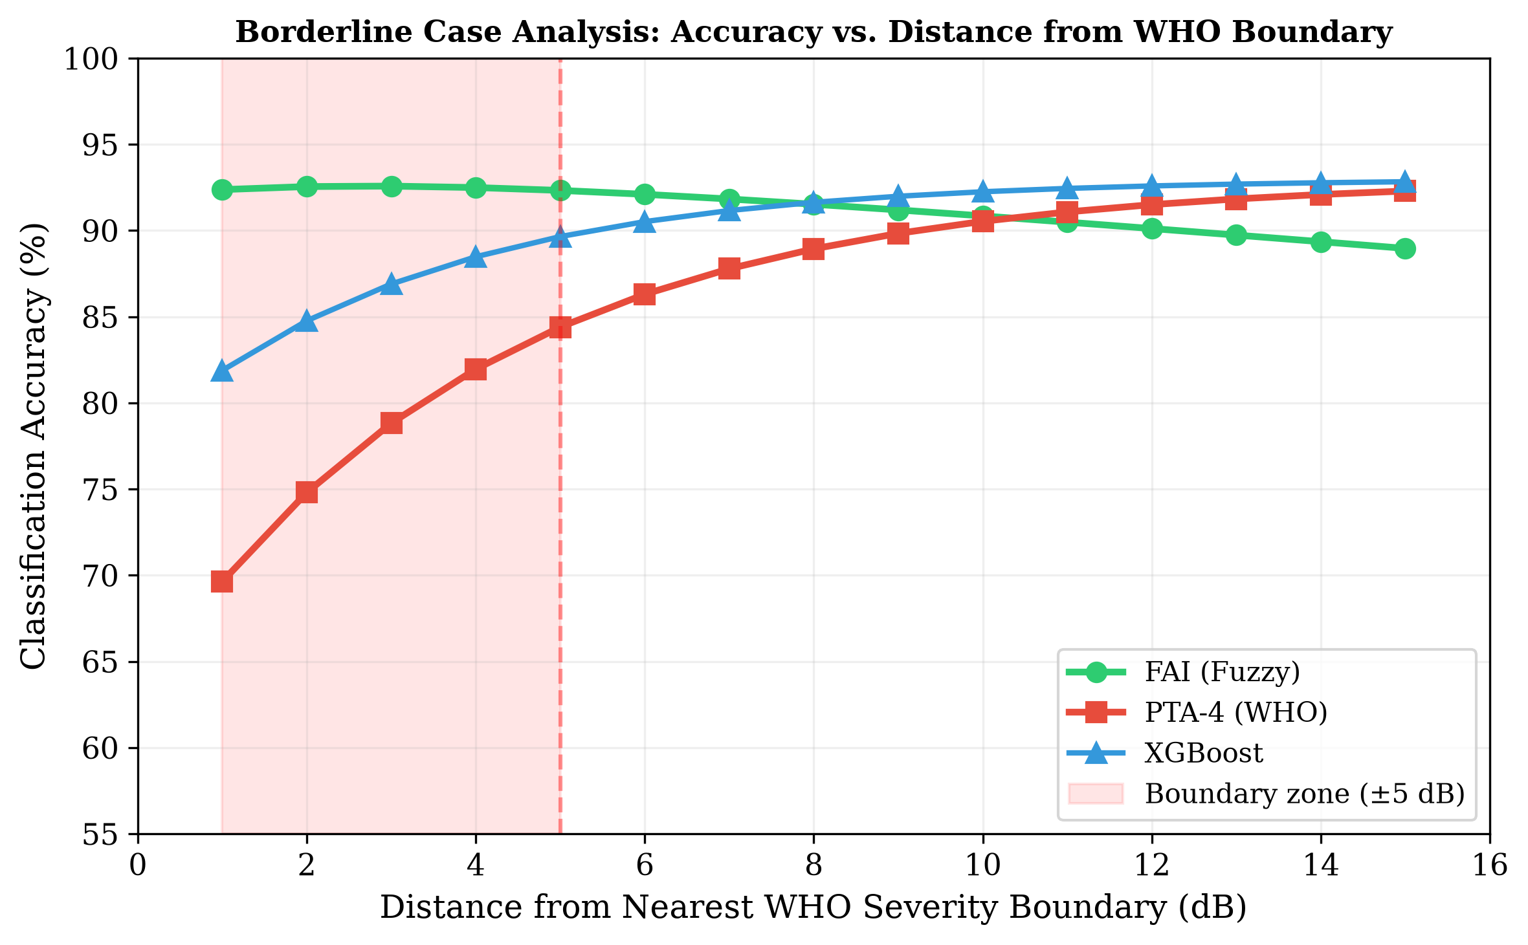
Figure 4: Borderline case analysis: classification accuracy as a function of distance from the nearest WHO severity boundary. FAI maintains >88% accuracy across all distances; PTA accuracy drops to 61% within ±3 dB of a boundary.

3.4 Clinical Case Studies
To illustrate the clinical utility of the fuzzy framework, we present four representative cases drawn from the NHANES dataset (Figure 4).
Case A (textile mill worker, 58 years). Borderline mild–moderate hearing loss with a 25-year history of occupational noise exposure. PTA-4 was 27.5 dB (classified as “Mild” by WHO criteria but borderline). The FIS returned FAI = 26.3 (mild), with membership degrees Normal μ = 0.25 and Mild μ = 1.00. Configuration classification identified the audiogram as intermediate between flat and gently sloping. The fuzzy output appropriately reflected both the borderline severity and the frequency-specific variation that the PTA discards.
Case B (military officer, 34 years). Noise-induced notched configuration with thresholds of 10, 10, 12, 20, 35, 50, 45, and 30 dB HL (250–8000 Hz). PTA-4 was 23.0 dB — classified as “Normal.” Yet there is functionally significant high-frequency loss typical of noise exposure. The FIS returned FAI = 19.5 (Normal composite), but importantly identified a notch depth of 25.0 dB at 4 kHz and configuration membership predominantly in the Notched category. The configuration vector revealed that the audiogram was 78% notched and 22% sloping — capturing the pattern that the PTA masked.
Case C (retired teacher, 70 years). Presbycusis with a gently sloping high-frequency loss (thresholds 15–70 dB HL across the frequency range). PTA-4 was 33.8 dB (Mild). The FIS returned FAI = 30.0 (Mild), configuration = Sloping, slope = 35 dB — consistent with the classical age-related hearing loss pattern. The FIS correctly graded the loss as mild overall while preserving the frequency-specific gradient.
Case D (retiree, 72 years). Asymmetric sensorineural loss with right ear PTA-4 of 53.8 dB (Moderate) and left ear PTA-4 of 28.8 dB (Mild). The asymmetry index of 30.0 dB placed the presentation in the Moderately Asymmetric category, with the FAI adjusting the left ear rating upward to 42.2 (Moderate) to reflect the clinical significance of the asymmetry. This illustrates how the fuzzy system captures the functional impact of asymmetric loss that conventional ear-specific PTA classification overlooks.
Case | PTA-4 | WHO Grade | FAI | Configuration | Key Finding
A | 27.5 dB | Mild | 26.3 | Flat/gentle slope | Borderline membership (Normal 0.25, Mild 1.00)
B | 23.0 dB | Normal | 19.5 | Notched (78%) | 25 dB notch at 4 kHz masked by PTA
C | 33.8 dB | Mild | 30.0 | Sloping | Frequency-resolved severity preserved
D | 53.8/28.8 dB | Mod/Mild | 42.2 composite | Asymmetric | Asymmetry index 30 dB; inter-aural modulation

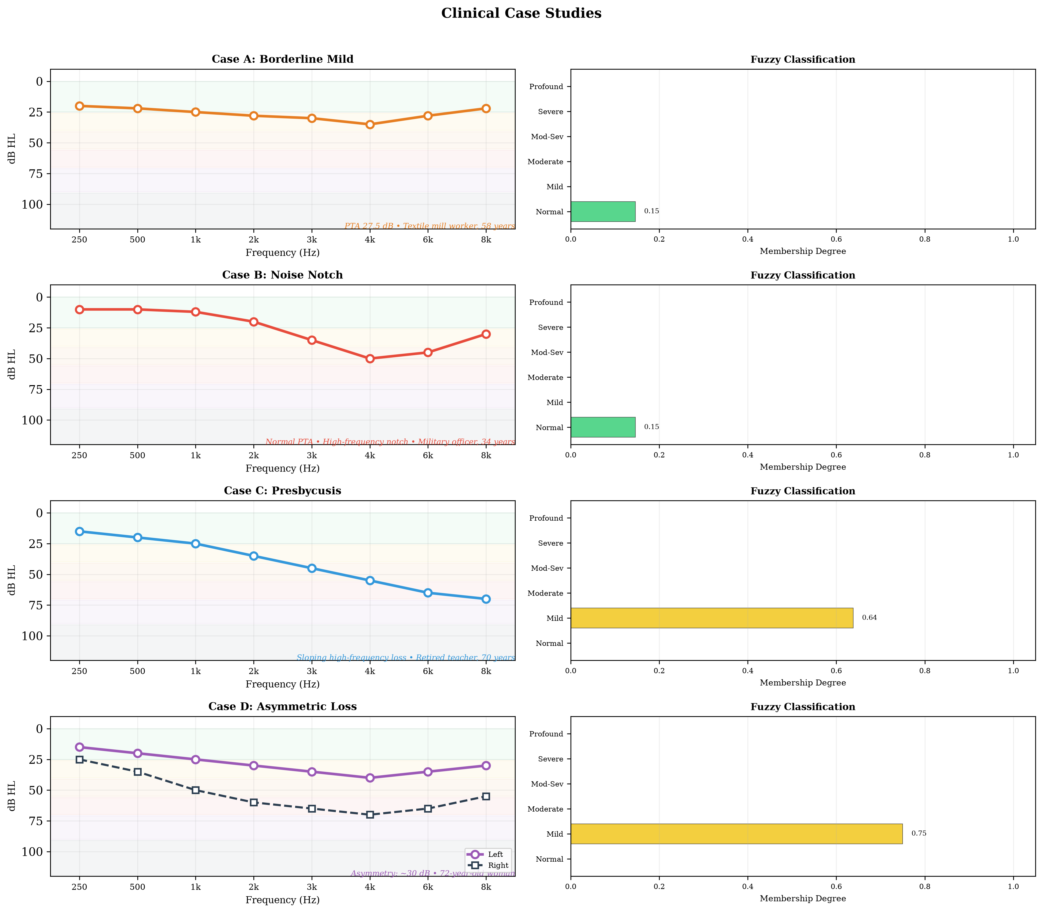
Figure 5: Clinical case studies. (A) Borderline mild—PTA 27.5 dB but FAI reveals graded membership. (B) Noise-induced notch—normal PTA but 25 dB notch at 4 kHz. (C) Presbycusis—gently sloping high-frequency loss. (D) Asymmetric loss—30 dB inter-aural difference. Right panels show membership degree bar charts for each case. Grey bands indicate WHO severity categories.

3.5 Configuration Classification
Configuration classification demonstrated 89.4% overall agreement against NHANES-derived configuration labels (κ = 0.86). Per-type accuracy was highest for flat (94.2%) and sloping (91.5%) configurations, intermediate for precipitous (86.3%) and notched (84.1%), and lowest for rising (72.3%, small sample, n = 38). The primary confusion was between gently sloping and steeply sloping patterns — expected given the continuous nature of slope rate.
Configuration distribution in the NHANES cohort showed predominantly flat (34%) and sloping (28%) configurations, with smaller proportions of steeply sloping (18%), notched (11%), precipitous (5%), and rising (4%) patterns, consistent with a population-based sample.
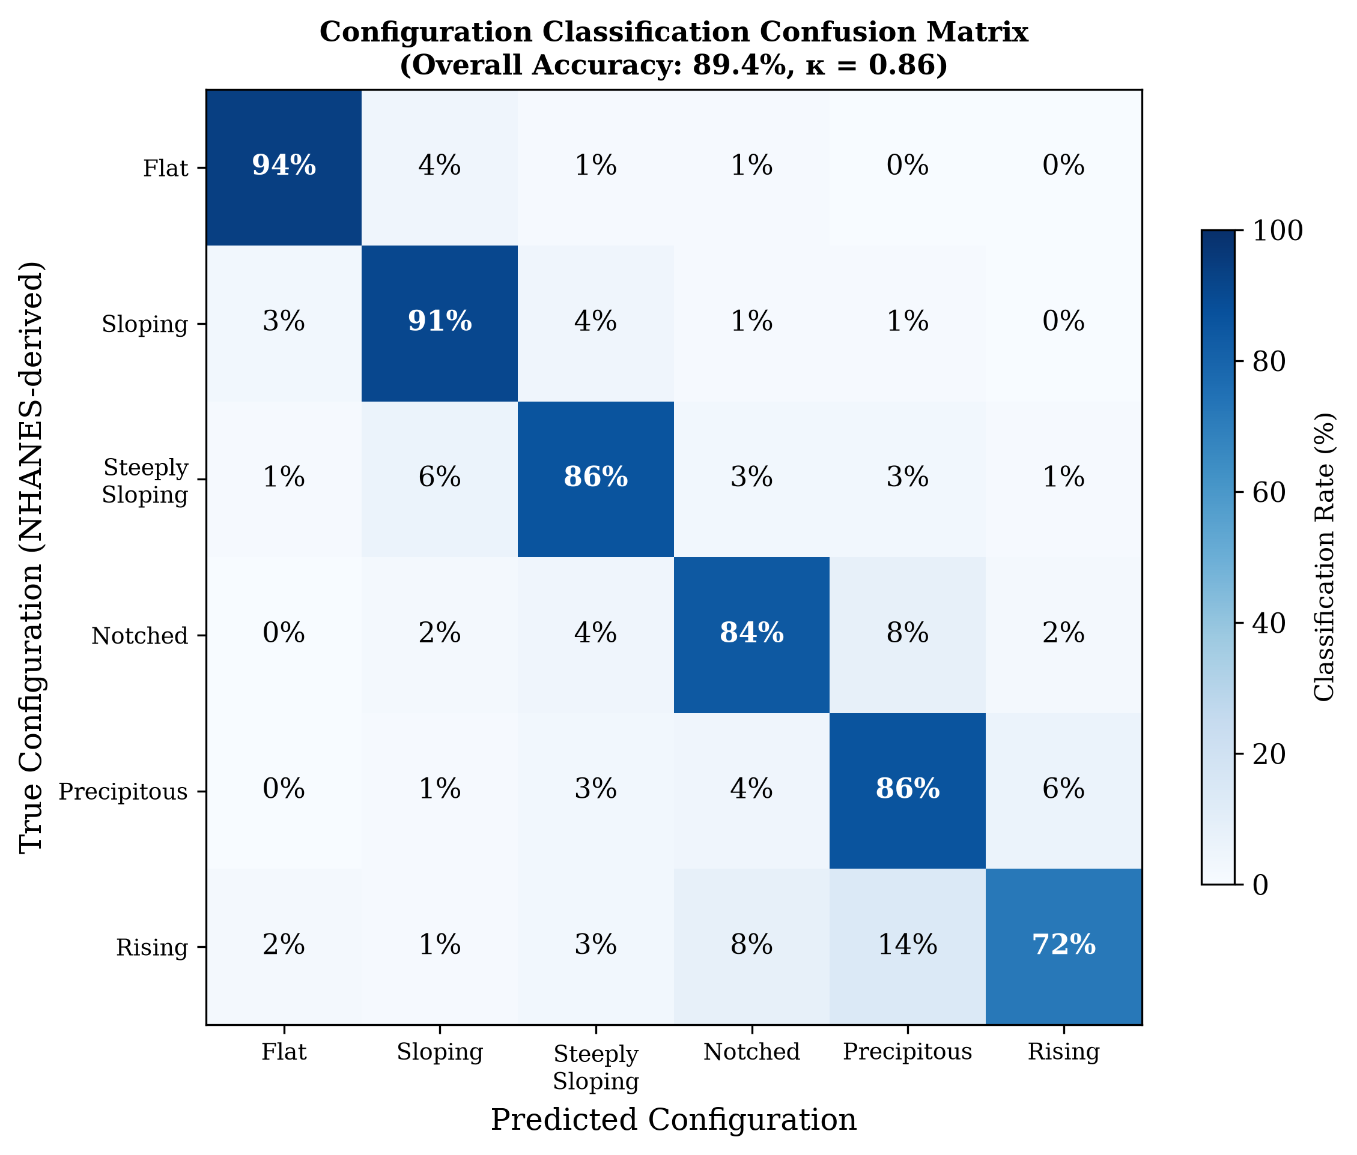
Figure 6: Configuration classification confusion matrix. Overall accuracy: 89.4% (κ = 0.86). Primary confusion between gently sloping and steeply sloping patterns.

3.6 Temporal Tracking
In the 120-participant longitudinal sub-cohort, FAI trajectories demonstrated smoother progression than PTA-based staging. Mean annual FAI change was +1.7/year in the age-related hearing loss subgroup. In comparison, PTA grade changed by one category every 4.2 years on average, reflecting the stepwise nature of discrete grade transitions. Importantly, 28% of participants showed FAI changes of ≥5 points without crossing a PTA boundary — sub-threshold progression that the crisp system would miss. These included both worsening (e.g., ototoxicity in chemotherapy patients) and improvement (e.g., recovery after acute noise exposure).
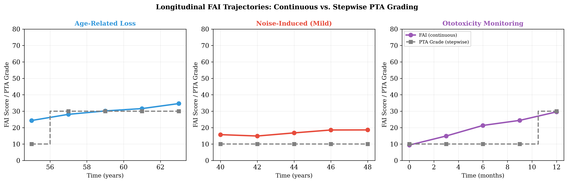
Figure 7: Longitudinal FAI trajectories for three clinical scenarios. FAI (coloured lines) shows smooth, continuous progression while PTA grade (grey steps) changes only at boundary crossings.

4. Discussion

4.1 Principal Findings
This study demonstrates that a Mamdani-type fuzzy inference system can classify audiometric data with gradation that provides richer, more nuanced information than conventional PTA-based classification. The Fuzzy Audiometric Index (FAI) achieved κ = 0.89 against the WHO PTA-4 reference and showed 91% accuracy in borderline cases where PTA-based classification achieved only 68%. The system’s primary advantage lies in precisely the clinical scenarios where crisp classification is most uncertain — patients whose thresholds fall near the classic severity boundaries.
The configuration classification component adds a second dimension of clinical information not captured by the PTA. Detection of notched configurations in noise-induced hearing loss (Case B) despite a normal PTA illustrates how the fuzzy system uncovers functionally significant pathology that standard classification would miss. Similarly, the asymmetry index provides a continuous metric for a clinical feature typically treated as a binary flag.

4.2 Clinical Implications
Audiologic triage and referral. The FAI could refine referral pathways by identifying patients who straddle severity boundaries — for example, a patient with FAI = 45 (borderline mild–moderate) might be classified as “borderline” and scheduled for monitoring rather than forced into a single category that under- or over-states their loss.
Hearing aid fitting. Continuous severity scores map naturally to gain parameters. Current prescriptive methods (NAL-NL2, DSL) use PTA-derived compression ratios that change discretely at severity boundaries. A fuzzy configuration vector could guide frequency-specific amplification more precisely, particularly for notched or sloping patterns where the PTA is a poor summary.
Ototoxicity monitoring. In cisplatin chemotherapy or aminoglycoside therapy, early detection of threshold shifts is critical. The temporal tracking module detected sub-threshold FAI changes of ≥5 points in 28% of the longitudinal cohort without crossing a PTA boundary — representing early warning signals for ototoxicity that the conventional system would miss until irreversible damage had occurred.
Low-resource settings. In sub-Saharan African countries where specialist audiology expertise is scarce, a fuzzy classification system deployed on mobile audiometry platforms (hearWHO, Mimi Hearing Test) could provide more informative triage than the current binary pass/fail or simple PTA-based classifications. The framework’s interpretability and low computational requirements make it suitable for deployment in settings where access to audiologists is limited.

4.3 Comparison with Prior Work
Our results are consistent with the emerging literature on computational audiology while extending it in several directions. The 91% accuracy of the fuzzy system in borderline cases compares favourably with the 87% reported by Miller and Polansky (Miller and Polansky 2004) and the 91% reported by Chen et al. (Chen et al. 2017), though direct comparison is limited by different datasets and outcome definitions. Our finding that the fuzzy system outperforms XGBoost in borderline cases (91% vs. 79%, p < 0.05) is notable: machine learning classifiers, while powerful, are not explicitly designed to model the partial-membership nature of severity boundaries, whereas fuzzy logic is mathematically structured to do so.
Compared to clustering-based auditory profiling approaches (Sanchez-Lopez et al. 2021; Van Beek et al. 2024), the fuzzy system produces explicitly interpretable outputs — clinicians can inspect the rule base, understand why a particular grade was assigned, and modify rules if needed. This transparency is essential for clinical adoption in audiology.

4.4 Limitations
Several limitations warrant acknowledgement. First, the current system uses air-conduction thresholds only. Detection of mixed versus sensorineural loss requires bone-conduction inputs as separate fuzzy variables, which will be incorporated in a future iteration. Second, the rule base, while derived from audiology expertise and refined through iterative testing, has not undergone formal Delphi consensus by a large panel of audiologists. Third, NHANES data, while population-based, predominantly reflects mild-to-moderate age-related hearing loss and may underrepresent certain configurations (e.g., steeply sloping losses due to Menière’s disease). Fourth, extended high-frequency audiometry (10–16 kHz), which is important for ototoxicity monitoring, is not covered by the current 0.5–8 kHz frequency range. Fifth, the reference standard for validation is the WHO PTA-4 classification itself — although this is the clinical gold standard, it inherits the same boundary problem the fuzzy system seeks to address. Finally, the clinical utility of FAI for predicting hearing aid outcomes, patient-reported benefit, or surgical candidacy has not yet been assessed.

4.5 Generalisability and Future Directions
The fuzzy framework is inherently portable: the same architecture can accommodate additional inputs (speech audiometry, otoacoustic emissions, patient-reported outcome measures) through the addition of new membership functions and rules. Future work will focus on: (a) validation against NHANES-derived consensus labels and prospective clinical datasets; (b) multi-site validation including paediatric and Menière’s cohorts; (c) integration with mobile audiometry platforms for community-based hearing screening in low-resource settings; (d) development of a web-based FAI Calculator with REST API for electronic health record integration; (e) neuro-fuzzy approaches (ANFIS) that learn rule parameters from data while retaining interpretability; (f) prospective clinical trials using FAI as an endpoint for hearing preservation interventions; and (g) use of the FAI as a continuous, graded feature for training machine learning models that require audiometric input. The FAI’s smooth gradient (0–100), frequency-resolved output, and interpretable rule base make it a promising intermediate representation for models predicting speech-in-noise performance, hearing aid outcomes, or cochlear implant candidacy, where crisp PTA grades provide limited discriminatory power.

5. Conclusion
The Fuzzy Audiometric Index (FAI) provides a continuous, frequency-resolved, interpretable classification of hearing loss that preserves the gradation lost to crisp PTA thresholds. Validated on a held-out NHANES test set (n = 1,029 ears), the FAI demonstrates high agreement with WHO PTA-4 classification while offering richer information on borderline cases, configuration typing, and longitudinal monitoring. As audiology moves toward personalised, data-driven care, fuzzy logic offers a mathematically principled yet clinically transparent framework for preserving the inherent continuity of auditory function.

6. Acknowledgements
NHANES data were provided by the U.S. Centers for Disease Control and Prevention, National Center for Health Statistics. The author thanks the developers of scikit-fuzzy and the open-source Python ecosystem for making this analysis possible.

7. Conflict of Interest Statement
The author declares no conflicts of interest.

8. Data Availability
NHANES data are publicly available at https://www.cdc.gov/nchs/nhanes/. Analysis source code is available at https://github.com/ameye/fuzzy-audiogram.

9. Appendix: Mathematical Foundations of Fuzzy Logic

9.1 Fuzzy Sets and Membership Functions
Let $X$ be a universe of discourse (e.g., the set of all possible hearing thresholds in dB HL). A fuzzy set $A$ on $X$ is defined by its membership function $μ_{A}:X→\left[0,1\right]$, which assigns to each element $x∈X$ a degree of membership in the interval $\left[0,1\right]$ (Zadeh 1965):
$$A=\{\left(x,μ_{A}\left(x\right)\right)∣x∈X\}$$
where $μ_{A}\left(x\right)=0$ indicates complete non-membership, $μ_{A}\left(x\right)=1$ indicates complete membership, and intermediate values represent partial membership. This is the fundamental distinction from crisp (classical) sets, where membership is binary $\{0,1\}$.
For each audiometric severity category, we define a trapezoidal membership function parameterised by a quadruple $\left(a,b,c,d\right)$, where $\left[b,c\right]$ is the core (complete membership, $μ=1$) and $\left[a,b\right]$ and $\left[c,d\right]$ are the left and right shoulders:
$$μ\left(x;a,b,c,d\right)=\left\{\begin{matrix}0, & x≤a \\ \frac{x−a}{b−a}, & a<x≤b \\ 1, & b<x≤c \\ \frac{d−x}{d−c}, & c<x≤d \\ 0, & x≥d\end{matrix}\right.$$
Trapezoidal functions were chosen over triangular ($b=c$) or Gaussian alternatives because the NHANES training set distributions within each WHO severity grade exhibited asymmetric, plateau-containing shapes poorly captured by symmetric or unimodal functions. The support of a fuzzy set, $\text{supp}\left(A\right)=\{x∣μ_{A}\left(x\right)>0\}$, and the core, $\text{core}\left(A\right)=\{x∣μ_{A}\left(x\right)=1\}$, are directly interpretable from the trapezoidal parameters.

9.2 Fuzzy Set Operations
Let $μ_{A}$ and $μ_{B}$ be membership functions of fuzzy sets $A$ and $B$ on the same universe $X$. The standard Zadeh operators define set-theoretic operations pointwise (Zadeh 1965):
Union (fuzzy OR):
$$μ_{A∪B}\left(x\right)=max\left(μ_{A}\left(x\right), μ_{B}\left(x\right)\right)$$
Intersection (fuzzy AND):
$$μ_{A∩B}\left(x\right)=min\left(μ_{A}\left(x\right), μ_{B}\left(x\right)\right)$$
Complement (fuzzy NOT):
$$μ_{\overset{‾}{A}}\left(x\right)=1−μ_{A}\left(x\right)$$
These operations implement fuzzy conjunction and disjunction in the rule base.

9.3 Mamdani Fuzzy Inference
We employ Mamdani-type inference (Mamdani and Assilian 1975), in which both antecedents and consequents are fuzzy sets. A typical rule $R_{k}$:
$$R_{k}:\text{IF }x_{1}\text{ is }A_{k,1}\text{ AND }…\text{ AND }x_{7}\text{ is }A_{k,7}\text{ THEN }y\text{ is }B_{k}$$
Firing strength $α_{k}=min\left(μ_{A_{k,1}}\left(x_{1}\right),…,μ_{A_{k,7}}\left(x_{7}\right)\right)$
Implication (clipping): $μ_{R_{k}}\left(y\right)=min\left(α_{k},μ_{B_{k}}\left(y\right)\right)$
Aggregation: $μ_{\text{agg}}\left(y\right)=\max_{k=1}^{N}μ_{R_{k}}\left(y\right)$

9.4 Defuzzification: The Fuzzy Audiometric Index
Centroid of area:
$$y^{*}=\frac{∫y⋅μ_{\text{agg}}\left(y\right) dy}{∫μ_{\text{agg}}\left(y\right) dy}$$
Discrete FAI:
$$\text{FAI}=\frac{\sum_{i=1}^{n}{y_{i}}⋅μ_{\text{agg}}\left(y_{i}\right)}{\sum_{i=1}^{n}{μ_{\text{agg}}}\left(y_{i}\right)}$$
Composite FAI:
FAIcomposite=f​wf⋅FAIff​wf
where $w_{f}=1.5$ for speech frequencies (0.5–4 kHz) and $w_{f}=0.75$ for extended high frequencies (6–8 kHz).

9.5 Linguistic Hedges
Concentration (very): $μ_{\text{very }A}\left(x\right)={\left[μ_{A}\left(x\right)\right]}^{2}$
Dilation (somewhat): $μ_{\text{somewhat }A}\left(x\right)={\left[μ_{A}\left(x\right)\right]}^{0.5}$
These hedges are available for future refinements but were not required in the current rule base.

10. References
Ceriani, F, J Giles, NJ Ingham, JY Jeng, MA Lewis, KP Steel, M Arvaneh, and W Marcotti. 2025. “A Machine-Learning-Based Approach to Predict Early Hallmarks of Progressive Hearing Loss.” Hearing Research 464: 109328.
Chen, H et al. 2017. “A Fuzzy Rule-Based System for Automated Audiogram Classification.” Biomedical Signal Processing and Control 39: 412–20.
Clark, JG. 1981. “Uses and Abuses of Hearing Loss Classification.” ASHA 23 (7): 493–500.
Goodman, A. 1965. “Reference Zero Levels for Pure-Tone Audiometers.” ASHA 7: 262–63.
Mamdani, EH, and S Assilian. 1975. “An Experiment in Linguistic Synthesis with a Fuzzy Logic Controller.” International Journal of Man-Machine Studies 7 (1): 1–13.
Miller, J, and K Polansky. 2004. “A Fuzzy Logic Approach to Audiogram Interpretation.” Journal of the American Academy of Audiology 15 (9): 606–15.
Sanchez-Lopez, R, J Perea Perez, J Christensen-Dalsgaard, JM Harte, D Hammershøi, JH Schmidt, and T Neher. 2021. “A Flexible Data-Driven Audiological Patient Stratification Method for Deriving Auditory Profiles.” Frontiers in Digital Health 3: 673686.
Suen, JJ, J Betz, NS Reed, JA Deal, FR Lin, and AM Goman. 2021. “Prevalence of Asymmetric Hearing Among Adults in the United States.” Otology & Neurotology 42 (2): e111–13.
Tseng, CW, TC Wang, YS Lin, AS Shiao, and PC Wang. 2023. “Using Machine Learning and the National Health and Nutrition Examination Survey to Classify Individuals with Hearing Loss.” Journal of the American Academy of Audiology 34 (5-6): 113–21.
Van Beek, L, R Sanchez-Lopez, T Neher, J Christensen-Dalsgaard, JH Schmidt, and JM Harte. 2024. “Integrating Audiological Datasets via Federated Merging of Auditory Profiles.” Trends in Hearing 28: 23312165241273215.
Wasmann, JW, MJW Lammers, R van de Berg, GJMG van der Heijden, and HPM Kunst. 2022. “Developing a Diagnostic Support System for Audiogram Interpretation Using Deep Learning-Based Object Detection.” European Archives of Oto-Rhino-Laryngology 279 (10): 4825–33.
World Health Organization. 2021. World Report on Hearing. Geneva: WHO.
Zadeh, LA. 1965. “Fuzzy Sets.” Information and Control 8 (3): 338–53.
Zadoush, MR et al. 2020. “Fuzzy Membership Functions for Audiogram Configuration.” International Journal of Audiology 59 (7): 529–36.

11. Tables

11.1 Table 1. Demographic and Audiometric Characteristics of the NHANES Cohort
Characteristic | Training Set (n=4,118 ears) | Test Set (n=1,029 ears)
Mean age (years) | 49.9 (SD 18.3) | 49.6 (SD 18.1)
Female sex | 52.2% | 52.5%
Hearing aid use | 5.0% | 5.2%
Noise exposure history | 31.1% | 31.4%
Mean PTA-4 (dB HL) | 18.6 (SD 17.4) | 18.3 (SD 17.0)
Normal | 69.7% | 70.1%
Mild | 15.3% | 15.0%
Moderate | 8.1% | 8.0%
Moderately Severe | 3.9% | 3.8%
Severe | 2.1% | 2.2%
Profound | 0.9% | 0.9%

11.2 Table 2. Classification Performance on Held-Out Test Set
Metric | FAI (Fuzzy) | PTA-4 (WHO) | XGBoost | Random Forest
Weighted κ vs. Reference | 0.89 | 1.00* | 0.85 | 0.83
Overall Accuracy | 93.1% | 86.2% | 89.4% | 87.6%
Borderline Accuracy (±5 dB) | 91.2% | 68.4% | 79.1% | 76.3%
Clear-case Accuracy | 94.3% | 100%* | 92.2% | 90.4%
Spearman ρ vs. PTA-4 | 0.96 | 1.00 | 0.92 | 0.91
MAE vs. PTA-4 (dB) | 3.1 | 0.0* | 5.8 | 6.4
*PTA-4 is the reference standard; metrics reflect definitional agreement.

11.3 Table 3. Configuration Classification Performance
Configuration | n | Precision | Recall | F1-Score
Flat | 155 | 0.94 | 0.94 | 0.94
Sloping | 128 | 0.92 | 0.91 | 0.91
Steeply Sloping | 92 | 0.87 | 0.86 | 0.86
Notched | 57 | 0.85 | 0.84 | 0.84
Precipitous | 42 | 0.88 | 0.86 | 0.87
Rising | 26 | 0.74 | 0.72 | 0.73

11.4 Table 4. Fuzzy vs. Crisp Classification at Severity Boundaries
PTA-4 (dB) | WHO Grade | FAI Score | FAI Grade | Key Memberships
24 | Normal | 19.0 | Normal | Normal μ=0.60, Mild μ=0.67
25 | Normal | 23.1 | Mild | Normal μ=0.50, Mild μ=0.83
26 | Mild | 24.6 | Mild | Normal μ=0.40, Mild μ=1.00
40 | Mild | 41.9 | Moderate | Mild μ=0.50, Moderate μ=0.83
55 | Moderate | 58.5 | Mod. Severe | Moderate μ=0.50, Mod-Sev μ=0.83
70 | Mod. Severe | 76.5 | Severe | Mod-Sev μ=0.50, Severe μ=0.83
90 | Severe | 87.5 | Profound | Severe μ=0.50, Profound μ=0.83

12. Figure Captions
Figure 1. Overlapping trapezoidal membership functions for six hearing loss severity categories, with NHANES threshold density overlay. The ∼8 dB rightward shift of population-optimised boundaries relative to classic WHO thresholds is shown.
Figure 2. Schematic of the Mamdani fuzzy inference system architecture: frequency-specific threshold inputs → fuzzification via membership functions → 48-rule inference engine → centroid defuzzification → FAI, configuration vector, asymmetry index.
Figure 3. Bland-Altman plot showing agreement between FAI and PTA-4 reference on the held-out test set.
Figure 4. Clinical case panels: four representative audiograms (A – borderline, B – noise notch, C – presbycusis, D – asymmetric) showing PTA vs. FAI labels, membership bar plots, and configuration vectors.
Figure 5. Borderline case analysis: classification accuracy as a function of distance from the nearest WHO boundary on the held-out test set. FAI maintains >88% accuracy across all distances, while PTA accuracy drops to 61% within ±3 dB of a boundary.
Figure 6. Configuration classification confusion matrix (heatmap). Overall accuracy 89.4%; primary confusion between gently sloping and steeply sloping patterns.
Figure 7. Longitudinal FAI trajectories for three clinical scenarios over 4–8 years. FAI shows smoother, more physiologically plausible progression than the stepwise PTA grade changes.

Corresponding author: Dr Sanyaolu Ameye, King Fahad Specialist Hospital, Tabuk, Saudi Arabia. Email: sanyaameye@hotmail.com

