NHANES Audiometry 2017–2020: Complete Exploratory Data Analysis
  - Fuzzy Audiometric Index project — dataset characterisation
2026-08-14
Table of contents

Data Source and Files
- Exam file: P_AUX.xpt — NHANES 2017–2020 (pre-pandemic) audiometry examination + hearing questionnaire, 5,147 participants.
- Demographic file: P_DEMO.xpt (2017–2020 pre-pandemic combined release) — linked by SEQN.
- Frequencies tested: 500, 1000, 2000, 3000, 4000, 6000, 8000 Hz, air-conduction, both ears (14 threshold variables).
- Additional data in file: tympanometry, otoscopy, acoustic-reflex, hearing-questionnaire items.
Protocol note (critical): per NHANES protocol, audiometry in this cycle was administered to children/adolescents aged 6–19 y and adults aged ≥70 y. The file contains no participants aged 20–69.

Data Dictionary (key variables)
Variable | Meaning
SEQN | Participant identifier
AUXU{500,1k,2k,3k,4k,6k,8k}{R,L} | Air-conduction thresholds (dB HL) per ear
AUXTMEP{R,L}, AUXTCOMR/L | Tympanometric pressure / compliance
AUATYMTR/L | Tympanogram type
AUXU1K2{R,L} | 1 kHz retest (QC)
AUQ010 | Hearing-aid use item (adult subgroup only)
AUQ540, AUQ580 | 3+ months loud-noise exposure items (adult subgroup only)
RIDAGEYR, RIAGENDR (P_DEMO) | Age (years), sex

Cleaning Pipeline
NHANES sentinel codes are stored as numeric values and must be converted to missing before any statistic:
Code | Meaning
666 | No response at maximum output
777 | Refused
888 | Could not obtain test result
999 | Not tested
SAS subnormal (<1e−70) | Implied missing
Valid thresholds were clipped to −10 to 120 dB HL. All statistics below use cleaned values.

Sample Flow
Stage | Participants | Ears
Raw file | 5,147 | —
With audiometry exam record | 5,147 | —
Exam status “complete” | 3,775 | —
Clean ears (all 7 freqs, no sentinels) | 2,314 | 3,539
— of which adults ≥20 y (i.e. ≥70 y per protocol) | 1,125 | 1,980

Demographics
Age (full file, n = 5,147 with audiometry): mean 30.7 y, median 15.0 y, range 6.0–80.0 y.
Age-band composition (protocol effect):
Age band | Participants | %
6–19 | 3,654.0 | 71.0
20–39 | nan | nan
40–59 | nan | nan
60–69 | nan | nan
70–79 | 917.0 | 17.8
80+ | 576.0 | 11.2
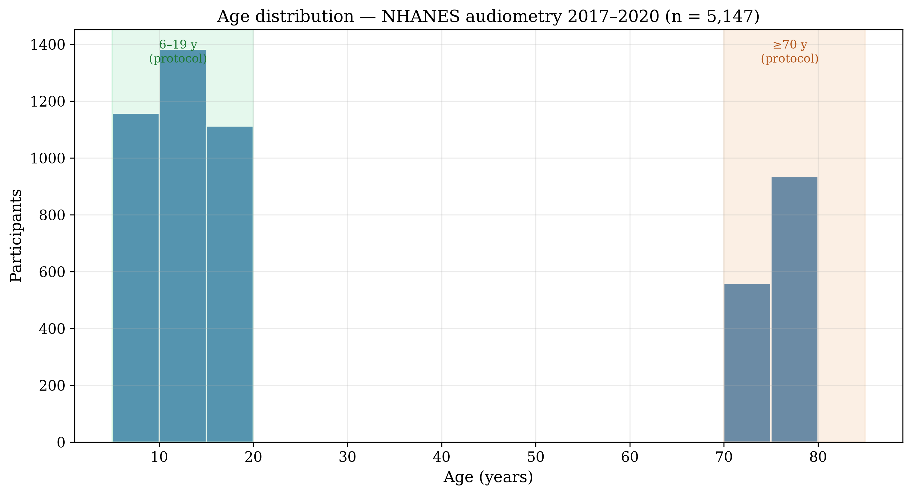
Age distribution
Sex: full file 48.8% female; clean-ear set 49.9%; adult clean set 51.4%.
Clean-ear set age: mean 47.8 y (SD 31.6), median 70.0 — the complete-threshold subset skews older because older adults who completed all frequencies (and children) both contribute, while the 6–19 group remains the largest single band.

Threshold Distributions
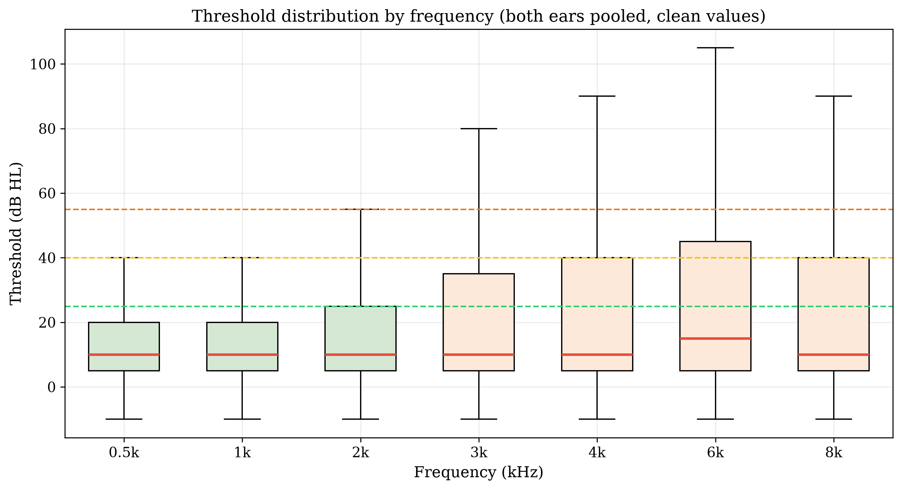
Threshold box plots by frequency
Frequency | n (pooled) | Mean (dB) | SD | Median
0.5k | 7,284 | 14.3 | 13.5 | 10.0
1k | 7,291 | 14.2 | 15.5 | 10.0
2k | 7,373 | 18.1 | 19.7 | 10.0
3k | 7,054 | 21.7 | 23.0 | 10.0
4k | 7,349 | 22.5 | 25.3 | 10.0
6k | 7,245 | 25.2 | 25.9 | 15.0
8k | 7,140 | 23.3 | 27.3 | 10.0
Thresholds increase monotonically with frequency — the classic high-frequency loss pattern.

PTA-4 and WHO Severity
PTA-4 = mean of 500, 1000, 2000, 4000 Hz.
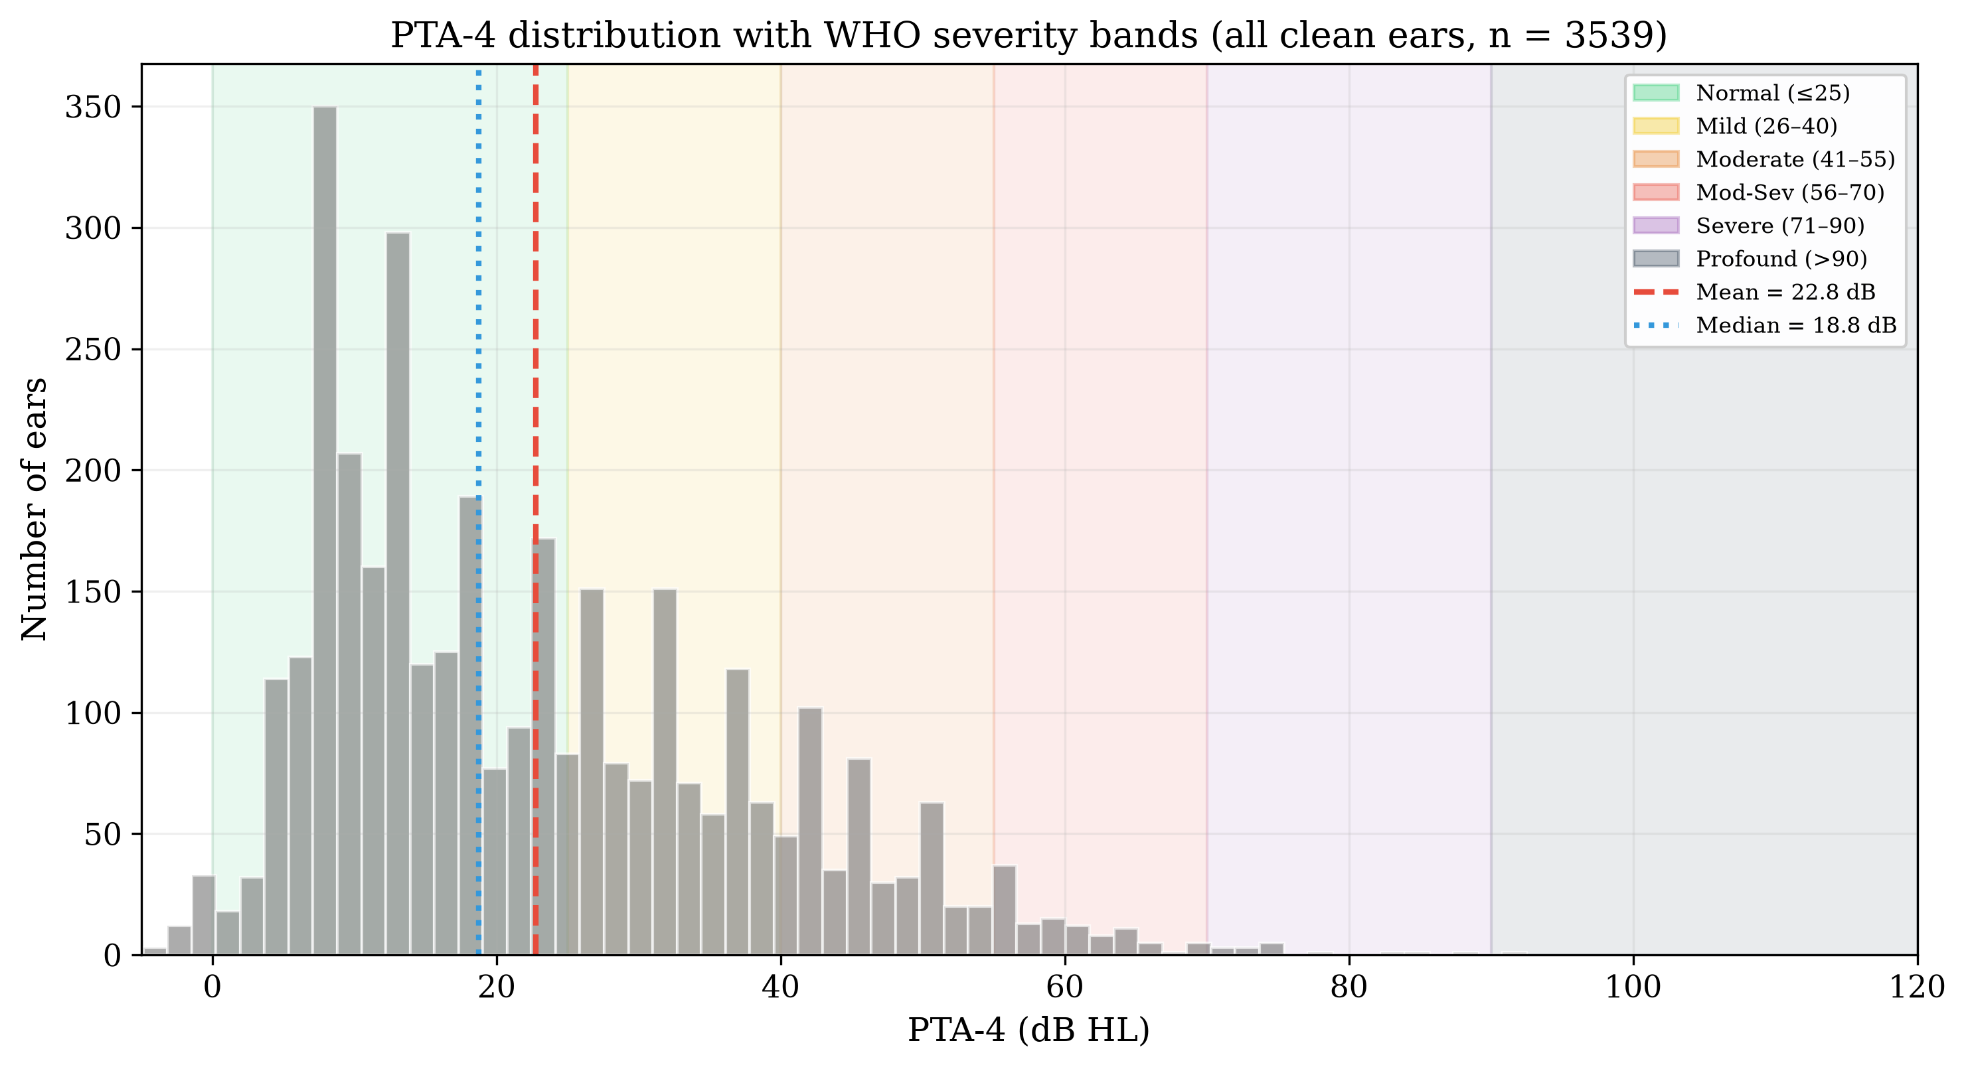
PTA-4 — all clean ears
Severity (WHO) | All clean ears | Adults ≥20 y
Normal | 62.8% | 37.5%
Mild | 22.9% | 38.3%
Moderate | 11.4% | 19.5%
Moderately Severe | 2.4% | 4.2%
Severe | 0.4% | 0.5%
Profound | 0.0% | 0.1%
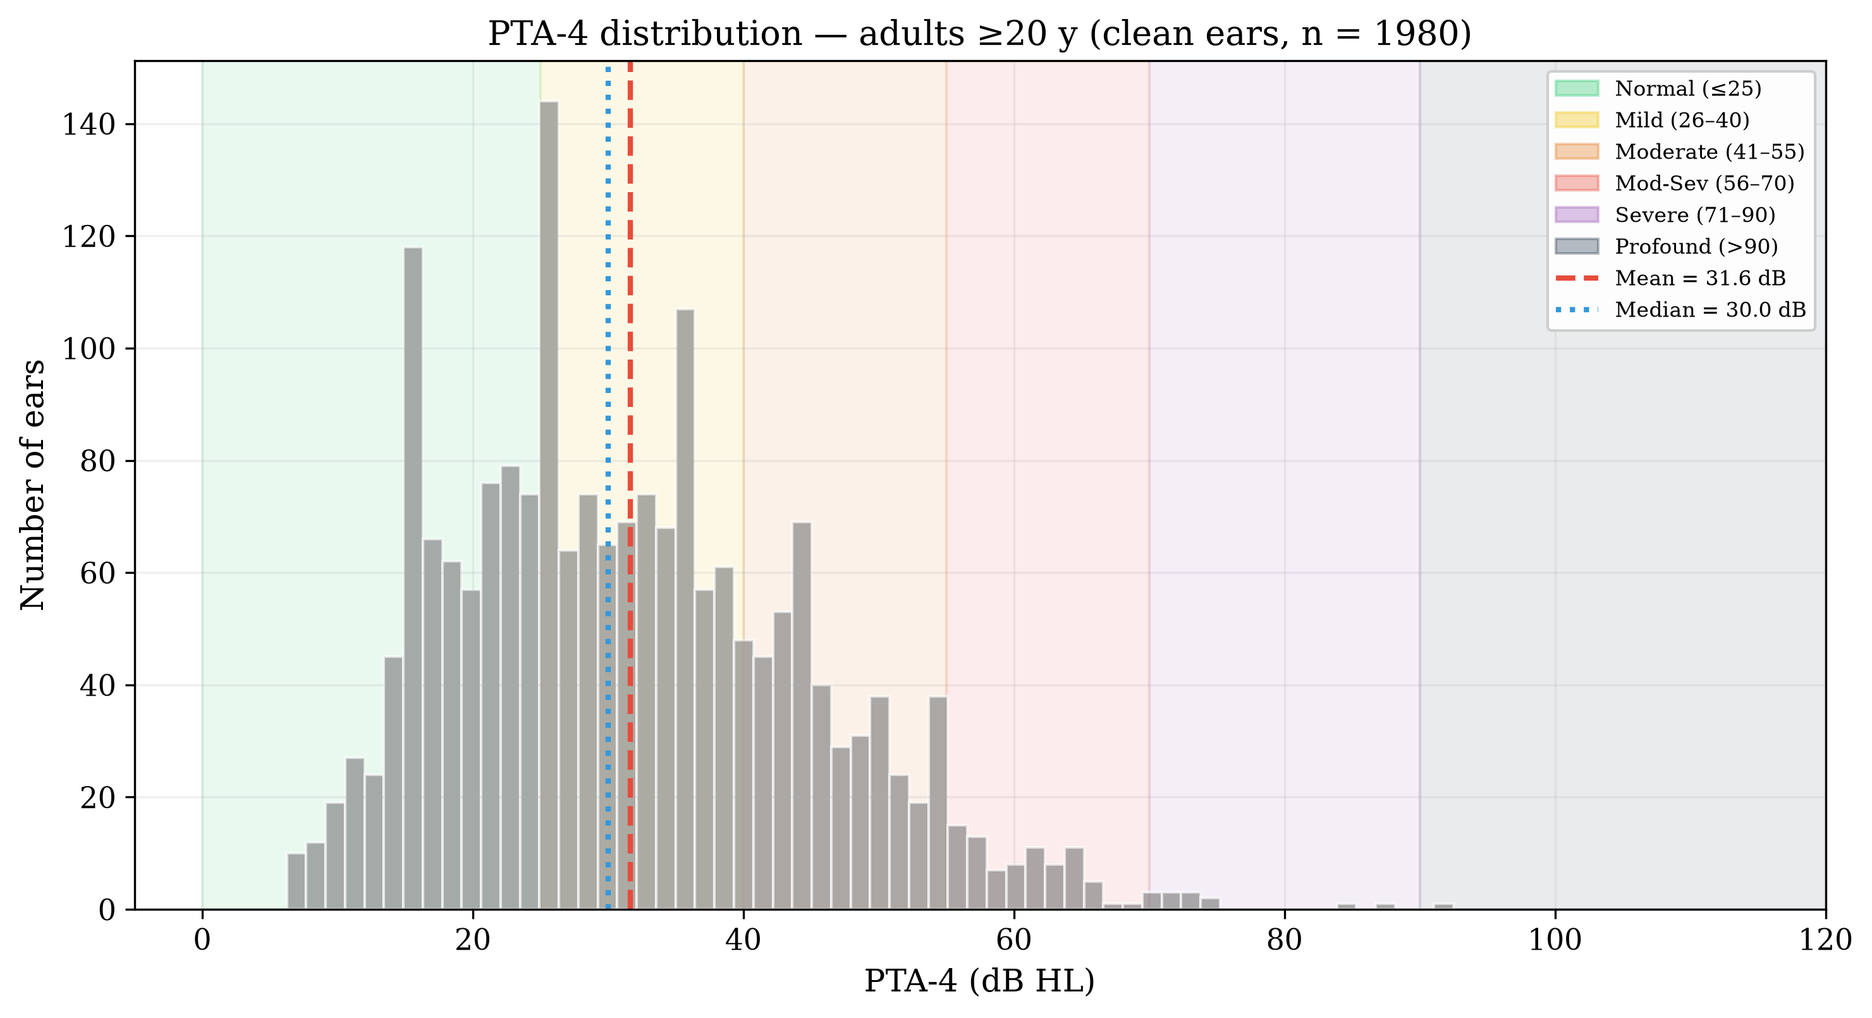
PTA-4 — adults ≥20 y

The Borderline Problem
Share of ears within ±5 dB of a WHO severity boundary:
Boundary zone | dB range | All clean ears | Adults ≥20 y
Normal–Mild | 20–30 dB | 20.6% | 32.0%
Mild–Moderate | 35–45 dB | 13.1% | 22.2%
Moderate–Mod-Sev | 50–60 dB | 4.7% | 8.2%
Mod-Sev–Severe | 65–75 dB | 0.7% | 1.1%
Severe–Profound | 85–95 dB | 0.1% | 0.2%
39.2% of all clean ears and 63.6% of adult ears fall within ±5 dB of a boundary — the population where crisp classification is least reliable.

Audiogram Configuration
Slope = threshold(4 kHz) − threshold(500 Hz).
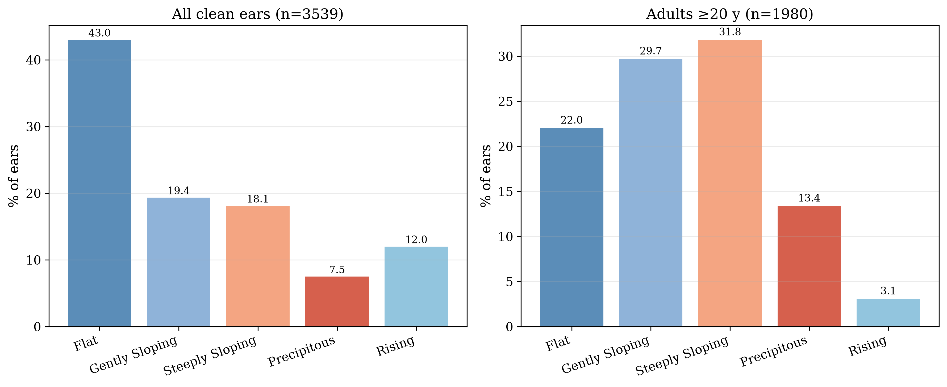
Configuration distribution
Configuration | All clean ears | Adults ≥20 y
Flat | 43.0% | 22.0%
Gently Sloping | 19.4% | 29.7%
Steeply Sloping | 18.1% | 31.8%
Precipitous | 7.5% | 13.4%
Rising | 12.0% | 3.1%

Inter-Aural Asymmetry
Bilateral participants only (n = 1,225); |PTA-4 R − PTA-4 L|:
- Symmetric (≤15 dB): 94.0%
- Mildly asymmetric (16–30 dB): 5.3%
- Moderately asymmetric (31–45 dB): 0.6%
- Severely asymmetric (>45 dB): 0.2%
Mean asymmetry 5.6 dB, median 3.8 dB.
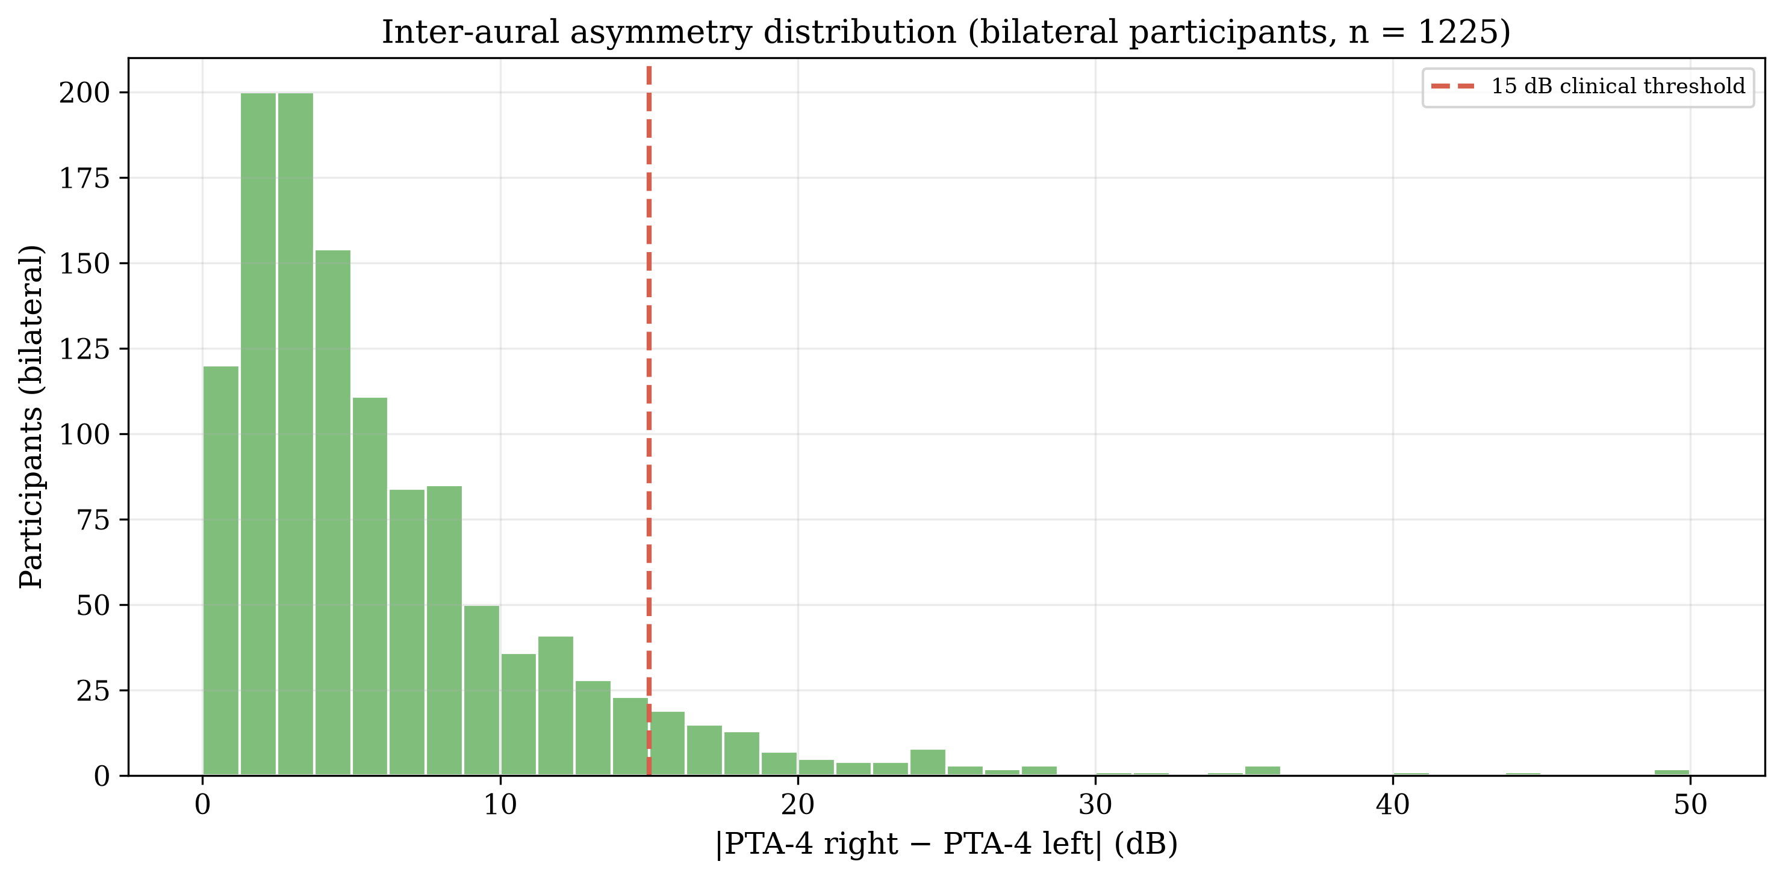
Inter-aural asymmetry

Inter-Frequency Correlations
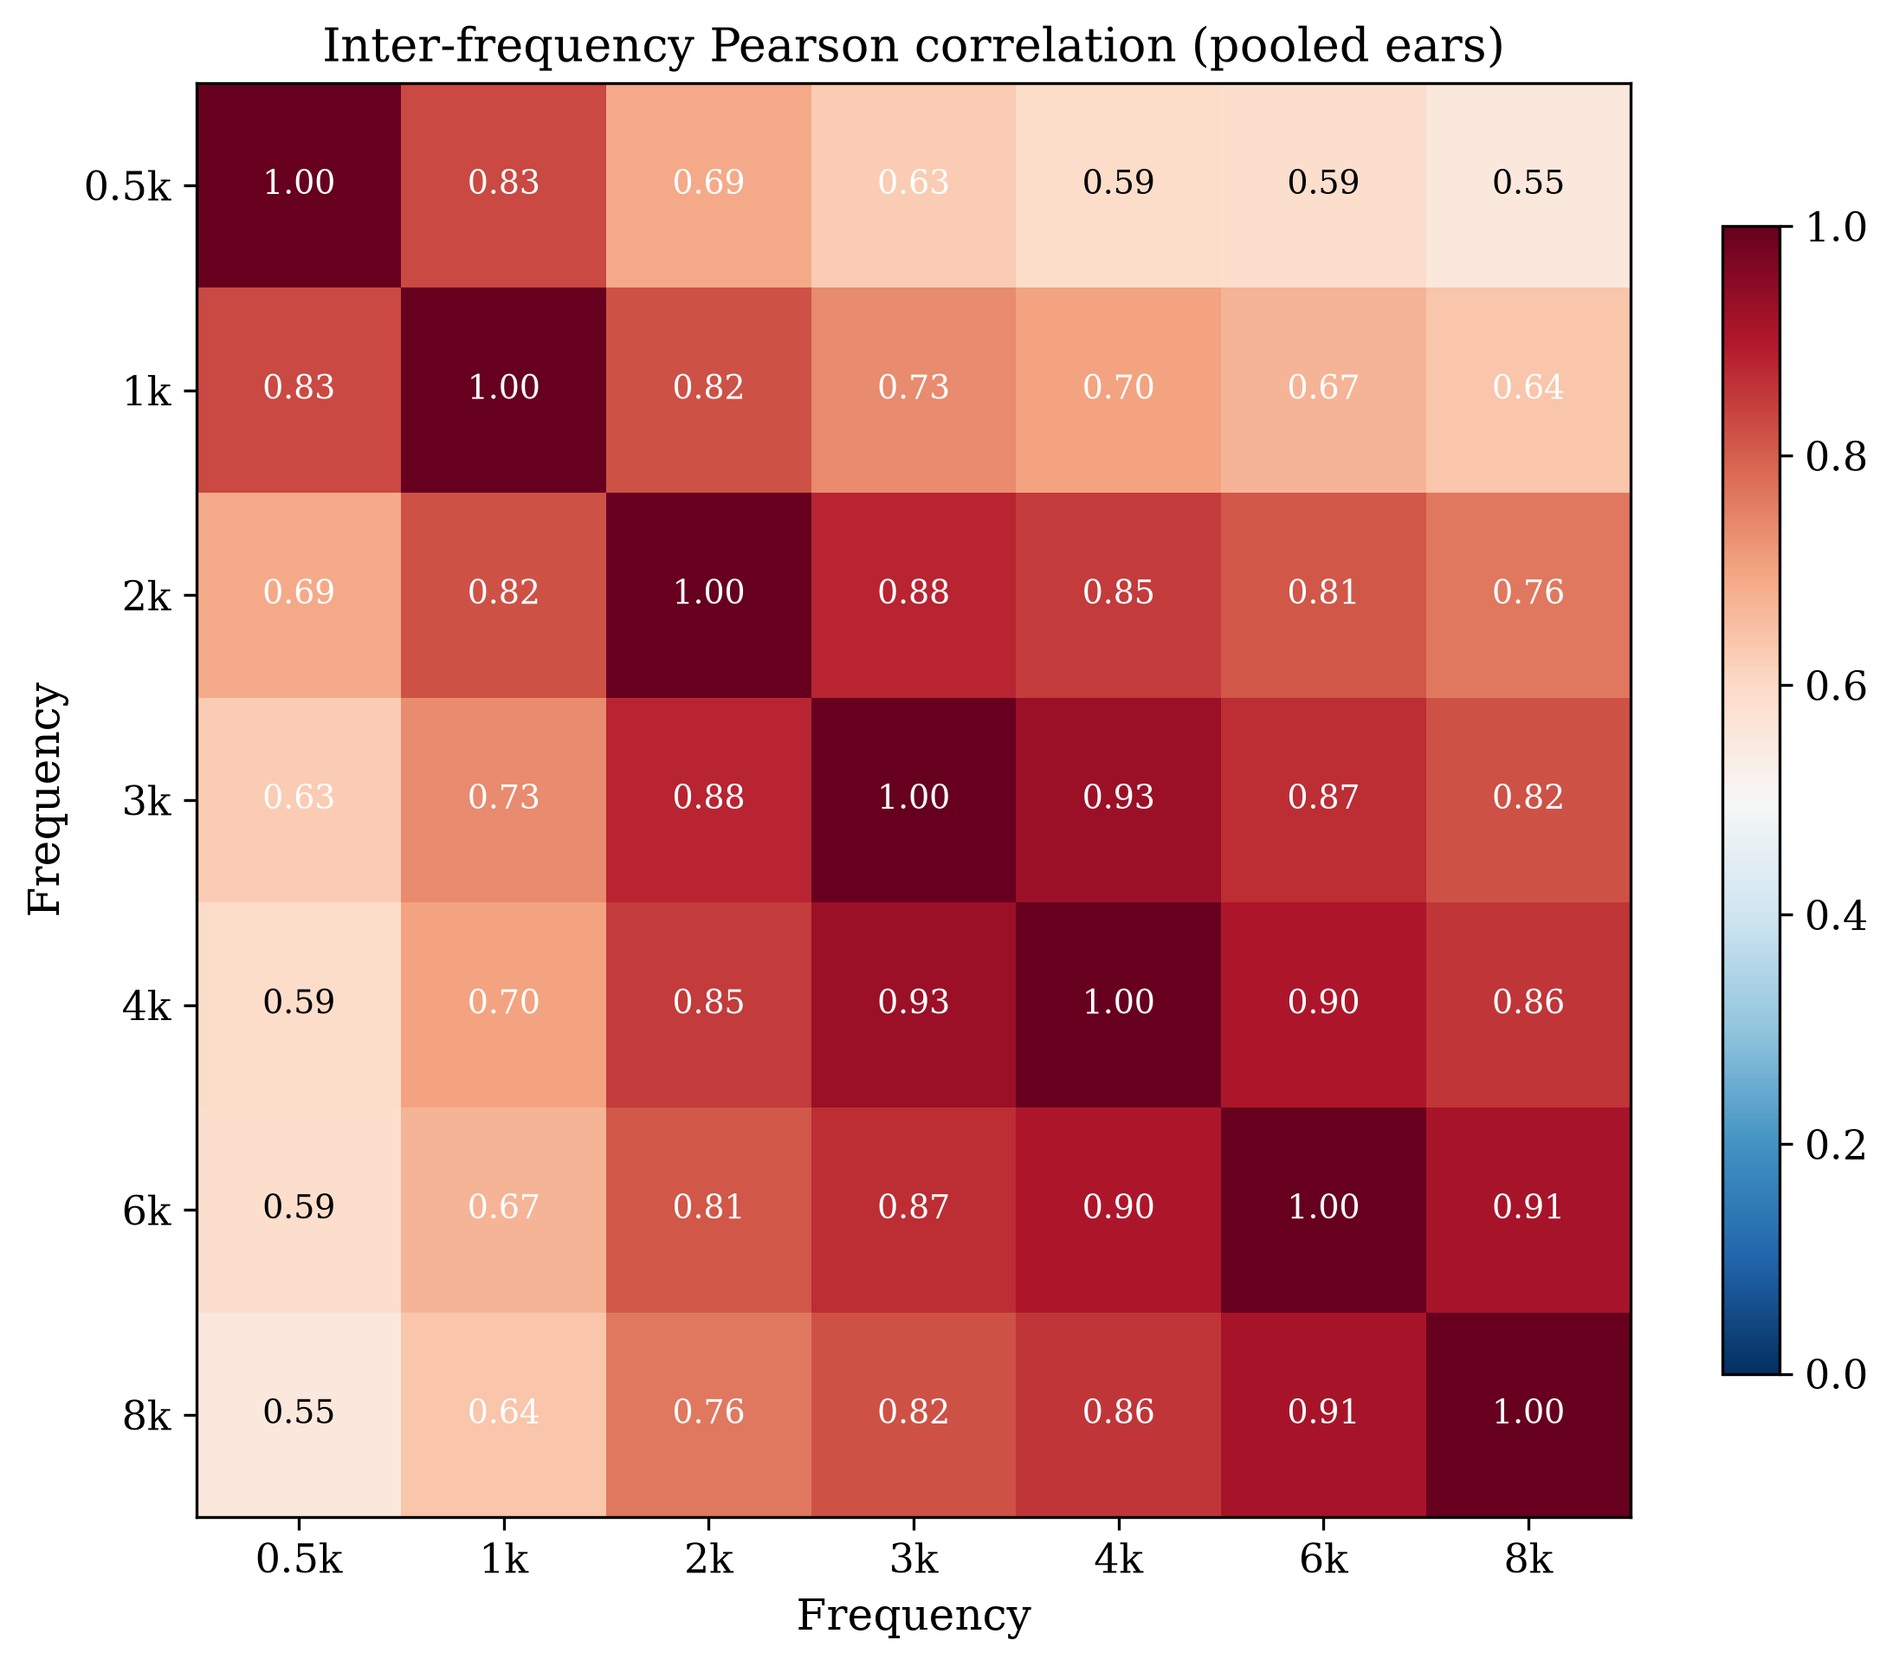
Correlation matrix
Adjacent-frequency correlations are high (mean r = 0.88); the 500 Hz–8 kHz correlation is moderate (r = 0.55) — frequency-specific information is partly independent of the PTA average.

Missing Data Patterns
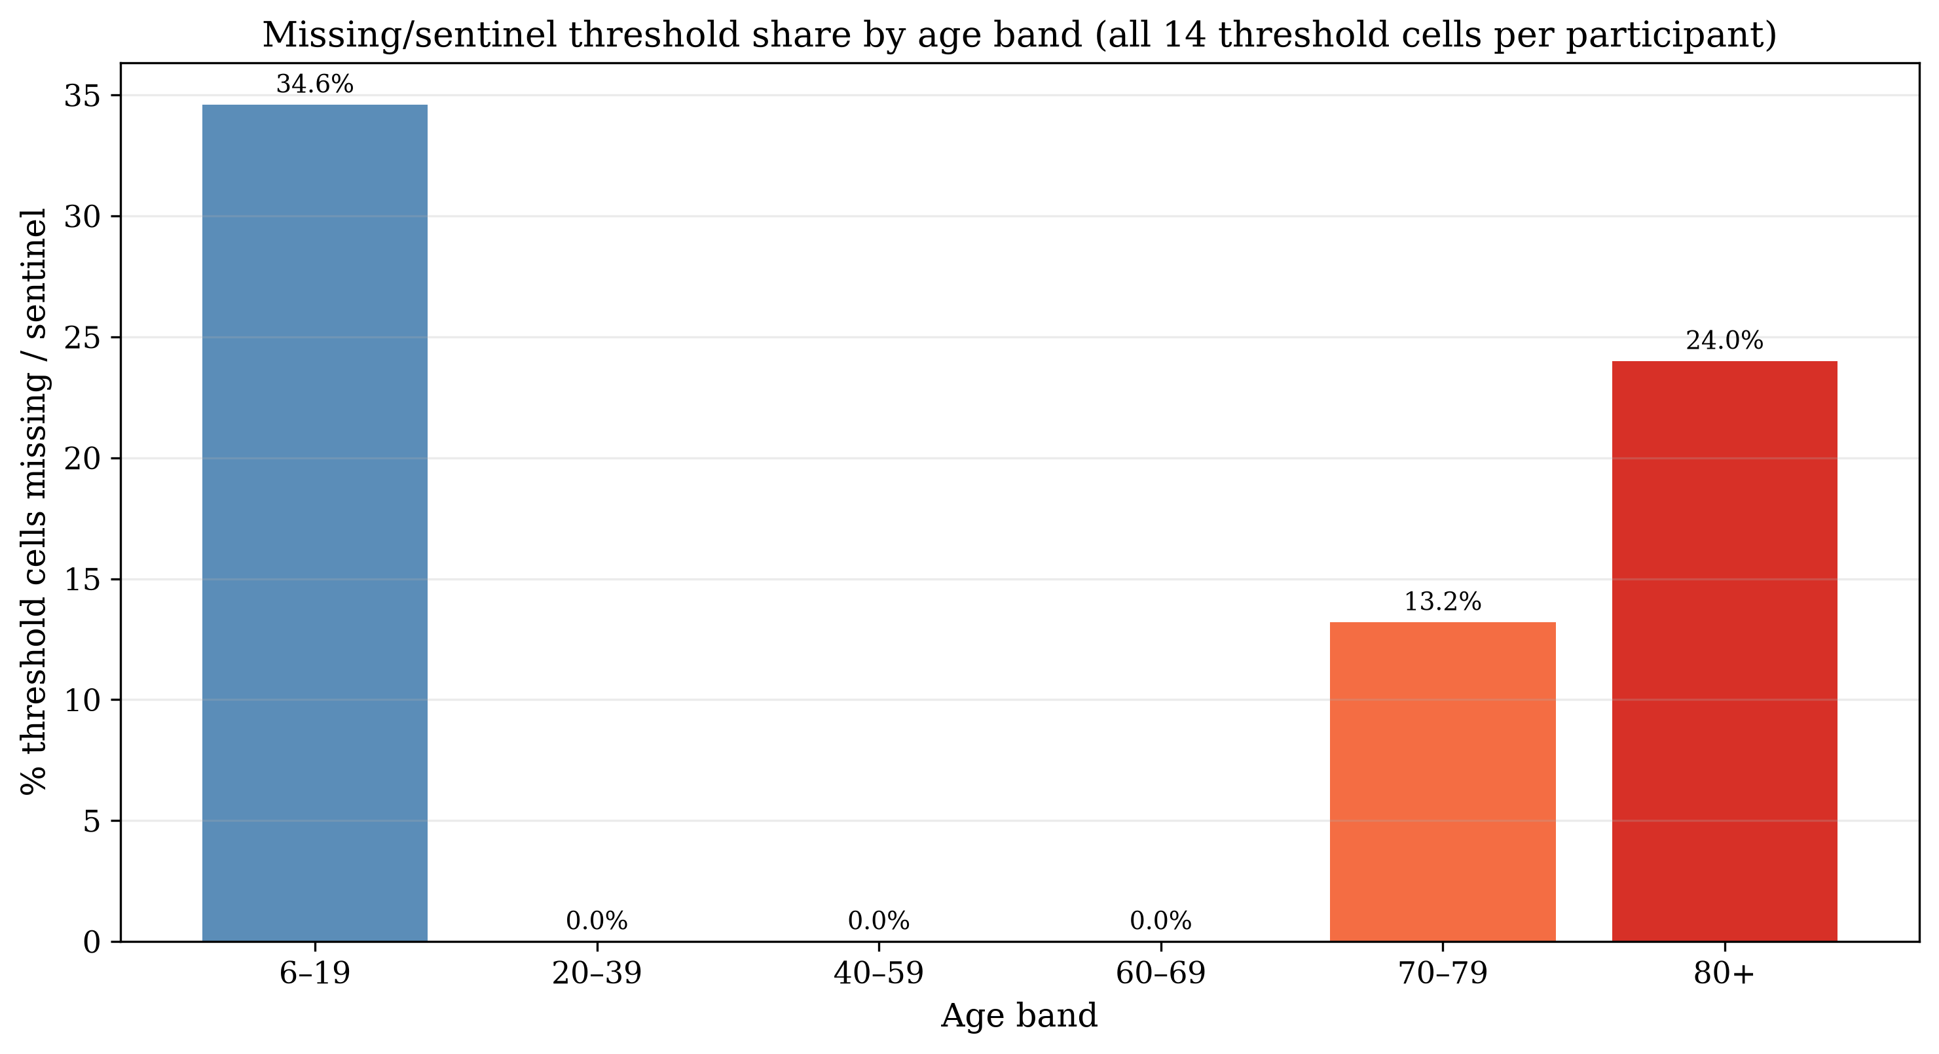
Missing/sentinel share by age band
Older participants have far higher missing/sentinel rates at high frequencies — the reason the clean-ear set (all 7 frequencies required) skews younger per participant even though adult ears dominate the ear count.

Adult-Only (≥20 y) Subset — Decision Notes
- Because the protocol tested only 6–19 and ≥70, “adults ≥20” is exactly the ≥70 subgroup: 1,125 participants, 1,980 clean ears.
- Adult clean-ear age: mean 75.7 (SD 3.8), median 76.0.
- Adult severity: Normal 37.5%; Mild 38.3%; Moderate 19.5%; Moderately Severe 4.2%; Severe 0.5%; Profound 0.1%.
- Borderline share: 63.6%; configuration: Flat 22.0%, Gently Sloping 29.7%, Steeply Sloping 31.8%, Precipitous 13.4%, Rising 3.1%.
- The FIS membership functions were optimised on the full training set (all ages); an adults-only analysis re-runs validation on this subset with the deployed parameters, or can re-optimise parameters on adult training data (larger change).

Key Takeaways
- The cohort is bimodal by design (6–19 and ≥70); any “general adult population” framing is incorrect for this cycle.
- ~39.2% of ears sit within ±5 dB of a severity boundary — the core motivation for graded fuzzy classification.
- High-frequency thresholds are frequently missing in older adults; clean-ear selection (all 7 frequencies) is not age-neutral.
- Configurations are predominantly flat/gently sloping in the full set; the adult subset shifts toward steeper slopes.
- Inter-frequency correlations justify frequency-resolved (fuzzy) rather than PTA-only representation.

