NHANES Adult Audiometry 20–69 y: Combined-Cycle EDA
  - AUX1 (1999–2000) + AUX_G (2011–2012) + AUX_I (2015–2016)
2026-08-14
Table of contents

Data Source and Files
Cycle | Exam file | Participants | Ages
AUX1 1999–2000 | /opt/data/AUX1_9900.xpt | 1,807 | 20–69
AUX_G 2011–2012 | /opt/data/AUX_G_1112.xpt | 4,500 | 20–69
AUX_I 2015–2016 | /opt/data/AUX_I_1516.xpt | 4,582 | 20–69
- Protocol: these cycles administered audiometry to adults aged 20–69 y (unlike the 2017–2020 P_AUX cycle, which tested only 6–19 and ≥70).
- Frequencies: 500, 1000, 2000, 3000, 4000, 6000, 8000 Hz, air-conduction, both ears.
- Demographics: linked via SEQN to each cycle’s DEMO file (age, sex).

Cleaning
Sentinel codes converted to missing before any statistic: 666 (no response), 777 (refused), 888 (could not obtain), 999 (not tested). Values clipped to −10–120 dB HL. (The 1999–2000 cycle uses 666 only; 2011–2016 use 666 and 888.)

Sample Flow
Stage | Participants | Ears
Combined audiometry participants | 10,889 | —
Clean ears (all 7 freqs, no sentinels) | 9,832 | 19,568
Ears per cycle: AUX_I 2015–2016 8,566, AUX_G 2011–2012 7,670, AUX1 1999–2000 3,332

Demographics
Age (full combined file): mean 43.9 y, median 44.0 y, range 20–69 y; 51.8% female.
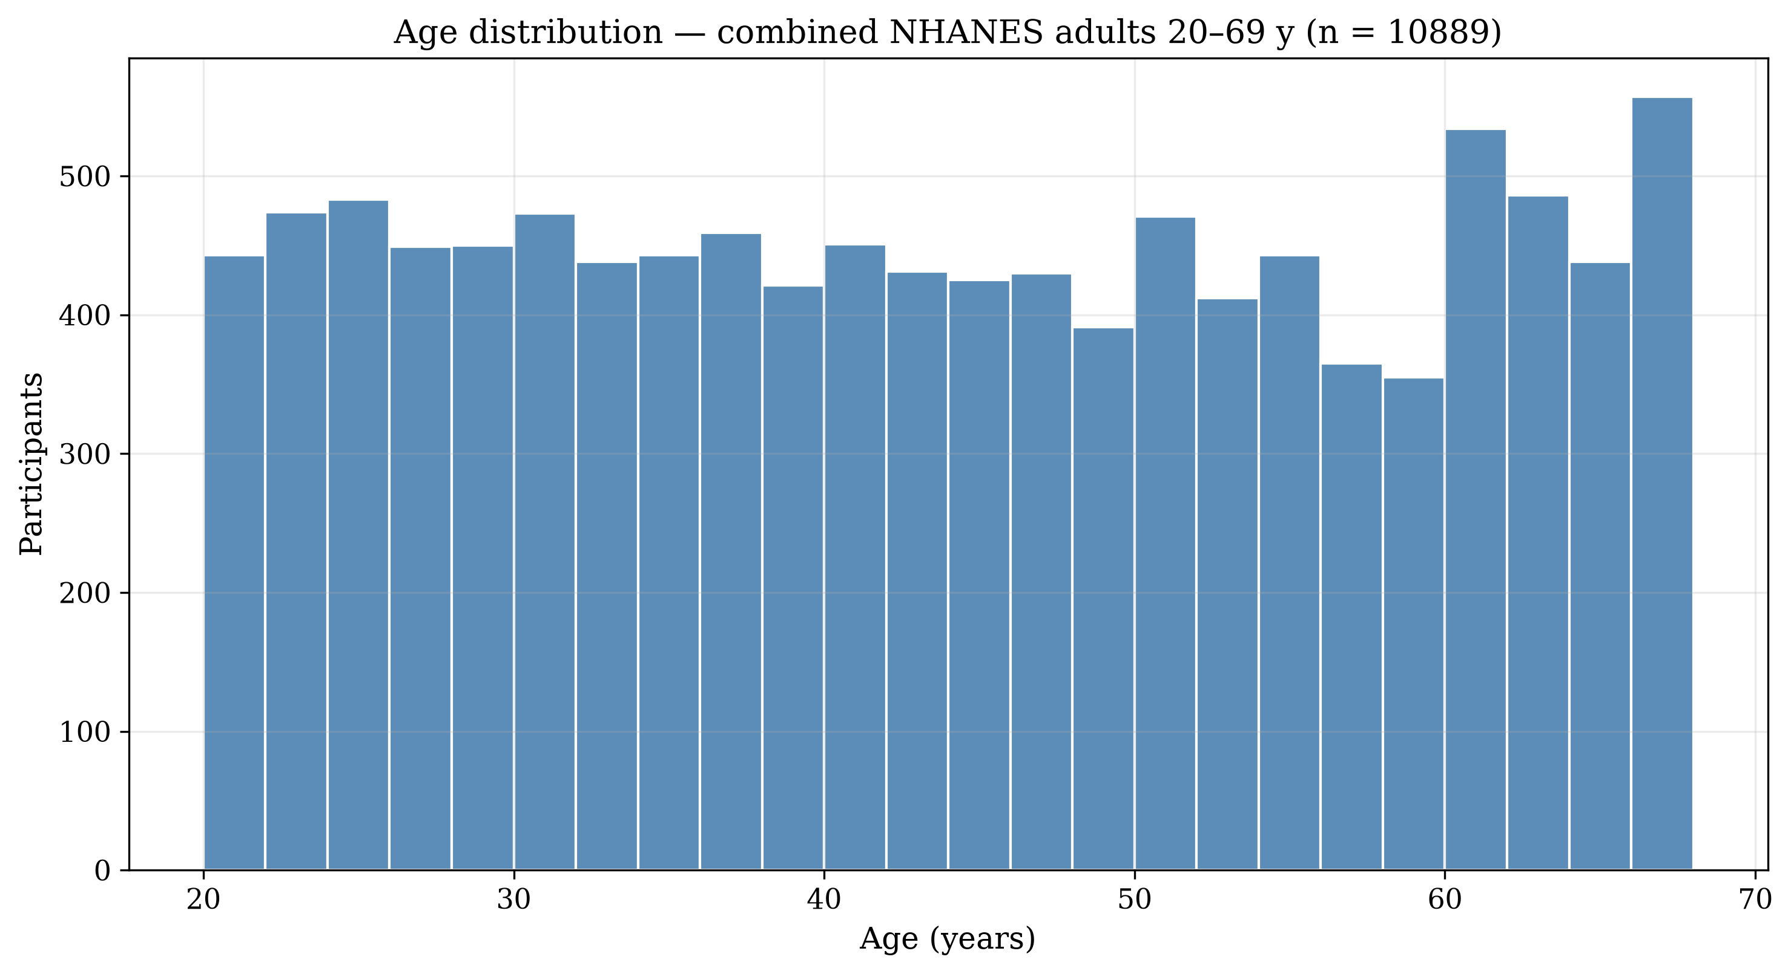
Age distribution
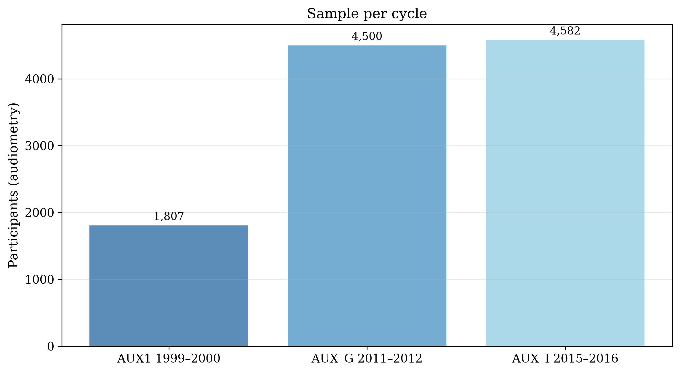
Sample per cycle
Clean-ear set: 9,832 participants, 19,568 ears, mean age 43.9 y, 50.9% female.

Threshold Distributions
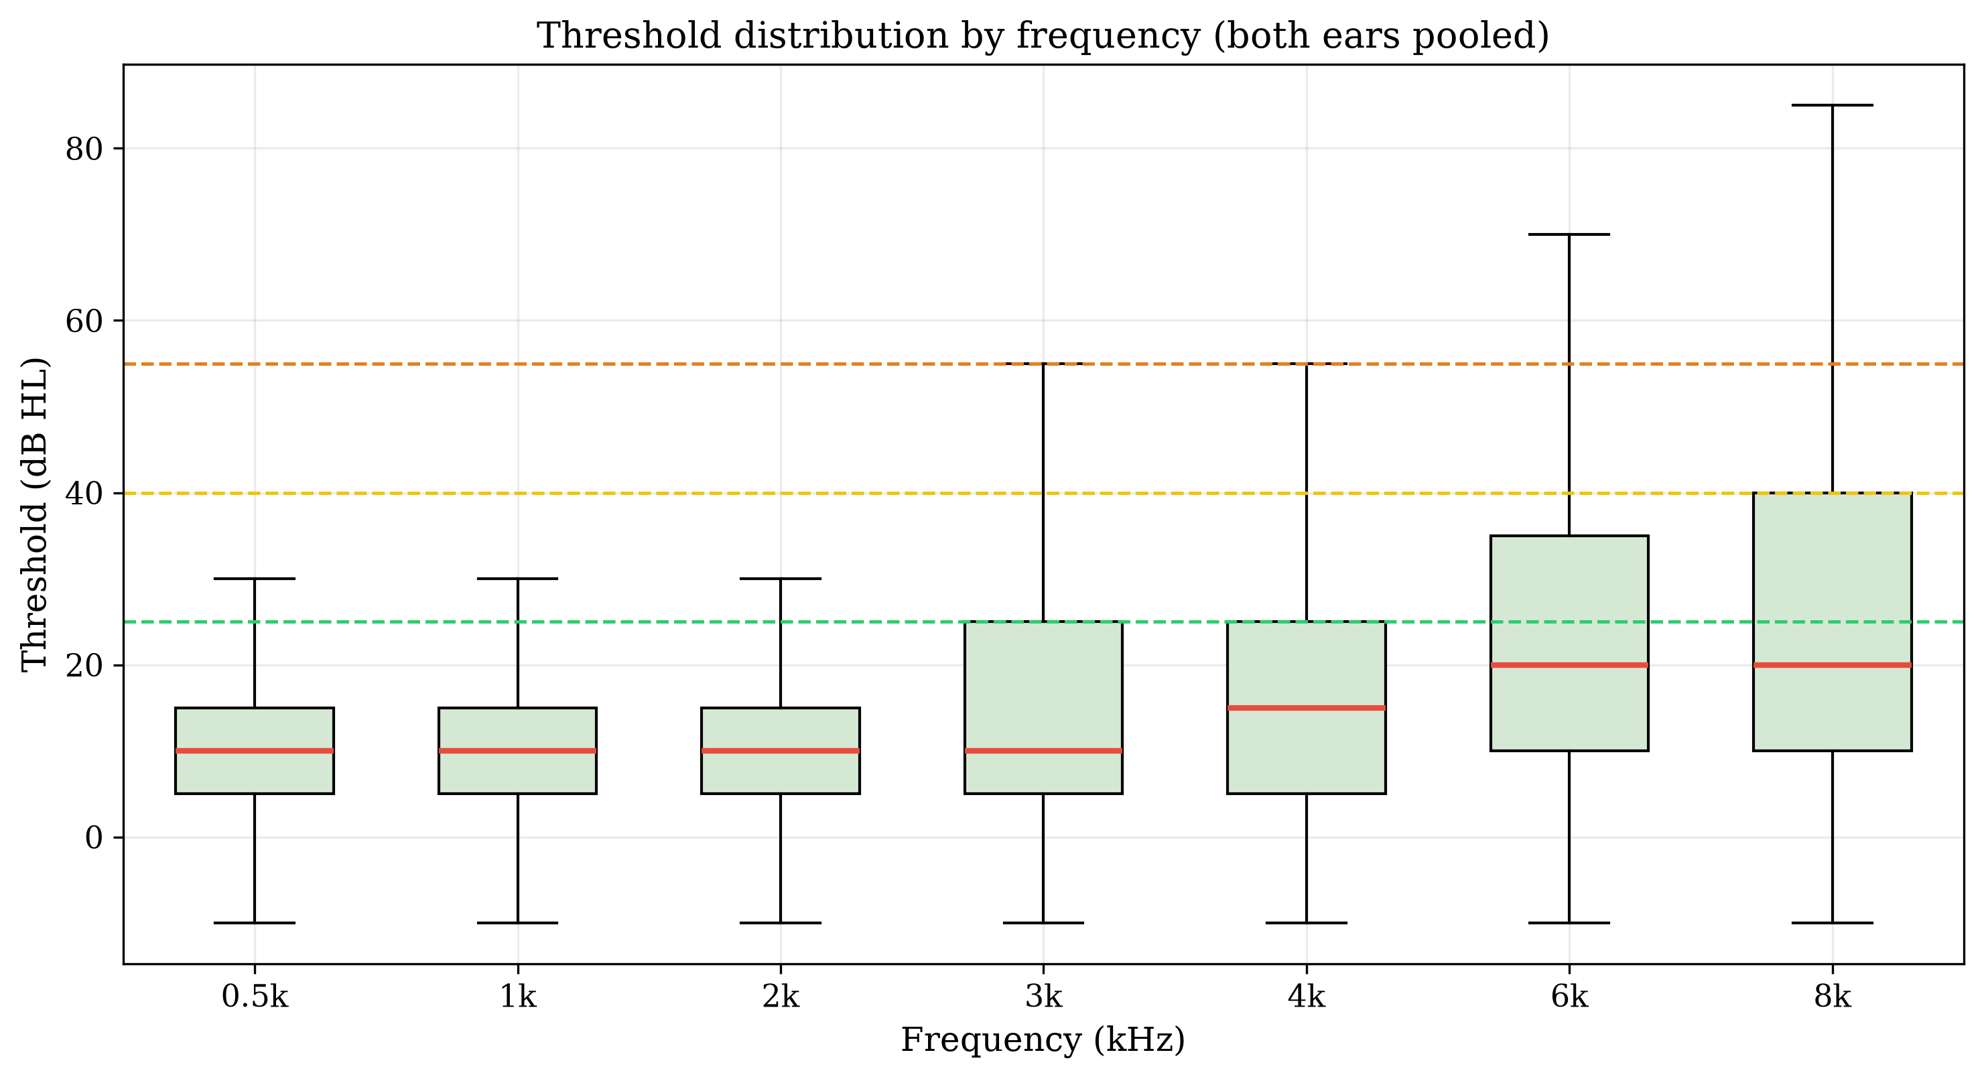
Threshold box plots by frequency
Frequency | n (pooled) | Mean (dB) | SD | Median
0.5k | 19,655 | 11.2 | 10.8 | 10.0
1k | 19,651 | 11.3 | 11.5 | 10.0
2k | 19,651 | 11.9 | 13.8 | 10.0
3k | 19,643 | 16.3 | 17.2 | 10.0
4k | 19,634 | 19.5 | 19.3 | 15.0
6k | 19,622 | 25.5 | 20.1 | 20.0
8k | 19,589 | 27.4 | 22.4 | 20.0

PTA-4 and WHO Severity
PTA-4 = mean of 500, 1000, 2000, 4000 Hz.
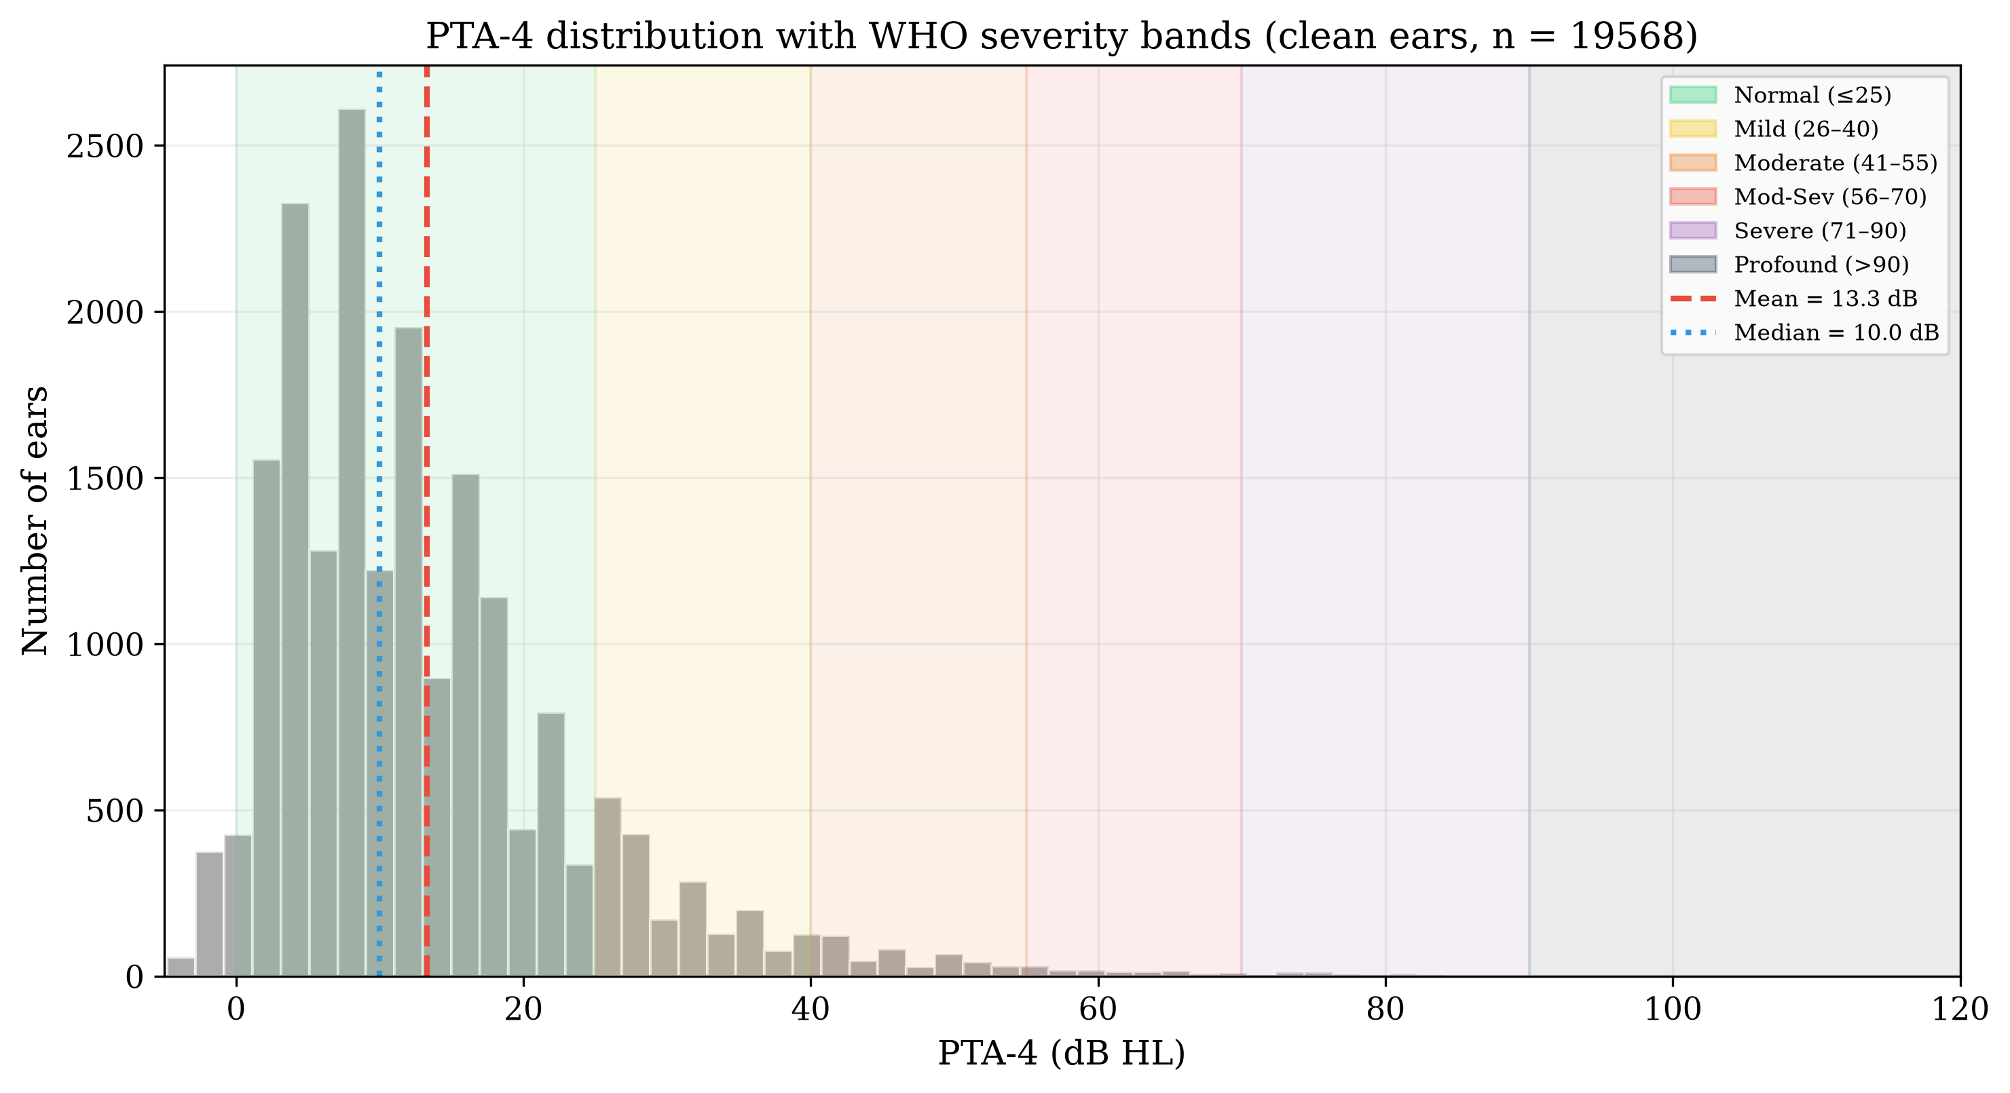
PTA-4 distribution with WHO severity bands
Severity (WHO) | % of clean ears
Normal | 88.1%
Mild | 8.7%
Moderate | 2.2%
Moderately Severe | 0.6%
Severe | 0.3%
Profound | 0.1%

The Borderline Problem
Share of clean ears within ±5 dB of a WHO severity boundary:
Boundary zone | dB range | % of ears
Normal–Mild | 20–30 dB | 13.9%
Mild–Moderate | 35–45 dB | 3.1%
Moderate–Mod-Sev | 50–60 dB | 0.9%
Mod-Sev–Severe | 65–75 dB | 0.3%
Severe–Profound | 85–95 dB | 0.0%
18.2% of clean ears fall within ±5 dB of a boundary.

Audiogram Configuration
Slope = threshold(4 kHz) − threshold(500 Hz).
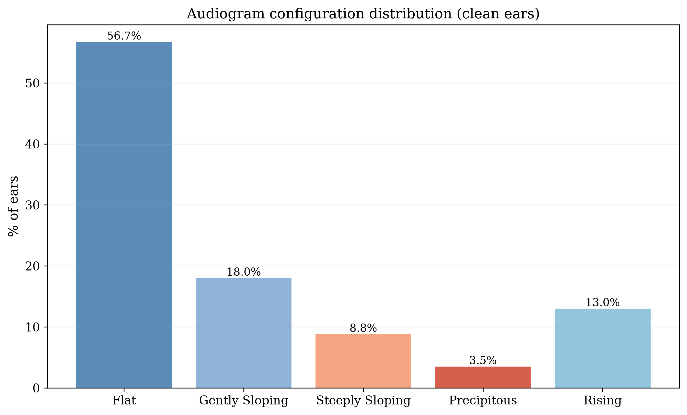
Configuration distribution
Configuration | % of clean ears
Flat | 56.7%
Gently Sloping | 18.0%
Steeply Sloping | 8.8%
Precipitous | 3.5%
Rising | 13.0%

Inter-Aural Asymmetry
Bilateral participants (n = 9,736); |PTA-4 R − PTA-4 L|:
- 94.9% symmetric (≤15 dB)
- 3.5% mildly asymmetric (16–30 dB)
- 0.9% moderately asymmetric (31–45 dB)
- 0.6% severely asymmetric (>45 dB)
Mean asymmetry 5.2 dB, median 3.8 dB.
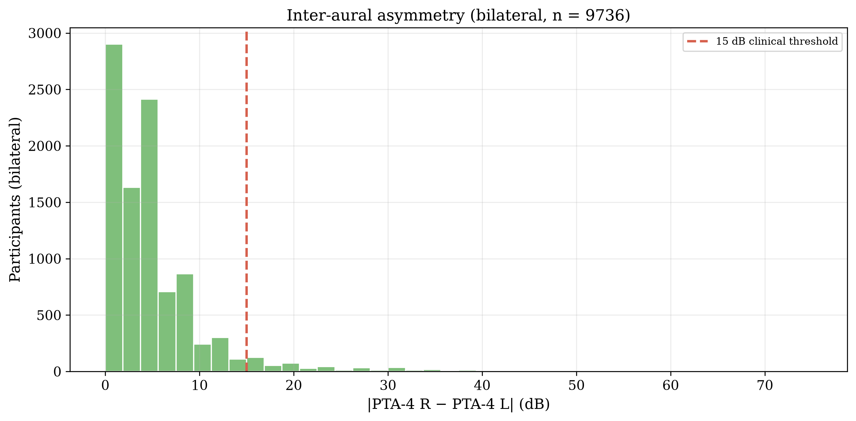
Inter-aural asymmetry

Inter-Frequency Correlations
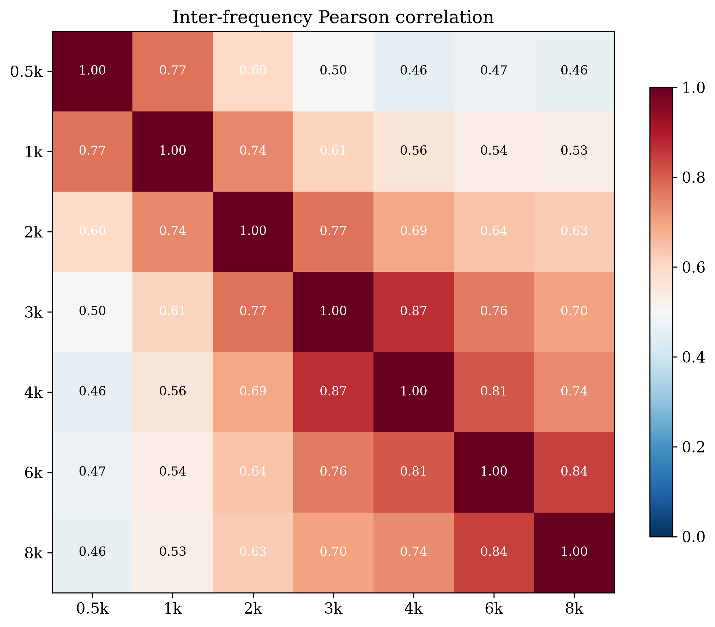
Correlation matrix
Adjacent-frequency mean r = 0.80; 500 Hz–8 kHz r = 0.46.

Missing Data Patterns
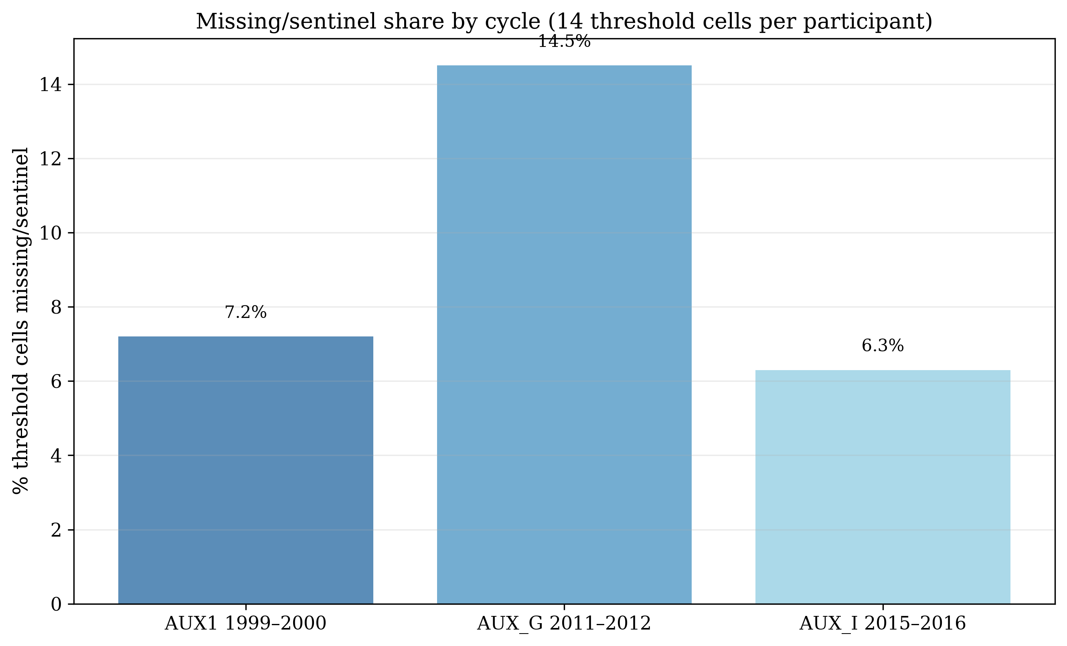
Missing/sentinel share by cycle

Key Takeaways
- True working-age adult cohort: 10,889 participants aged 20–69 across three cycles — the population the 2017–2020 P_AUX cycle does not contain.
- Hearing thresholds increase monotonically with frequency; absolute levels are lower than the ≥70 cohort (age-related loss less severe).
- 18.2% of ears sit within ±5 dB of a severity boundary — still a substantial borderline population.
- Configurations are predominantly flat/gently sloping; steeply sloping and precipitous patterns are less common than in the ≥70 cohort.
- Inter-frequency correlations justify frequency-resolved (fuzzy) representation.

