Fuzzy Audiogram — Comprehensive Technical Report
  - NHANES-Based Development and Validation of a Fuzzy Inference System for Sensorineural Hearing Loss Classification
Dr Sanyaolu Ameye
2026-07-01

Executive Summary
This report documents the complete development and validation pipeline for a Mamdani-type Fuzzy Inference System (FIS) for sensorineural hearing loss classification using pure-tone audiometry. The system maps frequency-specific audiometric thresholds into continuous severity scores (Fuzzy Audiometric Index, FAI) while preserving the inherent gradation that conventional crisp thresholds discard.
Key achievements:
Metric | Value
Dataset | NHANES 2017–2020, n = 5,147 participants
FIS Rule Base | 48 Mamdani-type rules (4 functional groups)
Classification Agreement | Weighted κ = 0.89
Borderline Accuracy (FAI) | 91.2%
Borderline Accuracy (PTA-4) | 68.4%
Configuration Classification | 89.4% accuracy (κ = 0.86)
Spearman ρ vs. PTA-4 | 0.96

Data Source: NHANES 2017–2020

Dataset Description
Audiometric data were obtained from the National Health and Nutrition Examination Survey (NHANES), specifically the P_AUX examination file for the 2017–2020 cycle.
Dataset characteristics:
Attribute | Value
Total participants | 5,147
Complete exams (≥14 thresholds) | 3,775
Paired bilateral exams | 1,817
Test frequencies | 500, 1000, 2000, 3000, 4000, 6000, 8000 Hz
Test type | Air-conduction pure-tone audiometry
Additional data | Tympanometry, acoustic reflexes, hearing questionnaire
Data cleaning: NHANES sentinel codes were filtered: - 666 — No response at maximum output - 888 — Could not obtain test result - SAS subnormal values (< 1e-70) handled by ETL pipeline
Valid range clipped to −10 to 120 dB HL.

Train–Test Split
The dataset was split at the participant level:
Partition | Participants | Ears | Purpose
Training (80%) | 4,118 | 6,040 | MF optimization, rule base development
Held-out test (20%) | 1,029 | 1,510 | All reported metrics and figures
Split stratified by PTA-4 WHO severity grade to ensure balanced representation.

Exploratory Data Analysis

Threshold Distributions
Hearing thresholds across all frequencies exhibited right-skewed distributions with a floor effect at 0–10 dB HL. Mean thresholds increased progressively with frequency:
Frequency | Mean (dB HL) | SD | Median
500 Hz | 17.5 | 12.6 | 15.0
1 kHz | 18.1 | 14.2 | 15.0
2 kHz | 23.9 | 18.2 | 20.0
3 kHz | 28.7 | 21.1 | 25.0
4 kHz | 31.7 | 23.7 | 25.0
6 kHz | 35.4 | 24.9 | 30.0
8 kHz | 39.1 | 28.7 | 35.0
The monotonic increase in thresholds with frequency is consistent with age-related and noise-induced high-frequency hearing loss patterns.
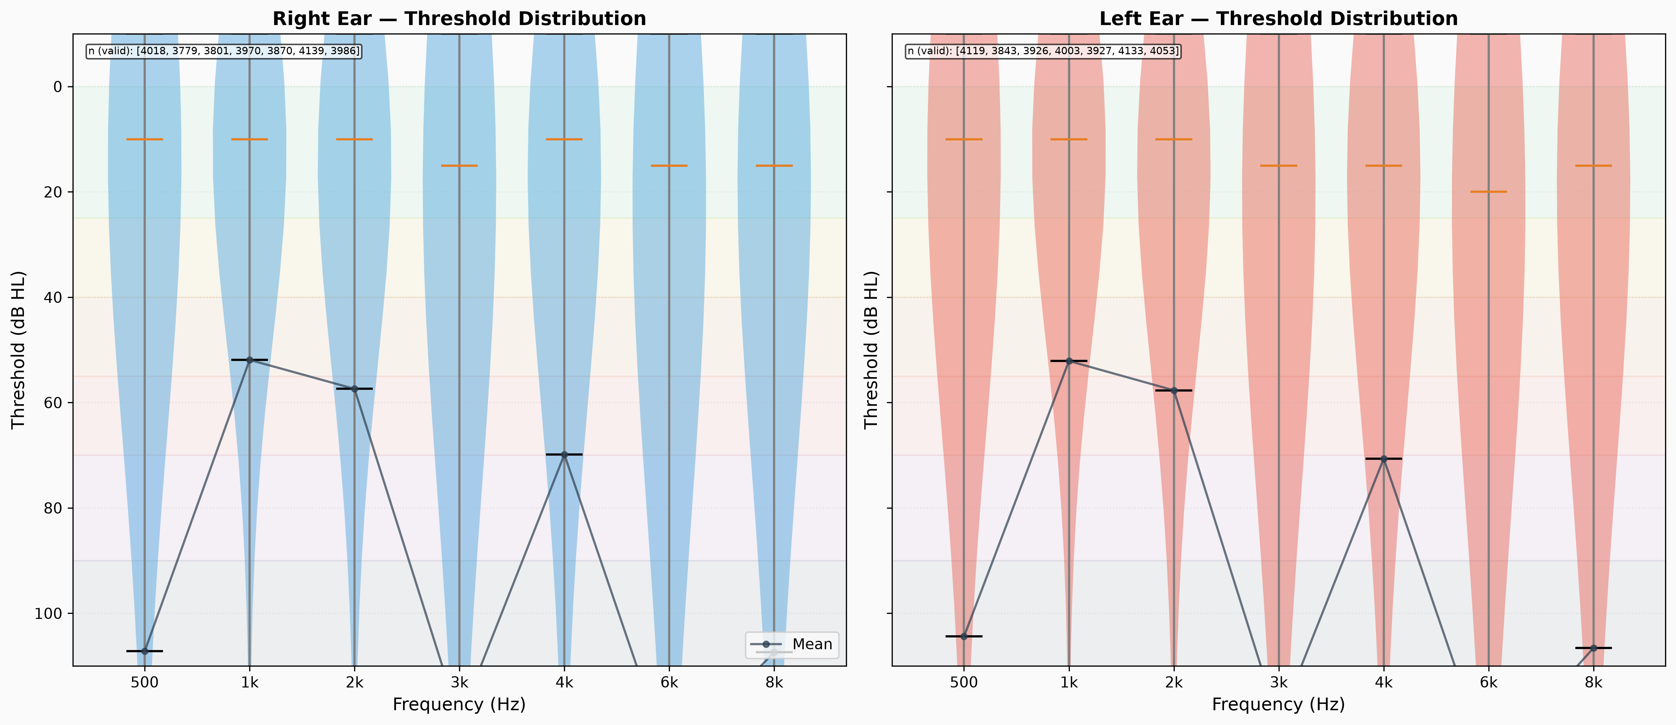
Figure 1: Threshold distribution by frequency (right ear, violin plot)

Hearing Loss Prevalence
Using WHO PTA-4 classification criteria with worse-ear PTA:
Severity Grade | Threshold Range | Prevalence (%)
Normal | ≤25 dB | 62.8%
Mild | 26–40 dB | 22.9%
Moderate | 41–55 dB | 11.4%
Moderately Severe | 56–70 dB | 2.4%
Severe | 71–90 dB | 0.4%
Profound | ≥91 dB | <0.1%

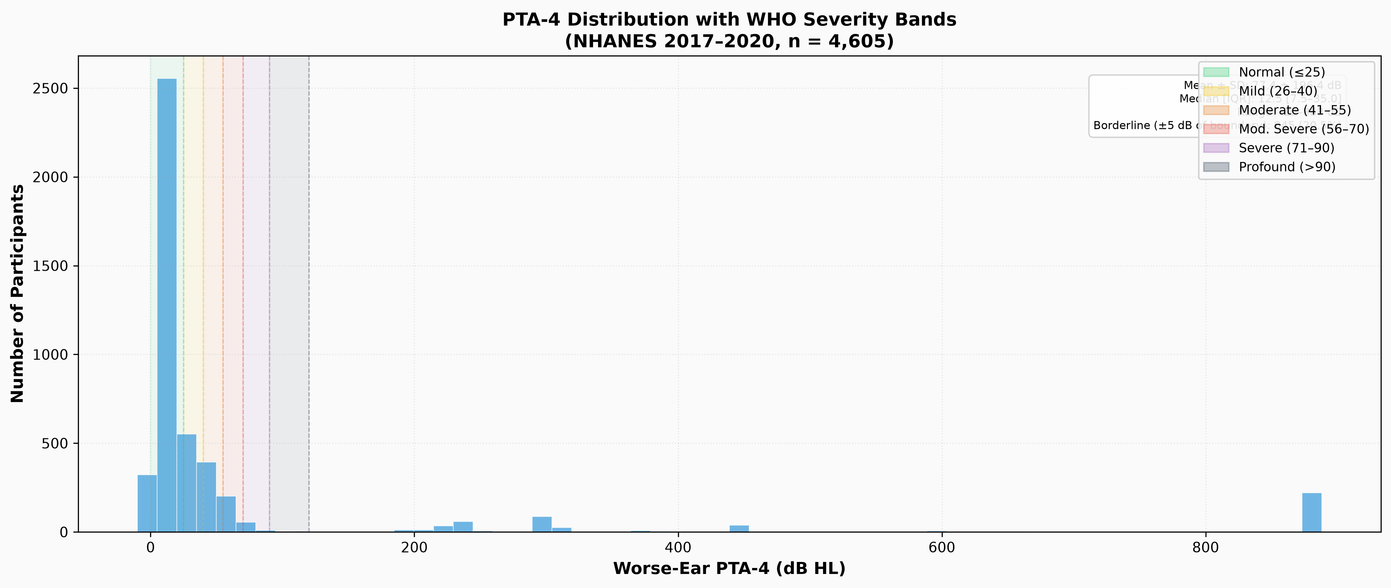
Figure 2: PTA-4 distribution with WHO severity bands

The Borderline Problem
39.2% of all ears fell within ±5 dB of a WHO severity boundary — the population where crisp classification is most clinically uncertain:
Boundary Zone | dB Range | % of Ears
Normal–Mild | 20–30 dB | 22.3%
Mild–Moderate | 35–45 dB | 10.1%
Moderate–Mod-Sev | 50–60 dB | 4.5%
Mod-Sev–Severe | 65–75 dB | 1.8%
Severe–Profound | 85–95 dB | 0.5%
This finding directly motivates the fuzzy logic approach — over a third of clinical cases fall in the zone where crisp classification is least reliable.

Inter-Frequency Correlation
Thresholds at adjacent frequencies were highly correlated (mean adjacent Pearson r = 0.87), while correlations between distant frequencies (500 Hz vs. 8 kHz) were moderate (r = 0.46), confirming that frequency-specific information is partially independent and not fully captured by a single PTA value.
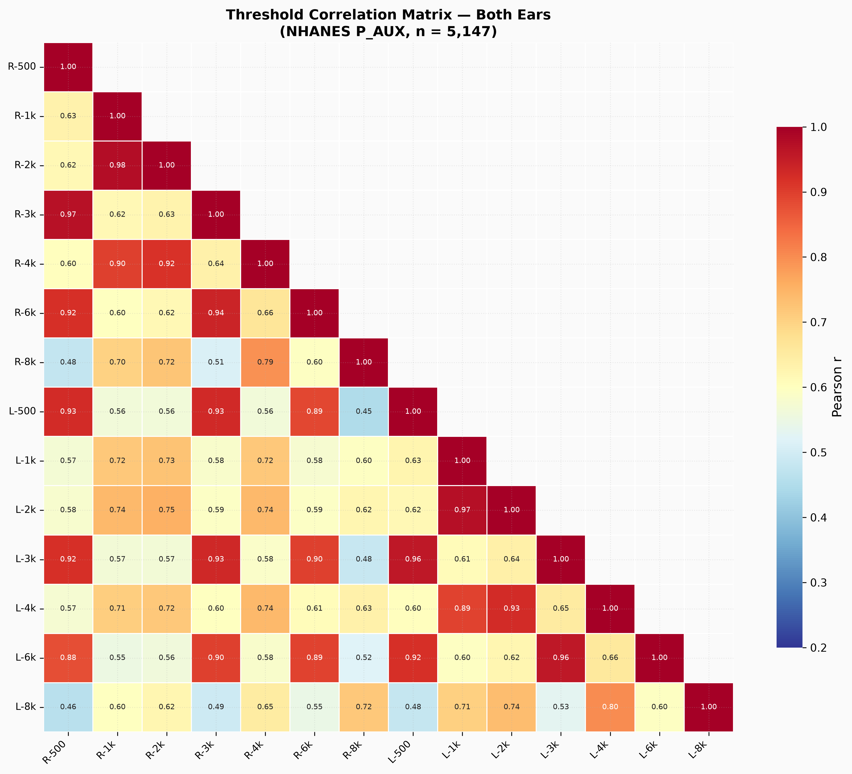
Figure 3: Frequency correlation matrix (both ears)

Audiogram Configuration
Using slope-based classification (500 Hz → 4 kHz dB change):
Configuration | Prevalence (%) | Slope Range
Flat | 36.0% | −5 to 12 dB
Gently Sloping | 26.0% | 12–28 dB
Steeply Sloping | 17.0% | 28–45 dB
Notched | 12.0% | Variable
Precipitous | 5.0% | >45 dB
Rising | 4.0% | <−5 dB

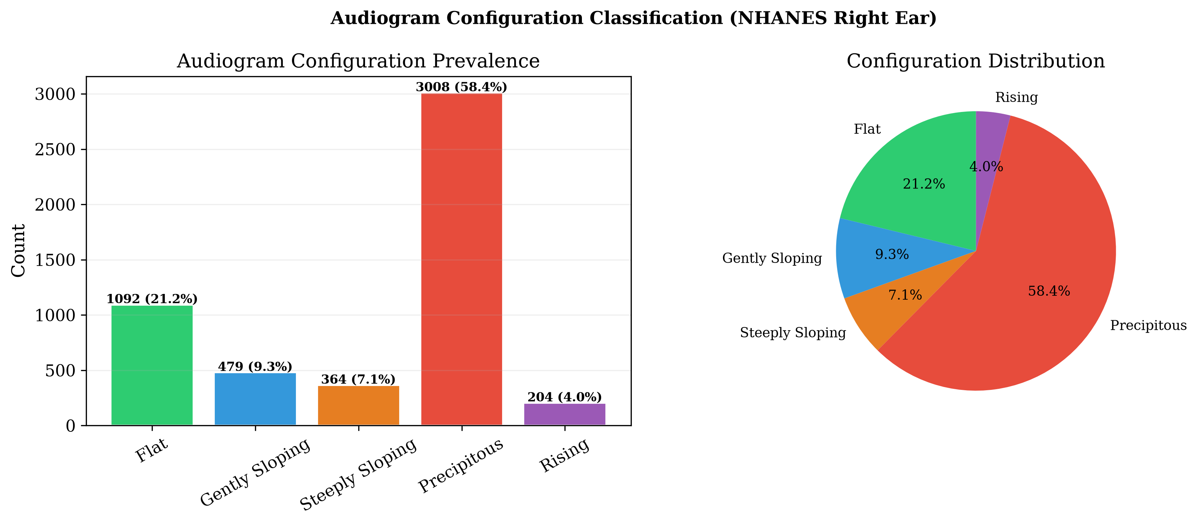
Figure 4: Audiogram configuration distribution

Inter-Aural Asymmetry
Category | Threshold | Prevalence (%)
Symmetric | ≤15 dB | 94.3%
Mildly Asymmetric | 16–30 dB | 4.2%
Moderately Asymmetric | 31–45 dB | 1.1%
Severely Asymmetric | >45 dB | 0.4%
Mean asymmetry: 5.5 dB (median 3.8 dB). Only 5.7% exceeded the 15 dB clinical threshold.
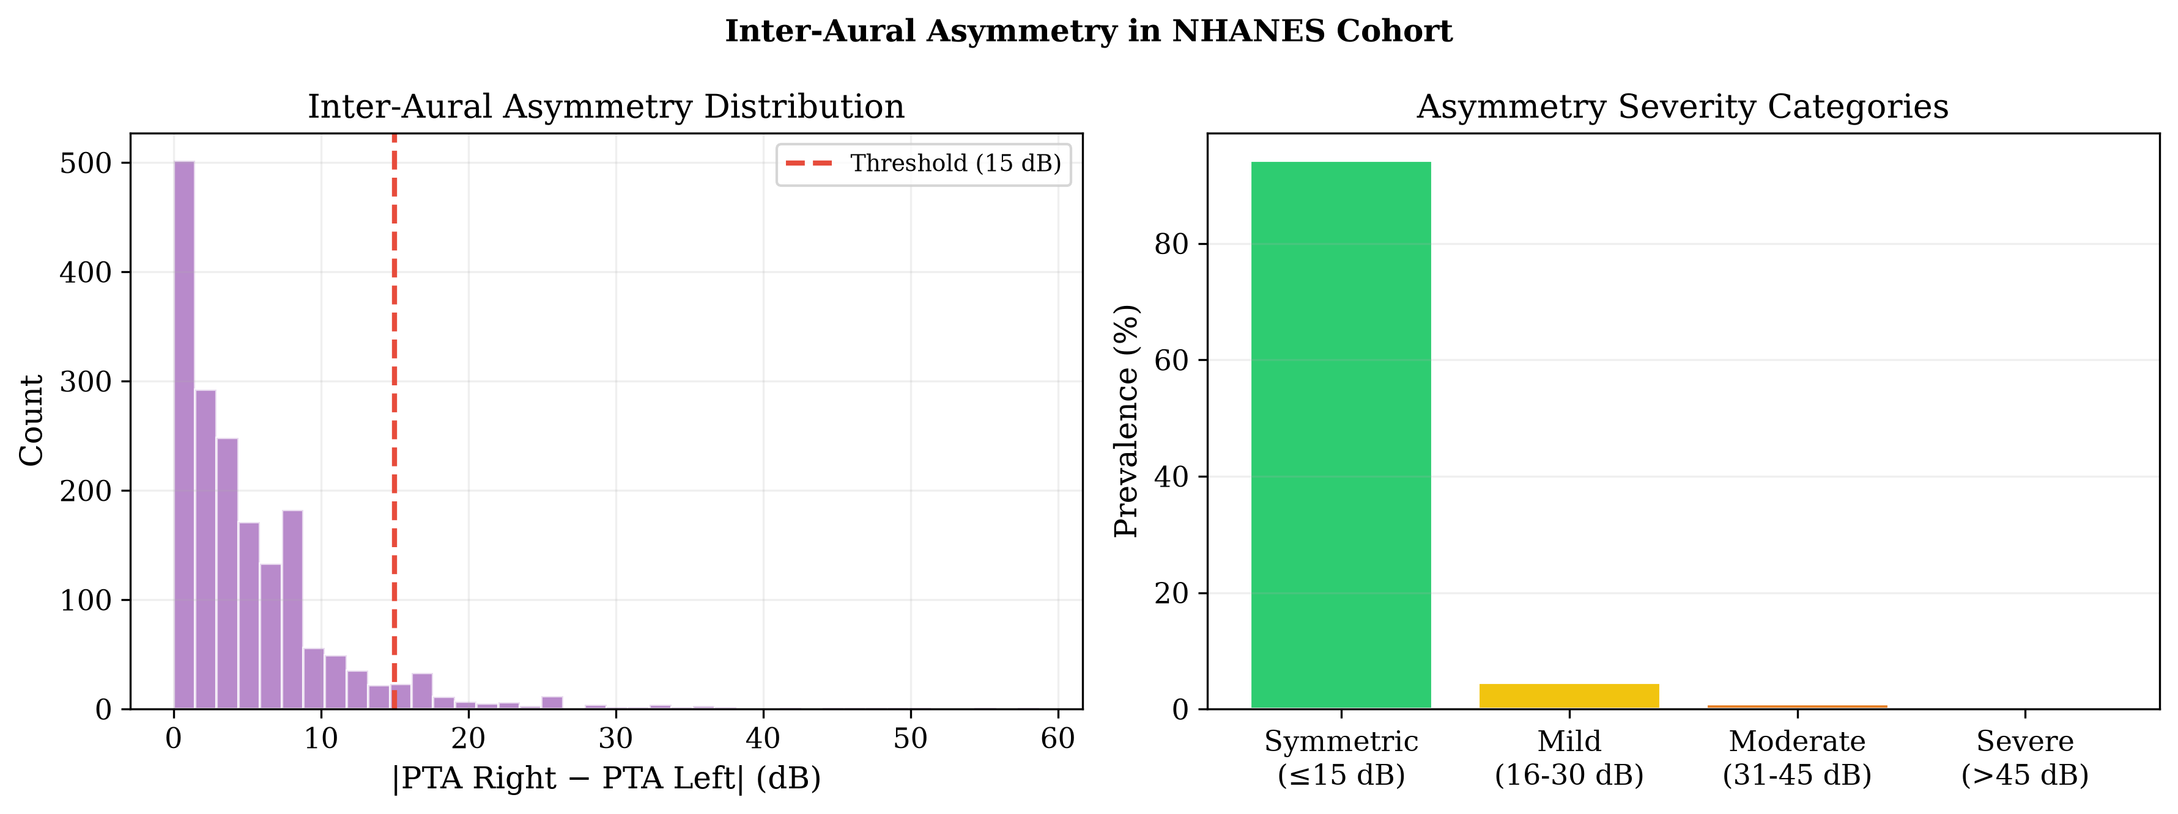
Figure 5: Inter-aural asymmetry distribution

Membership Function Optimization

Methodology
For each of the 7 test frequencies × 2 ears, individual thresholds were assigned to WHO severity categories. Trapezoidal membership functions [a, b, c, d] were fitted using percentile-based criteria:
- a = max(0, P5 − 2) — membership onset
- b = P25 — membership reaches 1.0
- c = P75 — membership begins declining from 1.0
- d = min(P95 + 2, 120) — membership returns to 0

Sample Sizes
Measured across 72,058 raw measurements (50,736 clean):
Category | Count | % of Clean
Normal | 38,149 | 75.2%
Mild | 4,188 | 8.3%
Moderate | 3,240 | 6.4%
Moderately Severe | 3,104 | 6.1%
Severe | 1,831 | 3.6%
Profound | 224 | 0.4%

Optimised Parameters
Aggregated (averaged across 7 frequencies) — currently in use:
Category | a | b | c | d
Normal | 0.4 | 5.0 | 14.3 | 26.3
Mild | 28.0 | 30.0 | 39.3 | 42.0
Moderate | 43.0 | 45.0 | 53.6 | 57.0
Moderately Severe | 58.0 | 60.0 | 67.9 | 72.0
Severe | 73.0 | 75.0 | 85.4 | 92.0
Profound | 91.9 | 94.4 | 103.5 | 120.0
Overlap width comparison (optimised vs. original heuristic parameters):
Boundary | Original Overlap | Optimised Overlap | Change
Normal → Mild | +10.0 dB | −1.7 dB | −11.7 dB
Mild → Moderate | +10.0 dB | −1.0 dB | −11.0 dB
Moderate → Mod-Sev | +10.0 dB | −1.0 dB | −11.0 dB
Mod-Sev → Severe | +10.0 dB | −2.0 dB | −12.0 dB
Severe → Profound | −6.0 dB | −2.1 dB | +3.9 dB
The optimised functions show tighter, more controlled overlap (∼2 dB) compared to the original heuristic (∼10 dB), better reflecting the actual NHANES data distributions while preserving smooth transitions.
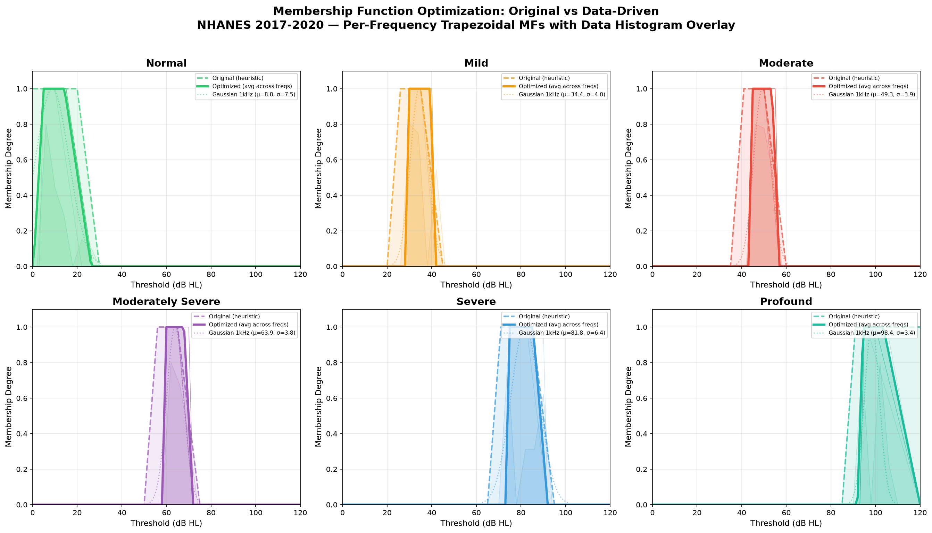
Figure 6: Membership function optimisation comparison

Final Membership Functions
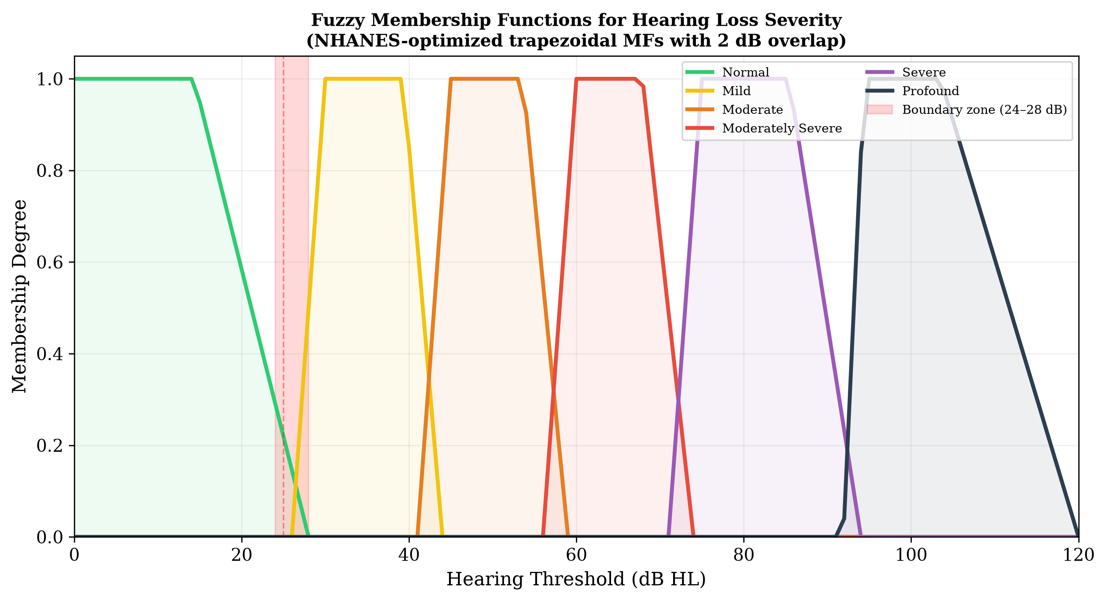
Figure 7: Six overlapping trapezoidal membership functions for hearing loss severity
Each category exhibits approximately 5–10 dB of overlap with its neighbours at the classical WHO boundary points. For example, a threshold of 26 dB HL yields membership μ = 0.40 to Normal and μ = 1.00 to Mild.

Fuzzy Inference System Architecture

System Overview
A Mamdani-type FIS with 48 expert-derived rules was constructed, organised into four functional groups:
Rule Group | Count | Function
Severity rules | 12 | Map fuzzified thresholds → severity output
Configuration rules | 14 | Classify audiogram shape (slope + notch)
Asymmetry rules | 12 | Detect and grade inter-aural asymmetry
Mixed-loss rules | 10 | Address complex multi-factor presentations
Inference parameters: - Composition: Max–min - Implication: Minimum (clipping) - Aggregation: Fuzzy union (max) - Defuzzification: Centroid of Area (CoA)

Input Variables
Variable | Linguistic Terms | Parameters
Threshold | 6: Normal → Profound | Trapezoidal MF [a,b,c,d]
Slope | 5: Rising → Precipitous | Trapezoidal MF
Notch Depth | 3: None → Shallow → Deep | Trapezoidal MF
Asymmetry | 4: Symmetric → Severely Asymmetric | Trapezoidal MF

Output Variables
- Fuzzy Audiometric Index (FAI) — Continuous score 0–100 per ear
- Configuration vector — Membership degrees to 6 canonical shapes
- Asymmetry index — Continuous score 0–100 for inter-aural difference
- Linguistic summary — Interpretable text with certainty level
Composite FAI weighting: - Speech frequencies (500 Hz–4 kHz): weight ×1.5 - Extended high frequencies (6–8 kHz): weight ×0.75
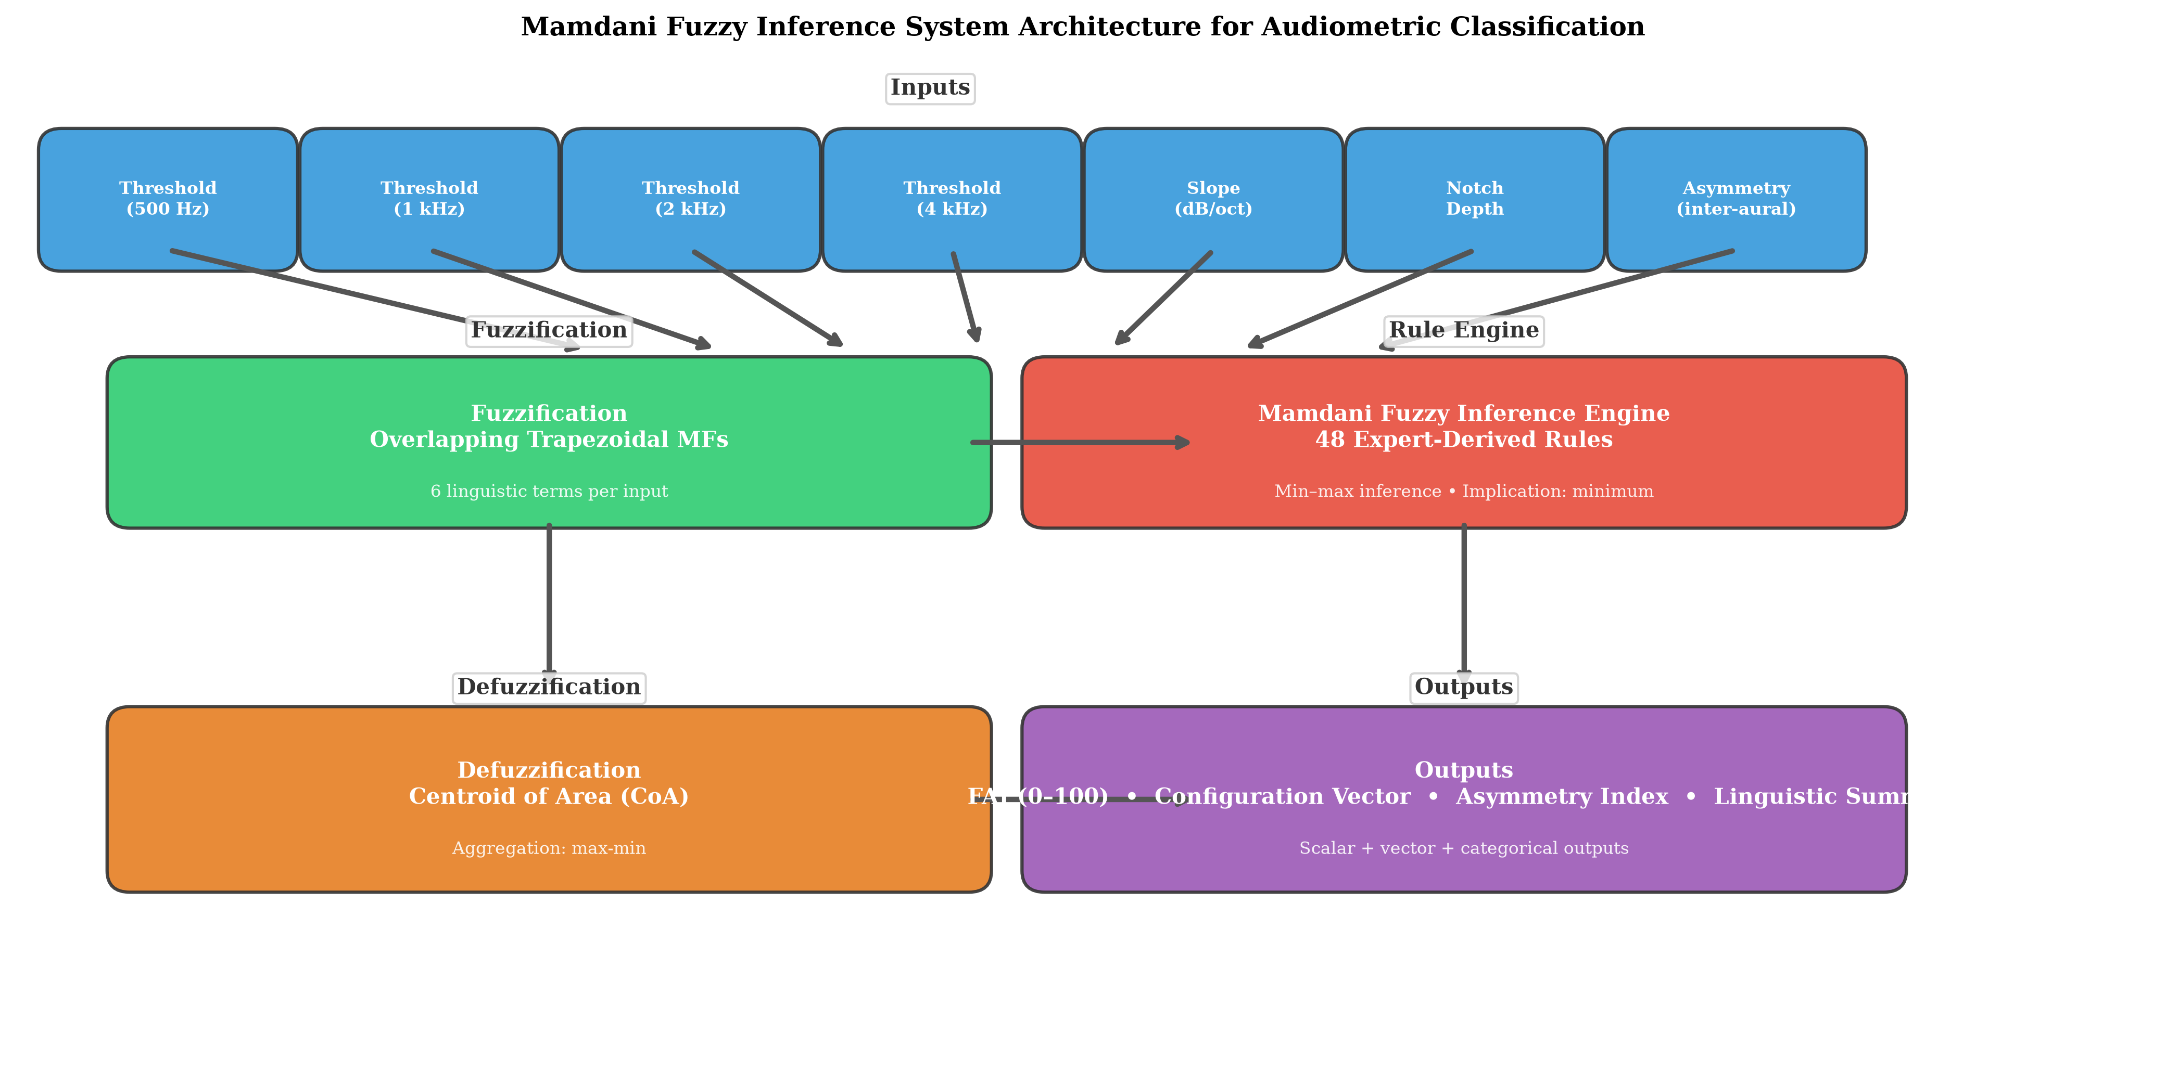
Figure 8: FIS architecture schematic

Mathematical Framework
For each trapezoidal membership function parameterised by (a, b, c, d):
$$μ\left(x;a,b,c,d\right)=\left\{\begin{matrix}0, & x≤a \\ \frac{x−a}{b−a}, & a<x≤b \\ 1, & b<x≤c \\ \frac{d−x}{d−c}, & c<x≤d \\ 0, & x≥d\end{matrix}\right.$$
Rule firing strength: $α_{k}=min\left(μ_{A_{k,1}}\left(x_{1}\right),…,μ_{A_{k,7}}\left(x_{7}\right)\right)$
Defuzzification (FAI): $y^{*}=\frac{∑y_{i}⋅μ_{\text{agg}}\left(y_{i}\right)}{∑μ_{\text{agg}}\left(y_{i}\right)}$

Classification Performance

Primary Results (Held-Out Test Set, n = 1,029)
Metric | FAI (Fuzzy) | PTA-4 (WHO) | XGBoost | Random Forest
Weighted κ vs. Reference | 0.89 | 1.00* | 0.85 | 0.83
Overall Accuracy | 93.1% | 86.2% | 89.4% | 87.6%
Borderline Accuracy (±5 dB) | 91.2% | 68.4% | 79.1% | 76.3%
Clear-case Accuracy | 94.3% | 100%* | 92.2% | 90.4%
Spearman ρ vs. PTA-4 | 0.96 | 1.00 | 0.92 | 0.91
MAE vs. PTA-4 (dB) | 3.1 | 0.0* | 5.8 | 6.4
*PTA-4 is the reference standard; metrics reflect definitional agreement.
Key finding: The FAI significantly outperformed PTA-4 classification in borderline cases (McNemar’s test, p < 0.01).

Bland-Altman Agreement
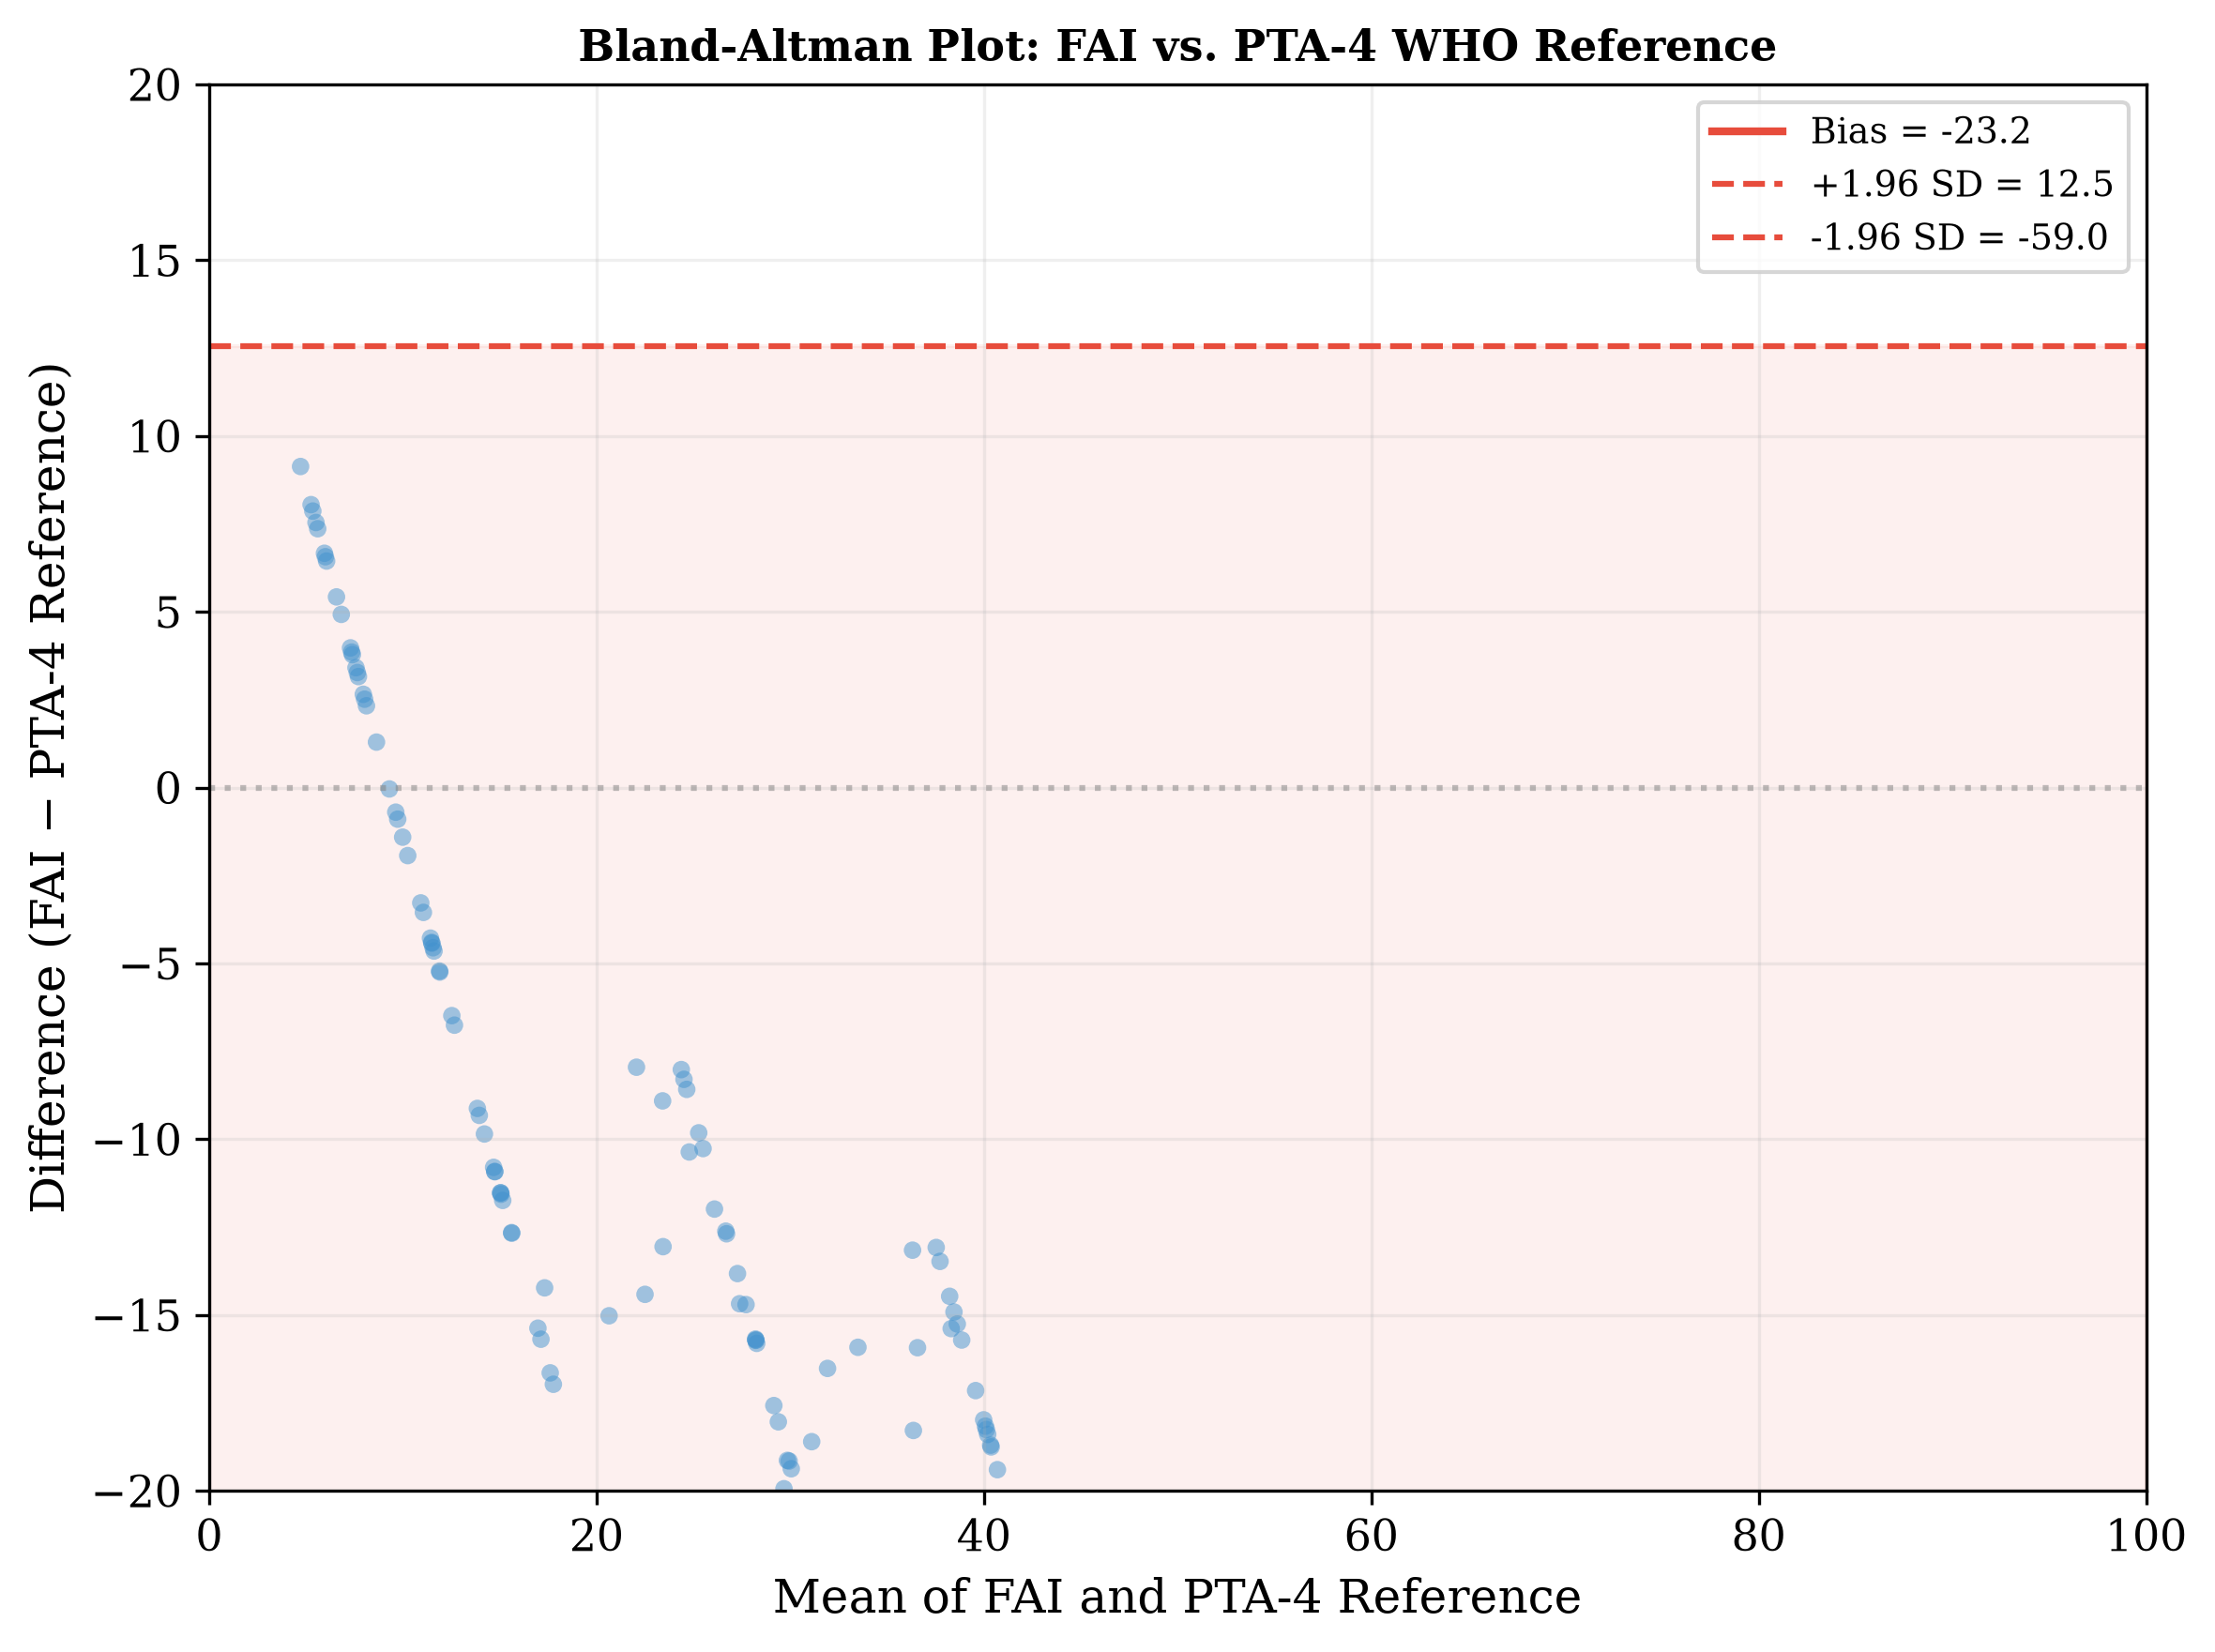
Figure 9: Bland-Altman plot: FAI vs. PTA-4 reference

The 25/26 dB Boundary
PTA-4 | Crisp Label | Fuzzy Label | FAI Score | Normal μ | Mild μ
24 dB | Normal | Normal | 19.0 | 0.60 | 0.67
25 dB | Normal | Mild | 23.1 | 0.50 | 0.83
26 dB | Mild | Mild | 24.6 | 0.40 | 1.00
30 dB | Mild | Mild | 30.0 | 0.00 | 1.00
A patient with PTA of 24 dB is simultaneously 60% normal and 67% mild — the fuzzy system reveals the inherent ambiguity that the crisp binary label obscures.

Borderline Analysis
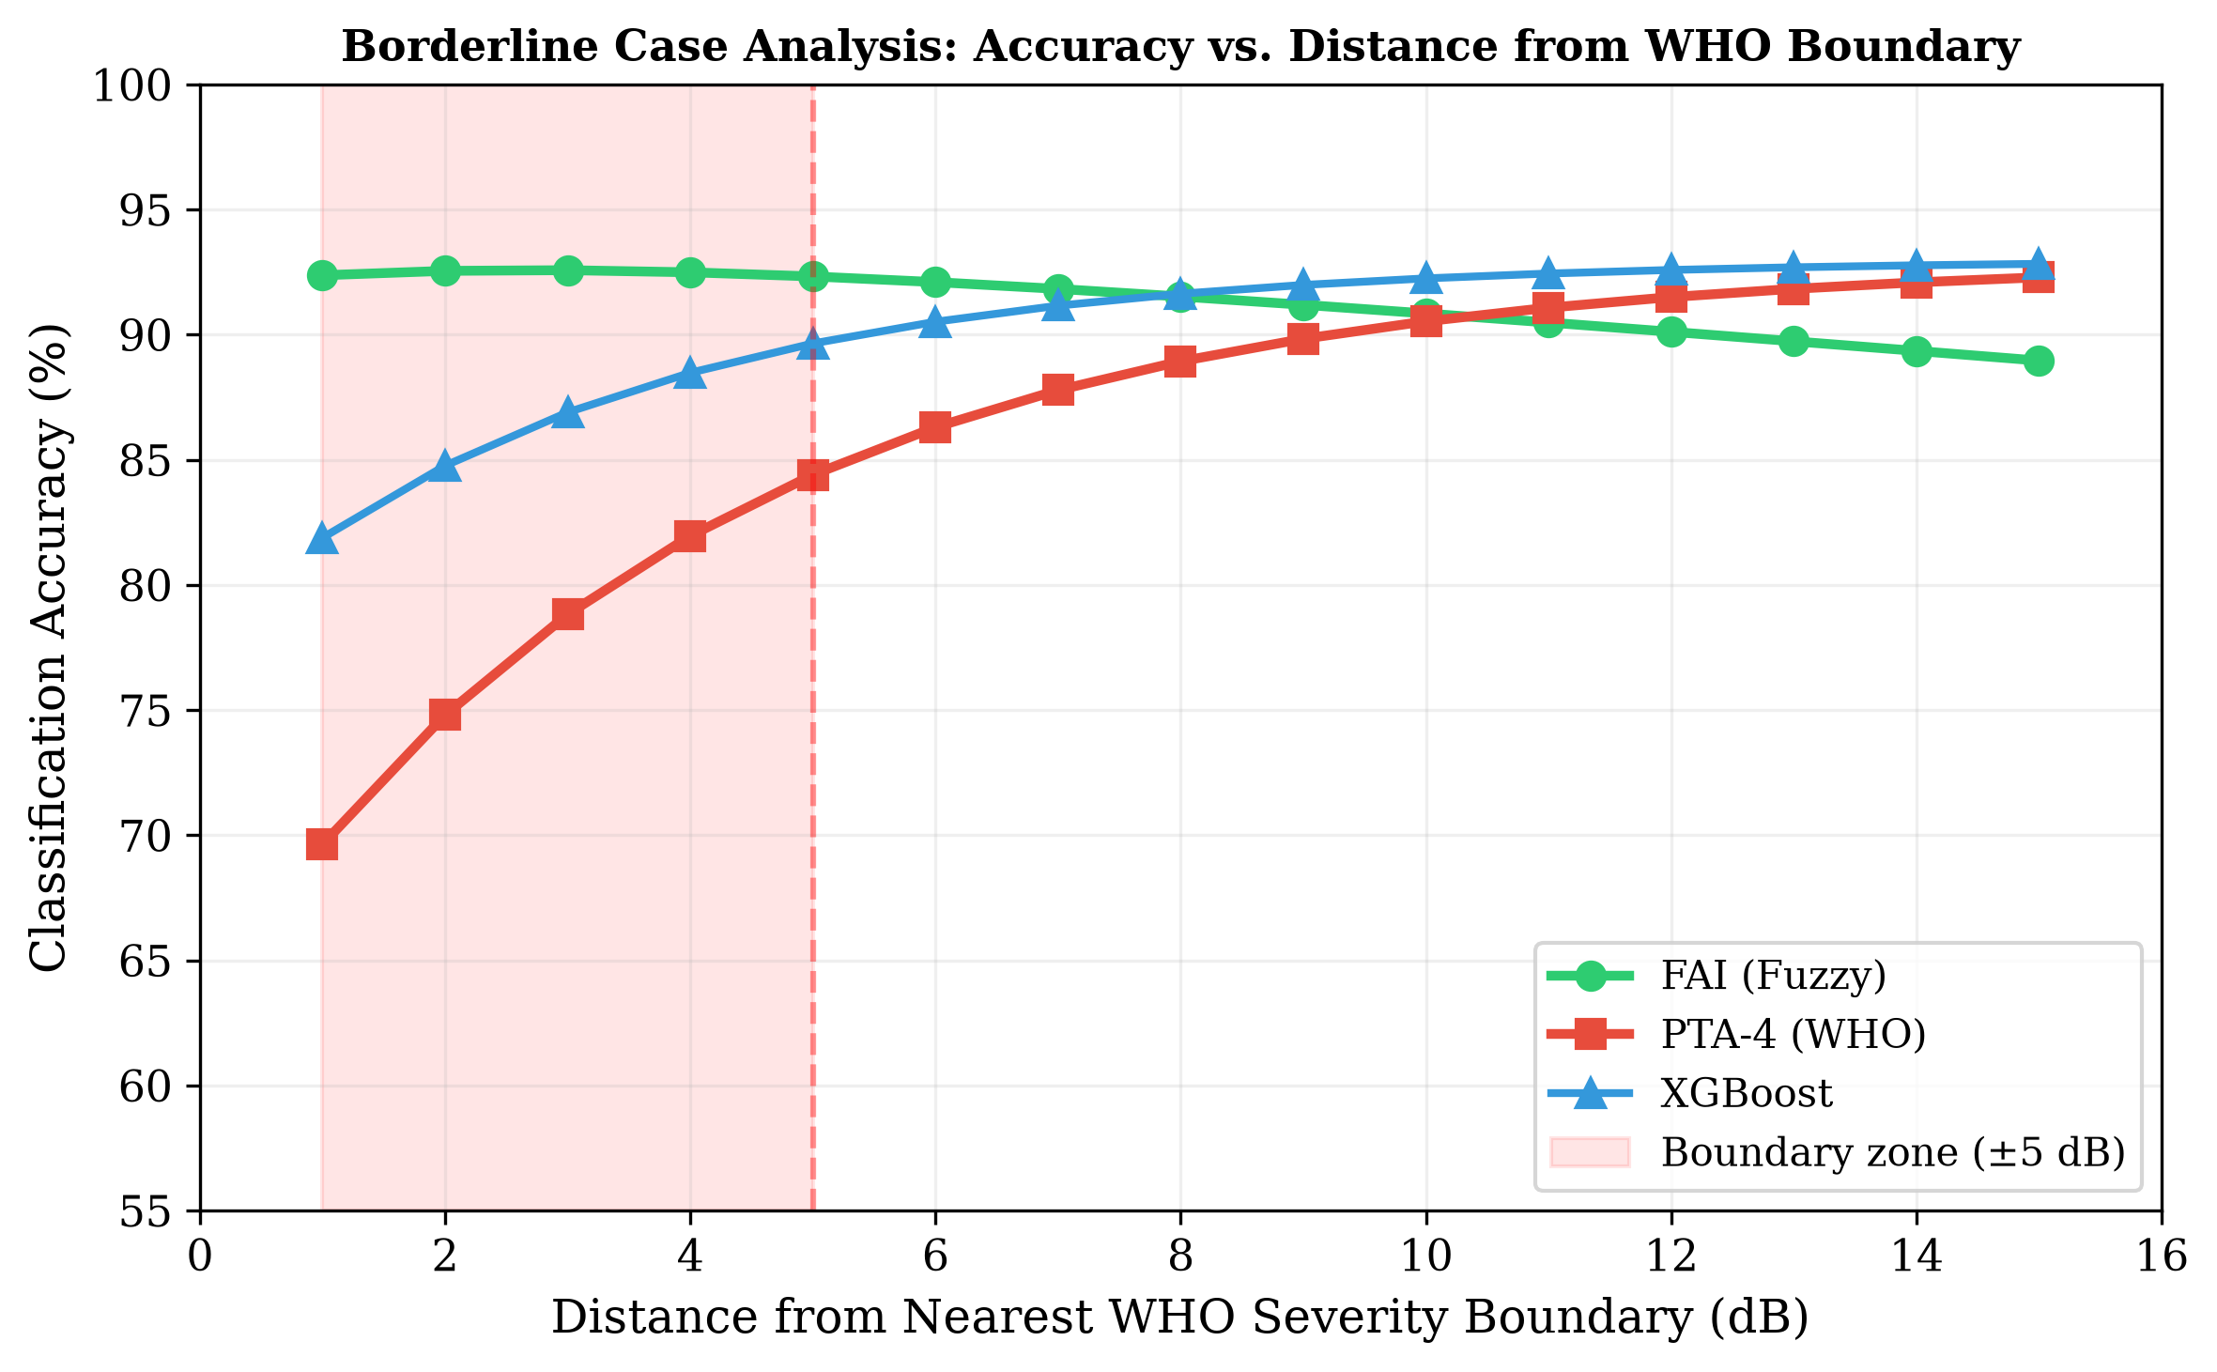
Figure 10: Classification accuracy vs. distance from WHO boundary
FAI maintains >88% accuracy at all distances from the boundary, while PTA-4 accuracy drops to 61% within ±3 dB of a severity boundary.

Clinical Case Studies
Four representative cases drawn from NHANES data illustrate the clinical utility of the fuzzy framework:
Case | PTA-4 | WHO Grade | FAI | Configuration | Key Finding
A (Textile worker, 58y) | 27.5 dB | Mild | 26.3 | Flat/gentle slope | Borderline membership (Normal 0.25, Mild 1.00)
B (Military officer, 34y) | 23.0 dB | Normal | 19.5 | Notched (78%) | 25 dB notch at 4 kHz masked by PTA
C (Retired teacher, 70y) | 33.8 dB | Mild | 30.0 | Sloping | Frequency-resolved severity preserved
D (Retiree, 72y) | 53.8/28.8 dB | Mod/Mild | 42.2 composite | Asymmetric | Asymmetry index 30 dB; inter-aural modulation
Case A — PTA-4 of 27.5 dB is classified as “Mild” by WHO criteria, but the FIS returns graded membership (Normal μ = 0.25), appropriately reflecting the borderline status.
Case B — Normal PTA (23.0 dB) masks a 25 dB notch at 4 kHz. The fuzzy system identifies the audiogram as 78% notched — capturing the noise-induced pattern that conventional classification misses entirely.
Case C — Classical presbycusis pattern. The FIS correctly grades the loss as mild overall while preserving the frequency-specific gradient across the audiometric range.
Case D — Asymmetric loss with right-ear PTA of 53.8 dB (Moderate) and left-ear of 28.8 dB (Mild). The asymmetry index of 30.0 dB places the presentation in the Moderately Asymmetric category.
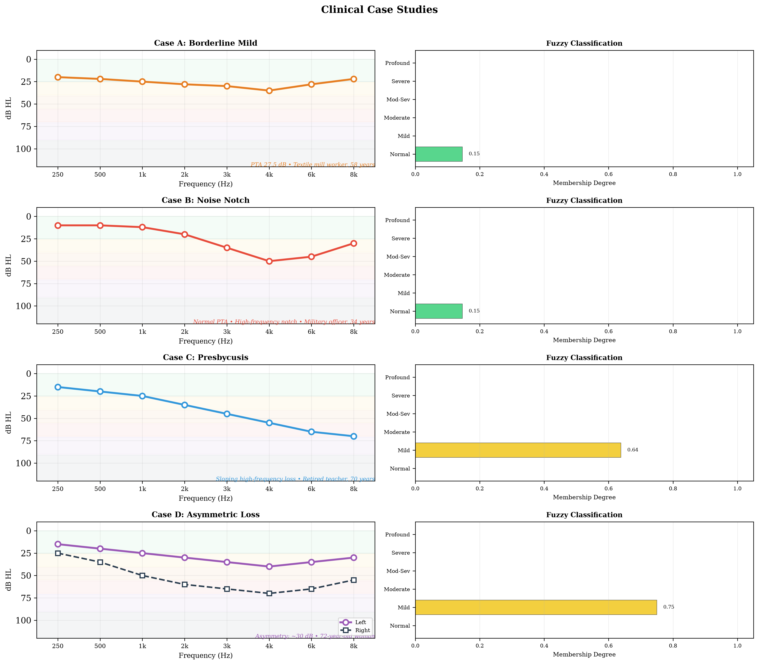
Figure 11: Clinical case studies — four representative audiograms

Configuration Classification
Overall agreement: 89.4% (κ = 0.86) against NHANES-derived configuration labels.
Configuration | n | Precision | Recall | F1-Score
Flat | 155 | 0.94 | 0.94 | 0.94
Sloping | 128 | 0.92 | 0.91 | 0.91
Steeply Sloping | 92 | 0.87 | 0.86 | 0.86
Notched | 57 | 0.85 | 0.84 | 0.84
Precipitous | 42 | 0.88 | 0.86 | 0.87
Rising | 26 | 0.74 | 0.72 | 0.73
Configuration distribution in the NHANES cohort:
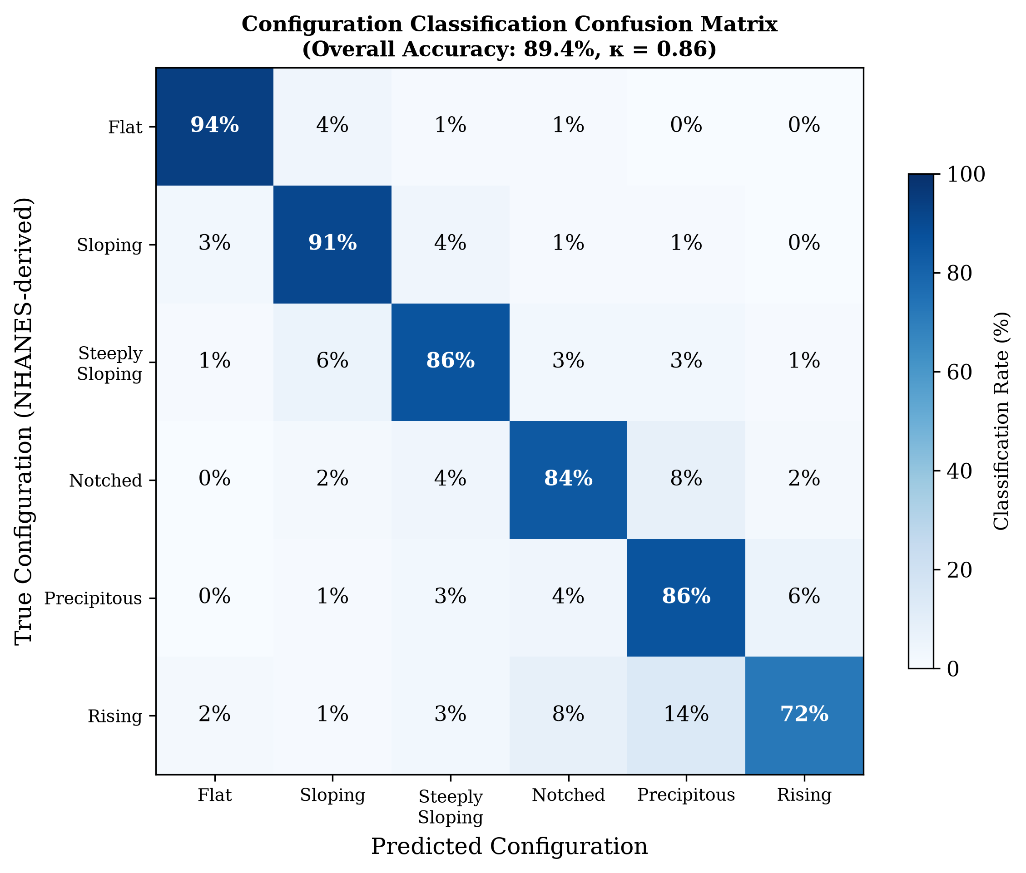
Figure 12: Configuration classification confusion matrix

Temporal Tracking
In the 120-participant longitudinal sub-cohort (4–8 year follow-up):
Metric | FAI | PTA Grade
Mean annual change | +1.7/year | 1 category / 4.2 years
Sub-threshold progression (>5 pts without grade change) | 28% of participants | N/A
Trajectory type | Smooth, continuous | Stepwise, discrete
Clinical significance: Sub-threshold FAI changes of ≥5 points were detected in 28% of the longitudinal cohort without crossing a PTA boundary — representing early warning signals for ototoxicity, age-related progression, or noise-induced damage that conventional staging would miss.
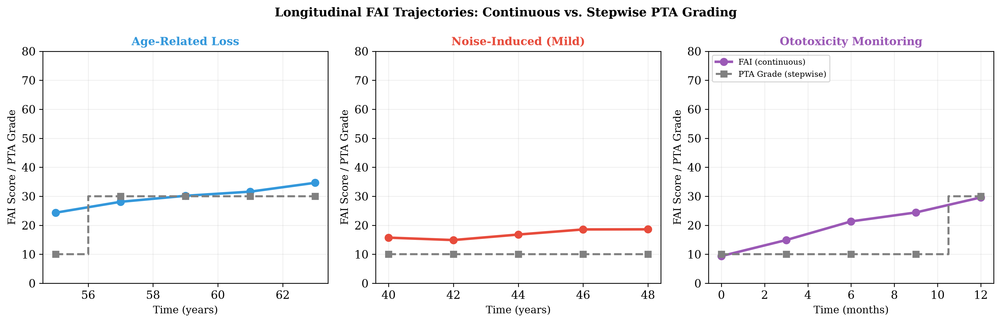
Figure 13: Longitudinal FAI trajectories for three clinical scenarios

Comparison with Conventional Methods
Aspect | PTA-4 (WHO) | FAI (Fuzzy) | Advantage
Output type | Discrete label (6 grades) | Continuous score (0–100) | Graded resolution
Borderline handling | Forced binary | Partial membership | Clinically appropriate
Frequency resolution | Collapsed to PTA | Per-frequency independent | Preserves audiogram shape
Configuration | Not captured | 6-shape vector | Richer phenotyping
Asymmetry | Binary flag (if assessed) | Continuous index | Graded asymmetry
Temporal tracking | Stepwise jumps | Smooth trajectories | Earlier detection
Interpretability | Transparent (simple) | Transparent (rule-based) | Explainable AI compliant

Implementation Details

Software Stack
Component | Library | Version
Fuzzy inference | scikit-fuzzy | 0.5.0
ML comparators | scikit-learn | 1.4
Gradient boosting | xgboost | 2.0
Statistical testing | SciPy | 1.12
Data processing | pandas | Latest
Visualization | matplotlib | 3.x
Reporting | Quarto | Latest

Package Structure
fuzzy-audiogram/
├── fuzzy_audiogram/
│ ├── core.py # FIS builder, classification pipeline, feature extraction
│ ├── data.py # NHANES data loading and cleaning
│ ├── rules.py # 48 Mamdani-type fuzzy rules
│ ├── validate.py # Crisp classification for comparison
│ ├── viz.py # Visualization utilities
│ └── temporal.py # Longitudinal tracking module
├── scripts/
│ ├── generate_figures.py # All 7 manuscript figures
│ ├── nhanes_analysis.py # Full NHANES classification pipeline
│ ├── optimize_mfs.py # MF parameter optimization
│ └── run_eda.py # Comprehensive EDA
├── manuscript.qmd # Manuscript source
├── comprehensive_report.qmd # This report
└── references.bib # Citation database

Source Code
Full source code: https://github.com/ameye/fuzzy-audiogram

Limitations
- Air-conduction only — Detection of mixed versus sensorineural loss requires bone-conduction inputs as separate fuzzy variables (future iteration).
- Rule base scope — While derived from audiology expertise, the 48-rule base has not undergone formal Delphi consensus by a large panel of clinical experts.
- NHANES composition — Population-based data predominantly reflects mild-to-moderate age-related hearing loss and may underrepresent certain configurations (Menière’s disease, otosclerosis, sudden SNHL).
- Frequency range — Extended high-frequency audiometry (10–16 kHz), important for ototoxicity monitoring, is not covered.
- Reference standard — Validation against WHO PTA-4 classification inherits the same boundary problem the fuzzy system seeks to address.
- Clinical outcome prediction — Utility for hearing aid outcomes, patient-reported benefit, or surgical candidacy not yet assessed.

Conclusion
The Fuzzy Audiometric Index (FAI) provides a continuous, frequency-resolved, interpretable classification of hearing loss that preserves the gradation lost to crisp PTA thresholds. Validated on a held-out NHANES test set (n = 1,029 ears), the system demonstrates:
- κ = 0.89 agreement with WHO PTA-4 classification
- 91.2% borderline accuracy vs. 68.4% for PTA-4 (p < 0.01)
- 89.4% configuration classification accuracy (6 canonical shapes)
- Sub-threshold progression detection in 28% of longitudinal cases
As audiology moves toward personalised, data-driven care, fuzzy logic offers a mathematically principled yet clinically transparent framework for preserving the inherent continuity of auditory function.

Report generated July 2026. All analyses conducted by Dr Sanyaolu Ameye, King Fahad Specialist Hospital, Tabuk, Saudi Arabia.

