CustomCommands.cy.js – Custom commands and overwriting a command
File | cypress/e2e/CustomCommands.cy.js
Website used | https://demo.nopcommerce.com/
Run status | Only the 'Login command' test runs (it.only). It needs a real registered account: the credentials in the file are placeholders, so it fails until valid ones are filled in.
Concepts | Custom command, Reusability (DRY), Overwriting a command, Support file, it.only

1. What this file does
Uses commands that we created in cypress/support/commands.js: clickLink (click a link by its text) and loginapp (fill and submit the login form). It also relies on an overwritten version of Cypress's own contains() command that ignores upper/lower case.

2. The code (screenshots)
Keep this next to the file in VS Code. Line numbers match the real file.
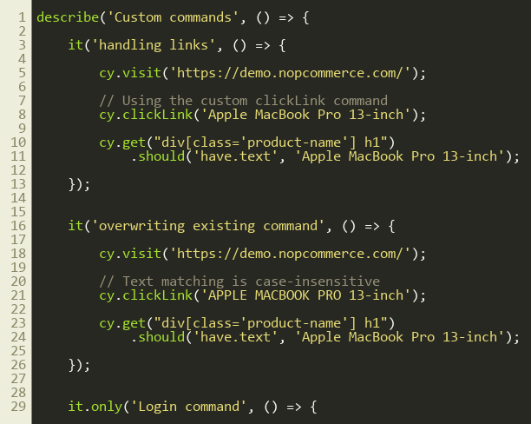
Lines 1–30
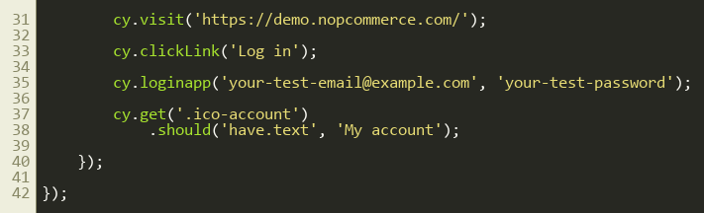
Lines 31–42
Custom commands used by this test: cypress/support/commands.js (from line 50)
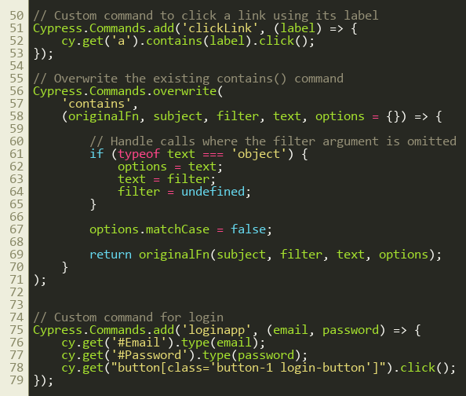
Lines 50–79

3. Step by step: what happens
Look for this in the code | What it does
Test 1: handling links | cy.clickLink('Apple MacBook Pro 13-inch') clicks the product link, then the product page heading is checked with should('have.text', ...).
Test 2: overwriting existing command | cy.clickLink('APPLE MACBOOK PRO 13-inch') uses different capitalisation. It still works because the overwritten contains() sets matchCase to false.
Test 3: Login command (it.only) | cy.clickLink('Log in') opens the login page. cy.loginapp(email, password) types into #Email and #Password and clicks the login button. Finally the header link text 'My account' is checked.
Last screenshot: support/commands.js | Shows how the three commands are written.

4. Concepts involved
Concept | Meaning
Custom command | Cypress.Commands.add('name', fn) creates a new cy.name() command available in all specs.
Reusability (DRY) | Write once, call from any test. cy.loginapp(email, pass) replaces three lines in every test.
Overwriting a command | Cypress.Commands.overwrite('contains', (originalFn, subject, filter, text, options) => {...}) changes how an existing command behaves. We set options.matchCase = false and then call the original function.
Support file | commands.js is loaded automatically because support/e2e.js imports it.
it.only | Only that test runs. Remove it to run all three.

5. How it is implemented
clickLink uses cy.get('a').contains(label).click(). loginapp types the email and password and clicks the login button. The overwrite intercepts every call to contains(): if the text argument is an object it shifts the arguments, sets options.matchCase = false and then calls the original contains.

6. Why it is useful
Common actions such as logging in become one-liners, and a global change (case-insensitive text matching) is made in one place.

7. Things to watch out for
- Replace the placeholder email and password with a real demo-site account before running, and never commit real passwords.
- Overwriting contains() affects EVERY use of contains() in all specs, including the older ones, so make sure that is what you want.
- The demo site can reset its data, so a registered account may disappear.

