LoginWithPOM.cy.js – Page Object Model (POM)
File | cypress/e2e/LoginWithPOM.cy.js
Website used | https://opensource-demo.orangehrmlive.com/
Run status | Runs. Uses the page class in cypress/PageObjects/LoginPage.js.
Concepts | Page Object Model (POM), JavaScript class, import / export, Separation of concerns, Maintainability

1. What this file does
Logs in to OrangeHRM using the Page Object Model: the locators and actions for the login page live in a separate class (Login), and the test just calls its methods. The test reads like plain English: set username, set password, click submit, verify login.

2. The code (screenshots)
Keep this next to the file in VS Code. Line numbers match the real file.
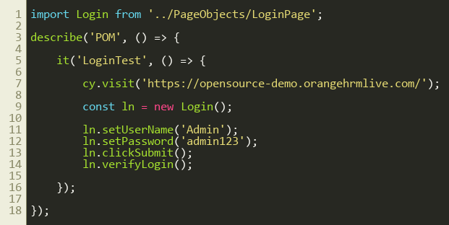
Lines 1–18
Page object used by this test: cypress/PageObjects/LoginPage.js
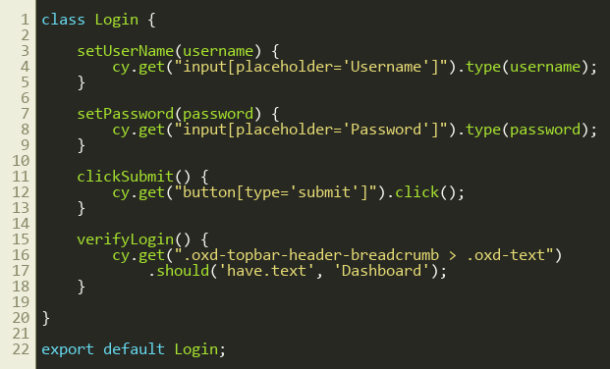
Lines 1–22

3. Step by step: what happens
Look for this in the code | What it does
import Login from '../PageObjects/LoginPage' | Brings the page class into the test. The path goes one folder up from e2e, then into PageObjects.
cy.visit(...) | Opens the OrangeHRM login page.
const ln = new Login(); | Creates an object of the page class. ln stands for 'login page'.
ln.setUserName('Admin'); ln.setPassword('admin123'); | Each method finds its input with cy.get() and types the value. The selectors are hidden inside the class (see the LoginPage.js screenshot).
ln.clickSubmit(); | Clicks the Login button.
ln.verifyLogin(); | Asserts that the breadcrumb header has the text 'Dashboard', proving login worked.

4. Concepts involved
Concept | Meaning
Page Object Model (POM) | A design pattern where each web page has a class holding its locators and actions.
JavaScript class | class Login { ... } with methods such as setUserName(). export default makes it importable.
import / export | Shares code between files (ES module syntax).
Separation of concerns | Test file = what to test. Page class = how to find and use elements.
Maintainability | If a locator changes, fix it once in LoginPage.js, not in every test.

5. How it is implemented
LoginPage.js defines a class with four methods. Every method wraps one Cypress step (type, click or assert). The test creates the class with new Login() and calls the methods in order. The class lives in cypress/PageObjects, outside the e2e folder, so Cypress does not try to run it as a test.

6. Why it is useful
Tests become short and readable. When the page changes, only the page class is edited. The same page class can be reused by many tests.

7. Things to watch out for
- Keep locators in the page class and the checks about what should happen in the spec.
- Selectors here are hard-coded strings inside the methods. The next file (LoginWithPOMFixture) stores them as variables.

