LoginWithPOMFixture.cy.js – Page Object Model + fixture data
File | cypress/e2e/LoginWithPOMFixture.cy.js
Website used | https://opensource-demo.orangehrmlive.com/
Run status | Runs. Uses cypress/PageObjects/LoginPage2.js and cypress/fixtures/orangehrm.json.
Concepts | POM with class properties, Fixtures, cy.fixture().then(), Combining patterns

1. What this file does
An improved version of the POM test. The locators are now stored as class variables in LoginPage2.js, and the username and password come from the orangehrm.json fixture instead of being typed into the test.

2. The code (screenshots)
Keep this next to the file in VS Code. Line numbers match the real file.
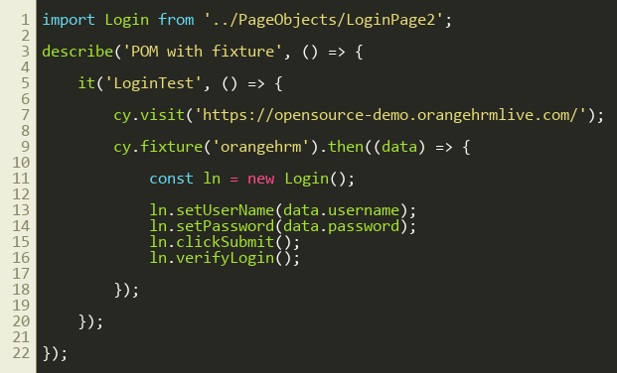
Lines 1–22
Page object used by this test: cypress/PageObjects/LoginPage2.js
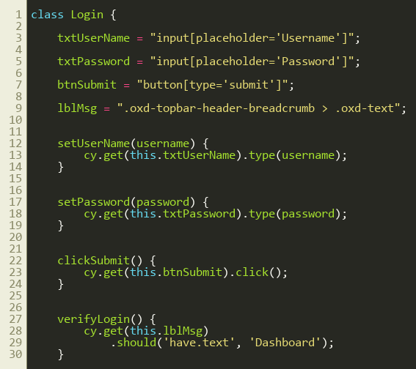
Lines 1–30
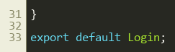
Lines 31–34

3. Step by step: what happens
Look for this in the code | What it does
import Login from '../PageObjects/LoginPage2' | Imports the second, improved page class.
cy.visit(...) | Opens the login page.
cy.fixture('orangehrm').then((data) => { | Loads orangehrm.json (username, password, expected) and passes it as data.
const ln = new Login(); | Creates the page object inside the callback.
ln.setUserName(data.username); ln.setPassword(data.password); | Types the values that came from the fixture file.
ln.clickSubmit(); ln.verifyLogin(); | Logs in and asserts the Dashboard heading appears.

4. Concepts involved
Concept | Meaning
POM with class properties | txtUserName, txtPassword, btnSubmit and lblMsg hold the selectors. Methods use this.txtUserName. All locators sit at the top of the class.
Fixtures | Test data lives in cypress/fixtures/orangehrm.json, separated from the test.
cy.fixture().then() | The data only exists inside the .then() callback.
Combining patterns | POM (structure) + fixtures (data) is how real frameworks are organised.

5. How it is implemented
In LoginPage2.js, selectors are fields (txtUserName = "input[placeholder='Username']"). Methods read them with this. When a locator changes, there is exactly one line to edit. The test passes fixture values into the setter methods.

6. Why it is useful
Locators are in one place at the top of the class, and data is in a JSON file. The test itself contains no selectors and no hard-coded credentials.

7. Things to watch out for
- LoginPage.js and LoginPage2.js both define a class called Login. That works because each is imported separately, but clearer names would help later.
- Compare the two page-class screenshots to see the difference.

