Navigation.cy.js – Browser navigation: back, forward, reload
File | cypress/e2e/Navigation.cy.js
Website used | https://demo.opencart.com/
Run status | Runs. One test.
Concepts | cy.go('back' | 'forward' | number), cy.reload(), cy.title(), Assertions after navigation

1. What this file does
Opens the OpenCart demo, goes into the Cameras category and then moves back and forward through the browser history in different ways, checking the page each time. It ends with a page reload.

2. The code (screenshots)
Keep this next to the file in VS Code. Line numbers match the real file.
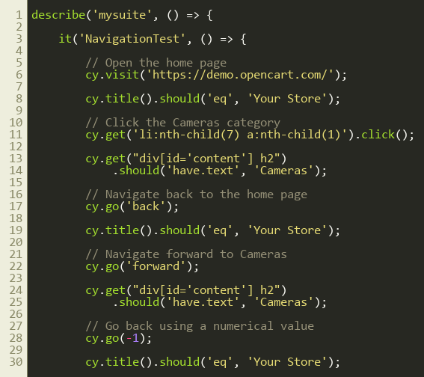
Lines 1–30
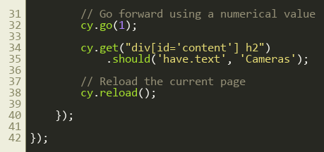
Lines 31–43

3. Step by step: what happens
Look for this in the code | What it does
cy.visit('https://demo.opencart.com/') | Opens the home page.
cy.title().should('eq', 'Your Store') | Home page title check.
cy.get('li:nth-child(7) a:nth-child(1)').click() | Clicks the Cameras category link.
cy.get("div[id='content'] h2").should('have.text', 'Cameras') | Confirms we are on the Cameras page by its heading.
cy.go('back') / cy.go('forward') | Same as pressing the browser Back and Forward buttons. The title or heading is checked each time.
cy.go(-1) / cy.go(1) | The same navigation using numbers: -1 = back one page, 1 = forward one page.
cy.reload() | Refreshes the current page.

4. Concepts involved
Concept | Meaning
cy.go('back' | 'forward' | number) | Moves in the browser history. Negative numbers go back, positive go forward.
cy.reload() | Reloads the page (cy.reload(true) skips the cache).
cy.title() | Used to know which page we are on.
Assertions after navigation | After every move we assert something, so the test proves we really arrived.

5. How it is implemented
The test builds a history (Home > Cameras) and then walks through it. Each step is followed by an assertion on the title or heading.

6. Why it is useful
Back, forward and refresh are common user actions. This checks the site behaves correctly while navigating.

7. Things to watch out for
- li:nth-child(7) a:nth-child(1) depends on the menu order. A selector based on the link text is safer, for example cy.contains('a', 'Cameras').
- cy.go() fails if there is no history to go back to.

