Screenshots&Videos.cy.js – Screenshots and videos
File | cypress/e2e/Screenshots&Videos.cy.js
Website used | https://demo.opencart.com/
Run status | Runs. Test 2 is MEANT to fail (to show the automatic failure screenshot and video).
Concepts | cy.screenshot(name), Automatic screenshot on failure, Video recording, Negative test, Mochawesome reporter

1. What this file does
Shows how to take screenshots manually (whole page and a single element) and how Cypress automatically captures a screenshot and a video when a test fails. Videos and failure screenshots are switched on in cypress.config.js.

2. The code (screenshots)
Keep this next to the file in VS Code. Line numbers match the real file.
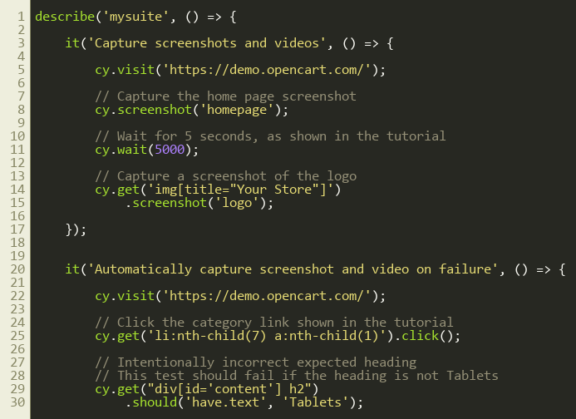
Lines 1–30
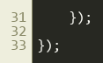
Lines 31–34

3. Step by step: what happens
Look for this in the code | What it does
Test 1: cy.visit(...) | Opens the home page.
cy.screenshot('homepage') | Takes a screenshot of the page and saves it as homepage.png in cypress/screenshots.
cy.wait(5000) | A 5 second pause, as in the tutorial. Not needed for screenshots.
cy.get('img[title="Your Store"]').screenshot('logo') | Takes a screenshot of just the logo element.
Test 2: click Cameras and assert 'Tablets' | Clicks the Cameras category and then expects the heading 'Tablets', which is wrong, so the test fails on purpose.
Automatic capture | Because the test fails, Cypress saves a screenshot (screenshotOnRunFailure: true) and records a video (video: true) when run with npx cypress run.

4. Concepts involved
Concept | Meaning
cy.screenshot(name) | Manual screenshot of the page; chained on an element it captures only that element.
Automatic screenshot on failure | On by default in cypress run; controlled by screenshotOnRunFailure in cypress.config.js.
Video recording | video: true in config records each spec. Videos are saved in cypress/videos (only in cypress run, not cypress open).
Negative test | A test written to fail so we can see the evidence.
Mochawesome reporter | Enabled by reporter: 'cypress-mochawesome-reporter' in cypress.config.js and the register import in support/e2e.js. After npx cypress run it writes an HTML report to cypress/reports/html with the failure screenshots embedded.

5. How it is implemented
Settings live in cypress.config.js (screenshotOnRunFailure, video). Manual screenshots are plain commands inside the test.

6. Why it is useful
Evidence for bug reports and for understanding why a test failed in CI where nobody is watching.

7. Things to watch out for
- Screenshots and videos only appear when running from the terminal with npx cypress run, not in cypress open.
- The cypress/screenshots and cypress/videos folders are in .gitignore, so they are not pushed to GitHub.
- The 'Tablets' failure is deliberate.

