DataDriven.cy.js – Data-driven testing
File | cypress/e2e/DataDriven.cy.js
Website used | https://opensource-demo.orangehrmlive.com/web/index.php/auth/login
Run status | Runs. One test that loops over three data records.
Concepts | Data-driven testing, Array fixtures, Conditional logic in a test, .contains(text)

1. What this file does
Runs the same login steps for three sets of data from orangehrm2.json: a valid login, a wrong username and a wrong password. Valid login must show the user name and then log out; invalid logins must show 'Invalid credentials'.

2. The code (screenshots)
Keep this next to the file in VS Code. Line numbers match the real file.
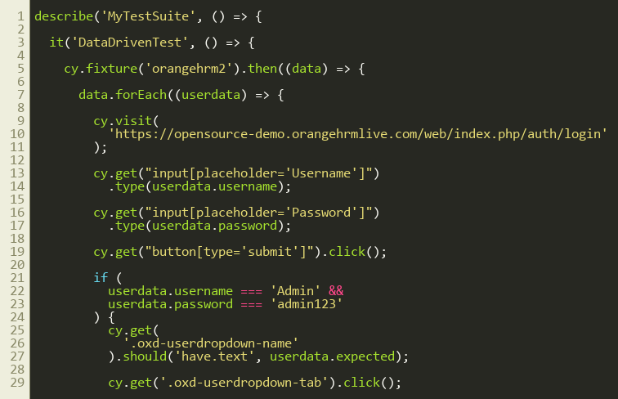
Lines 1–30
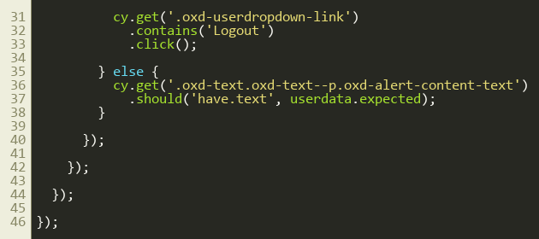
Lines 31–47

3. Step by step: what happens
Look for this in the code | What it does
cy.fixture('orangehrm2').then((data) => { | Loads the JSON array (3 objects with username, password and expected).
data.forEach((userdata) => { | Repeats everything inside for each record.
cy.visit(login URL) | Opens a fresh login page for every record.
type username, type password, click submit | Uses values from the current record.
if (username === 'Admin' && password === 'admin123') | The valid case: check the name in the header, open the user menu and click Logout using .contains('Logout').click() so the next loop starts logged out.
else | Invalid case: check the red alert text equals the expected 'Invalid credentials'.

4. Concepts involved
Concept | Meaning
Data-driven testing | One test, many data sets.
Array fixtures | A JSON array loaded with cy.fixture and looped over with forEach.
Conditional logic in a test | if/else decides what to verify based on the data.
.contains(text) | Finds the element that contains the given text.

5. How it is implemented
Data lives in the JSON file; the loop and the logic live in the test. Adding a fourth login needs only one more JSON object.

6. Why it is useful
Many scenarios with very little code, and it is easy to extend.

7. Things to watch out for
- All three scenarios are inside ONE it(), so if one fails the rest do not run and the report shows one test.
- A cleaner approach is generating one it() per record.

