MouseElements.cy.js – Mouse actions: hover, right click, double click, drag and drop, scroll
File | cypress/e2e/MouseElements.cy.js
Website used | localhost:8080 (local OpenCart), jQuery-contextMenu demo, w3schools, dhtmlgoodies, countries-ofthe-world.com
Run status | Only 'Scrolling Page' runs (it.only). The other four are it.skip. The hover test needs a local OpenCart server.
Concepts | .trigger('event'), .rightclick() / .dblclick(), { force: true }, .drag(target), .scrollIntoView({ duration }), Iframes with cypress-iframe

1. What this file does
Five mouse interactions. The drag and drop plugin is loaded at the top with require('@4tw/cypress-drag-drop').

2. The code (screenshots)
Keep this next to the file in VS Code. Line numbers match the real file.
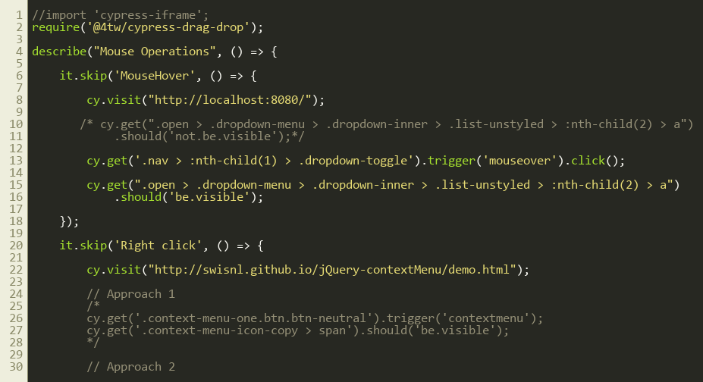
Lines 1–30
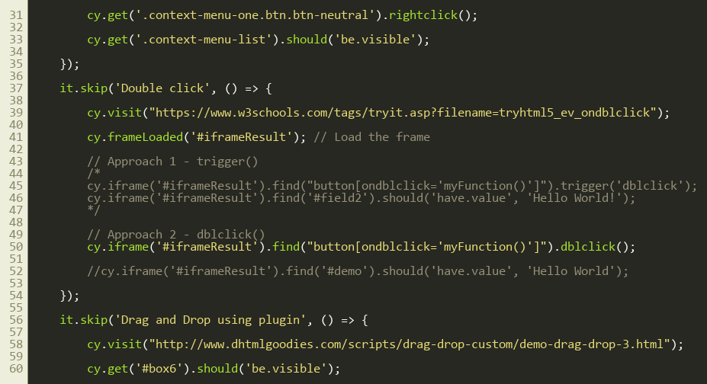
Lines 31–60
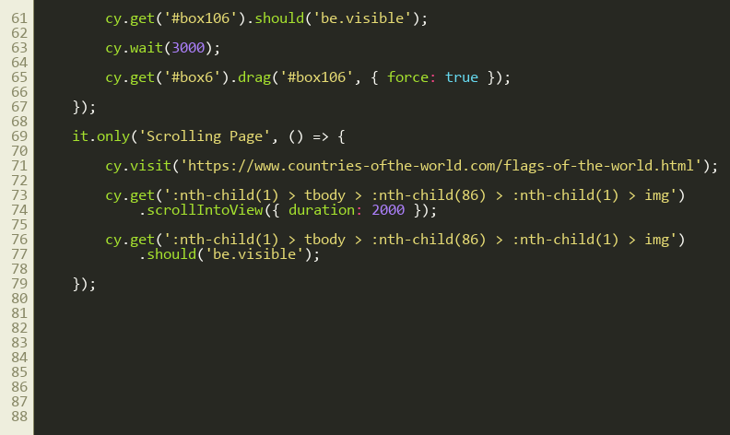
Lines 61–90
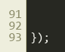
Lines 91–94

3. Step by step: what happens
Look for this in the code | What it does
Mouse hover (skipped) | Cypress has no real hover, so .trigger('mouseover') fires the event and .click() opens the menu. Then the submenu item is checked as visible.
Right click (skipped) | cy.visit(demo page); .rightclick() (approach 2) or .trigger('contextmenu') (approach 1), then the context menu should be visible. The first line was previously cy.skip(...) by mistake and is now cy.visit(...).
Double click (skipped) | The demo is inside an iframe: cy.frameLoaded('#iframeResult'), then cy.iframe('#iframeResult').find(button).dblclick() (approach 2) or .trigger('dblclick') (approach 1).
Drag and drop (skipped) | Check both boxes are visible, cy.wait(3000), then cy.get('#box6').drag('#box106', { force: true }).
Scrolling (active) | cy.get(image in row 86).scrollIntoView({ duration: 2000 }) then should('be.visible').

4. Concepts involved
Concept | Meaning
.trigger('event') | Fires any DOM event such as mouseover, contextmenu or dblclick.
.rightclick() / .dblclick() | Built-in shortcuts for the common cases.
{ force: true } | Do the action even if Cypress thinks the element is covered or hidden.
.drag(target) | From the @4tw/cypress-drag-drop plugin.
.scrollIntoView({ duration }) | Scrolls smoothly until the element is in view.
Iframes with cypress-iframe | frameLoaded and iframe, as in the iFrames file.

5. How it is implemented
Each test uses either a built-in command or fires the raw event with .trigger(). The commented 'Approach 1' blocks show the raw-event alternatives.

6. Why it is useful
One reference for all the 'advanced' mouse actions.

7. Things to watch out for
- nth-child(86) is a brittle selector; it breaks if the table changes.
- { force: true } can hide real UI problems, so use it only when needed.

