alerts.cy.js – JavaScript alerts, confirms, prompts and basic auth
File | cypress/e2e/alerts.cy.js
Website used | https://the-internet.herokuapp.com/javascript_alerts and /basic_auth
Run status | Only test 1 runs because it has it.only. Remove it to run all five.
Concepts | cy.on(event, callback), Return value of window:confirm, cy.stub(), cy.window(), Basic authentication, Order matters

1. What this file does
Handles the different kinds of browser pop-ups. These pop-ups are drawn by the browser, not the web page, so cy.get() cannot find them. Cypress gives us events and stubs for them.

2. The code (screenshots)
Keep this next to the file in VS Code. Line numbers match the real file.
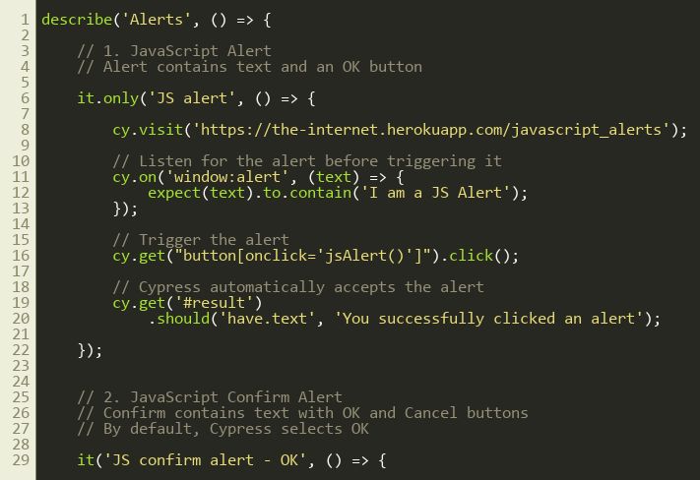
Lines 1–30
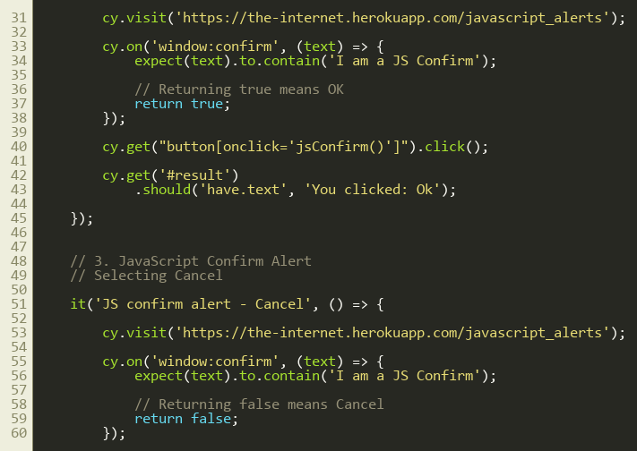
Lines 31–60
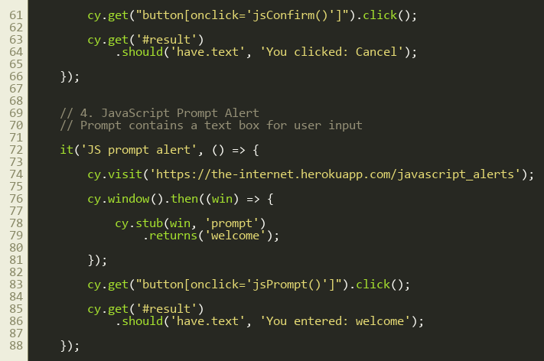
Lines 61–90
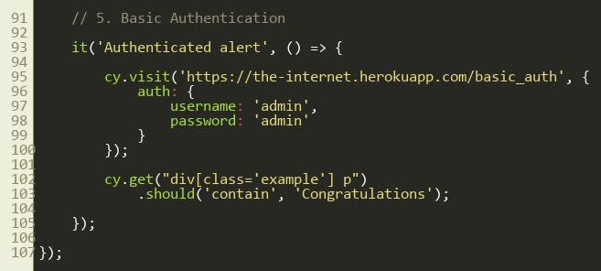
Lines 91–108

3. Step by step: what happens
Look for this in the code | What it does
Test 1 – JS alert (it.only) | cy.on('window:alert', ...) listens for the alert and checks its text. Then we click the button. Cypress presses OK automatically. Finally we check the result message.
Test 2 – Confirm, OK | cy.on('window:confirm', ...) and return true, which means OK. Result: 'You clicked: Ok'.
Test 3 – Confirm, Cancel | Same listener but return false, which means Cancel. Result: 'You clicked: Cancel'.
Test 4 – Prompt | A prompt has a text box and no event. We stub window.prompt so it returns 'welcome': cy.window().then(win => cy.stub(win,'prompt').returns('welcome')). Result: 'You entered: welcome'.
Test 5 – Authenticated alert | Basic-auth pop-ups are an HTTP feature. We pass credentials in the visit: cy.visit(url, { auth: { username:'admin', password:'admin' } }). The page then says 'Congratulations'.

4. Concepts involved
Concept | Meaning
cy.on(event, callback) | Listens for browser events such as window:alert and window:confirm.
Return value of window:confirm | true = OK, false = Cancel.
cy.stub() | Replaces a function with a fake one that returns what we choose.
cy.window() | Gets the browser window object.
Basic authentication | Sent with the visit() options, so no pop-up appears.
Order matters | Register the listener BEFORE the click that triggers the alert.

5. How it is implemented
Cypress auto-accepts alerts and confirms. We only add a listener when we want to check the message or choose Cancel. The Chrome flag in cypress.config.js keeps the auto-accept working on newer Chrome versions.

6. Why it is useful
Alerts cannot be handled with normal commands, so knowing these four patterns covers almost every pop-up scenario.

7. Things to watch out for
- image.png in the project root is a screenshot of this exact alert showing in the runner.
- With it.only on test 1, tests 2 to 5 are ignored. Remove it to run all.

