checkBoxes.cy.js – Checkboxes
File | cypress/e2e/checkBoxes.cy.js
Website used | https://qaplayground.com/practice/radio-checkbox
Run status | Runs. It ticks all the skill checkboxes. Other options are commented examples.
Concepts | .check() / .uncheck(), be.checked / not.be.checked, .first() / .last(), uncaught:exception, /// <reference types='cypress' />

1. What this file does
Finds a group of checkboxes and ticks them, checking they are checked. Other ways to select one, untick, first and last are kept as comments.

2. The code (screenshots)
Keep this next to the file in VS Code. Line numbers match the real file.
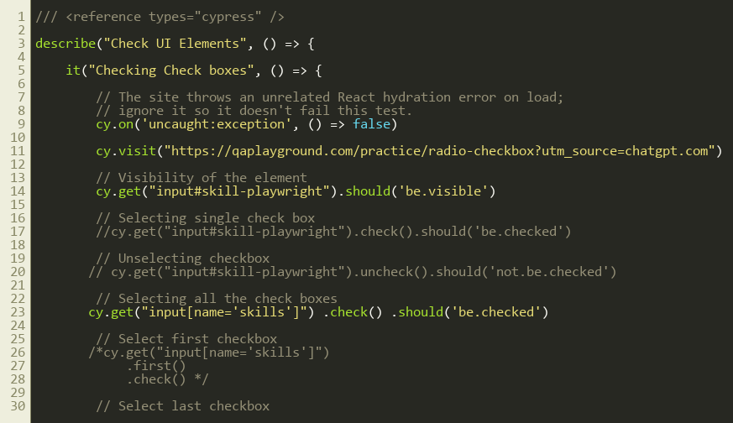
Lines 1–30
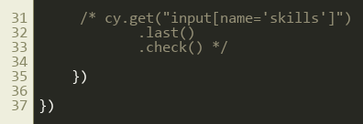
Lines 31–37

3. Step by step: what happens
Look for this in the code | What it does
cy.on('uncaught:exception', () => false) | The website itself throws an unrelated React error. Returning false tells Cypress not to fail the test because of it.
cy.visit(...) | Opens the practice page.
cy.get("input#skill-playwright").should('be.visible') | Sanity check that the checkbox exists and is shown.
Commented: .check().should('be.checked') | Ticks a single checkbox and verifies.
Commented: .uncheck().should('not.be.checked') | Unticks and verifies.
cy.get("input[name='skills']").check().should('be.checked') | The selector matches ALL skill boxes, so one command ticks them all.
Commented: .first().check() / .last().check() | Ticks only the first or only the last of the group.

4. Concepts involved
Concept | Meaning
.check() / .uncheck() | Tick and untick. check() does nothing if it is already ticked, so it is safe to repeat.
be.checked / not.be.checked | Assertions for the state.
.first() / .last() | Pick one element out of many.
uncaught:exception | Ignoring errors that come from the app, not from our test.
/// <reference types='cypress' /> | A comment at the top that gives VS Code auto-complete for cy commands.

5. How it is implemented
One selector with a shared attribute (name='skills') selects the whole group; Cypress then applies .check() to each.

6. Why it is useful
Ticking or verifying many boxes takes one line.

7. Things to watch out for
- Only use uncaught:exception when you are sure the error is unrelated to what you are testing; otherwise it can hide real bugs.

