cssSelectors.cy.js – Finding elements with CSS selectors
File | cypress/e2e/cssSelectors.cy.js
Website used | https://tutorialsninja.com/demo/ (OpenCart demo shop)
Run status | Runs. It has no assertion, so it only proves the steps do not error.
Concepts | CSS selectors, cy.get(selector), .type(text), .click()

1. What this file does
Opens a demo shop, types 'MacBook' in the search box and clicks the search button. The element locators are CSS selectors. The comment block at the bottom is a mini cheat-sheet of CSS selector forms.

2. The code (screenshots)
Keep this next to the file in VS Code. Line numbers match the real file.
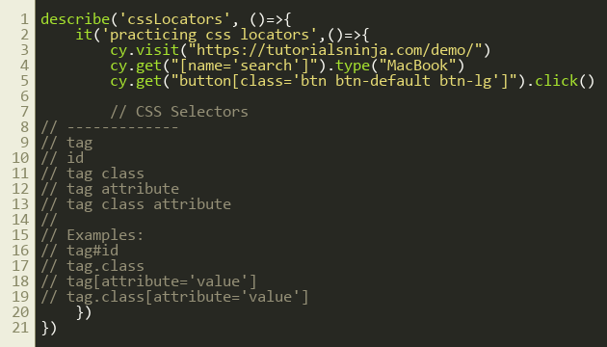
Lines 1–21

3. Step by step: what happens
Look for this in the code | What it does
cy.visit(...) | Opens the shop home page.
cy.get("[name='search']").type("MacBook") | Finds the element whose name attribute is 'search' (the search box) and types into it like a user.
cy.get("button[class='btn btn-default btn-lg']").click() | Finds the button whose class attribute is exactly that text and clicks it.
Comment block | Lists the selector patterns: tag, id, tag.class, tag[attribute], tag.class[attribute].

4. Concepts involved
Concept | Meaning
CSS selectors | The default way to locate elements in cy.get(). # = id, . = class, [attr='value'] = attribute.
cy.get(selector) | Finds elements and retries until they appear (up to 4 seconds).
.type(text) | Types text into an input one key at a time.
.click() | Clicks the element. Cypress first checks it is visible and not covered.

5. How it is implemented
Selectors can be combined: input#user (tag + id), button.btn (tag + class), input[name='q'] (tag + attribute), button.btn[type='submit'] (all three). [class='a b c'] matches the WHOLE class string in that order, while button.a.b.c matches regardless of order, which is safer.

6. Why it is useful
CSS selectors are short, fast and the default. Knowing them well is the basis for every other test.

7. Things to watch out for
- No assertion means the test passes even if the search results are wrong. Add something like cy.url().should('include','search').
- Prefer ids or data-* attributes over long class lists, which break when the design changes.

