dropdowns.cy.js – Four kinds of dropdowns
File | cypress/e2e/dropdowns.cy.js
Website used | example.cypress.io, dummyticket.com, wikipedia.org, google.com
Run status | Tests 1 to 3 are it.skip. Only the Dynamic dropdown (Google) runs, and it is fragile.
Concepts | .select(), Special keys, .contains(text), .each(($el, index, $list) => ...), cy.wrap($el), cy.wait(ms)

1. What this file does
A small catalogue of dropdown types, each handled differently: a normal select, a select2 style dropdown, an auto-suggest box and a dynamic dropdown whose items change as you type.

2. The code (screenshots)
Keep this next to the file in VS Code. Line numbers match the real file.
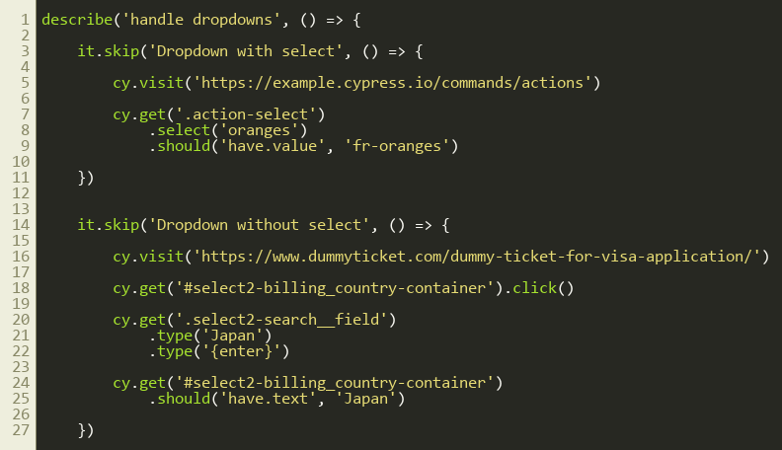
Lines 1–30
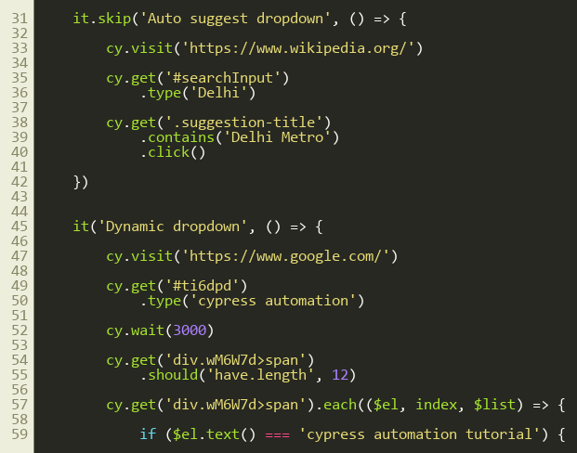
Lines 31–60
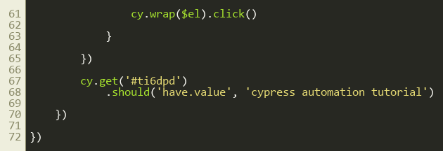
Lines 61–73

3. Step by step: what happens
Look for this in the code | What it does
1. Dropdown with select (skipped) | cy.get('.action-select').select('oranges').should('have.value','fr-oranges'). .select() picks by visible text or value on a real <select>.
2. Dropdown without select (skipped) | select2 is a styled div. Click the box to open it, type 'Japan' into its search field, press {enter}, then check the box shows Japan.
3. Auto suggest (skipped) | Type 'Delhi' in the Wikipedia search, then use .contains('Delhi Metro').click() on the suggestion list.
4. Dynamic dropdown (active) | Type into Google search, cy.wait(3000) for suggestions, check there are 12, loop with .each() and click the one whose text matches, then check the input value.

4. Concepts involved
Concept | Meaning
.select() | Only for real <select> elements.
Special keys | {enter}, {esc}, {backspace} etc. inside .type().
.contains(text) | Finds an element by the text it contains.
.each(($el, index, $list) => ...) | Loops through every matched element.
cy.wrap($el) | Converts the plain jQuery element so .click() can be used on it.
cy.wait(ms) | Hard wait. Works but should be avoided in real projects.

5. How it is implemented
Check how the dropdown is built (inspect the page). If it is a <select>, use .select(); otherwise treat it like normal clickable elements.

6. Why it is useful
Dropdowns are everywhere and each type needs a different approach, so this is a quick reference.

7. Things to watch out for
- Google's class names (#ti6dpd, .wM6W7d) are auto-generated and change often; Google may also show captchas to automation.
- Use stable practice sites to learn.

