explicitAssertions_BDD_Style.cy.js – Explicit assertion with expect()
File | cypress/e2e/explicitAssertions_BDD_Style.cy.js
Website used | https://opensource-demo.orangehrmlive.com
Run status | Runs. May fail if the OrangeHRM demo user name changes (it is not controlled by us).
Concepts | Explicit assertion, BDD style, .then(callback), jQuery .text()

1. What this file does
Logs into OrangeHRM, reads the logged-in user's name from the page into a normal JavaScript variable and compares it with the expected name using Chai's BDD style expect().

2. The code (screenshots)
Keep this next to the file in VS Code. Line numbers match the real file.
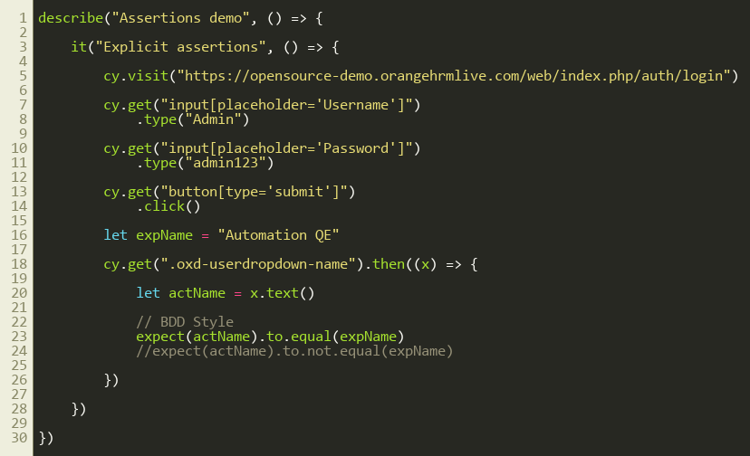
Lines 1–30

3. Step by step: what happens
Look for this in the code | What it does
cy.visit(...) | Opens the login page.
type Admin / admin123, click submit | Logs in using locators on username, password and the Login button.
let expName = "Automation QE" | Stores the name we expect to see.
cy.get(".oxd-userdropdown-name").then((x) => { | Gets the name element and passes it as x (a jQuery object) to the callback.
let actName = x.text() | Reads the text from the element into a normal variable.
expect(actName).to.equal(expName) | BDD style assertion. The test fails if the two are different. The line below it (to.not.equal) is the negative version.

4. Concepts involved
Concept | Meaning
Explicit assertion | We get the value ourselves and compare it, instead of chaining .should().
BDD style | expect(actual).to.equal(expected) reads like English (Behaviour Driven Development).
.then(callback) | The way to get the real value out of a Cypress command, because commands do not return values.
jQuery .text() | Reads text from the element inside the callback.

5. How it is implemented
Cypress commands are queued, so we cannot write let name = cy.get(...). We use .then() and work with the value inside it.

6. Why it is useful
Use explicit assertions when .should() is not flexible enough: comparing two values from the page, doing maths, or using if conditions.

7. Things to watch out for
- Assertions inside .then() do NOT retry. .should() does.
- The demo site's user name is random, so the expected 'Automation QE' may not match any more.

