explicitAssertions_TDD_Style.cy.js – Explicit assertion with assert()
File | cypress/e2e/explicitAssertions_TDD_Style.cy.js
Website used | https://opensource-demo.orangehrmlive.com
Run status | Runs. Same caveat as the BDD file: the demo user name can change.
Concepts | TDD style, BDD vs TDD

1. What this file does
Exactly the same scenario as the BDD file (log in and compare the displayed user name), but the comparison uses Chai's TDD style assert.equal().

2. The code (screenshots)
Keep this next to the file in VS Code. Line numbers match the real file.
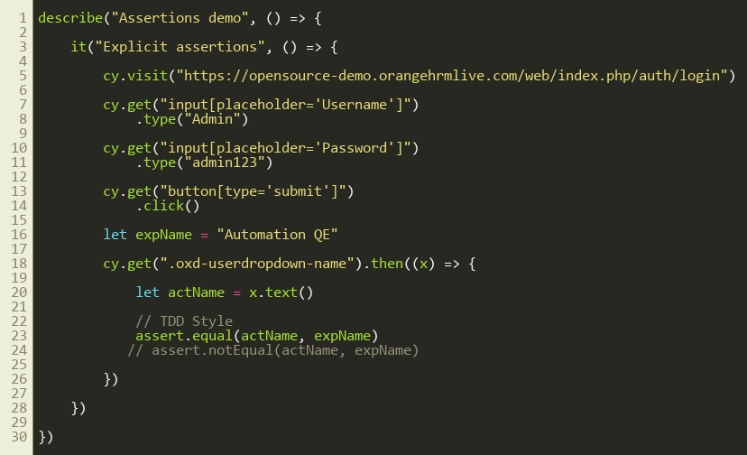
Lines 1–30

3. Step by step: what happens
Look for this in the code | What it does
cy.visit(...) and login steps | Same as the BDD file.
let expName = "Automation QE" | Expected value.
cy.get(...).then((x) => { let actName = x.text() | Pull the actual text into a variable.
assert.equal(actName, expName) | TDD style check. The commented line below uses assert.notEqual() for the negative check.

4. Concepts involved
Concept | Meaning
TDD style | assert.equal(actual, expected): a function-style assertion (Test Driven Development).
BDD vs TDD | expect(a).to.equal(b) <-> assert.equal(a, b); expect(a).to.not.equal(b) <-> assert.notEqual(a, b); expect(a).to.be.true <-> assert.isTrue(a).

5. How it is implemented
Only the last line differs from the BDD file. Both styles come from the Chai library that Cypress bundles, so no import is needed.

6. Why it is useful
Seeing the two files side by side shows that BDD and TDD are only different writing styles. Pick one and use it consistently.

7. Things to watch out for
- assert.equal uses loose equality (==). Use assert.strictEqual for strict (===) comparison.

