fileUploads.cy.js – File uploads
File | cypress/e2e/fileUploads.cy.js
Website used | the-internet.herokuapp.com, davidwalsh.name, htmlelements.com
Run status | Only the Shadow DOM test runs (it.only). The other four are it.skip.
Concepts | Fixtures as upload files, subjectType, Shadow DOM, Built-in alternative

1. What this file does
Five ways to upload files using the cypress-file-upload plugin: single, renamed, drag and drop, multiple files and a file input inside Shadow DOM. Files come from cypress/fixtures.

2. The code (screenshots)
Keep this next to the file in VS Code. Line numbers match the real file.
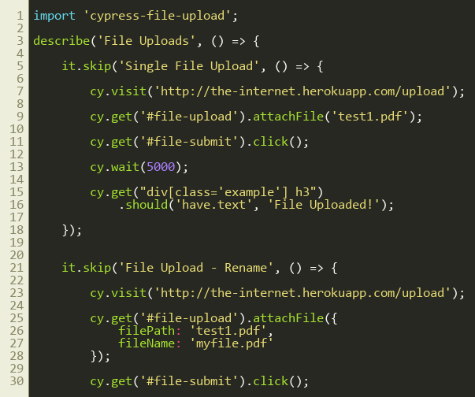
Lines 1–30
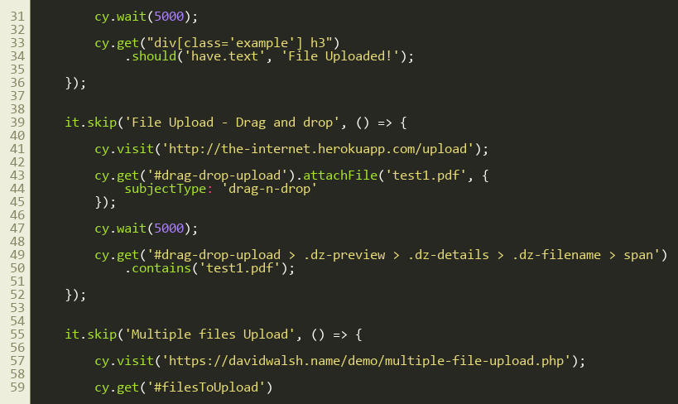
Lines 31–60
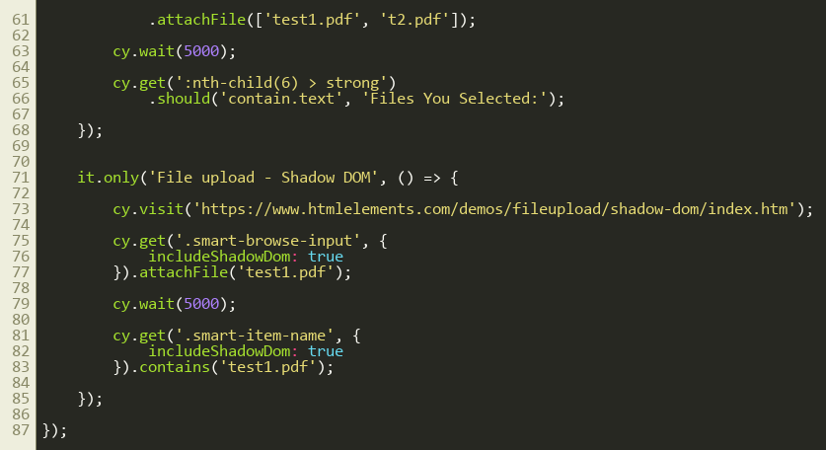
Lines 61–87

3. Step by step: what happens
Look for this in the code | What it does
import 'cypress-file-upload' | Adds .attachFile() to Cypress.
Single file | cy.get('#file-upload').attachFile('test1.pdf'), click Upload, wait, check the heading says 'File Uploaded!'.
Rename | attachFile({ filePath:'test1.pdf', fileName:'myfile.pdf' }) uploads it under a different name.
Drag and drop | attachFile('test1.pdf', { subjectType:'drag-n-drop' }) simulates dropping the file on the zone; then check the preview shows the file name.
Multiple files | attachFile(['test1.pdf','t2.pdf']) passes an array to a file input that allows multiple files.
Shadow DOM (active) | cy.get('.smart-browse-input', { includeShadowDom: true }).attachFile('test1.pdf'), then check the name appears with .contains('test1.pdf').

4. Concepts involved
Concept | Meaning
Fixtures as upload files | attachFile looks inside cypress/fixtures (test1.pdf and t2.pdf).
subjectType | Chooses between input and drag-n-drop uploading.
Shadow DOM | A hidden mini-DOM inside a component. Use { includeShadowDom: true } to search inside it.
Built-in alternative | Since Cypress 9.3, .selectFile() does uploading without any plugin.

5. How it is implemented
A real file dialog cannot be driven by Cypress, so the plugin sets the file directly on the input element.

6. Why it is useful
Uploads are a common feature; this covers the usual variants.

7. Things to watch out for
- cy.wait(5000) is a hard wait; replace it with an assertion that retries.

