fixtures.cy.js – Using a fixture (test data from a JSON file)
File | cypress/e2e/fixtures.cy.js
Website used | https://opensource-demo.orangehrmlive.com/
Run status | Runs. The first version is commented out; the second version is active.
Concepts | Fixture, cy.fixture('name'), before hook + shared variable, Separating data from tests

1. What this file does
Reads login details from cypress/fixtures/orangehrm.json instead of hard-coding them, and uses them to log in and check the displayed name.

2. The code (screenshots)
Keep this next to the file in VS Code. Line numbers match the real file.
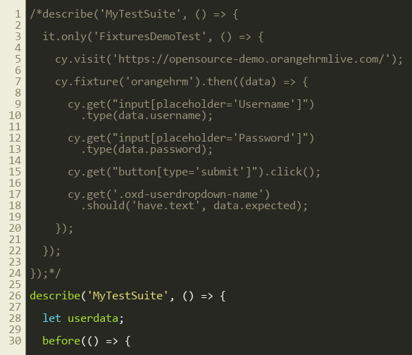
Lines 1–30
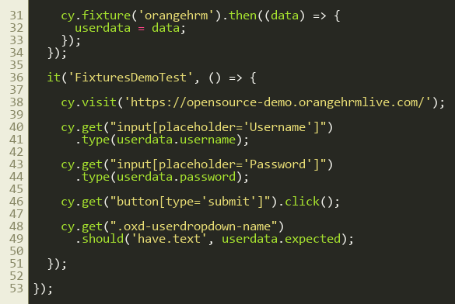
Lines 31–53

3. Step by step: what happens
Look for this in the code | What it does
Commented block (top) | First approach: load the fixture inside the test itself using cy.fixture().then(). Works for one test only.
let userdata; | A variable declared outside the tests so every test in the suite can use it.
before(() => { cy.fixture('orangehrm').then((data) => { userdata = data; }); }); | Runs once. cy.fixture reads orangehrm.json and parses it. The data is stored in userdata.
cy.visit(...) | Opens OrangeHRM.
type(userdata.username) / type(userdata.password) | Types the values that came from the JSON file.
click submit | Logs in.
.should('have.text', userdata.expected) | Checks the displayed name equals the expected value from the JSON file.

4. Concepts involved
Concept | Meaning
Fixture | A data file in cypress/fixtures, normally JSON.
cy.fixture('name') | Loads the file. The .json extension is optional.
before hook + shared variable | Load once, use in many tests.
Separating data from tests | Change the data without touching the test code.

5. How it is implemented
cy.fixture returns a Cypress chain, not the data, so the data is only available inside .then(). That is why we assign it to userdata there.

6. Why it is useful
If the password or user changes, I edit one JSON file instead of many tests. It is also the basis for data-driven testing.

7. Things to watch out for
- The expected value 'manda user' is whatever the demo site currently shows for that login; the test fails if the site changes it.

